Shavington Academy
‘Together we enjoy, aspire, create, and achieve’

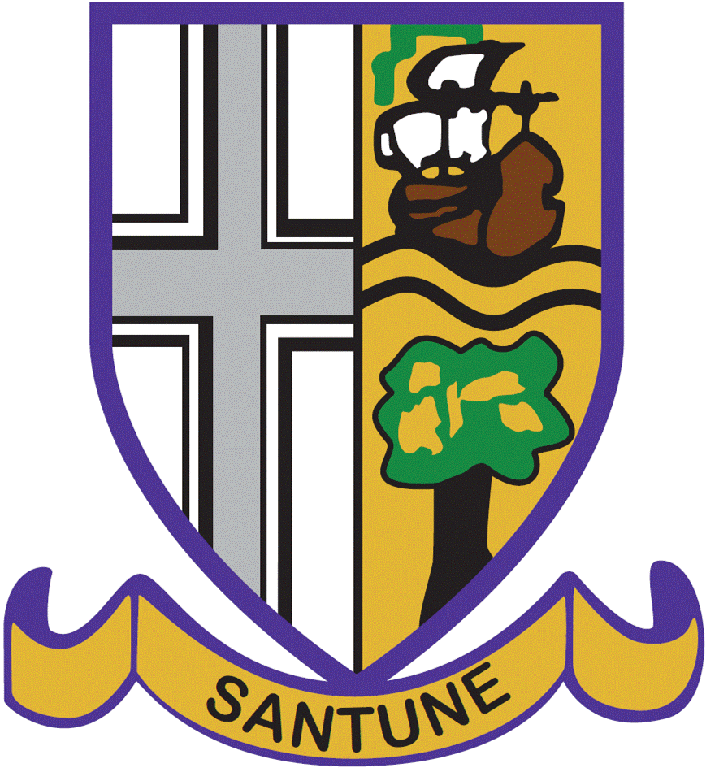

Applications are invited for a full time permanent
Teacher of Modern Foreign Languages

From September 2021
£25,714 - £36,961

Trustees and Governors are seeking to appoint a dynamic and skilled Modern Foreign Language professional, with a proven track record in MFL pedagogy and pupil outcomes, in a secondary context. Trustees/Governors are seeking to appoint a well- qualified and dynamic language specialist, to teach Key Stages 3 & 4. The ability to teach French & German is desirable, with at least one to GCSE being essential. Applicants must be an outstanding classroom practitioner and have the interpersonal skills to drive an ethos of continual improvement.

We are very proud of our Academy and believe that our mission statement ‘Together we enjoy, aspire, create and achieve’ underpins our ethos and our collective drive for all pupils both academically and personally. Here at Shavington, we value the ethical and moral development of our pupils, promoting integrity, kindness, gratitude, respect and tolerance across all elements of Academy life, as well as promoting academic success.

Our Academy has high aspirations for all of our pupils to enable them to achieve their potential and beyond. Pupils achieve well, above the national average for the majority of subjects within the curriculum. We have an exceptional track record of preparing pupils for post 16 study, as well as the workplace and beyond. We pride ourselves on the Academy values that will enable our pupils to become a responsible member of our community, as well as preparing them for the diversity and demands of the modern-day world.

Background Information

Shavington Academy has been a Multi Academy Trust since 1st September 2015 for pupils aged 11-16, serving the villages and conurbation to the South of Crewe. Our catchment includes Wistaston Church Lane, The Berkeley, Shavington, Weston and Wybunbury Delves Primary Schools, though we draw pupils from across Crewe and South Cheshire. Our current school population is approximately 830 pupils; we have over 200 first choices for September 2021 and admitted 180 in 2020. As such we have a growing school population with a maximum Pupil Admission of 850 for the current building. Housing developments locally and the academy’s growing reputation suggest that we will grow to this size in the next few years.

In 2012 we became one of fourteen high schools in Cheshire East to form the Chimney House Teaching School Alliance. Being a member of a teaching school has many benefits for teachers across the Teaching School; we both deliver and receive high quality training to support professional development at all levels, within the partnership.

Applications

Informal enquiries prior to application should be made to rchell@shavington.academy, Assistant Head Teacher. To apply for this post, please complete an application form with a supporting statement of no more than two sides of A4 on your suitability for the post and the academy, with reference to your areas of expertise. The closing date for applications is 20th April 2021. All applications should be returned by email to recruitment@shavington.academy.

The closing date for applications is: Tuesday 20th April 2021 – 12 noon

Interview date week beginning: 26th April 2021

Many thanks for your interest in Shavington Academy.

With kind regards,

Miss Emma Morris
Head Teacher

