TEACHER OF MFL
Spanish & French
ECT/MPS/UPS
TLR available for the right candidate

Candidate Pack

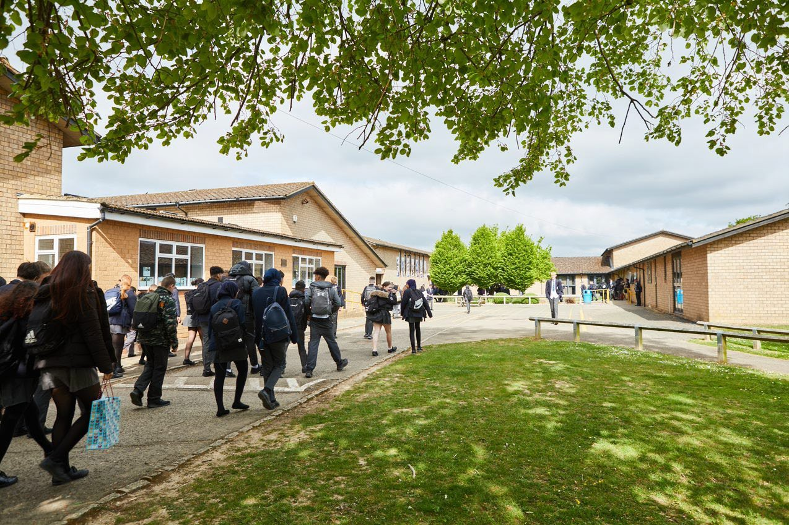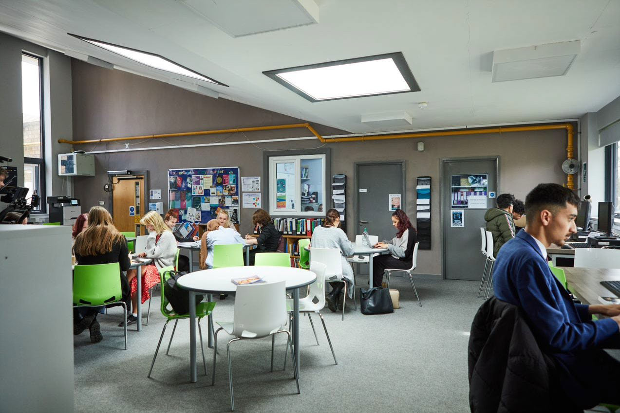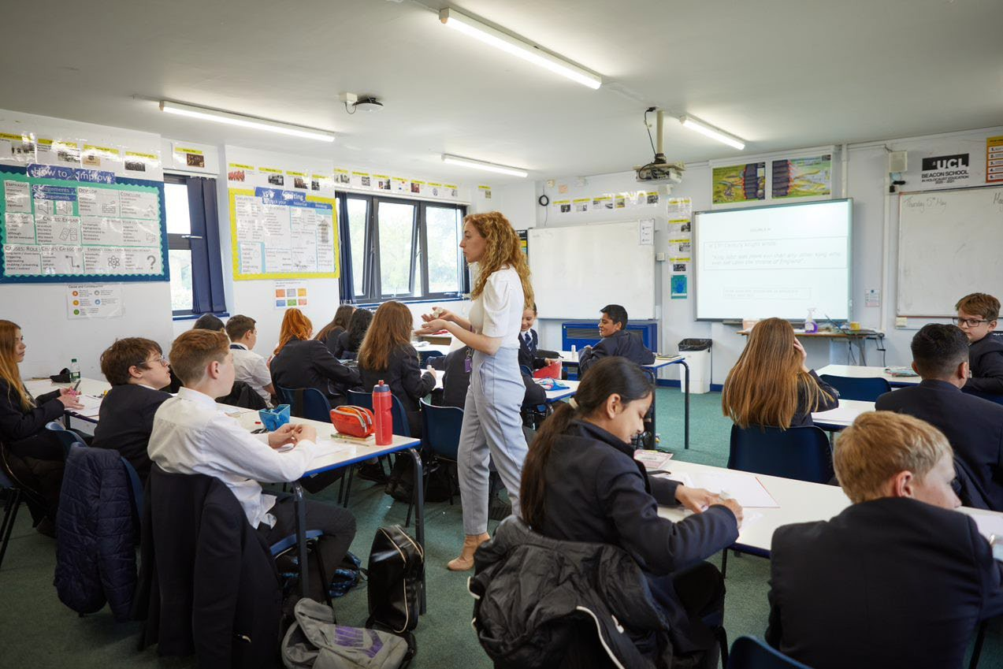
Welcome Letter from the Headteacher

Dear Prospective Candidate

Thank you for your interest in the position of Teacher of MFL at Sir William Ramsay School.

I joined Sir William Ramsay School as the new Headteacher in May 2022 and am committed to getting the school back to ‘Good’ as quickly as possible. Clarity, consistency and rigour are central to our plans to ensure that all students enjoy learning and make good progress. Our plans include significant developments in high quality teaching and learning, the introduction of ambitious targets, a focus on developing excellent teaching, meaningful homework and improvements in behaviour for learning. We are also rolling out a digital learning 'One to One Device' strategy across the school to ensure that students can receive innovative teaching and access state of the art resources at both home and school.

We are looking to appoint a dynamic Teacher of MFL to contribute to the development of this successful area. The ideal candidate will have a belief in the ability of all students to achieve and a passion for raising student achievement. You will have a desire to strive for continuous school improvement and a commitment to team work as well as a sense of fun.

If you would like to find out more about the role or to arrange a conversation with the Head of Faculty, Ms Sanmartin, please contact ssanmartin@swr.school.

I will hope to meet you in the near future.

Yours faithfully
Paul Ramsey
Headteacher

Vision and Values at Sir William Ramsay School

Empowering Everyone to Achieve

Vision
A community where every voice counts, where talent and creativity are brought to life, where students grow in confidence, build resilience and are prepared for the rest of their lives.

Values
- We are respectful – we always treat people, property and the environment with kindness and consideration
- We are ambitious – we ask for help when we need it and strive to be the best we can be
- We are reliable – we do what is asked of us and deliver on our commitments
- We are resilient – we prepare for the future and adapt and grow from challenges

Mission
We aim to achieve our vision by:
- Raising students above the ordinary by developing and delivering lifelong learning which transforms lives
- Ensuring every person feels valued, safe and happy
- Enabling students to feel proud of themselves, and to take pride in the success of others
- Promoting a culture of mutual respect where everyone is treated as a valued member of the school community
- Encouraging positive communication so that words and actions are thoughtful, supportive and motivational
- Placing parents and carers at the heart of the life of the school
- Having highly dedicated and well-qualified staff who are committed to continuous professional development
- Adopting an ethos of continuous improvement within all aspects of school life

Equality
Sir William Ramsay is an inclusive and diverse community. We work to eliminate all forms of discrimination on the grounds of ethnic origin, religion, sexual orientation, gender, disability or ability. This is achieved via the following principles:
- Ensure that students have the opportunity to reach their potential in all areas of school life
- Ensure that parents/carers and students can make choices free from prejudice and stereotyping
- Oppose any form of racism, sexism, disability discrimination, homophobia or any other form of discrimination
- Value every student’s language and cultural background
Job Description

Job Title: | Teacher of MFL (Spanish & French)  ECT/MPS/UPS
Aim and Main Job Purpose: | To teach, enthuse and inspire students about MFL

Teaching and Managing Student Learning
Teacher of MFL will:
- Be able to teach effectively across the full range of age and abilities.
- Possess high expectations of students in relation to standards of achievement and behaviour.
- Have an active input in the creation, consistent implementation and improvement of schemes of work which encapsulate key school learning strategies.
- Monitor the progress of students including those requiring additional support and challenge them to ensure students are engaged in their learning and achieve success.

Assessment and Self-Evaluation
Teacher of MFL will:
- Implement policies and practices for assessing, recording and reporting on student achievement and to assist in setting targets for further improvement.
- In conjunction with the Head of MFL, use data effectively to identify students who are underachieving and, where necessary, create and implement an effective intervention plan.

Relationships with Parents/Carers
Teacher of MFL will:
- Establish a partnership with parents/carers to involve them in their child’s learning of the subject, as well as providing information about targets and attainment.
- Communicate effectively, both orally and in writing, with parents/carers.

Managing Own Performance
Teacher of MFL will:
- Prioritise and manage their own time effectively.
- Take responsibility for their own professional development.
- Share good practice resulting in a tangible impact on student learning.
- Form constructive relationships with staff including team working and mutual support.
- Actively implement the key aspects of the school’s behaviour management policies.
- Be a form tutor.
- Make a contribution to the wider school life including specialist MFL enrichment activities.
- Contribute to faculty planning and developments.

Strategic Leadership
Teacher of MFL will:
- Contribute fully to the Faculty Development Plan which contributes positively to the achievements of the School Development Plan.

Other Responsibilities
- To promote the School’s vision, values and aims.
- To be aware of and comply with the codes of conduct, regulations, policies, procedures.
- To work as part of a team.
- To be generally responsible for safeguarding and promoting the welfare of students.
- To be responsible for own and team health and safety including well-being.
- To actively participate in the School’s appraisal system.
- To do Continued Professional Learning as agreed with the Line Manager.

This job description is current at the date indicated below but, in consultation with the postholder, it may be changed by the Headteacher to reflect or anticipate changes in the post commensurate with the grade or job title.
The MFL Department

Teacher of Spanish and French
The MFL Department are a successful and well-resourced team with a relentless focus on raising attainment. We follow the AQA GCSE Spanish course and have introduced French in Year 7 and Year 8. We also have a small number of students enter for GCSE language examinations in their native language. In past years these have included Portuguese, Turkish, Urdu, Polish and Italian. If you are enthusiastic, passionate about contributing to the development of teaching and learning in the MFL team, enjoy challenges and are committed in helping us to make a difference to the lives of young people, then you are the person to join our progressive and forward-thinking team.

The MFL Curriculum
At KS3, Spanish and French serves a cultural and linguistic purpose in that it exposes students to foreign language and culture, therefore promoting global citizenship. The curriculum builds on prior learning at KS2 by reinforcing vocabulary, basic grammar and transactional language. We follow the VIVA coursebook in Spanish and Dynamo in French which also serves to enrich students’ use of their mother tongue through comparison of the language and culture of another country. In KS4 Spanish, the curriculum builds on prior learning at KS3 by revisiting many of the same topics to deepen knowledge and increase linguistic and grammatical sophistication. The GCSE curriculum allows students to deepen their knowledge about how language works and enrich their vocabulary for them to increase their independent use and understanding of extended language in a wide range of contexts.

MFL Facilities
We have a departmental office with working space for all and a suite of three specialist classrooms, all equipped with data projectors and smartboards connected to laptop computers which facilitates lesson delivery via PowerPoint and Internet resources. Year 7 and Year 10 students all have their own devices which are used in lessons. At KS3 we use Viva 1, 2 and 3 textbooks as our main coursebook for Spanish and Dynamo 1 and 2 for French. At KS4 we use VIVA GCSE in conjunction with Active Teach online.

Extra-Curricular Activities
The MFL Department is particularly proud of its extra-curricular provision. We have thriving exchange links with a school in Logroño and our Year 9 cohort are currently in the process of exchanging letters on a termly basis with our partner school. We organise for a Spanish theatre company to come into school to conduct a play completely in Target Language to further immerse students in the culture and language, which was eagerly anticipated by students and staff alike. We also run a number of clubs within the department offering languages such as French and Italian for those who wish to try their hand at a new language and we have a Booklet club which is very popular with KS3.

This is an exciting time for the school, and we are looking for applicants with a passion to work with young people to drive their success even further. In return, you can expect effective support from our strong leadership team along with a hardworking, talented and passionate staff body. We are committed to professional development and there is considerable opportunity for career development within the school.

How to Apply

If you wish to discover more about this exciting opportunity, need any further information or you wish to have an informal discussion, please contact Head of Faculty: ssanmartin@swr.school 01494 815211.

Please email your completed application form to: jointheteam@swr.school

Closing Date: Noon – Wednesday 21st June 2023
Interviews: Week commencing Monday 26th June 2023

Sir William Ramsay School is committed to safeguarding and promoting the welfare of children and young people and expects all staff and volunteers to share this commitment. We will ensure that all our recruitment and selection practices reflect this commitment.

All successful candidates will be subject to DBS checks along with other relevant pre-employment checks.

