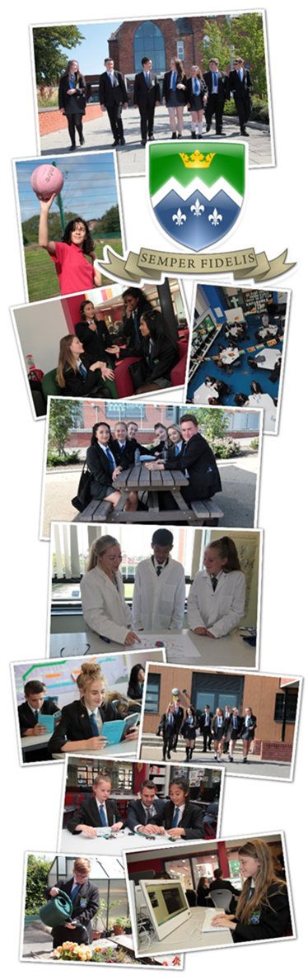

Teacher of MFL

Information to Candidates

June 2021

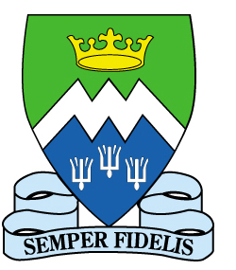
St Mary’s Catholic Academy
St Walburga’s Road
Blackpool. FY3 7EQ
Tel: 01253 396286
Email: admin@st-mary.blackpool.sch.uk
Web: www.st-mary.blackpool.sch.uk
Head Teacher: Mr. S. Eccles B.Sc. (Hons) MEd
Dear Colleague,
Thank you for considering St. Mary's Catholic Academy for the next stage in your career.
We are seeking to appoint a talented Teacher with the relevant knowledge and expertise to teach Spanish and/or French, who has the potential to develop into an outstanding teacher. The role commences in September 2021.
This post has been advertised to replace a successfully promoted member of our MFL department. The successful candidate would need to be able to teach Spanish or French as a main language with the ability to teach a second language of Spanish or French at Key Stage 3 desirable. The role would be a fantastic opportunity for a talented teacher to develop their skills. Further details of the post are outlined in this information pack. Applications must be sent electronically to admin@st-mary.blackpool.sch.uk by 12pm on Thursday 17th June.
St Mary's is a highly regarded oversubscribed Catholic Academy in Blackpool in the Diocese of Lancaster. The school is very much a Catholic family where everyone works together to support and challenge one another to be the best they can be.
Our Catholic Ethos, founded on the hallmarks of:
Catholic Caring Community Challenge
is key to our success. Students and staff are all encouraged, as our mission statement states, to grow in wisdom, understanding, self-esteem and closeness to God. Many of our staff and students are Catholic or Christian, we are joined by a number of staff and students who aren’t, anyone is welcome to come and be part of our family as long as they are willing to support and contribute to the ethos and success of the Academy.
As Head Teacher, I believe that a happy, highly trained and well supported staff is the key to our success. Staff at St Mary's receive a full induction programme and access our outstanding weekly professional development. All teaching staff also have 90 minutes of additional non-contact time per fortnight to focus on their own area of interest in enhanced professional development. New staff are also supported by regular, weekly coaching meetings and support from their subject areas; a range of leadership development programmes is also available.
St Mary's is designated as Blackpool's research school and provides staff with the opportunity to benefit from the latest research and evidence in education. Everything we do, whether that be our innovative key stage 3 reading programme; our approach to revision and practice homework; or the design of our professional development curriculum for teachers; is research evidence based.
Staff wellbeing is also a key part of our success as a school. A hard-working staff should be well supported and cared for to allow them to meet the demands made of teachers in a modern context. All staff are provided with their own personal laptop and extensive training and the support of colleagues. A well-resourced support team of ICT technicians, admin staff, chaplaincy staff and site staff work hard to make sure the Academy runs smoothly and that teaching staff are well supported to focus on our core business of teaching. Workload issues are regularly discussed with our staff committee and policies around marking, assessment, reporting and homework are carefully designed to try and manage the workload for staff. An email protocol ensures staff are not disturbed by emails in an evening and small gestures like free tea, coffee and biscuits served by our amazing housekeepers; free access to the school fitness suite; free annual flu jabs; a car valet service and regular staff social events including a free Christmas “do” and a Trust summer ball all help to make our Academy and Trust a rewarding place to work. All of this work takes place in state of the art facilities. St. Mary's was lucky enough to benefit from a 22.5 million pound partial rebuild and refurbishment, we are so lucky to work in one of the best school buildings in the region.
Staff retention is high at St Mary’s because staff are valued and in return work hard to ensure our students achieve the best possible outcomes. If what you have read so far is exciting and you feel that St Mary’s is a community in which you will thrive and make a positive contribution to our ethos and journey, then we would love to receive your application. You will find more information about St Mary’s and information specific to this role and the application process in the rest of this document. You can also find further information out about the Academy on our website.
Yours sincerely
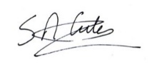
Mr Simon Eccles
Headteacher
What others say about St Mary’s
OFSTED
A short Ofsted Inspection of St Mary’s in March 2017 was extremely positive and confirmed that St Mary’s Catholic Academy continues to be good. A copy of the full inspector’s letter is available on the Academy website. The following quotes are taken from the body of the inspector’s letter:
- The leadership team has maintained the good quality of education in the school since the inspection of your predecessor school.
- Pupils spoken to during the inspection showed great pride in their school and parents wholeheartedly appreciate the efforts made by staff.
- Comments from parents such as ‘The staff go above and beyond what is expected’ and ‘The staff clearly have the best interests of the children at heart’ were typical.
- Staff were equally positive; their comments portray a school where people are valued and supported. One member of staff put this very clearly: ‘Each and every pupil knows there are people in school who care deeply for them…who will go the extra mile for them…that is something of which I am incredibly proud.’
Diocesan Section 48 inspection
Our Diocesan Inspection Report in March 2017 graded us as “outstanding”. A copy of the full report is available on the Academy website. Some of the inspector’s findings were:
- This is an outstanding Catholic Academy. Christ is at the centre of all it does and Gospel values permeate throughout.
- The leadership of the academy is outstanding as Directors and leaders are totally committed to the Church’s mission of high quality Catholic education for all.
- Staff are authentic witnesses to Gospel values and endeavour to live these out in their work with pupils, especially the most vulnerable. The quality of the pastoral care is outstanding with all pupils and staff expressing the caring community that exists in all aspects of the life of the academy. Pupils care deeply about their school with one Year 11 pupil saying, “I feel lucky to come here.”
The prayer and liturgical life of the academy is outstanding. There is a very strong Chaplaincy team whose work permeates the whole of Report
Our Investors in People status was renewed in April 2018. The latest report is available on our website and contains the following comments:
“The sense of team is very strong in the Academy, everyone pitches in to get the job done. As a result there is a strong culture of everyone learning and sharing together. In addition everyone is clear about the standard of work required.”
“People described a ‘family’ culture where staff work collaboratively for the benefit of the Students and the community.”
“High levels of staff retention; people do not leave St Mary’s Catholic Academy.”
“People unanimously commented on the Academy as being a ‘great place to work’ referring to the environment as being hardworking but friendly, supportive and flexible.”
“People said that they appreciated the extra treats they received e.g. refreshments, breakfasts/ buffets at end of term, 100 minute extended CPD, opportunities to undertake research/ projects/ qualifications to list but a few.”

Public examination results:

In our last set of data prior to the pandemic in 2018-19 our GCSE attainment passed 60% grade 4-9 in English and Maths for the second time. Our progress 8 score was -0.25. Results in centre assessed grades in 2019-20 showed further improvement with 67.5% of students achieving a grade 4 or better in English and Maths. We continue to focus on closing the gap between Pupil premium and non-Pupil premium students, there is still much work to do here.

At A level results were the best we have ever achieved in 2018-19 with 100% pass rate and 50% of grades at A or B. This year students achieved 100% pass with 62% of grades at A or B. All of our Y13 students were successful in moving on to employment or education.

COMPLETING YOUR APPLICATION

INFORMATION FOR CANDIDATES

Application process:

Candidates should complete a CES application form (attached to the advert on the Academy website) and a letter of application, the details of which can be found below. Please do not include a CV as this will not be considered as part of the process. Evidence will be drawn from:

- Letter in support of application.
- Application Form.
- Lesson observation & task.
- Response to questions during interview.
- References.

Letter of application should:

- Be clear, concise and well presented.
- Demonstrate how you meet the person specification.
- Describe your vision for teaching and learning in the Modern Foreign Languages Department at St. Mary’s Catholic Academy in the 21st Century.
- Be no more than two sides of A4 in length.

Applications can only be accepted in electronic format via email to admin@st-mary.blackpool.sch.uk the closing date is 12pm on Thursday 17th June 2021.

Modern Foreign Languages Department Information
INFORMATION FOR CANDIDATES

PERSONNEL
The staffing from September 2021 is:
Mr P Brown – Senior Assistant Headteacher and Senior Line Manager for MFL.
Miss F Lynch - Head of MFL.

Miss R Jack – Teacher of MFL, Part Time.
Mrs Melanie Jaunâtre - Teacher of MFL.

CURRICULUM
Pupils currently study Spanish in Years 7-9, with the opportunity to opt to start a second language (French) in Year 9. The Academy is considering returning to alternating French and Spanish at Key Stage 3. Both French & Spanish are optional at GCSE and currently uptake is very good. At KS4 Studio & Viva GCSE are used. At KS5 both French & Spanish are offered, with class sizes of 5 on average. The department runs a very successful foreign trip each year and are developing links with a school in Spanish with a view to establishing exchanges in the future.

ACCOMMODATION

The MFL Department shares the learning house accommodation with the English Department. The learning house consists of a suite of nine different rooms including two rooms with fixed ICT. The environment is light, comfortable and engaging for all. There is a teacher “grab and go” area within the large flexible learning space. There is some variety in the learning spaces available which would allow for different approaches to the teaching of MFL to be explored.

PLANNED DEVELOPMENTS

In line with the Academy Raising Achievement Plan the key objectives for MFL this year are:

- Establishing MFL as a high-profile subject within the academy and raising uptake at KS4 & 5.
- Embedding the DAFITAL process across the key stages in order to raise achievement overall.
- Developing the MFL team with clear CPD to meet their needs.

ST. MARY’S CATHOLIC ACADEMY

TEACHER OF MFL

Person Specification

The successful candidate will be someone with enthusiasm, initiative and very good subject knowledge. S/he will demonstrate a clear commitment to promoting the highest possible standards of achievement and developing excellent relationships with staff and students across the full age and ability range at St. Mary's. The person appointed will have a professional and personal profile that most closely matches the specification given below:

- QUALIFICATIONS

- Qualified teacher status at graduate level.
- MFL Degree/Degree containing substantial MFL element.
- Recent professional development/teaching placement relevant to the post.

- EXPERIENCE, SKILLS, KNOWLEDGE and APTITUDE

- A clear philosophy for the teaching of MFL.
- Knowledge of some strategies that will enhance learning and raise the attainment of all students in MFL.
- Ability to use MFL to transform learning.
- Effective communicator – verbally and in writing.

- PERSONAL QUALITIES

- Ability to form good relationships with both colleagues and students.
- Commitment to actively supporting the distinctive ethos of the school.
- Commitment to assisting with the development of extra-curricular activities.
- Resilience, commitment, ability to work under pressure and a sense of humour.
- An excellent attendance and punctuality record. (Please note that excellent attendance is considered to be 95% attendance over the past two academic years. Governors will take note of one off illnesses/absences and individual circumstances).
- High expectations of all students.
- Enthusiasm for career development.

The standard contact time for teachers is 26 out of 30 periods per fortnight (23 for NQTs) including a period of PSHE with your form.

JOB DESCRIPTION – TEACHER OF MFL

All teachers have a responsibility to contribute to the realising of high standards of attainment and discipline in their classes and subject area. They are also responsible for the pastoral care of a form group. The duties should be discharged in such a manner as to actively enhance the Catholic ethos of the Academy.

Responsible to: Head of MFL

Key Outcomes

- A caring, Catholic ethos built on high quality relationships.
- Increased proportions of outstanding and very good teaching.
- Consistently high standards of attainment across all key stages.
- A well-disciplined and stimulating learning environment.
- Promotion and safeguarding of the welfare of all students.

The key outcomes will be achieved by:

Contributing to a Common Mission and Shared Vision through:
- Helping preserve the existing strengths of St. Mary’s Catholic Academy and further developing its distinctive mission with the Catholic Church.
- Being the significant adult and main role model for a form group.
- Assisting with the implementation and evaluation of the MFL Department Development Plan and the Academy’s Development Plan.
- Implementing the Academy’s Child Protection Policies and procedures.

Developing a commitment to learning by:
- Having high expectations of all students and promoting transformational learning and teaching that leads to consistently high levels of achievement for all.
- Working as a member of the MFL Department to establish and maintain a highly effective team.
- Contributing to the development of Schemes of Work and lesson plans that fulfil and enrich examination syllabi requirements.
- Implementing high quality assessment and student tracking procedures that assist learning.
- Ensuring high standards of discipline through recognising and rewarding positive student behaviour and dealing appropriately with unacceptable behaviour.
- Assisting with extra-curricular activities.
- Assisting in the maintenance of a safe and stimulating learning environment within the MFL Department.

In addition, to the specific duties outlines above you will be expected to carry out the duties of a Teacher as stated in the current School Teachers’ Pay and Conditions Document.

This post is subject to:
- The CES (Catholic Education Service) form of contract,
- To DBS (Disclosure and Barring Service) formerly the CRB,
- Medical clearance
- Verification of your qualifications and National Insurance number.

Please note as part of the Academy’s commitment to the protection and safety of its students:
- References will be required including a judgement about your suitability to work with children. Referees will be asked whether you have any disciplinary offences relating to children (even if spent) and whether you have been the subject of any child protection concerns.
- Open references supplied by candidates will not be accepted.
- A member of the interview panel will be trained in implementing Child Protection procedures.

These responsibilities will be reviewed in the light of the Academy’s raising achievement plan and changing needs.

S. Eccles May 2021
Academy Raising Achievement Plan Long Term Objectives

New Objectives |  | Academic year
 |  | 2019/20 | 2020/21 | 2021/22 | 2022/23
1 | Develop and embed the St Marys Way for staff, students and parents. | Embed
2 | Further develop the CPD curriculum for staff to include stage appropriate training, improved training for support staff and better use of enhanced CPD time. | Develop | Implement | Embed
3 | Develop, Implement and embed a strategy to increase the numbers of Post 16 students in St Mary's Sixth Form. | Develop | Implement | Embed
4 | Implement an effective plan to close the progress gap for disadvantaged students. | Implement | Implement | Embed
5 | Develop an effective curriculum offer for all students at St Mary's. | Implement | Embed
6 | Develop the current behaviour for learning policy to improve the climate for learning and ethos at St Mary's. | Implement | Embed
7 | Implement and embed a clear quality assurance framework to ensure clear leadership of the Academy. | Implement | Embed

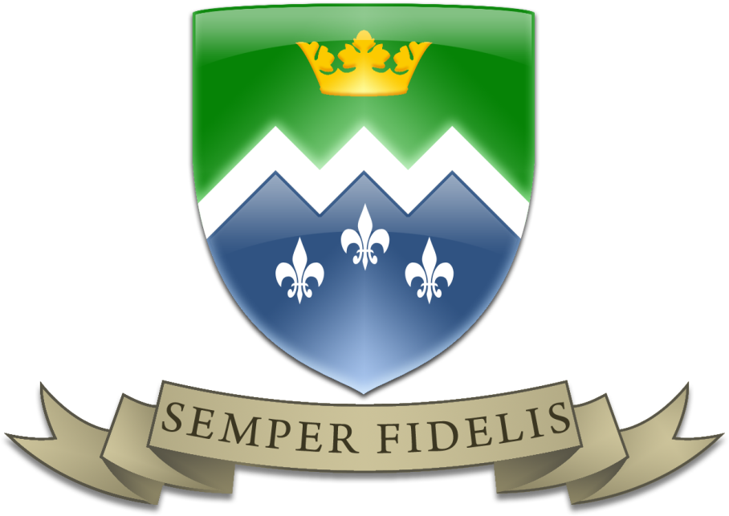

The Saint Mary’s Way
The distinctive ethos or “St Mary’s Way” is based on the four dimensions of the pastoral mission of the church:
- Kerygma (Announcing – distinctiveness of witness, religious contribution to every aspect of our education. The Proclaiming School).
- Leitourgia (Liturgy – Grace builds on nature but must acknowledge the sphere beyond the natural world. The work of the Christian assembly to adore God in prayer, thanksgiving and penitence. The Worshipping School).
- Diakonia (Ministry - Culture has to be changed and transformed by the Christian Gospel. This emphasises social activism and the service of the poor. The Serving School).
- Koinonia (Community – Christian community existing in reasonable harmony with the surrounding society. Christian school plays a part in the country’s general education provision. One mission of all Christians is the creation of community which inevitably involves at times compromise and creating common ground with the surrounding culture. The Civic School).

All of these elements are part of the Mission of the Church and all these elements will be found in an authentically Catholic school. Kerygma and Leitourgia give the essential “roots” to the community and help define our distinctiveness. They provide the opportunities to gather and centre ourselves around a core of beliefs. The Trust will be respectful of parents as the first and foremost educators of their children and seek to engage them in their child’s education.
Both Diakonia and Koinonia give the opportunity for our faith to take “wings” and reach out beyond our own community in order to have a positive impact on other communities, particularly those suffering from poverty, and society in general. The service and civic nature of our schools helps give witness and richness to our distinctive way of living. This will include an education rich in the spiritual, moral, social and cultural and supportive of British Values.
Proclaiming, worshipping, service and civic duty are essential elements of the Catholic school. We need both roots and wings to ensure we deliver an education in faith and wisdom which is the hallmark of a Catholic school.
These four dimensions of the mission of the church are reflected in our Academy mission statement:
St. Mary’s Catholic Academy is a caring faith community. Our mission is to provide an outstanding whole-person education through which all are challenged to grow in wisdom, understanding, self-esteem and closeness to God.
The hallmarks of St. Mary’s are:
Catholic Caring Community Challenging
St. Mary’s is a Catholic academy where prayer and reflection are woven into the fabric of the academy’s life. The universal message of the Church and its call to new life encourages us to value every individual as precious in God’s sight. The distinctive education offered at the academy includes the continuing development of morals and Christian values.
Respecting the uniqueness of each person is central to the caring nature of the academy and a reflection of the Gospel message of love. A strong and supportive pastoral system continues to care for all and helps build people’s self-esteem.
The academy strives to be a community where high quality and enriching relationships are built. Tolerance and the valuing of others are key points of daily life. We seek to manage every aspect of academy life, with justice, for the common good of all.
We challenge all people to use their God-given gifts to achieve excellence and make significant progress in their learning. Opportunities exist for aesthetic, performing and creative talents to be nurtured.

The St Mary’s Way:

The St Mary’s Way is based on the mission of the church and academy and is built around a way of living and working together as a community centred on Pope Francis modern day beatitudes:

IMAGO DEI – RESPECTING GOD IS IN EVERYTHING WE SEE
- We see the value of every member of our community
- How we speak to others is a reflection of our care for them
- We will leave no member of our community feeling alone or that they don’t belong
- As people made in the image of God, we act with honesty and integrity
- Each day represents a chance to grow in wisdom

A SERVING COMMUNITY
- We look out for the needs of others
- Our behaviour should not harm the learning of others
- We try to empathise and understand those who may be struggling
- We see our role in the community as being there to help and encourage each other

A COMMUNITY OF GRATITUDE
- Staff and students thank each other at the end of each lesson
- We show appreciation for all that is done for us in the Academy, whoever has done it
- We recognise the expertise of those who work in the academy
- We recognise that education is a privilege not enjoyed by everyone around the world
- We appreciate the people we share this place with and from whom we can learn

A COMMUNITY OF STEWARDSHIP
- We look after the things we need to help us learn
- We regard all of the academy as ours to look after
- We cultivate our talents and use them for the good of ourselves and others
- We play all of our roles with our best efforts
- We respect the academy environment and enable it to be enjoyed by everyone

A FORGIVING COMMUNITY
- We avoid unnecessary conflict, often by talking it through
- We are not quick to take offence or to ‘hit back’
- We know the power of words to heal arguments and rebuild relationships
- We work hard to forgive each other and ourselves

A PROPHETIC COMMUNITY
- We recognise the power of our words
- We speak the truth with compassion
- We ensure that everyone is treated fairly
- We keep a special eye out for those who may feel vulnerable

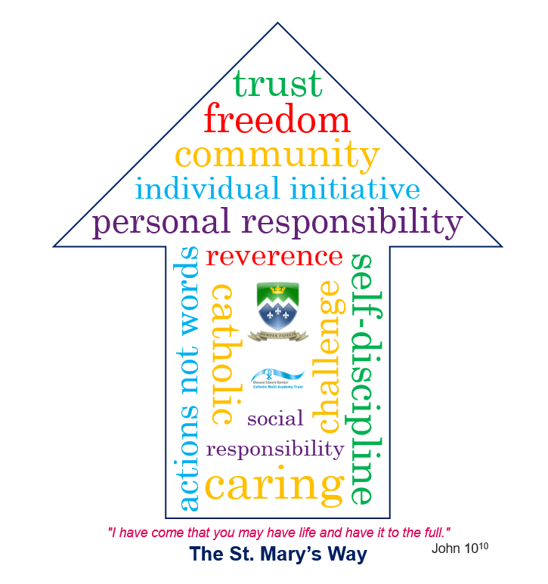

OUR HANDBOOK
TABLE OF CONTENTS
Message from our Headteacher 3
1. Our history 4
2. Cornelia Connelly 6
3. What has formed our values? 7
4. Our mission 7
5. The St Mary’s Way 8
6. Our expectations of you 9

A message from our Headteacher
Welcome to our family and to our handbook for “The St. Mary’s Way.” You are very welcome to our community. As our mission statement says: “St. Mary's Catholic Academy is a caring faith community. Our mission is to provide an outstanding whole-person education through which all are challenged to grow in wisdom, understanding, self-esteem and closeness to God.”
St. Mary’s is not just about exam results and academic success; it is also about walking with you and your family on your faith journey through our school, helping you to develop your whole character and “Live life to the full”.
As you will read in this handbook, our school is built on 150 years of tradition. This started with Blessed Cornelia Connelly and the Society for the Holy Child Jesus. They set up the first Catholic School for Girls in Blackpool in 1870. The Society believed in a caring and Christian approach to school which challenged their students to be the best they could possibly be. We still follow the key principles of this in our own St. Mary’s Way, which you will read about in this handbook. This “Way” helps us to understand who we are as a community and how we live and work together as a family. Please read it carefully it is the most important information you will read as you start St. Mary’s.
I will see many of you in assemblies and around the Academy but I want to take this opportunity to wish you every success at our Academy. This is a new start in your education journey and a fantastic opportunity to live life to the full by following our St. Mary’s Way.
Kind Regards
Mr Eccles
Head teacher

Our history

The St. Mary’s Way
"I have come that you may have life and have it to the full."

Cornelia Connelly
Cornelia Connelly, an American-born wife and mother and a zealous convert, founded the Society of the Holy Child Jesus in England in 1846.
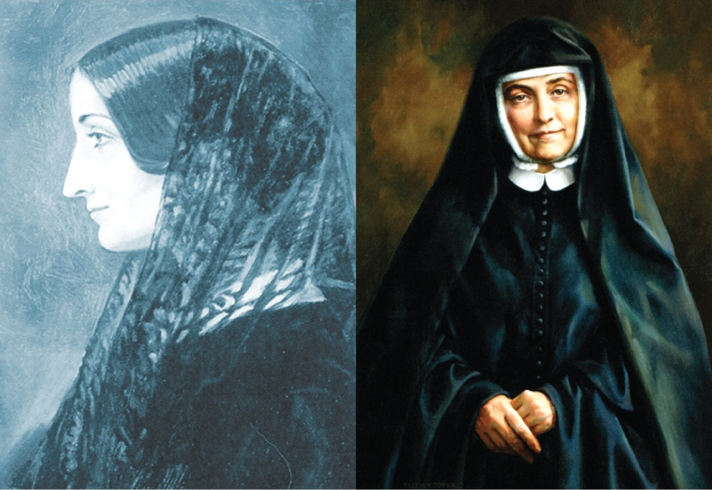
Her sisters were primarily trained as educators, and her educational system was praised for its innovative and effective methods.
Cornelia imbued her community with the value of respect for the dignity of every human being, and this spirit of trust and reverence for all God’s people has been handed down through the generations.
In 1862, six sisters from England took the Society to the United States. Various initiatives by European and North American sisters followed over the next century. In 1930, three sisters brought the Society to Nigeria, and in 1967, four sisters established the Society in Chile.
Today the Society has a presence in North America, Africa, Europe and South America, and the Sisters of the Holy Child Jesus live according to the Society’s motto, “Actions Not Words”, in a variety of ministries living out religious life in the third millennium.

What has formed our values?
Holy Child schools around the world are rooted in the educational tradition of the Society of the Holy Child Jesus, sharing in its mission to help others believe that God lives and acts in them and in our world.
Cornelia Connelly developed an educational system based on trust and reverence for the dignity of every human being. She wanted Holy Child educators to carry this spirit to students of diverse backgrounds as they sought to respond to the wants and needs of the age in which they lived.
Since 1846, those educating in the tradition of Cornelia Connelly’s spirituality and philosophy of education have helped students to grow strong in faith and lead full lives, educating their students according to the following core values:
- Freedom
- Creativity
- Self-discipline
- Individual initiative
- Personal and social responsibility.

Our MISSION
At St Mary’s we are a caring faith community. Our mission is to provide an outstanding whole-person education through which all are challenged to grow in wisdom, understanding, self-esteem and closeness to God. As a result, we have developed four hallmarks, which look to build upon the spirituality and philosophy set out by Cornelia Connelly.
Our hallmarks are often referred to as the 4Cs:
- Catholic
- Caring
- Community
- Challenge

The St Mary’s way
The St Mary’s Way is the term we use to bring everything together. It provides a structure, gives clarity, and points our young people and our staff in the right direction. St Mary’s Catholic Academy not only provides our young people with the opportunity to achieve academic success, but also the chance to grow and develop as an individual.

We believe that if a young person can live their life according to the values of the St Mary’s Way, they will go on to be a happy, successful and positive member of their community.

The values of the St Mary’s Way are the same core values that laid the foundation for the early work that Cornelia Connelly began. In modern society, they seem to have even more relevance than they did 1846, and that is why they form an integral part of our St Mary’s Way today.

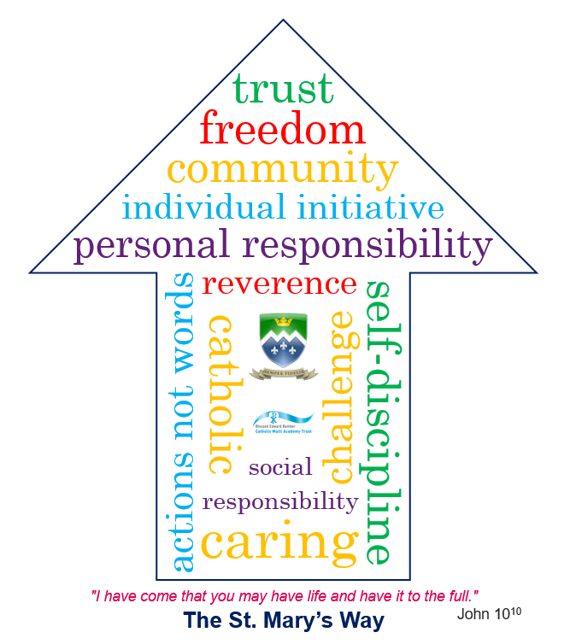

Our expectations of you
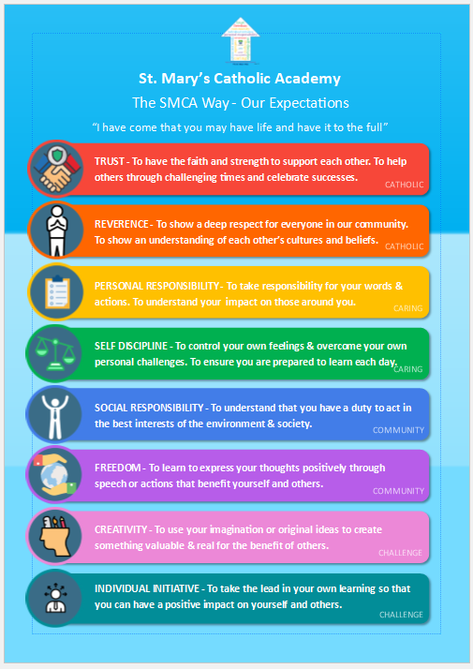

The St. Mary’s Way

