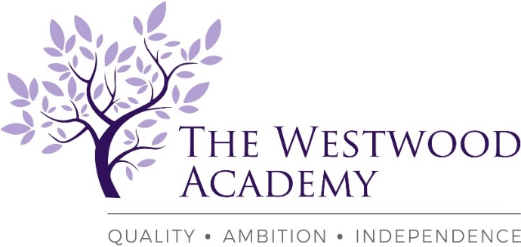

The Westwood Academy – Part of the Kenilworth Multi Academy Trust family of schools
Mitchell Avenue, Coventry, CV4 8DY
Teacher of Modern Foreign Languages – Spanish & French
Full Time or Part Time
TMS/MPS/UPS currently £25,714 - £41.604: Required; January 2023 or earlier if available

We are looking to appoint, an enthusiastic, creative and innovative teacher of Modern Foreign Languages into a continuously popular, highly successful and ambitious department. You will be required to teach both Spanish and French across Key Stages 3 and 4 as appropriate to your skill and experience, initially we are likely to need more Spanish teaching.

We are happy to consider both part time or full-time applications, as a rapidly growing and now oversubscribed school we are increasing our teaching numbers across all subjects. This is therefore an excellent opportunity to gain a full-time post for the academic year 2022/2023 onwards. We are looking for teachers with a love of their subject, ambition and the ability to engage young people in learning. We provide a unique environment in which both teachers and pupils thrive. You must be able to teach both Spanish and French with a minimum of either language to GCSE and a willingness to upskill as required over a period of time. Post 16 experience would be a bonus. However, that said whatever your teaching experience to date we would welcome your application as the existing team are a very encouraging group of teachers who will be there to support your teaching journey. This is an exceptional opportunity for an experienced Teacher or enthusiastic ECT looking to build a career.

The Westwood Academy is part of the Kenilworth Multi-Academy Trust a forward thinking and ambitious trust. We offer a motivating learning environment with an excellent shared CPD programme. We are proud of our academic record and of our pastoral care, which maintains a feeling of community in a small, but rapidly growing school.
The school works tirelessly to ensure that every pupil’s potential is successfully achieved, through excellent teaching, the establishment of positive learning relationships, effective assessment and constructive feedback.

We encourage all potential candidates to come and visit the school and meet the staff and pupils to fully appreciate our wonderful community.
Role Requirements:
- Qualified Teacher Status or ECT with recent UK classroom experience essential gained during training
- Either Spanish or French to GCSE with a willingness to train in other key stages
- Full or Part Time considered
- Up to date knowledge of your specialist area for years Year’s 7 – 11 & an interest in Post 16
- Dedicated, creative and hardworking individual
- A real willingness to learn new skills
- Employees benefit from an extensive and bespoke CPD programme and enrolment in our Benenden Health Scheme is available for all employees from the commencement of employment

You are most welcome to visit the school to meet our staff and pupils. If you would like to discuss this opportunity further, please contact the Head of School.

Further details and application forms are available via the school website at:
https://www.thewestwoodacademy.co.uk/760/recruitment
Please send completed application forms to admin@thewestwoodacademy.co.uk
If you require any further information please contact
Mrs J Westwell: PA to Head of School
Telephone number: 024 7642 6901
E-mail: admin@thewestwoodacademy.co.uk
Closing date: Tuesday 6th September2022: 10:00am
This school is committed to safeguarding and promoting the welfare of children and young people and expects our staff and volunteers to share this commitment. This post is subject to two satisfactory references and an Enhanced Disclosure and Barring Service check.

