MFL Teacher
Summerhill School

Thank you for your interest in joining the MFL department at our school.
Visits to the school are always welcome. Please contact Miss K Stone, Headteacher’s PA on 01384 816165 or via email at kstone@summerhill.dudley.sch.uk
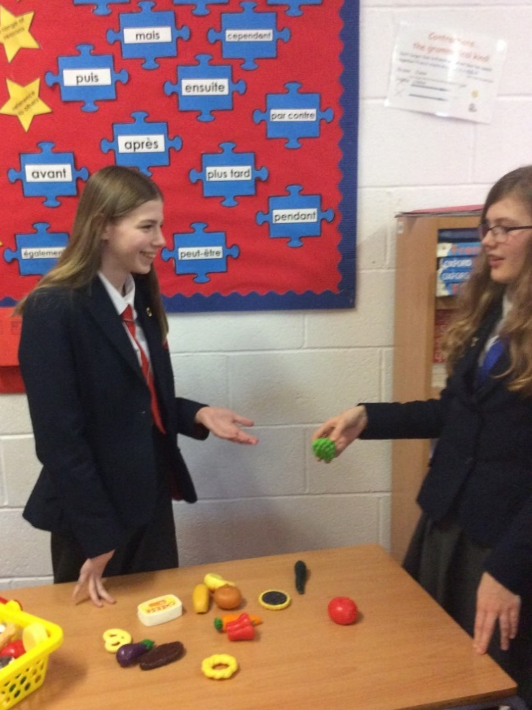
Departmental Context

We believe in delivering Languages in a fun and interactive environment. Lessons are delivered in target language with the curriculum serving to widen students’ knowledge and understanding of the culture, history and literature of speakers of the language, without compromising progression of vocabulary, grammar and language learning skills.
We ensure that our curriculum equips students with the skills to effectively apply language learned in a variety of contexts.
Students are taught over a one-week timetable, with six 50 minute lessons a day. In the MFL department we see Year 7-9 main language students 3 times per week, and KS3 option groups 2 times per week. GCSE students in year 10 and 11 have 3 lessons per week. All language groups are taught in groups of mixed ability.

In KS3, students follow a Scheme of Learning which broadly follows Pearson Progression Steps alongside resources from the Viva and Dynamo courses. In KS4 we follow the Edexcel specification in French and Spanish.

Students are able to study both French and Spanish to GCSE level.

Wider School Context
Summerhill School was historically recognised as the best secondary school in the local area. In 2016, the school was judged by Ofsted to require improvement and endured a turbulent period of time. Since then, the school has been transformed, our results have improved and we are delighted that in April 2019 we received a Good judgement following inspection.
We’re not complacent and we know that further efforts will be needed to ensure that we are consistently excellent in everything we do, but Summerhill is now a very positive place to work and we are definitely a school on an upward trajectory. Our Progress 8 score is already highly positive (+0.20).
Pupils currently at the school make good progress
across year groups and in the different subjects.

The school is located on the western edge of the West Midlands conurbation, in an area with desirable housing and easy access to the countryside. As a result, our students are largely from homes with above average incomes and we have a lower than typical proportion of Pupil Premium students, though we still have students who need support in a wide range of ways. The school was rebuilt completely under a PFI agreement in 2003 and we benefit from a modern, well-maintained building.

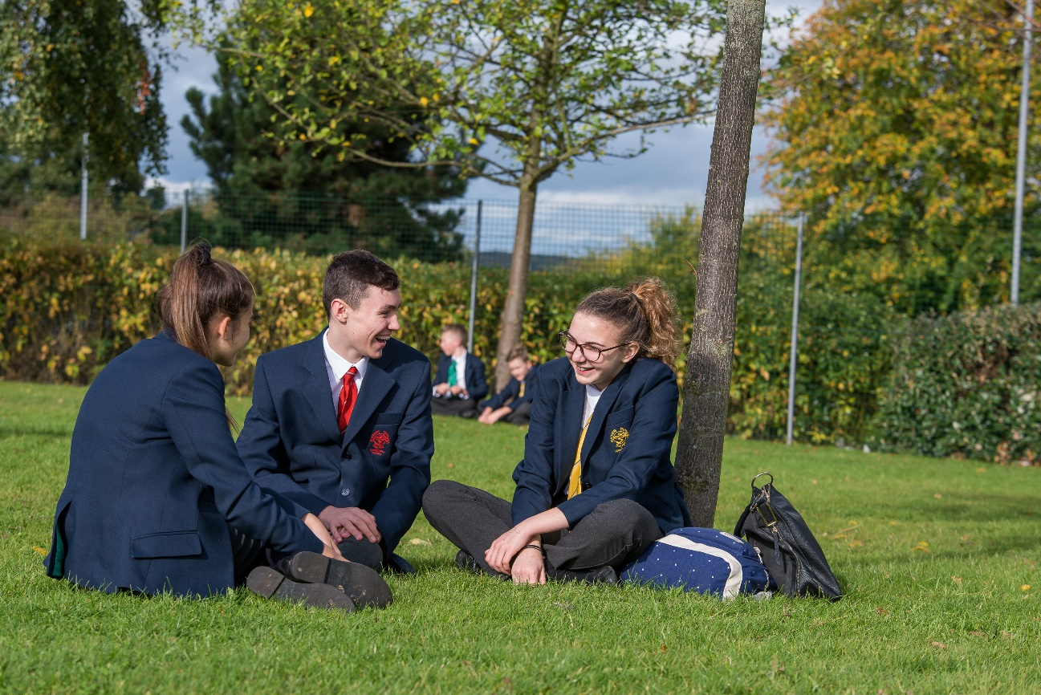
The House system plays a big part in the life our school. Every student, parent and member of staff is a member of a House. Our tutor groups are vertical, featuring students from Y7-Y11 from the same House. Inter-House competitions are fiercely competitive but also friendly!
..the house system is used to promote
a wide range of personal qualities,
such as self-confidence and leadership skills.

We have very high expectations of student behaviour and parents are typically very supportive. There is a lovely community feel to the school.
Pupils dress smartly and wear the relatively new
school uniform with pride. Pupils value learning
and have good attitudes to their studies.
Department Facilities
Summerhill is a modern, well-designed building equipped with a swimming pool, a Learning Resource Centre which houses 60 computers and a hall with professional theatre lighting used for assemblies and House competitions.

The MFL Department is located on the ground floor, where there are 5 large teaching classrooms with interactive whiteboards. There is an MFL resource base and workroom as well as the main staffroom on the first floor. Staff are provided with an iPad in order to assist their teaching as each room also has an Apple TV so you can directly link your iPad to the interactive board. The MFL Department also has a membership to The Association for Language Learning.

All students currently have ActiveLearn and Linguascope subscriptions.

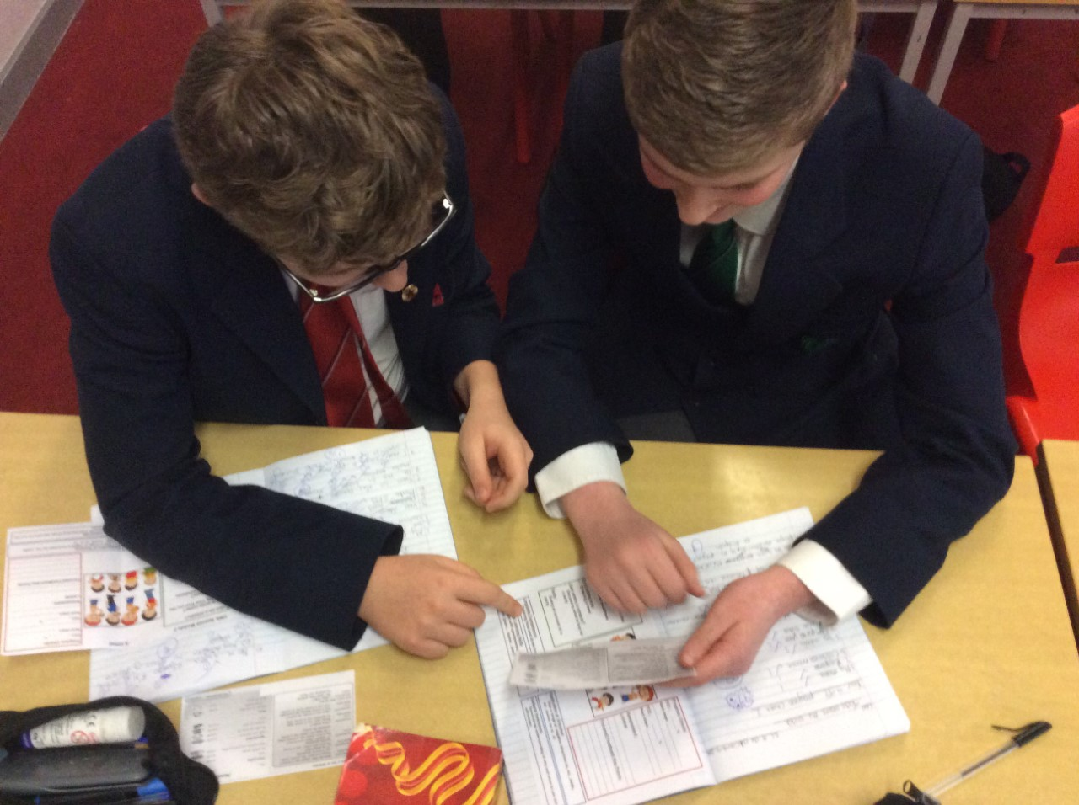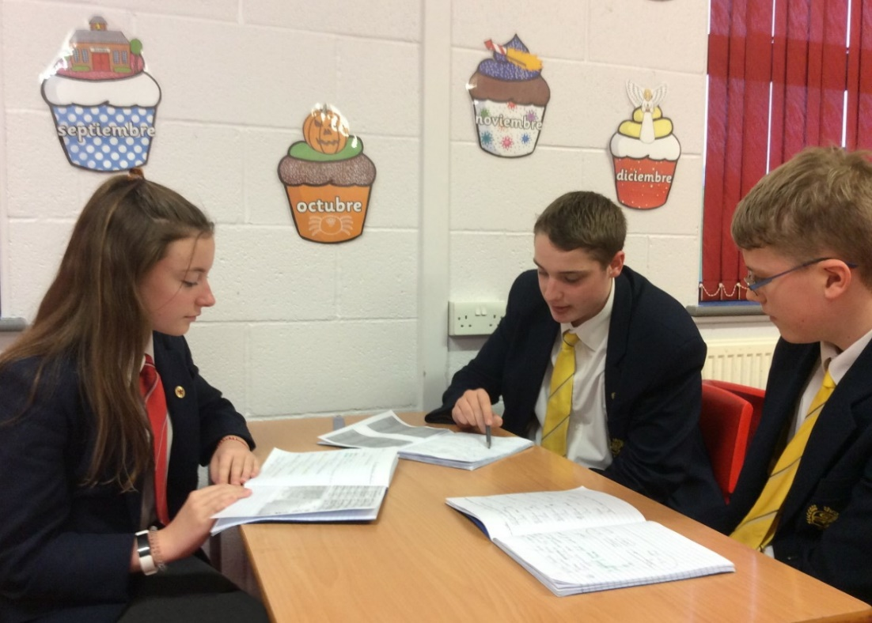
Staffing
The department consists of five specialist teachers (some part-time), all with substantial teaching experience.
All of our teachers are able to teach both French and Spanish at KS3, though naturally most staff have a preference for one language and this is their focus at KS4. The current blend within the department means that it would be possible to accommodate a new colleague with either French or Spanish as their main specialism.

As Head of Languages, Deb Bennett leads a friendly and welcoming team, who will be able to offer support and also be receptive to new ideas. Our school has a full programme of staff development which is tailored depending upon where in your professional journey you are. We support staff to attend good quality external courses and also use twilight sessions and training days to share and promote good teaching practice.

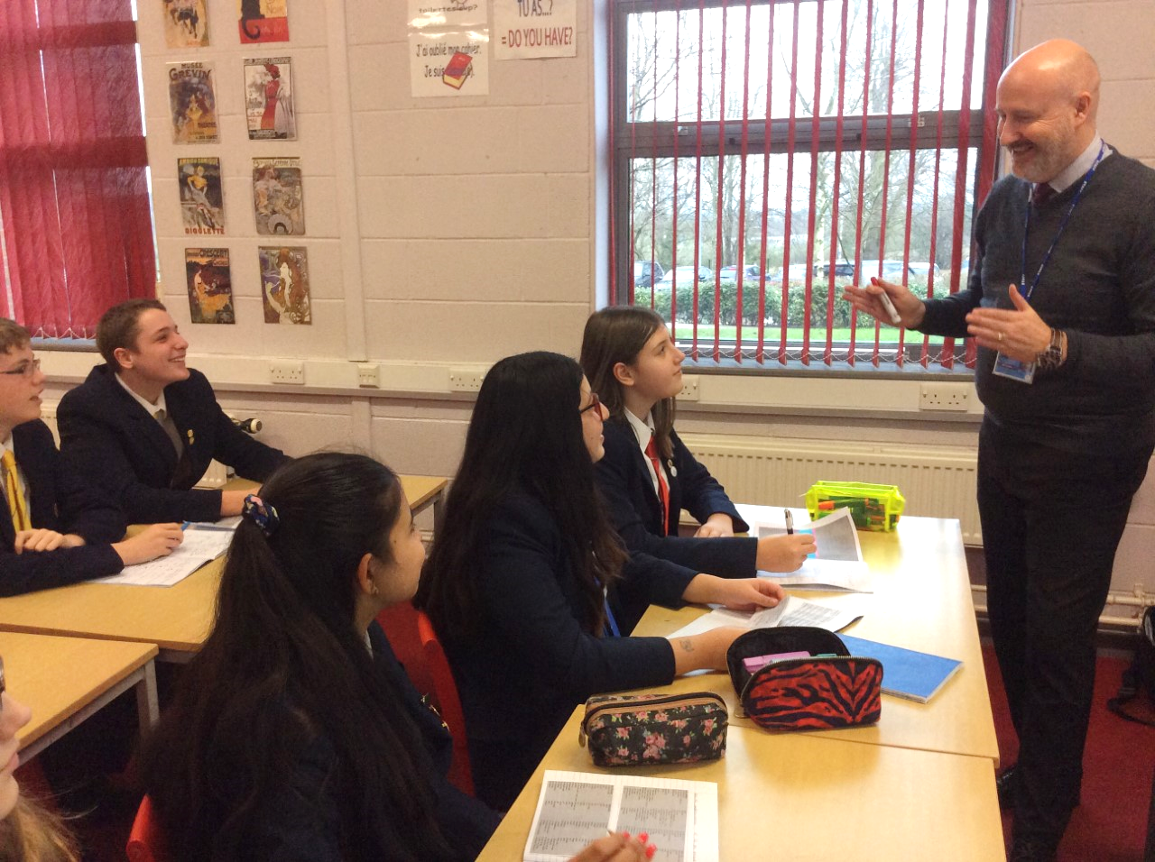
Behaviour is good.
Pupils are polite, well mannered and courteous

Curriculum
Primary
Students typically begin their language learning journey with Summerhill during their Primary years. We are incredibly proud of our Primary Languages Curriculum, which we help to deliver in seven of our feeder Primary schools.
KS3
In Y7, Y8, Y9, students study either French or Spanish for three 50 minute lessons per week. In year 8 most students pick up a second language and study this for 20 minute lessons a week, which can be carried on into year 9 following a mini options process.
KS4
French and Spanish are offered as optional GCSE subjects where they have been studied in KS3. Students have three 50 minute lessons per week. The number of students opting for MFL has been stable at around 40% of the cohort for a number of years. We are working to increase this further.

Extra-Curricular Activities
The department participates in a range of events and competitions. At lunch times and after school we offer revision and catch up sessions.
Each year we offer a varied programme of events to promote European Day of Languages. Summerhill students have also attended Routes into Languages events and entered national competitions offered by L’Institut Francais and the British Council. Similarly the MFL department also host House Competitions, trips to Paris and joint trips to Spain with PE.

The range of educational visits and trips…and programme of extra-curricular activities, makes a strong contribution to pupils’ SMSC awareness and personal development

Departmental Results
Our MFL results have been consistently impressive for a number of years, with a pleasing proportion of students going on to study languages at A-level and beyond.

Year | French  Grade 4+ | Spanish  Grade 4+
2017 | 74% (grade C or above) | 62% (grade C or above)
2018 | 91% | 76%
2019 | 83% | N.A
2020 | 86% | 94%
2021 | 92% | 91%
2022 | 90% | 88%

French Curriculum
Year | Key Features | Term 1 | Term 2 | Term 3 | Term 4 | Term 5 | Term 6
7 | La rentrée  Learning to pronounce key French sounds, saying your name and learning numbers, talking about brothers,sisters and age,using the verb avoir,describing a classroom, using ‘a’ and ‘some’, talking about likes and dislikes, using aimer, describing yourself and others, using adjective agreement, saying what you do, understanding infinitives and regular ‘er’ verbs, giving dates in French | En Classe  Talking about colours. Telling the time, opinions of school subjects, talking about likes and dislikes using ‘er’ verbs, talking about what you wear to school, using adjectives after nouns, talking about your school day, using new ‘er’ verbs, learning about a typical school in France, reading and listening for gist, saying what there is /isn’t, agreeing and disagreeing | Mon temps libre  Talking about weather and seasons, learning more about key French sounds, talking about which sports you do, using jouer à, talking about activities you do, using the verb faire, discovering sport in French speaking countries, using cognates and context, talking about what you like doing, using aimer + infinitive, forming and answering questions, creating an interview with a celebrity | Ma vie de famille  Talking about animals, using higher numbers, describing your family, using the possessive adjectives ‘my’, and ‘your’, describing where you live, using the nous form of er verbs, talking about breakfast, using ‘some’, learning about Bastille day, using a glossary | En ville  Talking about places in a town/ village, understanding prices in French, saying where you go at the weekend, using the verb aller, inviting someone out, using the verb vouloir, ordering drinks and snacks in a café, using the tu and vous froms of the verb, saying what you are going to do, using the near future tense (aller+inf), talking about plans for a special weekend, using two tenses together | Paris  Une vie de chat
8 | 3 x 50 Minute lessons a week  END OF YEAR AIMS  Students can talk about themselves and their lives and express opinions with reasons.  Students can use some transactional language and some more formal register.  Students can use three tenses (present, near future, perfect).  Students able to use more complex structures (e.g. comparative, imperative)  Students develop their Knowledge of Francophone culture. | Vive les vacances  Talking about school holidays  Revising the verbs avoir and être, saying what you did during the holidays, using the perfect tense of regular er verbs, describing a visit to a theme park, using the perfect tense of irregular verbs, saying where you went and how, using the perfect tense of verbs that take être, listening for negatives in the perfect tense, reading to spot the perfect tense in a text, asking and answering questions, using the present and perfect tenses together | J’adore le fêtes  Talking about festivals and celebrations, saying what you like and dislike, describing festivals and special days, using the present tense of ir and re verbs, buying food at a market, using transactional language, using prediction to help with listening, giving answers in French in listening and reading tasks, writing about New Year, combining past, p[resent and future tenses | A loisir  Talking about celebrities and TV programmes, using singular and plural adjective agreement, talking about digital technology, forming and answering a range of questions, arranging to go to the cinema, buying cinema tickets, talking about leisure activities, using negatives, spotting synonyms, using 3 tenses when speaking, speaking from notes | Le monde est petit  Talking about where you live, discussing the weather, describing where you live, using pouvoir + infinitive, talking about how you help at home, talking about daily routine, using reflexive verbs, talking about moving house, using irregular adjectives (BAGS), | Le sport en direct  Talking about sports, using jouer à and faire de, giving opinions about sports, using the comparative, asking the way and giving directions, using the imperative (bossy verbs), using ‘il faut’ (you must), Talking about injuries and illness, takin part in a conversation with the doctor | Interviewing a sports person  Tour de France
8 Option | 2 x 50 Minutes a week  END OF YEAR AIMS  Students can talk about themselves and their lives and express opinions with reasons  Students can use some transactional language  Students can use two tenses (present and near future)  Students get an introduction to Francophone culture | La rentrée  Learning to pronounce key French sounds, saying your name and learning numbers, talking about brothers,sisters and age,using the verb avoir,describing a classroom, using ‘a’ and ‘some’, talking about likes and dislikes, using aimer, describing yourself and others, using adjective agreement, saying what you do, understanding infinitives and regular ‘er’ verbs, giving dates in French | En Classe  Talking about colours. Telling the time, opinions of school subjects, talking about likes and dislikes using ‘er’ verbs, talking about what you wear to school, using adjectives after nouns, talking about your school day, using new ‘er’ verbs, learning about a typical school in France, reading and listening for gist, saying what there is /isn’t, agreeing and disagreeing | Mon temps libre  Talking about weather and seasons, learning more about key French sounds, talking about which sports you do, using jouer à, talking about activities you do, using the verb faire, discovering sport in French speaking countries, using cognates and context, talking about what you like doing, using aimer + infinitive, forming and answering questions, creating an interview with a celebrity | Ma vie de famille  Talking about animals, using higher numbers, describing your family, using the possessive adjectives ‘my’, and ‘your’, describing where you live, using the nous form of er verbs, talking about breakfast, using ‘some’, learning about Bastille day, using a glossary | En ville  Talking about places in a town/ village, understanding prices in French, saying where you go at the weekend, using the verb aller, inviting someone out, using the verb vouloir, ordering drinks and snacks in a café, using the tu and vous froms of the verb, saying what you are going to do, using the near future tense (aller+inf), talking about plans for a special weekend, using two tenses together | Paris  Une vie de chat
9 | 3 x 50 Minute lessons a week  End of year aims  Students can talk about themselves and their lives and about wider ranging issues (environment, good causes), expressing opinions with reasons  Students can use some transactional language and some more formal register  Students can use multiple tenses (present, near/simple future, perfect, imperfect, conditional)  Students can use more complex structures (e.g. comparative, superlative, infinitives)  Students develop their knowledge of Francophone culture | Mon monde à moi  Talking about likes and dislikes, using aimer +noun OR inf, talking about after school clubs and activities, using verbs in the present tense, describing your friends, using reflexive verbs, describing birthday celebrations, using the perfect tense, discussing what you are going to wear, using the near future tense,  Ma vie de courgette | Projet d’avenir  Talking about earning money, usaing pouvoir and devoir, talking about what you want to do when you are older, using vouloir, talking about what you will do in the future, using the future tense, talking about what things will be like in the future  Learning a language?? | Ma vie en musique  Talking about your musical tastes, using direct object pronouns, talking about what you used to be like, using the imperfect tense, comparing your primary and secondary schools, using the comparative, talking about how things have changed, | Le meilleur des mondes  Talking about food, describing a photo, discussing eating habits, using a range of negatives, talking about the protecting natural word, talking about plastic and the environment, talking about what you would like to change, using the conditional tense | Le monde francophone
9 Option  (NO group 2019-20) | 1 x 110 minute lesson | Mon monde à moi  Talking about likes and dislikes, using aimer +noun OR inf, talking about after school clubs and activities, using verbs in the present tense, describing your friends, using reflexive verbs, describing birthday celebrations, using the perfect tense, discussing what you are going to wear, using the near future tense,  Ma vie de courgette | Projet d’avenir  Talking about earning money, usaing pouvoir and devoir, talking about what you want to do when you are older, using vouloir, talking about what you will do in the future, using the future tense, talking about what things will be like in the future  - Learning a language?? | Ma vie en musique  Talking about your musical tastes, using direct object pronouns, talking about what you used to be like, using the imperfect tense, comparing your primary and secondary schools, using the comparative, talking about how things have changed, | Le meilleur des mondes  Talking about food, describing a photo, discussing eating habits, using a range of negatives, talking about the protecting natural word, talking about plastic and the environment, talking about what you would like to change, using the conditional tense |  | Le monde francophone
10  GCSE | 1 x 50 minute lesson  1 x 110 minute lesson week | Qui suis-je?  Relationships, describing self, family, friends, socializing, everyday life, Describing a night out,  Life when younger, role models | Les temps des loisirs  Sport, extreme sports, life online, reading, televisions viewing preferences, film and actors | Jours ordinaires, jour de fete  Describing daily life, food for special occasions, using polite language, family celebrations, describe festivals and traditions | De la ville à la campagne  Describing a region, talking about your town/ village, discussing whath there is to see and do, making plans and discussing weather, describing community projects | Le grand large  What normally do on holidays, past holiday, why holidays are important, dream holiday, Booking accommodation, ordering food in a restaurant, directions, holiday disasters, buying souvenirs
11  GCSE | 1 x 50 minute lesson  1 x 110 minute lesson week | Le grand large  What normally do on holidays, past holiday, why holidays are important, dream holiday, Booking accommodation, ordering food in a restaurant, directions, holiday disasters, buying souvenirs | Au Collège  Description of school, subjects, comparison of French/British state school systems, school rules, uniform, improvements to school, getting the best out of school, trips, events | Bon Travail  Discussing jobs and work preference, career choices, plans, hopes, wishes, importance of langs, applying for jobs, case studies | Un oeil sur le monde  Environmental problems and their solutions, global issues, inequality, poverty, volunteering

Spanish Curriculum
Year | Key Features | Term 1 | Term 2 | Term 3 | Term 4 | Term 5 | Term 6
7 | 3 x 50 minute lessons per week | Mi vida  Introduce self –Name, age, nationality, say where I live, ask and answer simple questions, describe personality, ask s.o when their birthday is, say when my birthday, alphabet  Pets  L/R | Mi familia y mis amigos  Talk in detail about family and extended family, physical description, describe house, Día de los muertos,  Speaking | Tiempo Libre  Hobbies and free time, sports we play, mobile technology, what others enjoy doing, weather, giving opinions with reasons  Writng | Mi insti  School subjects, school day, justifying opinions, 24hr Clock, school facilities, break time, differences between Spanish and British school systems, Project – Guatemala Actionaid – The right to an education | El mundo hispanohablante  Project – Guatemala Actionaid – The right to an education; Las Fallas – Carnaval en Cadiz, Semana Santa | Mi Ciudad  Describing town, directions, ordering snacks, weekend plans, using two tenses together to advertise your town
8 | 3 x 50 minute lessons per week | Vacaciones  Talking about what you normally do on holiday, describing events from a past holiday, what you did, describing a day | Todo sobre mi vida  Mobile phone use, music, range of opinions, tv, understanding authentic texts, tv guide, differences in young people’s lives in Spain and uk, Spanish celebrities | A comer  Food, likes, dislikes, describing mealtimes, food in Spanish speaking countries, ordering meal, giving an account of a party |  | ¿Qué hacemos?  Arranging to meet up with friends, making excuses, daily routine, getting ready to go out, talking about clothes. | Operación verano  Booking Holiday accommodation, activities, directions, destinations, transport
8 Option | 2 x 50 minutes per week | Mi vida  Introduce self –Name, age, nationality, say where I live, ask and answer simple questions, describe personality, ask s.o when their birthday is, say when my birthday, alphabet  Pets | Mi familia y mis amigos  Talk in detail about family and extended family, physical description, describe house, Día de los muertos, | Tiempo Libre  Hobbies and free time, sports we play, mobile technology, what others enjoy doing, weather, giving opinions with reasons | Mi insti  School subjects, school day, justifying opinions, 24hr Clock, school facilities, break time, differences between Spanish and British school systems, Project – Guatemala Actionaid – The right to an education | El mundo hispanohablante  Project – Guatemala Actionaid – The right to an education; Las Fallas – Carnaval en Cadiz, Semana Santa | Mi Ciudad  Describing town, directions, ordering snacks, weekend plans, using two tenses together to advertise your town
9 | 3 x 50 minute lessons per week | Somos Así  Discussing likes/ dislikes, discussing films – genres - preferences- buying tickets – birthday celebrations  talking about weekends in detail – celebrity study | Orientate  Discussing work and future plans- work experience – how earn pocket money – helping at home – describe personality | En forma  Healthy / Unhealthy diet – active lifestyle, daily routine – recommendations – Ilness and ailments –Visiting doctors. Pharmacy | Jóvenes en acción  Children’s rights, fair trade, recycling ways to be environmentally friendly, charity work, how an area has changed – before and after  Project Shelter aid |  | Paz y Guerra Identity and Stereotypes lessons, Voces Inocentes – El Salvador Civil War
9 Option | 1 x 100 minute lesson per week | Somos Así  Discussing likes/ dislikes, discussing films – genres - preferences- buying tickets – birthday celebrations  talking about weekends in detail – celebrity study | Orientate  Discussing work and future plans- work experience – how earn pocket money – helping at home – describe personality | En forma  Healthy / Unhealthy diet – active lifestyle, daily routine – recommendations – Ilness and ailments –Visiting doctors. Pharmacy | Jóvenes en acción  Children’s rights, fair trade, recycling ways to be environmentally friendly, charity work, how an area has changed – before and after  Project Shelter aid |  | Paz y Guerra Identity and Stereotypes lessons, Voces Inocentes – El Salvador Civil War
10  GCSE | 1 x 50 minute lesson and  1 x 100 minute lesson per week | ¡Desconéctate!  Holidays, weather, discuss what you do in summer, holiday preferences, past holiday, describing accommodation booking accommodation, dealing with problems, using three tenses together | Mi vida en el insti  Introduction to school subjects, giving opinions, comparing subjects, describe school day, describe school facilities, school rules and uniform, school exchanges, activities and achievements |  | Mi gente  Socialising with family, family relationships, friendships, use of technology arranging to go out, reading preferences. | Intereses y influencíás  Free time activities, tv and film preferences, what you usually do, sports, role models | Revision and exam preparation, feedback and Speaking exam preparation
11  GCSE | 1 x 50 minute lesson  and  1 x 100 minute lesson per week | Ciudades  Describing town and region, discussing shopping habits, planning what to do, role play – shopping for clothes and presents, discussing problems with a town and improvements  EL medio Ambiente  Discussing local and global issues and environmental concers and what can be done to improve the problems at a local and international level |  | El muno de trabajo  Discussing future plans for study and employment, travel, importance of learning languages, | Hacía un mudo mejor  Brinigin the world together – sporting events, music events, charity work and voulnteerng | Revision  Bespoke revision lessons – tiered Hier and foundation

