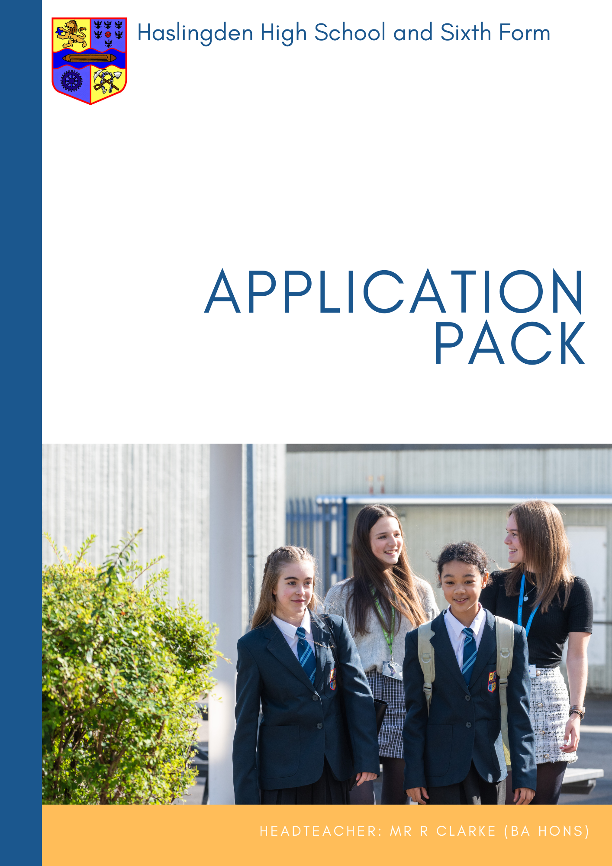

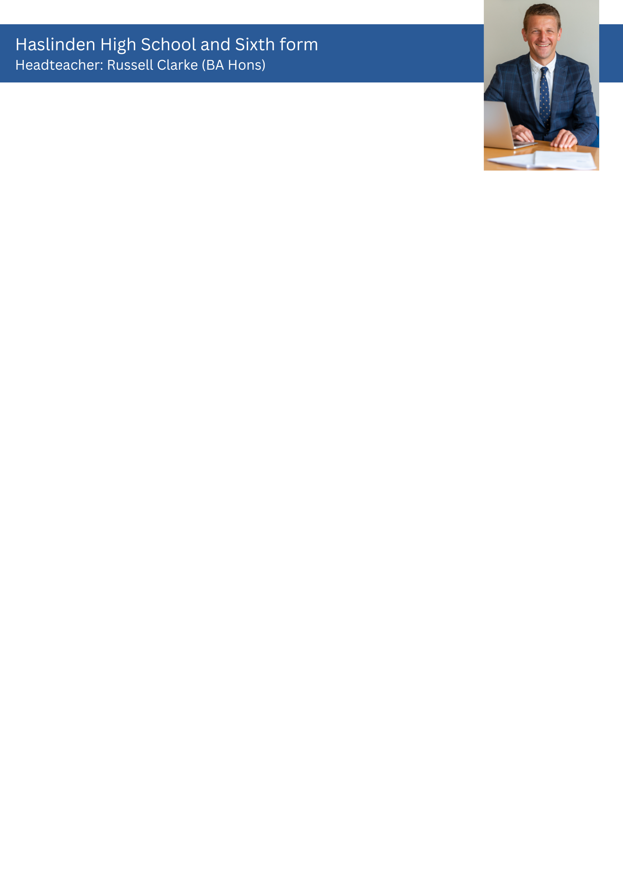



Dear Applicant

**Post: Teacher of Modern Foreign Languages**

Thank you for your interest in the post of Teacher of Modern Foreign Languages at Haslingden High School and Sixth Form. The role includes teaching French and / or German.  This is an excellent opportunity to join a successful department that has ambitious plans for the future and has a record of achieving strong academic results. The successful candidate should share our passion for creating and maintaining the best possible learning environment for our students, securing positive outcomes and have a willingness to contribute to the rich extra-curricular provision.

I am extremely proud to be the headteacher at Haslingden High School and Sixth Form, a successful, caring and high performing 11-18 school in the beautiful Rossendale Valley. The school is regularly, heavily oversubscribed for the 270 places available in year 7 each September.  We have a thriving sixth form with over 250 students studying mainly a range of Level 3 courses.  We are a truly comprehensive school welcoming students of all backgrounds and abilities and are the largest maintained school in Lancashire, with over 1600 students on roll.  There are just under 100 members of the teaching staff and approximately 70 support staff.  Our supportive, experienced governing body play a crucial role in our success and provides clear direction, remaining heavily involved in the life of the school.

Our overarching aim is **Achievement for All:** for all our students to be safe, happy and successful, developing as individuals into caring, responsible citizens equipped for life in the 21st century. This is underpinned by the five [school aims](https://haslingdenhigh.com/2017/10/30/our-aims/) and we invite you to look at these closely when considering your application.

We strive to create successful learners and we believe that we achieve this by offering an exciting, ambitious and inclusive curriculum. The consistently high-quality teaching and learning, taking place in a safe, supportive environment provides the basis upon which our students grow. We are passionate about providing access to a wide range of opportunities and experiences beyond the taught curriculum, guiding and helping students to become kind, resilient and ethical individuals who will make a positive contribution to their local community and beyond. We hope that you will also share this passion and on reading the [whole school curriculum rationale](https://haslingdenhigh.com/curriculum-statement/), you feel it closely aligns to your own vision for education.

Students’ physical, mental and emotional wellbeing is at the forefront of everything we do. We recognise the importance of working in partnership with parents and external agencies to deliver a personalised approach to care, guidance and support that will ensure students feel safe and happy and that they are empowered to make informed choices, both now and in the future.

At Haslingden High School, success is defined in its broadest sense: students achieve a wide range of qualifications which equip them with the skills and knowledge to enable them to be ambitious, resilient and capable learners. They are able to embrace change, and leave us as well-rounded individuals with a strong set of values and beliefs.

We are proud of our collective achievements – our examination success, our well designed and expertly delivered curriculum, the depth and diversity of our extra-curricular programme and our desire to contribute to our community. We are committed to the pursuit of the highest possible academic, personal and moral standards and to the development of informed citizens with lively, enquiring minds.

This commitment is underpinned by a belief in hard work and a culture of care, respect and support for others. If you share our ethos and feel that you want to join our dedicated staff to help us achieve our aims together, then we believe that Haslingden High School and Sixth Form is the place for you.

The successful applicant will find caring, friendly and supportive colleagues, committed to providing the very best life chances for all our students. We look forward to receiving your completed application form, together with a letter of application which should be no more than 2 sides. This should demonstrate how your skills, experience and vision make you a strong candidate for this position and clearly outline your strengths in relation to the role. The closing date for applications is **Wednesday 11 June** at **9.00am** with interviews scheduled for **Tuesday 17 June 2025**.

Haslingden High School and Sixth Form is committed to safeguarding and promoting the welfare of children and young people and takes its statutory duties and responsibilities in this context very seriously. We fully expect everyone working in or on behalf of the school to share our commitment. As such, this post is subject to satisfactory enhanced DBS clearance and references.

Yours faithfully



Russell Clarke

Headteacher



**Haslingden High School**

**Modern Foreign Languages Faculty**

Modern Foreign Languages Rationale

‘*To enable learners to successfully communicate with and understand speakers of French/German in a variety of contexts and for a variety of purposes. To broaden horizons and develop cultural knowledge and understanding of the identity of the countries and communities where French/German is spoken. To foster transferable skills such as confidence and resilience which enable deeper learning where the foreign language may become a medium for constructing and applying knowledge. To provide access to opportunities and experiences where students can engage with speakers of French/German. To provide an ambitious, inclusive and well-sequenced curriculum for students who progress to further study in MFL and for those who do not.’*

Faculty information

The Modern Foreign Languages Faculty is currently made up of a team of six members of staff. Two of these are full time. The Curriculum Leader is also the Subject Leader for French. There is a Lead Teacher who has specific responsibilities across the two subjects. All current members of the Faculty are able to teach French and German.

The Faculty endeavours to keep up with all developments in language pedagogy and uses a variety of approaches in the delivery of lessons. A key strength of the Faculty is the sharing of good practice and resources, and its willingness and openness to try and adopt new ideas and methodologies. Colleagues are open and supportive of each other.

The Faculty has four specialist rooms which are all equipped with projectors and smart boards. The school operates a highly successful iPads for Learning scheme with all students having access to an iPad which they can use in school and at home. This has transformed the way students learn and use ICT.  This initiative has had a significant impact on the way students learn languages at Haslingden High School and Sixth Form.

All Year 7 classes start with either French or German and this alternates each year. All Year 7 students in September will be learning German. In Year 8 and Year 9 they continue with the first language and have taster sessions in the second, either French or German.  Students then choose their GCSE options in in Year 9 to commence their studies in Year 10. Languages remain an option subject and the numbers choosing to study a language at GCSE have increased in recent years.

Students have three periods of MFL study per week in Years 7 and 8 and 2 periods in Year 9.

In Year 10, students start the GCSE specifications. They currently follow the Educas specifications.  We use the Studio and Stimmt resources but supplement these with our own materials. Students have 3 periods of language study per week.

GCSE results in 2024 were as follows:

|  |  |  |  |
| --- | --- | --- | --- |
|  | 9 - 7 | 9 - 4 | Cohort |
| French | 100 | 100 | 2 |
| German | 25 | 76 | 63 |

At KS5 students follow A- Level specifications for the AQA exam board. A level results in 2024 were as follows:

|  |  |  |  |
| --- | --- | --- | --- |
|  | A* - B | A* - E | Cohort |
| French | 100 | 100 | 1 |
| German | 67 | 100 | 3 |

Holly Taylor Curriculum Leader; Modern Foreign Languages                      Sian Nixon - Lead Teacher MFL

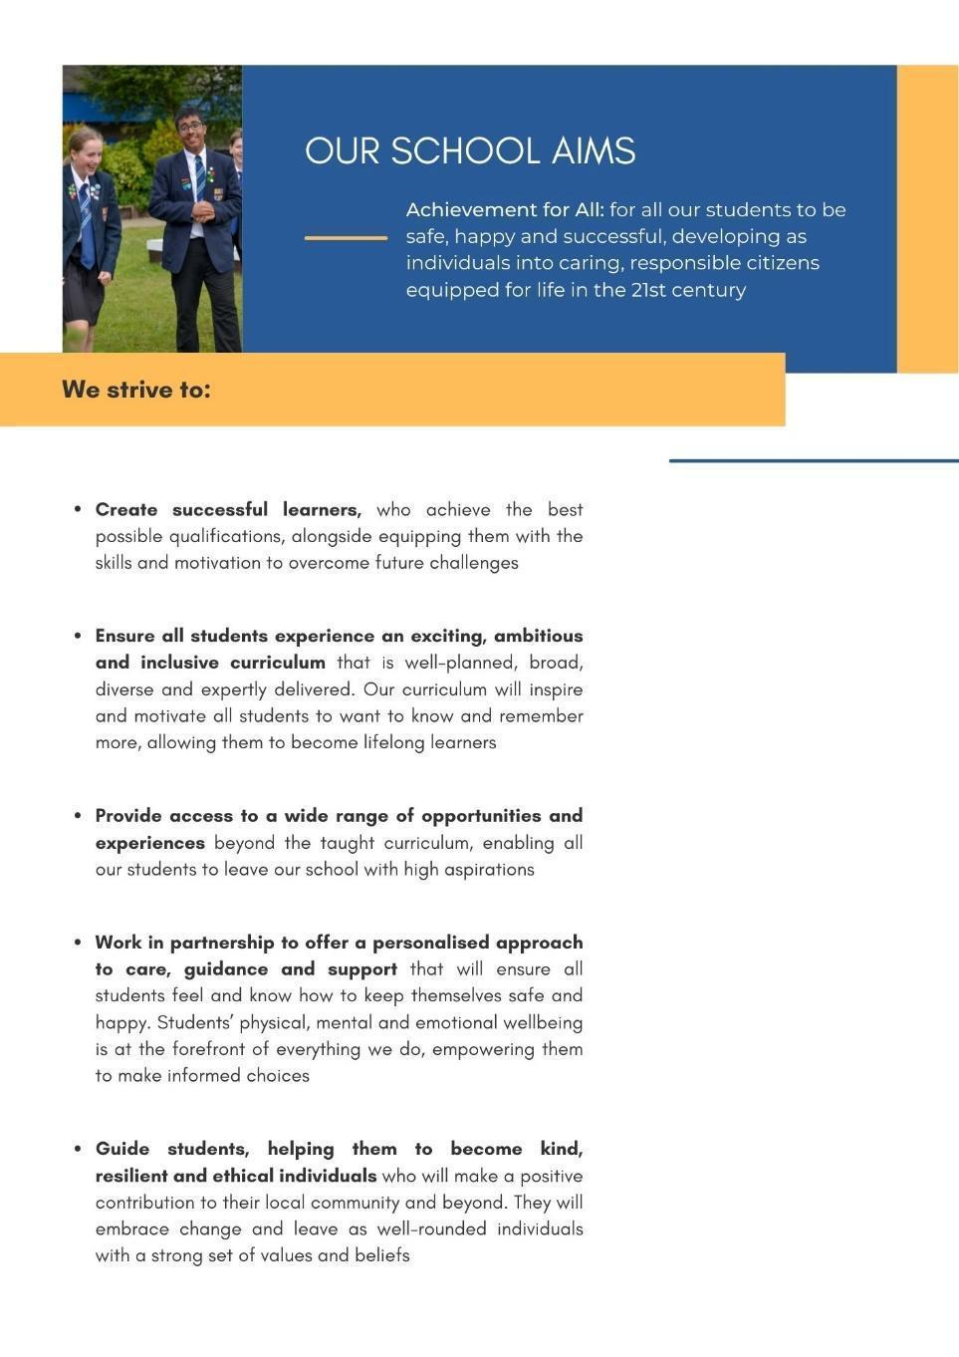





|  |
| --- |
| **Teacher of Modern Foreign Languages**  **Responsible to the Curriculum Leader**  **Purpose**     1. Contribute to “Achievement for All” by being a champion for the 5 school aims 2. To raise standards of student attainment and achievement within your teaching groups   and to monitor and support student progress  c. To plan and deliver high quality lessons   1. To assess and report on the achievement of students 2. To act as a form tutor as required   **Key Knowledge & Understanding:**     * All teaching staff must understand and uphold the professional code of the General   Teaching Council for England by demonstration of all the professional standards for QTS;   * A detailed knowledge of the relevant aspects of the National Curriculum and other   statutory requirements and the demands expected of students in relation to KS3, KS4 & KS5.   * Where appropriate, a knowledge of relevant post-16 courses; * An understanding of subject progression KS2 to KS5.   **Key functions**  **1. Planning**     * Identify clear learning outcomes, content, lesson structures and sequences appropriate to   the subject matter and the students being taught;   * Select and make good use of textbooks, ICT and other learning resources to enable   learning outcomes to be met;   * Set appropriate and demanding expectations for students’ learning and motivation.  Set   clear targets for students’ learning, building on prior attainment;   * Familiarise yourself with students who have special educational needs, and know where to   get help in order to give positive and targeted support.  Implement and keep records on Individual Education Plans (IEPs);   * Take account of the needs of all students in each class, including the most and least able; * Provide opportunities to develop students’ understanding by relating their learning to real   and work-related examples;   * Maintain records of the delivery of the curriculum and on student progress in line with   school and Faculty policy.  **2. Teaching & Managing Student Learning**     * Use teaching methods with whole classes, groups and individuals that ensure that students   are engaged and stimulated; that teaching outcomes are met; that momentum and challenge are maintained and best use made of teaching time;   * Set high expectations for students’ behaviour, establishing and maintaining a good   standard of discipline through well-focused teaching and through positive and productive relationships.  **3.  Assessment & Reporting**     * Assess how well learning outcomes have been achieved and use this assessment to inform   future teaching;   * Mark and monitor students’ classwork and homework, providing constructive oral and   written feedback and setting targets for students’ progress.  Work to secure progress towards targets;   * Prepare and present informative reports to parents; * Provide accurate data for the school’s Monitoring / ARR System as required.   **4. Guidance & Welfare**  Where appropriate, act as a form tutor, fulfilling the following functions:     * Take overall responsibility for monitoring students’ academic and wider progress and   development, acting in line with school policies in this area;   * Carry out the tutor group registration, following up any absences as directed by school   policy;   * Review progress and support students in target setting and action planning; * Ensure that all students are valued and treated according to the aims of the school.      1. **Wider Professional Effectiveness**      * Take responsibility for own professional development, keeping up to date with research   and developments in pedagogy and in subject areas;   * Understand professional responsibilities in relation to school policies and practices; * Set a good example to students in personal presentation and conduct; * Evaluate own teaching critically, using this to improve effectiveness; * Work effectively with other school colleagues, attending meetings and liaising with   representatives of other agencies as necessary;   * Contribute to, and through faculty assistants organise, displays of work in classroom and   faculty areas;   * Contribute positively to the ethos of the school.   For the full Conditions of Employment please refer to the relevant pages of the School Teachers’ Pay and Conditions Document |

# Equal opportunities

We are committed to achieving equal opportunities in the way we deliver services to the community and in our employment arrangements. We expect all employees to understand and promote this policy in their work.

# Health and safety

All employees have a responsibility for their own health and safety and that of others when carrying out their duties and must help us to apply our general statement of health and safety policy.

# Safeguarding Commitment

This school is committed to safeguarding and protecting the welfare of children and young people and expects all staff and volunteers to share this commitment.

# Attendance

# Good attendance enhances the service delivered by schools, minimises staffing difficulties and ensures best value to the school. It is essential that applicants for positions in this school can evidence a previous satisfactory attendance record/commitment to sustaining regular attendance at work.



**Teacher of Modern Foreign Languages**

|  |  |  |  |
| --- | --- | --- | --- |
| **ATTRIBUTES** | **DESCRIPTION** | **E** | **D** |
| **QUALIFICATIONS, EXPERIENCE AND PROFESSIONAL DEVELOPMENT** | * Teaching Qualification | **✓** |  |
| * Good Honours degree or equivalent | **✓** |  |
| * A commitment to CPD | **✓** |  |
| **KNOWLEDGE, SKILLS AND PERSONAL QUALITIES** | * A genuine belief in the value of each child | **✓** |  |
| * A knowledge of the GCSE specification and Locally Agreed Syllabus requirements of the subjects with excellent knowledge of French and / or German as a whole | **✓** |  |
| * A good knowledge and understanding of current curricular developments in French and / or German | **✓** |  |
| * The ability to maintain a high standard of teaching which ensures all students are actively engaged in their learning and make excellent progress | **✓** |  |
| * The ability to establish an excellent climate for learning | **✓** |  |
| * The ability to work well in a team | **✓** |  |
| * High levels of commitment, motivation and initiative | **✓** |  |
| * Ability to use ICT to enhance the quality of learning within the classroom | **✓** |  |
| * The ability to relate well to all members of the school | **✓** |  |
| * Excellent communication skills | **✓** |  |
| * A warmth and empathy when dealing with young people | **✓** |  |
| * High personal standards and high expectations of themselves and others | **✓** |  |
| * A flexible approach to school life and someone who embraces change | **✓** |  |
| * A solutions focussed approach | **✓** |  |
| * Experience of teaching at KS3, KS4 and KS5 |  | **✓** |
| * An excellent health and attendance record | **✓** |  |
| * An ability and willingness to contribute to extra-curricular activities | **✓** |  |
| * A sense of humour | **✓** |  |
| **APPLICATION LETTER** | * The letter should be clear and concise (no more than two sides) with organised views | **✓** |  |
| * The letter should address the requirements of the post and clearly indicate why you have applied for the position | **✓** |  |
| * The application form should be fully completed and clearly legible | **✓** |  |

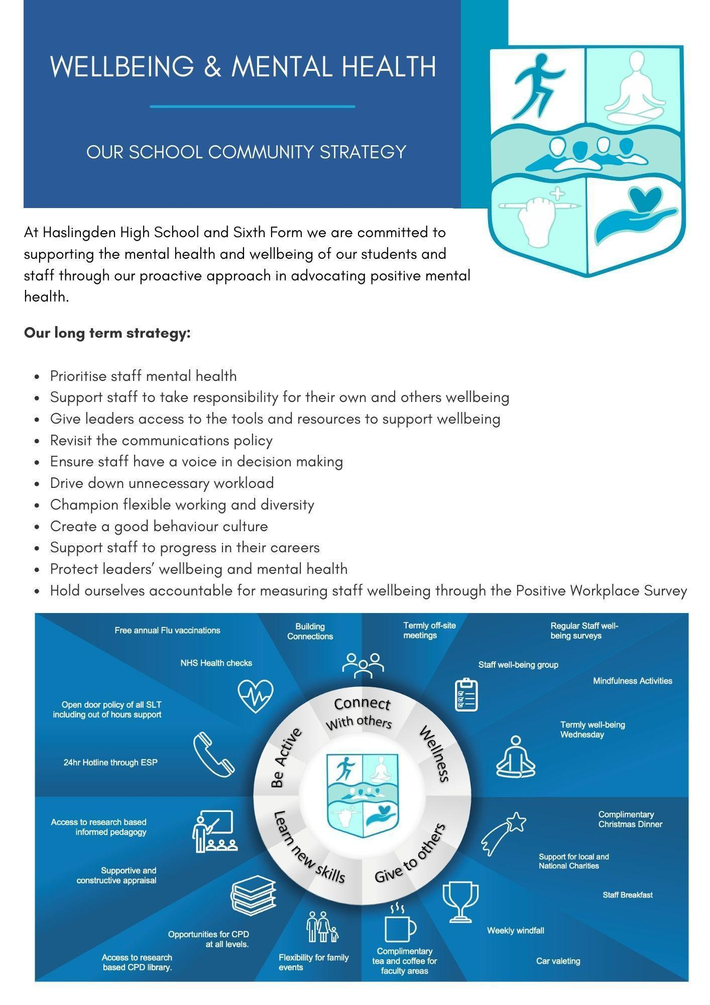

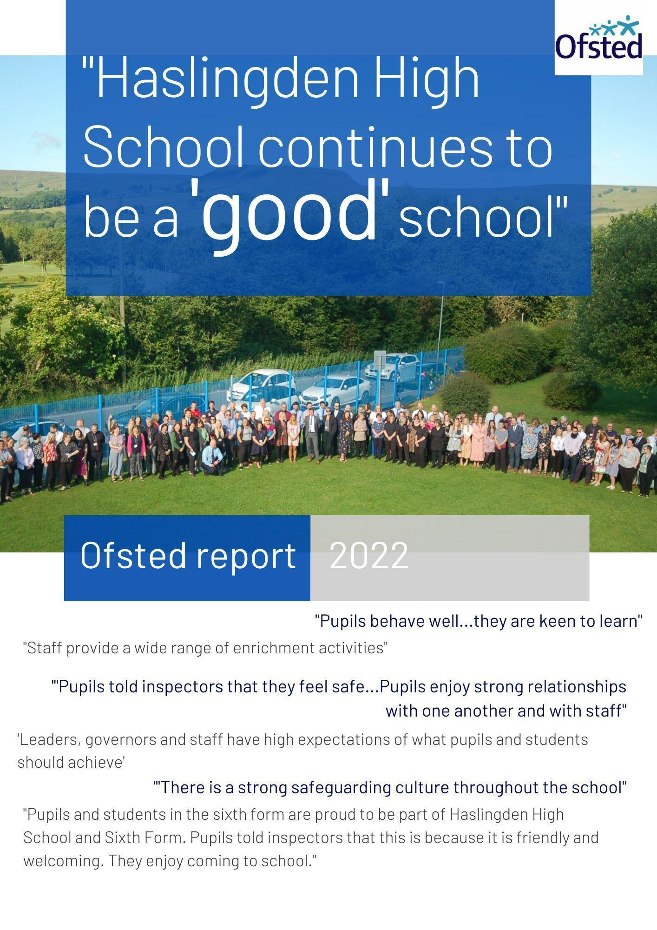

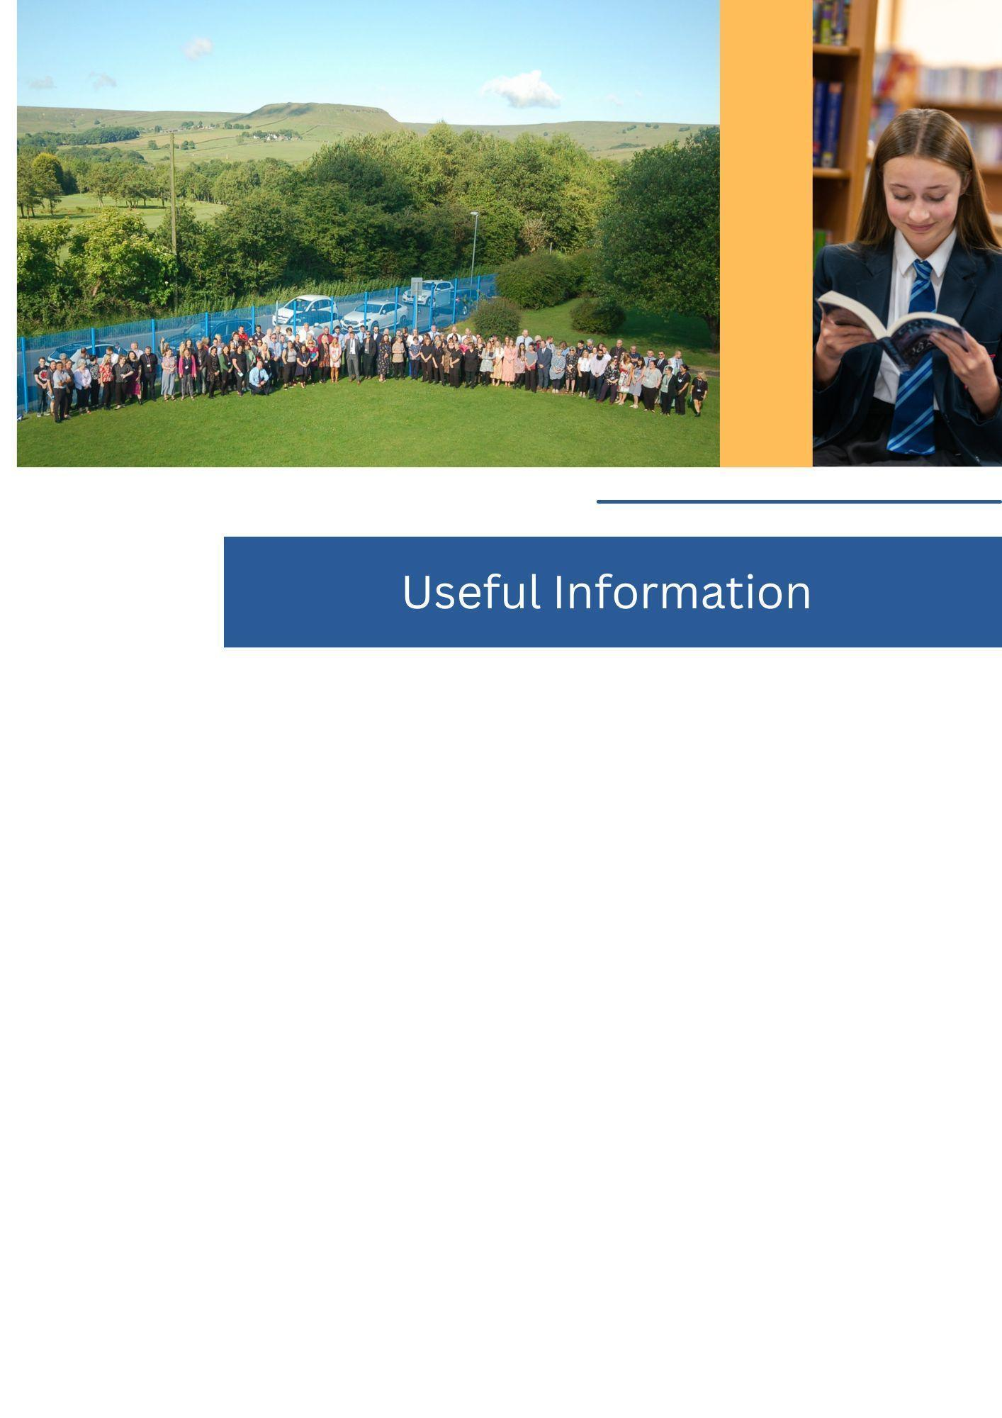

Thank you for your interest in joining our incredible team of staff here at Haslingden High School and Sixth Form.

Application forms can be found at the bottom of the [vacancies section](https://haslingdenhigh.com/vacancies/) of our website.

Please email your application to [vacancies@haslingdenhigh.com](mailto:vacancies@haslingdenhigh.com)

If you have any questions, please do not hesitate to get in touch.





