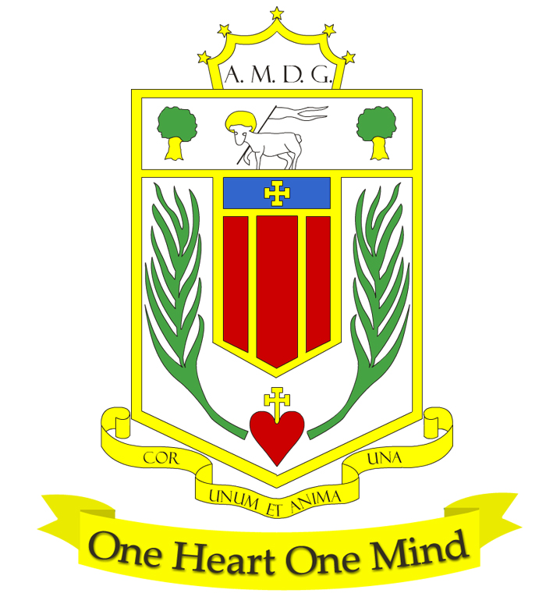
BROUGHTON HALL CATHOLIC HIGH SCHOOL
Yew Tree Lane

Liverpool, L12 9HJ

Telephone 0151 541 9440 / Fax 0151 259 8448
E.mail: smithg@broughtonhall.com
Head Teacher: Mr G Preston B.A. (Hons), NPQH, PGCE
Number on Roll 1211 including 182 in Sixth Form

TEACHER OF MODERN FOREIGN LANGUAGES

Required for September 2023

SALARY: MPS/UPS
CONTRACT: Fixed Term
HOURS: Part-Time 0.6 fte - 1.00 fte Full-time will be considered
CLOSING DATE: Monday, 26th June 2023
INTERVIEWS TO BE HELD: Date to be confirmed

The Governors wish to appoint a first rate, enthusiastic Teacher of Modern Foreign Languages with the ability to teach across the full age and ability range. If you are highly motivated, have a passion for Languages and have the ability to inspire our pupils then we would love to hear from you. The post is suitable for an NQT or more experienced colleague wishing to join a dedicated Languages Team.

The MFL Department is a successful, supportive one and offers qualifications at both Key Stages 4 and 5 in Spanish. It is a well-resourced forward thinking department.

The successful candidate will be:
- An outstanding classroom practitioner with a dedication and desire for teaching and learning
- Someone who is passionate about Languages and has the ability to inspire and foster a love of
learning
- Committed to the school’s vision and demonstrating compassion through the mission statement
- Dedicated in ensuring students achieve the best outcomes

Applications from newly qualified teachers most welcome.

About Broughton Hall Catholic High School
Broughton Hall is a Catholic High School, proud of its strong Catholic ethos and values. The school has an excellent reputation and promotes an inclusive education which develops creativity, confidence and independence. The school is committed to the continuous professional development of all staff including our Aspiring Leaders, NPQML and NPQSL programmes.

The Trustees are the Sisters of Mercy

For further information about the school and Application Pack please visit the school’s website www.broughtonhall.com

The post will be subject to an enhanced DBS clearance & satisfactory references.

Broughton Hall Catholic High School is committed to safeguarding and promoting the welfare of children and we expect all staff and volunteers to share this commitment to keeping children safe. Any offer of employment will be subject to statutory pre-employment checks including satisfactory references and Enhanced DBS and Barred List checks. This post is exempt from the provisions of the Rehabilitation of Offenders Act 1974 (as amended in 2013 & 2020) and shortlisted candidates will be required to disclose any relevant criminal history prior to interview.

