Shipston High School
___________________________
High achieving - Student-centred


Teacher of
Modern Foreign Languages- fixed term

Candidate Information Brief

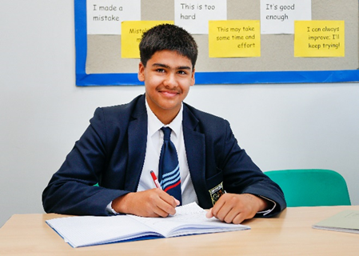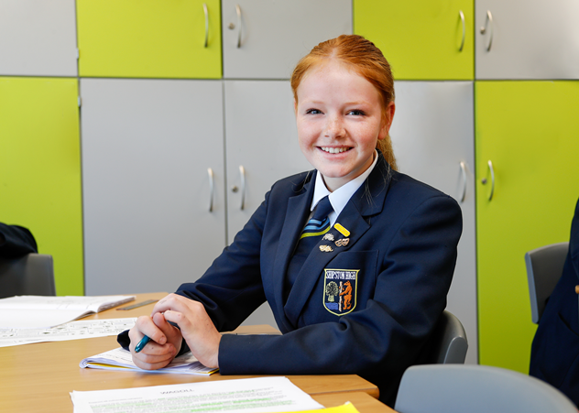

SHIPSTON HIGH SCHOOL
Darlingscote Road
Shipston on Stour
CV36 4DY
(01608) 661833

www.shipstonhigh.co.uk
Dear Candidate,

Post of Teacher of MFL at Shipston High School

Thank you for your interest in this position. Shipston High School is a fantastic place to work, and we very much hope you will wish to apply for this exciting opportunity. The post of Teacher of MFL is a full‑time temporary role. We seek a candidate able to teach Spanish up to GCSE level and French at Key Stage 3.

Shipston High School has a unique atmosphere, arising from our high expectations and strong student‑centred ethos. It is an environment in which teachers can focus on both the wellbeing and academic progress of our young people. As a result, staff and students flourish. This post offers the successful candidate excellent opportunities for professional development and will be of interest to both early career and experienced teachers.

We are seeking an outstanding practitioner with a commitment to academic excellence and high standards. The successful applicant will have secure subject knowledge in both Spanish and French and a strong understanding of effective MFL pedagogy at Key Stages 3 and 4.

Visits to the school are encouraged. For further information or to arrange a visit, please contact the Headteacher’s Secretary on 01608 661833 or cdaubney@shipstonhigh.co.uk.

We look forward to receiving your application.

Yours sincerely,

Ms Jordan Allsworth & Mr Andrew Larkin

Acting Headteachers

INFORMATION ABOUT APPLYING FOR THE POST

Please complete an application form and forward it by e-mail to Lydia Ernst, HR Manager: lernst@shipstonhigh.co.uk

In your application please indicate (no more than 2 sides of A4) how you feel your experience to date has prepared you for this post and what strengths you feel you could offer the school. Please include specific examples of where your work has enhanced pupil progress.

Applications are welcome from both experienced and newly qualified teachers.

The closing date for applications is 9.00am on Wednesday 11th February with interviews planned for shortly afterwards.

JOB DESCRIPTION

Title: TEACHER OF MFL – FIXED TERM POSITION

Responsible to: Headteacher

Grade: Main Scale / Upper Scale. A TLR is available for the right candidate, subject to experience and the capacity to take on additional departmental responsibilities.

The Role
To teach Spanish up to GCSE and French at Key Stage 3, ensuring high‑quality teaching and learning for all students.

Key responsibilities
- Deliver highly effective MFL teaching that motivates and inspires students
- Secure strong academic outcomes in line with school targets
- Plan, teach and assess in accordance with departmental and school policies
- Analyse assessment data and adapt teaching to support student progress
- Create a positive, orderly learning environment that reflects the school’s ethos
- Contribute to curriculum development within the department
- Participate actively in professional development

Other
- Serve as a Form Tutor (as allocated)
- Contribute to the school’s extracurricular programme
- Undertake additional responsibilities as directed by the Headteacher

Annual review
This job description will be reviewed annually. This is not a comprehensive statement of procedures and tasks but sets out the main expectations of the school in relation to the professional responsibilities and duties of the postholder.

PERSON SPECIFICATION

Title: TEACHER OF MFL -FIXED TERM POSITION

The following will be assessed from applications, interviews and references:

Qualification criteria
- Qualified to at least degree level or professional equivalent
- Qualified to teach and work in the U.K.

Experience
- Successful teaching experience in secondary MFL
- Evidence of promoting strong pupil progress
- Spanish teaching to GCSE essential; French to KS3

Behaviours

Teaching
- Up to date with latest pedagogy, curriculum developments and assessment requirements
- Excellent classroom teacher with a genuine passion and a belief in the potential of every student
- Effective behaviour management, with clear boundaries, praise, rewards and sanctions
- Good planning, organisational and communication skills
- Resilience, motivation and commitment to driving up standards of achievement for all students
- Commitment to regular ongoing professional development to improve practice
- A role model to students, parents and other staff
- Alignment to the Shipston High School ethos and vision
- Commitment to the safeguarding and welfare of all students

Other
- An excellent health and attendance record
- A satisfactory enhanced Disclosure and Barring Service check

INFORMATION ABOUT THE SCHOOL

Shipston High School is a non-selective 11-16 mixed High School with a very special ethos and character. Our students are high achieving and increasingly successful. The school itself is located on an attractive green-field site on the outskirts of Shipston-on-Stour in South Warwickshire. Our buildings are spacious and offer a wealth of specialist and general accommodation. Significant development of the site saw a first phase of new classrooms open in 2015, with a further teaching and reception block completed in the summer of 2018. A £10.5 million refurbishment and redesign of the original building is currently underway, Including a new sports hall, due for completion in 2027.

Visitors frequently remark on the distinctive ethos of Shipston High School. In particular, they praise the obvious energy and enthusiasm of staff and students, the excellent relations, and the happy and mutually respectful atmosphere. They also express admiration for the unusual confidence and maturity of our students and the way they rise to the challenge of taking on increasing levels of responsibility.

The Three Rivers Alliance
Shipston High School is proud to be a founding member of an ambitious alliance of five schools. Alcester Academy, Alcester Grammar School, King Edward VI School in Stratford, Shipston High School and Stratford Girls’ Grammar School have come together to form The Three Rivers Alliance. The Three Rivers name is inspired by the rivers close to each school; the Arrow in Alcester, the Stour in Shipston and the Avon in Stratford
Each school is successful in its own right, and enjoys a distinct identity and ethos. However, the five schools share important qualities and values. All promote and achieve academic success, and all value and promote the development of the whole child, enabling young people to grow academically and as independent and confident young adults. By working together for our students, each school will be strengthened through shared best practice in both the academic curriculum and wider opportunities for young people.
The Three Rivers Alliance is taking a different approach to collaboration. This is not a Multi Academy Trust (MAT), but an alliance of successful schools retaining their independence as Single Academy Trusts. As a group, we recognise that the opportunities for schools working together are substantial. This is a strong alliance of schools with fantastic potential for our young peoples’ education.

Some recent highlights

- The school has year on year been improving its examination results. In our most recent (2025) results 76 % of students achieved 4+ GCSE in English and Maths. Subjects areas that consistently outperform national averages include Art, Drama and REP.
- In our 2023 Ofsted inspection the school was judged to be good overall with our students seen as ‘at the centre of school life at Shipston High School’.
- The school has achieved positive progress 8 outcomes in the majority of years this measure has been active.
- Owing to its continuing success the school has become increasingly popular and is now regularly oversubscribed. Numbers on roll are rising. We currently have nearly 600 students in the school but plan to expand over the forthcoming few years.
- The school became a new Academy on 1st September 2012 and has developed an imaginative and ambitious project to redevelop the entire school in phases. The first phase, a new £1.6M state-of-the-art teaching block, opened in September 2015, with the second £2.25M building opened in the summer of 2018. A further £10.5 million investment will see new buildings on site in 2024 - 2027.

Teaching and Learning

We put learning at the heart of everything we do. Staff have high expectations of all students, whatever their backgrounds or abilities, and we expect students to make the most of the many opportunities the school provides. Class sizes are kept as small as possible so that we cater more effectively for every student’s needs. We believe firmly in the importance of homework and independent study as important tools to help our students become successful, self-motivated learners.

Resources for Learning
The range and quality of our facilities ensure that teaching and learning is varied, interesting and successful. ICT facilities throughout the school have been increased and upgraded significantly during recent years.

All classrooms are equipped with audio visual technology; our students are learning in high quality, well-equipped subject environments.

The School Curriculum
All National Curriculum subjects are taught through both Key Stages 3 and 4. Students are initially grouped by ability in most subjects at Key Stage 3. At Key Stage 4 all students follow a “core” curriculum and then choose from a wide range of options. The curriculum is robust, and fulfills national accountability measures whilst enabling a personalised programme for our learners.

Pastoral Care and Guidance
All students are expected to meet the very high standards of behaviour required of them. There is a very experienced pastoral team based on a House system that looks after the needs of all our students. We also rely on the support of parents to maintain our high standards.

We place a strong emphasis on establishing a caring community that encourages growth and confidence in all our students. Each student is assigned to a form and a form tutor whose purpose is to enable youngsters to obtain the best out of all aspects of the school life. The positive relationships that exist with our partner primary schools ensures that we have detailed information about students as they transfer at 11 years old.

During Years 10 and 11 students are encouraged to take on leadership roles by applying to become school prefects. They take on responsible duties and are expected to use their own initiative in helping with the day-to-day running of the school. Senior prefects are appointed annually.

Celebrating Achievement
Our school is founded on the belief that all students have talents and can achieve. We make it our mission to bring out the talents of our individual students and to celebrate their endeavours and successes at all levels. The school takes a proactive stance with regard to rewarding students for good behaviour, achievement, motivation and service to the school and wider community. Our system of rewards is designed to encourage positive attitudes above and beyond normal working expectations. Some examples of the many ways that we reward achievement include:
- Individual praise
- The award of merit points
- Letters, postcards and certificates sent home
- Celebration in House and whole school assemblies
- Special, end of term “Celebration Assemblies”
- Letter of commendation from the Headteacher
- An award at our annual Awards Evening when students receive public recognition for their efforts and achievements

Extra curricular Activities
A wide range of opportunities exist for the students to be involved in sporting, dramatic, computing and musical activities. Our student participation rate is exceptionally high. We regularly compete on the sports field with neighbouring schools and youngsters are involved both locally and with county teams. We have staged many dramatic productions of varying types, along with regular music concerts. Opportunities also exist for students to take part in a wide range of educational visits to places in this country and abroad.

From the first telephone conversation to your school we were met with the utmost courtesy and attention and the boys who showed us round are to be particularly commended. They were truly ambassadors to your school and their knowledge, interest and enthusiasm for the school was clearly obvious to see. The comment from our son afterwards was that Shipston High School was his number one choice.

Prospective parent visiting the school

Communication with Parents
We are keen to see parents involved in helping their youngsters to learn. Much of this contact is achieved informally through parents coming into the school or by telephone. On a more formal level, regular consultation sessions take place including termly reports home.

Post 16 Destinations
On completion of their GCSEs the majority of our students leave school to follow a wide range of AS/A level and other post 16 courses at local sixth form centres and colleges. Many then go on to university and higher education in order to enter a wide range of professions and careers.

SHIPSTON HIGH SCHOOL’S SAFE RECRUITMENT PROCEDURE

Shipston High School is committed to safeguarding and promoting the welfare of children and young people and expects all staff and volunteers to share this commitment.

Disclosure
Shipston High School requires all employees to undertake an enhanced DBS check. You are required, before appointment, to disclose any unspent conviction, cautions, reprimands or warnings under the Rehabilitation of Offenders Act 1974 (Exceptions) Order 1975.

Non-disclosure may lead to termination of employment. However, disclosure of a criminal background will not necessarily debar you from employment – this will depend upon the nature of the offence(s) and when they occurred.

Shortlisting
Only those candidates meeting the right criteria will be taken forward for interview.

Interview
- Shortlisted candidates will be subject to an in-depth interview process including a lesson observation
- Candidates will be asked to address any discrepancies, anomalies or gaps in their application form

Reference checking
References from the previous and current employer will be taken up for shortlisted candidates, and where necessary employers may be contacted to gather further information.

Probation
All new staff will be subject to a probation period of six months (which may, in certain circumstances, be extended by up to a further three months). The probation period is a trial period to enable the assessment of an employee’s suitability for the job for which they have been employed. It provides the school with the opportunity to monitor and review the performance of new staff in relation to various areas, but also in terms of their commitment to safeguarding and relationships with students.

