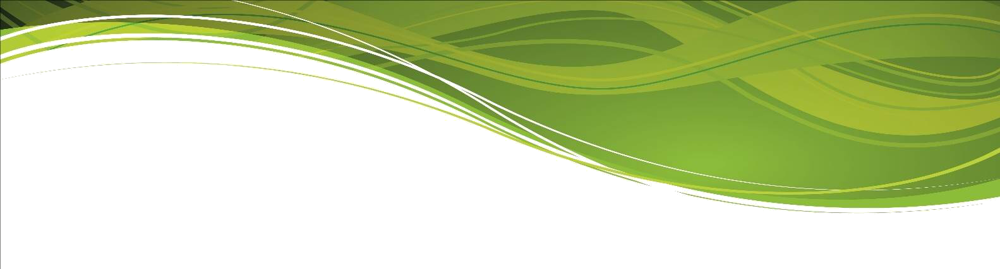

**Modern Foreign Languages**

**Department Profile**

The Languages Department at Millom School is passionate about the learning and teaching of Languages to all students, regardless of their ability. At present French is taught both at Key Stages 3 and 4.

The department has developed close links with our Primary feeder schools and as such, we have an exceptionally clear understanding of the knowledge-base that the students have developed in the primary phase of their education. We build on the knowledge, understanding and skills the students have gained so that everyone can progress quickly from the beginning of Year 7. Then, from year to year, progression is ‘mapped’ through our schemes of work.

Throughout our schemes of work, we ensure that each unit is linked with another, either through the language or the grammatical points taught. We believe in making Language learning interactive and fun and are conscious of our opportunity to improve our students’ literacy skills.

We look for good participation from the students to be able to teach with a communicative approach. Participation is encouraged, whether students are working with a partner or taking part in whole class activities.

We expect our students to learn by:

a) **Listening** to the teacher, to others in class, to a recording or video, to the computer. They are exposed to as much of the target language as possible.

b) **Speaking** to each other and their teacher in the target language whenever possible, either

for "survival" activities (asking for help, asking for permission to do something…) or to practise new vocabulary and structures using cue cards, working with ICT, playing games.

c) **Reading** in the target language, using readers, authentic materials or purchasing magazines as well as carefully chosen literature pieces.

1. **Writing** in the target language for creative purposes
2. **Manipulating** language, physically or mentally.
3. **Looking** at demonstrations, word patterns, moving images...

Developing thinking skills and cultural awareness are an important part of our teaching.

At Key Stage 3, students follow a combination of schemes of work developed by the department, such as the one we use for transition between primary and secondary that encourages good pronunciation through the teaching of phonics, and amended Dynamo schemes, which at the moment, are used in Key Stage 3. All year groups in Key Stage 3 are currently taught 2 lessons of French per week; each lesson lasting for 50 minutes.

At Key Stage 4, students are currently taught 3 x 50 minute lessons of French per week. We follow the French AQA Specification in languages and students have access to the AQA GCSE French Studio course, both at Foundation and Higher levels. Class sizes are usually small at Key Stage 4.

Languages is an optional subject at Millom School (Key Stage 4).

The Languages department has a dedicated classroom base. The teaching classroom has an office. The classroom is equipped with an interactive whiteboard and desktop computer.