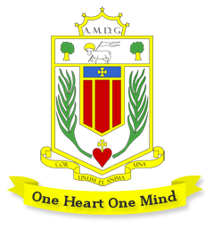
Broughton Hall Catholic High School: Music Department

The Music team currently consists of 6 peripatetic tutors plus two classroom teachers, one of whom is the Head of Subject. The department has many strengths and we are looking to expand its offer, building KS4 and extra curricular music.

We are constantly striving to improve students’ opportunities in music via links to the local music industry and Resonate, Liverpool’s Music Hub.
Accommodation and Resources
Music and Drama share fantastic facilities:

Drama: Drama Studio & Dance Drama performance space (also used by the Music department)
Music 1 large specialist teaching space, four practice rooms and a recording studio

The main teaching room is equipped with 16 student iMacs with Logic Pro plus touch sensitive, full-size keyboards, a teacher iMac with keyboard & amplifier plus a Promethean board. Classroom music also utilises a range of acoustic tuned and untuned instruments including guitars, ukuleles and drum kits.

A number of string, woodwind and brass instruments are available for music tuition students to borrow.

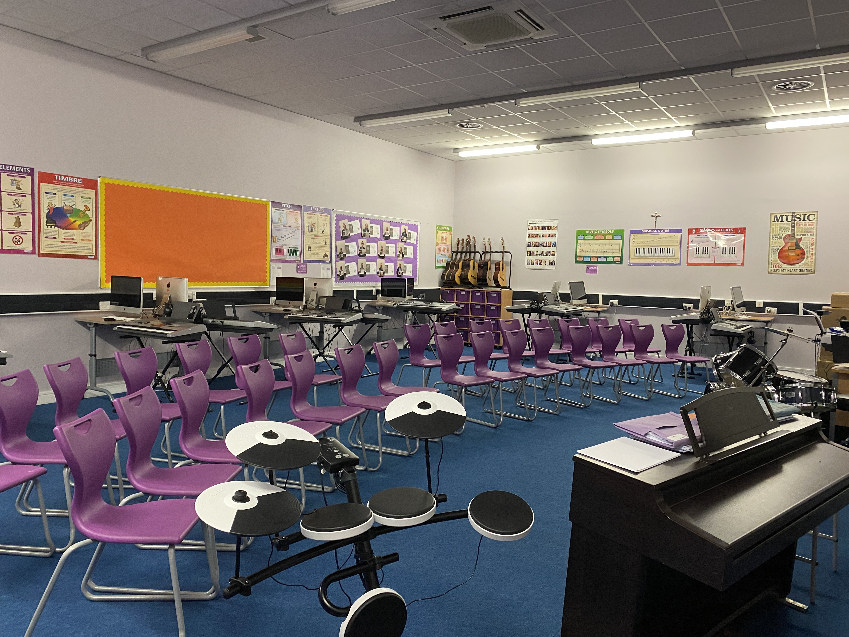
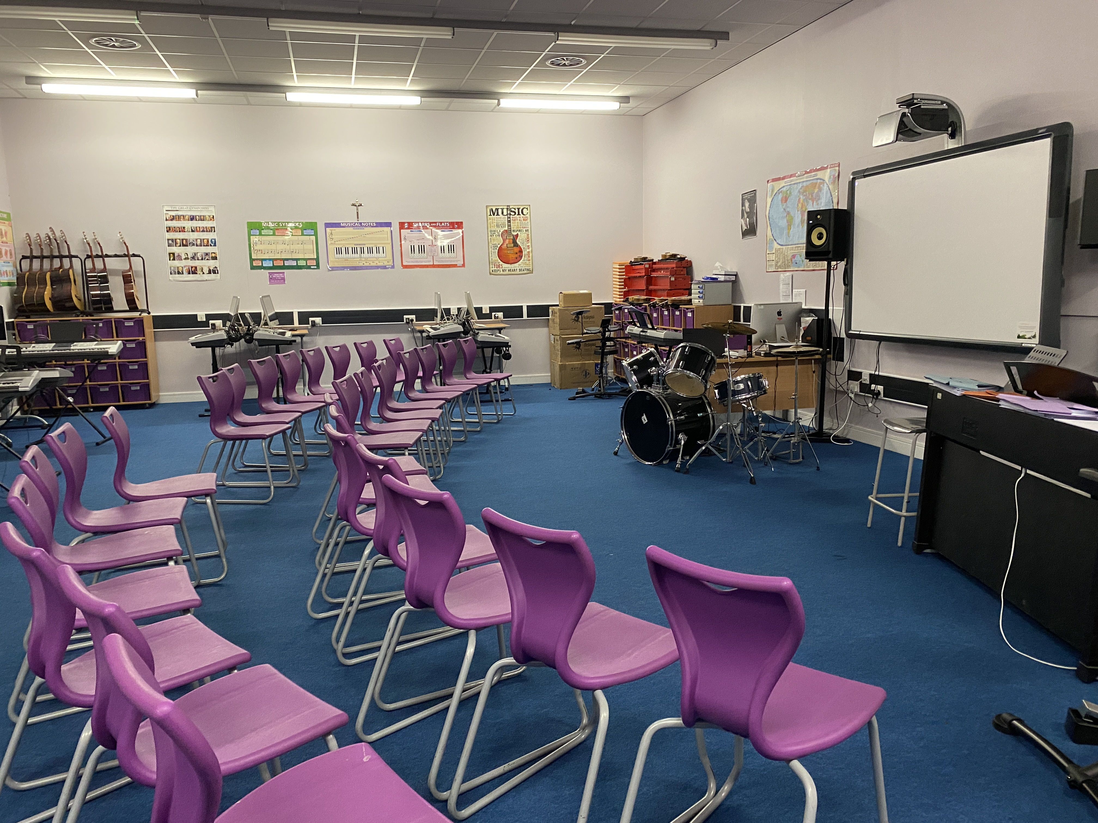

Key Stage 3 Music: 2021-22

Year 7-8: One hour lesson per week
Year 9: One fortnightly lesson, with a view to one hour per week in 2022-23.

All Key Stage 3 students experience listening, performing and composing, with high expectations of each student. They learn to follow notation, perform (focusing on voice and keyboard in class) and use Logic software. Liverpool is a UNESCO World City of Music and we aim to help students access this fantastic musical setting, working with industry professionals and visiting key places such as the Philharmonic Hall and the British Music Experience. Lessons are designed to be rigorous but highly practical. Above all, we want students to love music-making!

We formally assess every 8-12 lessons, with attention paid to developing knowledge, skills, co-ordination and technique. Personalised verbal feedback plus regular assessment is essential to our developmental approach. Homework is set when appropriate, with extra curricular opportunities open to all.

Key Stage 4 Music: 2021-22: GCSE Music (Edexcel) or RSL Music Practitioners Level 2

Year 11: 6 students
Year 10: 4 students

Engaging students at KS4 is a major development point for us. We want to help students understand the personal, academic and professional benefits of studying Music as one of their KS4 qualifications.

Some students have additional instrumental or vocal tuition prior to Key Stage 4 but many don’t. We don’t see this as a barrier to success, as our teaching enables all to make good progress. Music has great facilities, dedicated teachers and strong examination results.
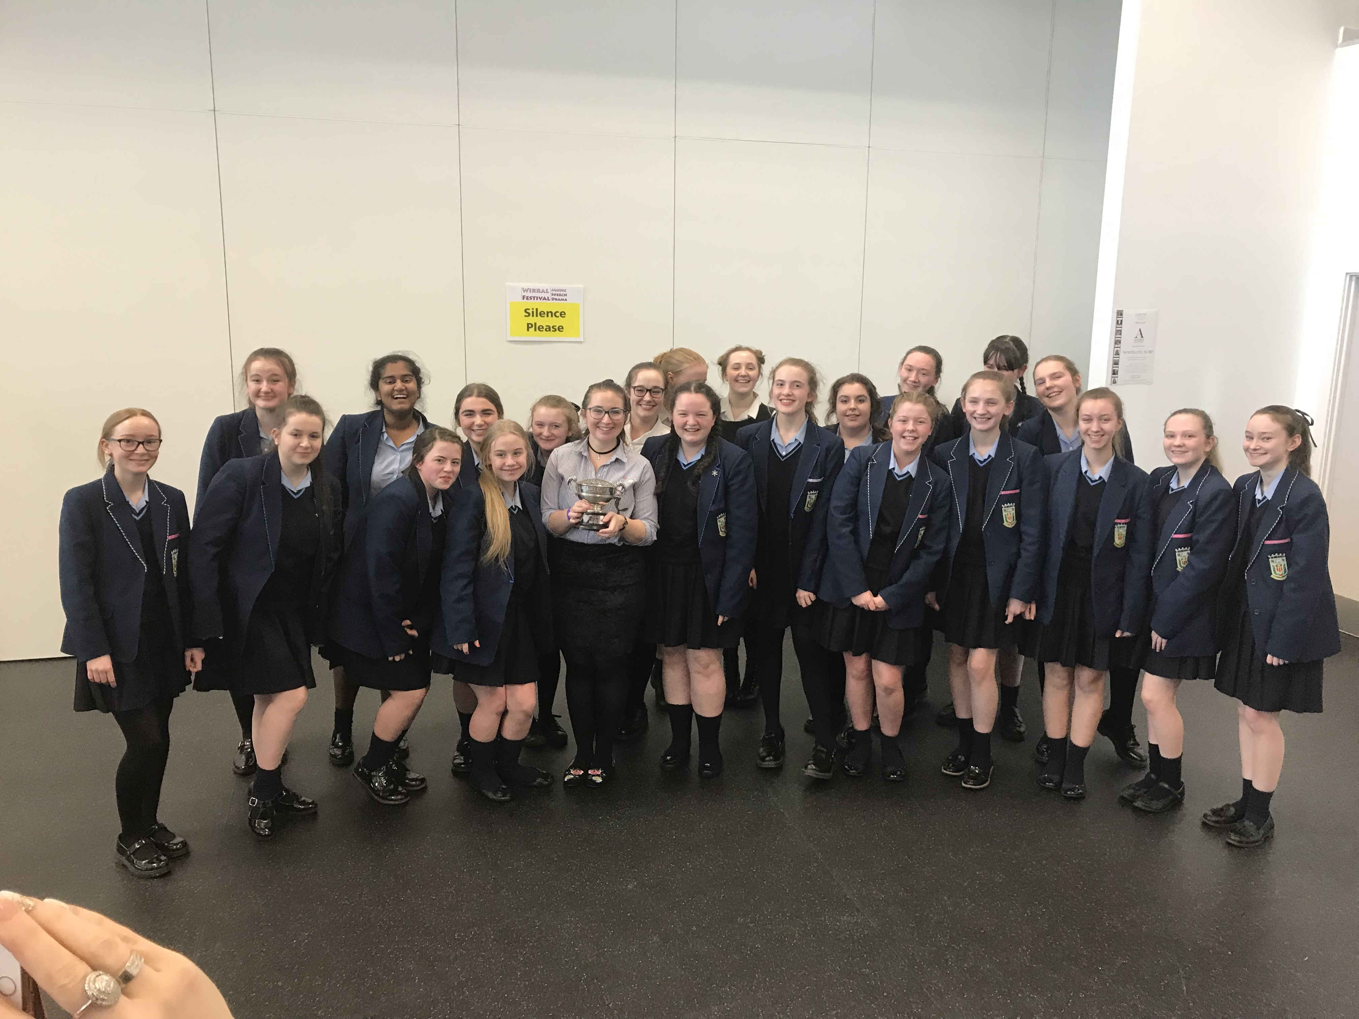
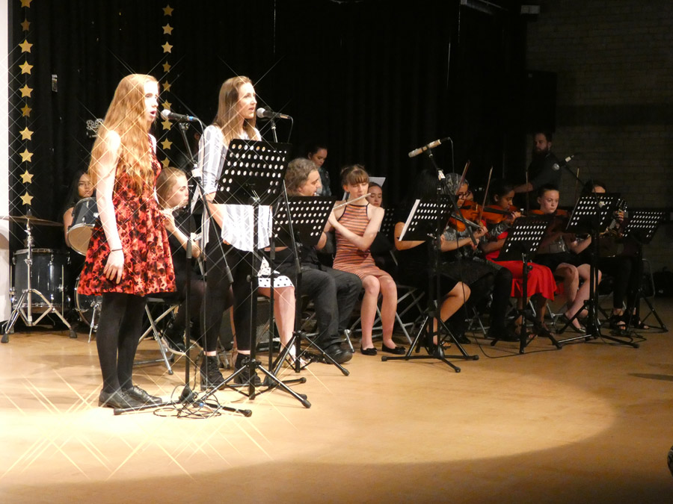
Current Extra Curricular Activities
- Music Tuition Programme (strings, woodwind, brass, drum kit, guitar, piano, voice)
- Band and smaller instrumental groups (keyboard club, guitar club)
- Vocal Group
- Practice rooms for student rehearsal
The successful candidate will have many opportunities to build our extra curricular programme and we are keen to hear more from applicants about what they can offer. Growth opportunities include our annual school musical, vocal and instrumental ensembles in a range of styles & facilitating rehearsals at breaks, lunches and after school each day.

Events
- Performances at a variety of community and school events e.g. Year 7 Mass, Awards Evening, Carol Singing

- School Production (Easter Term)
- Summer Concert (Summer Term)
- Various festivals/competitions

