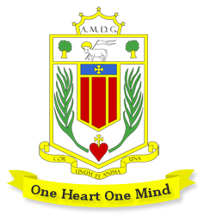
Broughton Hall Catholic High School: Music Department

The Music team currently consists of 6 peripatetic tutors plus one classroom teacher who is also the Head of Subject. The department is at an exciting stage in its development where we are looking to expand its offer.

Broughton Hall Music aims to inspire, equip and enrich young people through the power of music and the creative arts. We are constantly striving to improve students’ opportunities in music and have strong links to the local music industry as well as Resonate, Liverpool’s Music Hub.
Accommodation and Resources
Music and Drama share fantastic facilities which give all students the chance to meet their fullest potential.

Drama: Drama Studio & Dance Drama performance space (also used by the Music department)
Music 1 large specialist teaching space, four practice rooms and a recording studio

The main teaching room is equipped with 16 student iMacs with Logic Pro plus touch sensitive, full-size keyboards, a teacher iMac with keyboard & amplifier plus a Promethean board. Classroom music also utilises a range of acoustic tuned and untuned instruments including guitars, ukuleles and drum kits.

A number of string, woodwind and brass instruments are available for music tuition students to borrow.

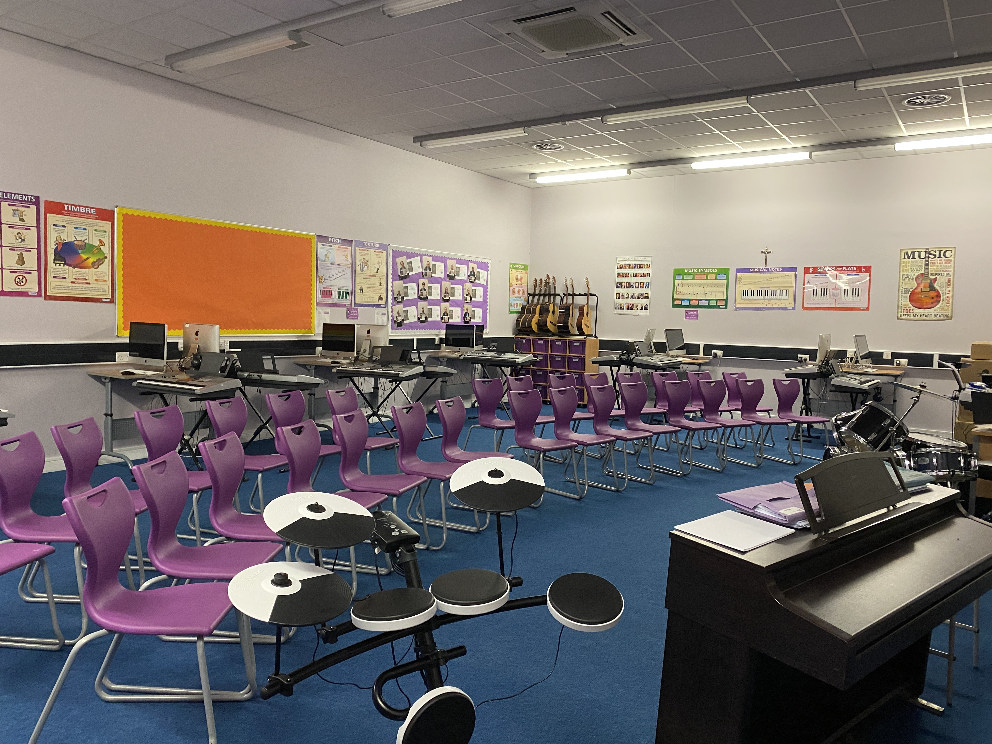
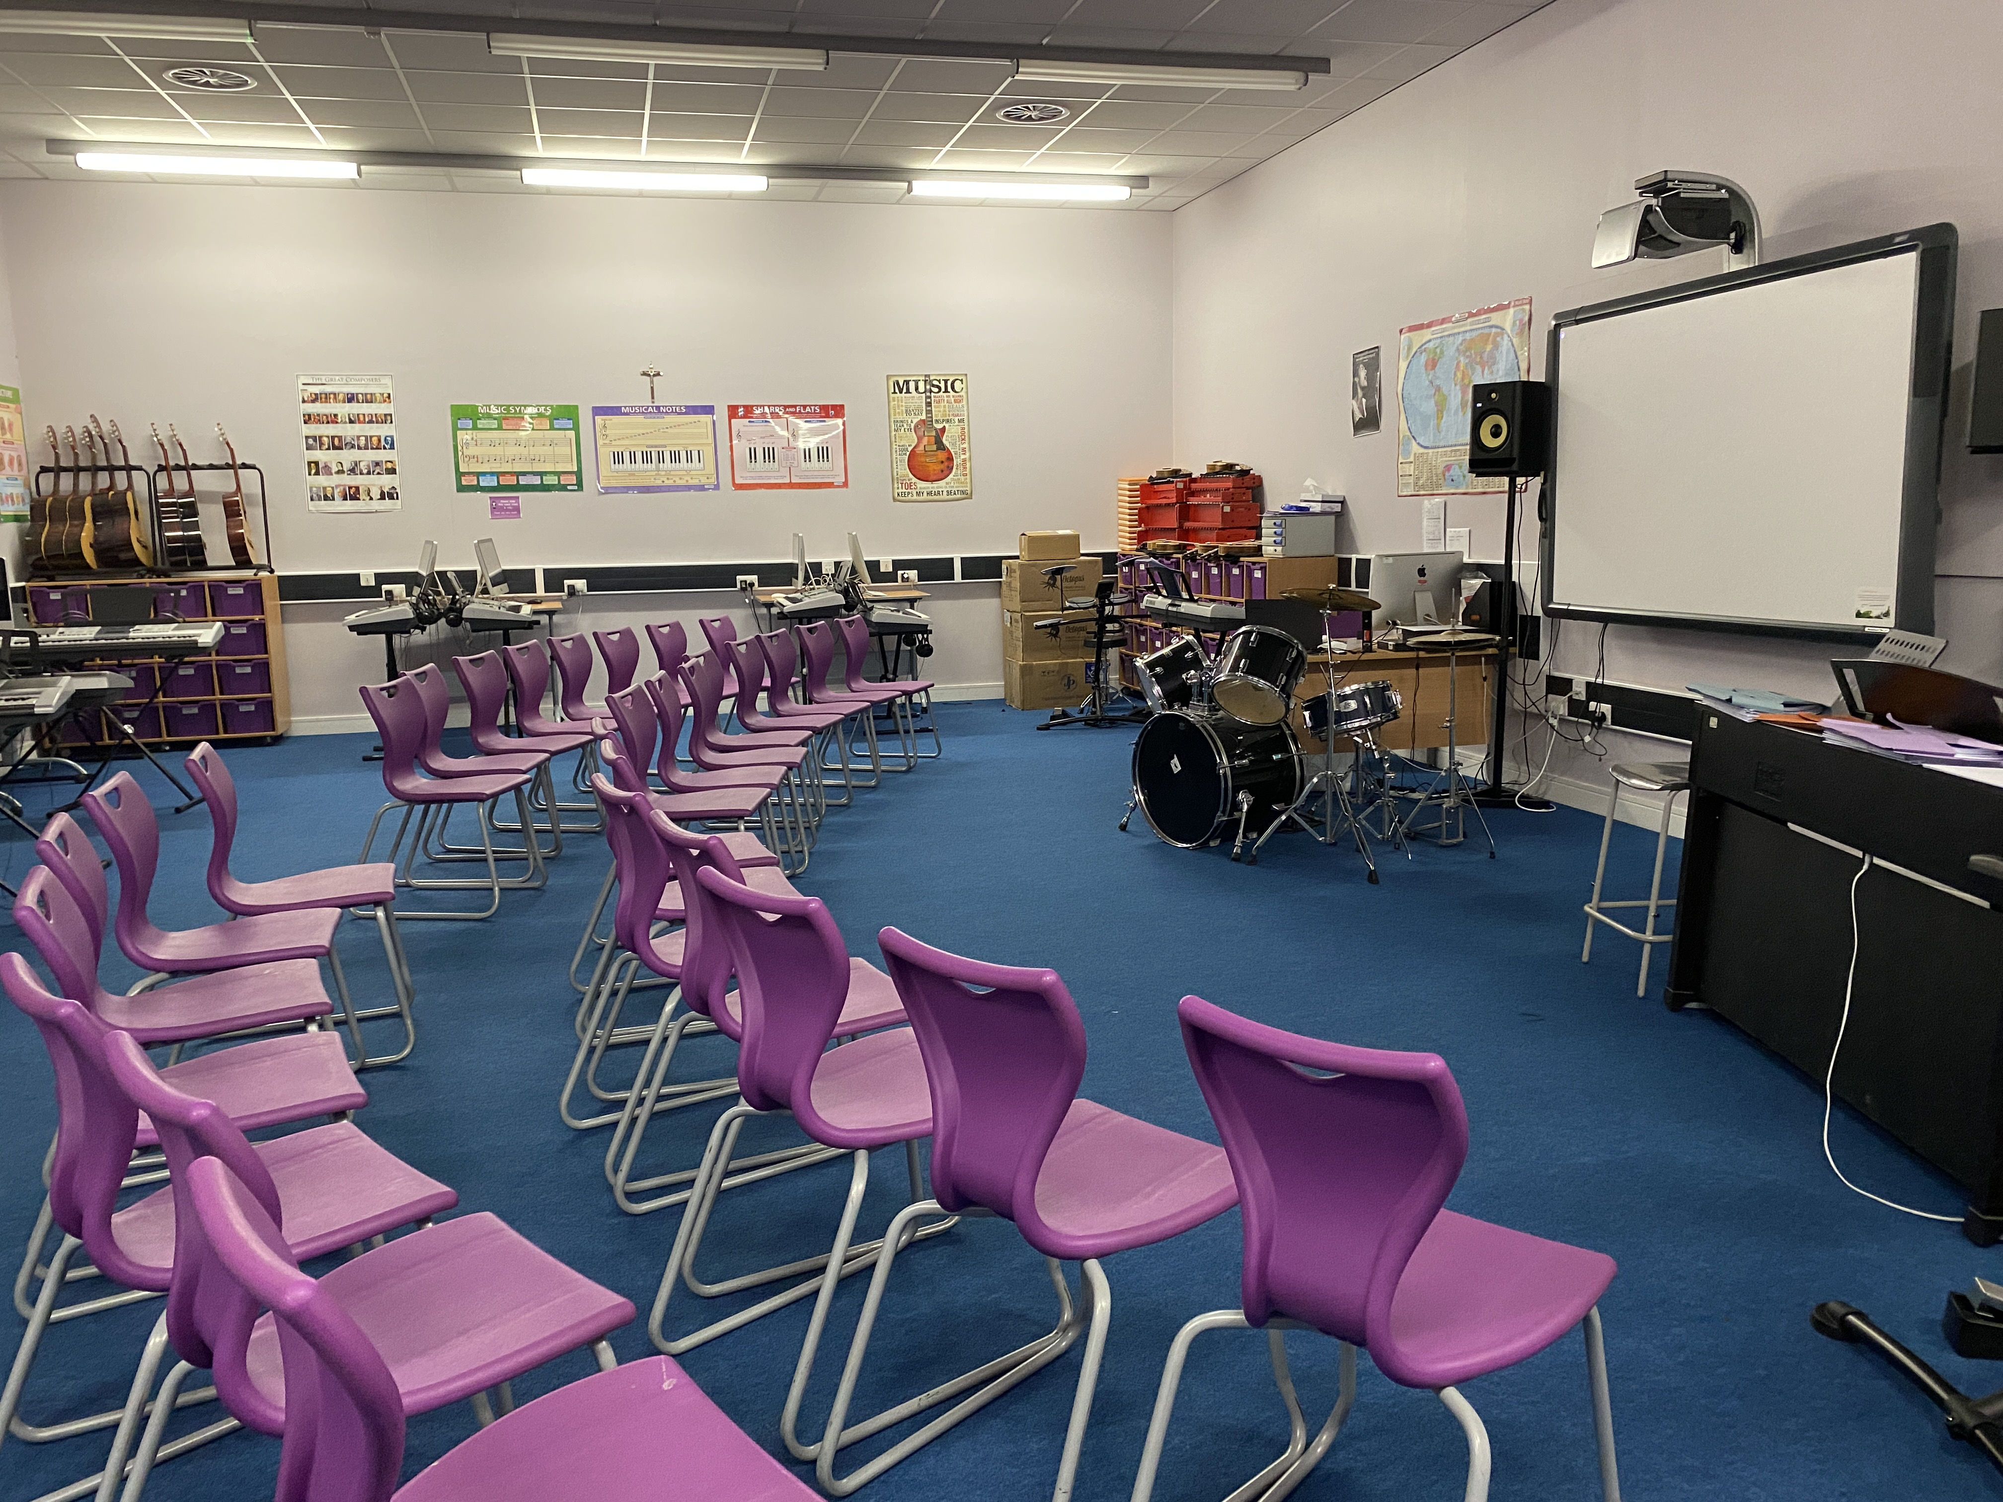

Key Stage 3 Music: 2021-22

Year 7-8: One hour lesson per week
Year 9: One fortnightly lesson, with a view to one hour per week in 2022-23.

All Key Stage 3 students learn the key skills of listening, performing and composing, with high expectations that each student will work hard to achieve their potential. They will learn to follow notation, perform (voice, keyboard, drumming, ukulele) and use Logic software on iMacs to explore and develop their skills. Liverpool is a UNESCO World City of Music and we aim to help students access this fantastic musical setting, working with industry professionals and visiting key places such as the Philharmonic Hall and the British Music Experience. Lessons are rigorous but highly practical and above all, we want the students to love music-making!

Students can expect to be formally assessed every 8 lessons, with attention paid to developing knowledge, skills, co-ordination and technique. Personalised verbal feedback plus regular assessment is essential to our developmental approach. Homework is set when appropriate and there are plenty of extra curricular opportunities open to all.

Key Stage 4 Music: 2021-22: GCSE Music (Edexcel) or RSL Music Practitioners Level 2

Year 11: 6 students
Year 10: 4 students

KS4 Music is facing recruitment challenges nationally and we want to buck this trend. Engaging students at KS4 is a major development point for us in the coming year.

Some of our students have had additional instrumental or vocal tuition prior to Key Stage 4 but many have not. We don’t see this as a barrier to success, as our teaching enables all to make good progress. Music has great facilities, dedicated teachers and strong examination results. We work hard to support and develop students’ personal, musical and academic skills, both in and outside the classroom.

In the coming year we want to help students understand the personal, academic and professional benefits of studying Music as one of their KS4 qualifications.
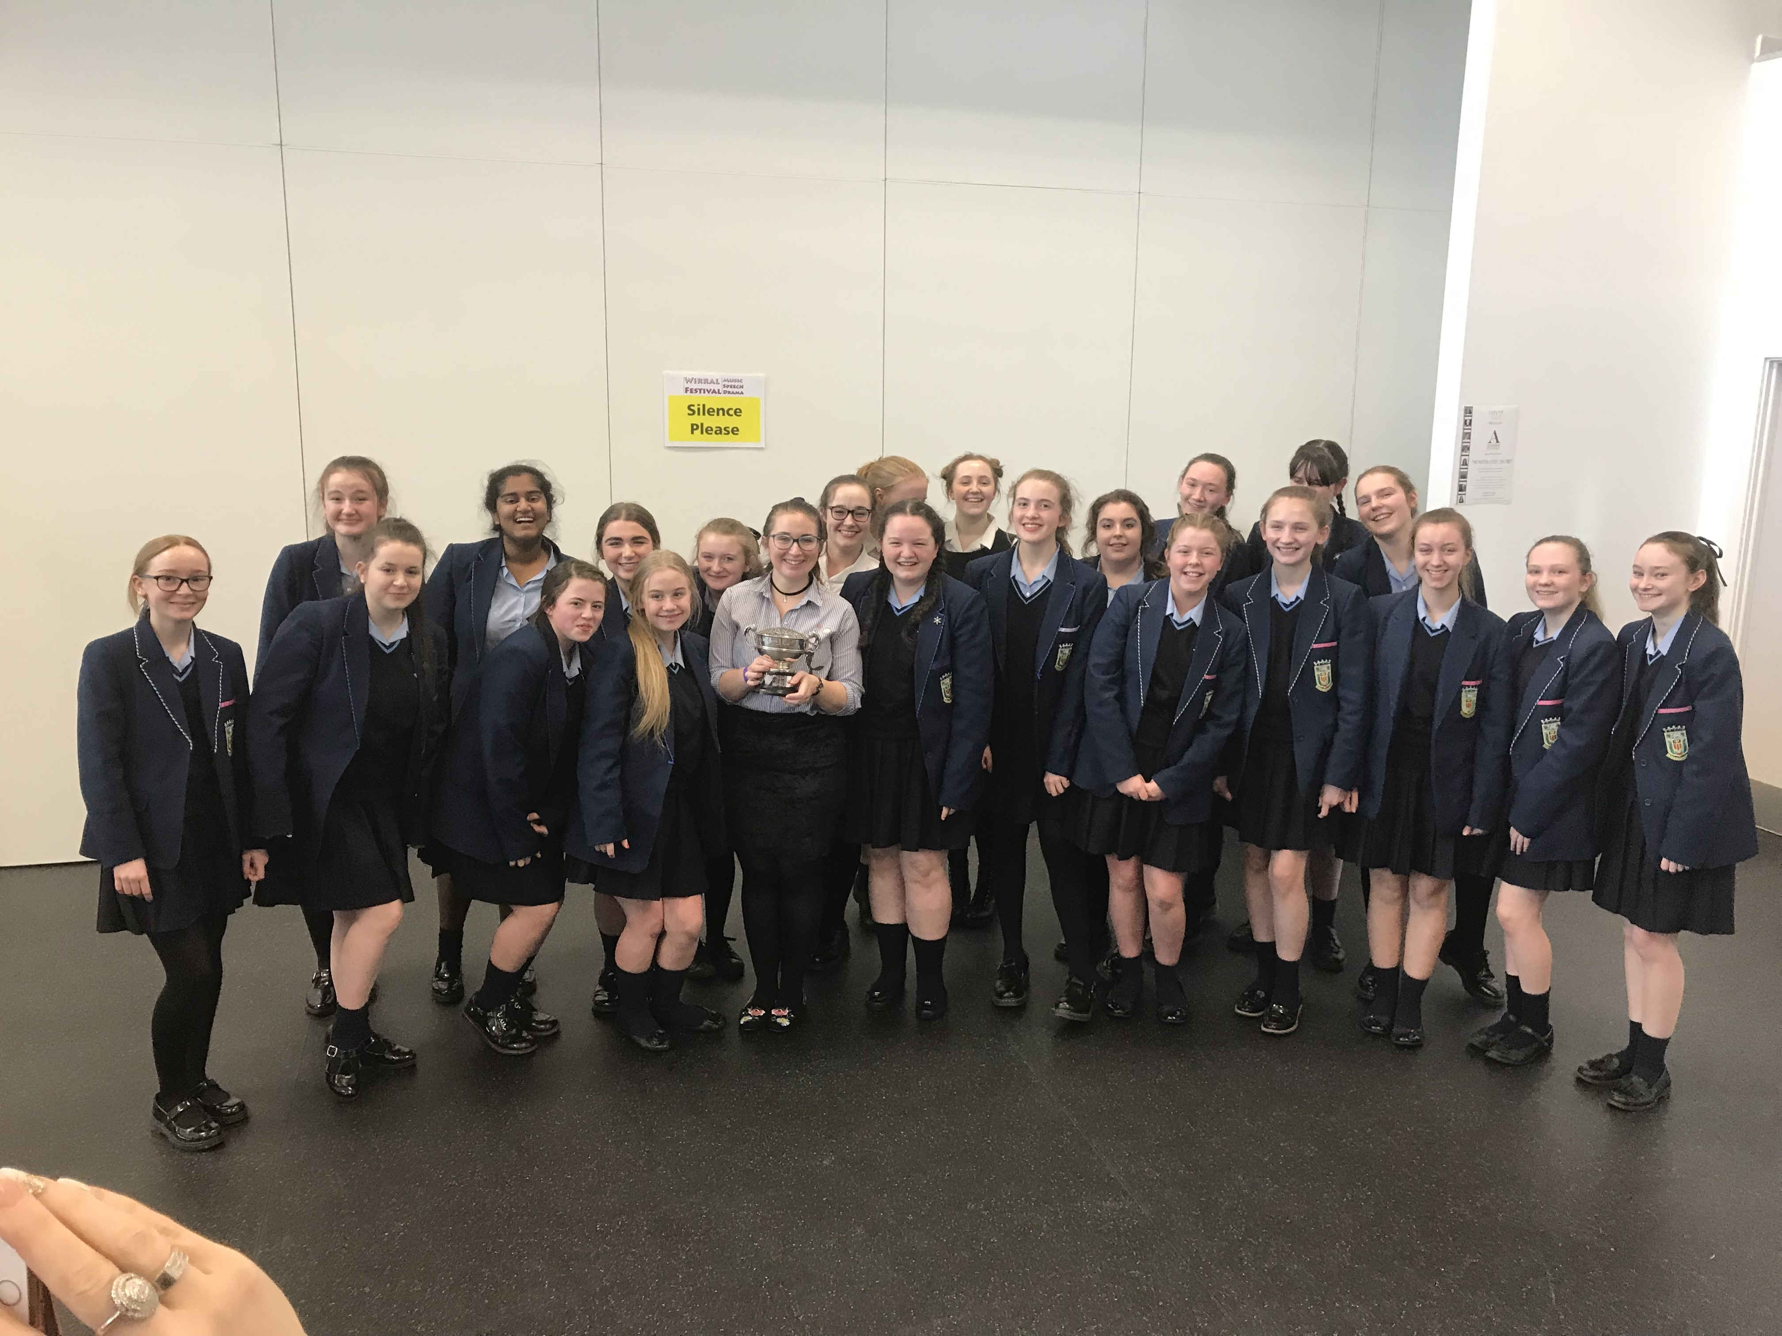
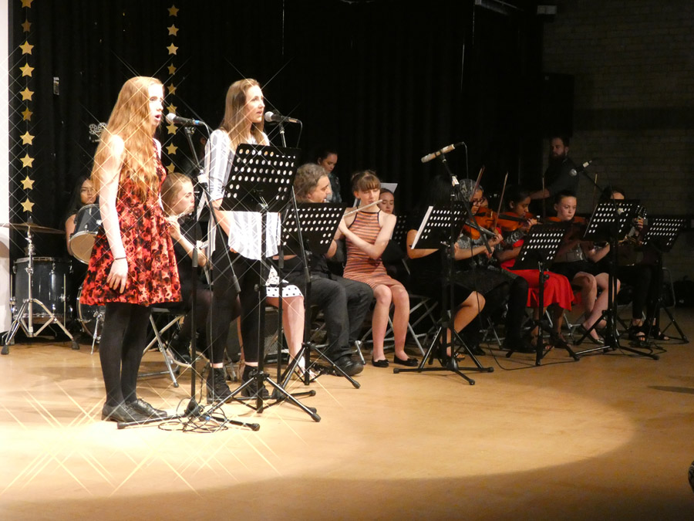
Current Extra Curricular Activities
- Music Tuition Programme (strings, woodwind, brass, drum kit, guitar, piano, voice)
- Band
- Choir and Vocal Group
The successful candidate will have many opportunities to build our extra curricular programme and we are keen to hear more from applicants about what they can offer. Growth opportunities include our annual school musical, vocal and instrumental ensembles in a range of styles & facilitating rehearsals at breaks, lunches and after school each day.

Events
- Performances at a variety of community and school events e.g. Year 7 Mass, Awards Evening, Carol Singing

- School Production (Easter Term)
- Summer Concert (Summer Term)
- Various festivals/competitions

