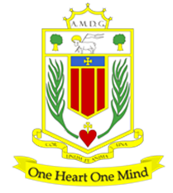
Broughton Hall Catholic High School
Start Date: 1st Sept 2024
Closing Date: 16th April 2024
Shortlisting: After the closing date
Interview Date: To be confirmed
Contract Term: Permanent
Salary Scale: MPS/UPS
Hours: 1.00 FTE

http://www.broughtonhall.com/information/vacancies.php
INFORMATION PACK
TEACHER OF MUSIC

Broughton Hall Catholic High School
Founded in 1928 under the trusteeship of the Sisters of Mercy, Broughton Hall Catholic High School, an all-girls Catholic secondary school in Liverpool, provides the very best in modern education based on the Gospel values of mutual respect and care.

The central aim of our school is to provide excellent educational opportunities enabling each pupil to develop their God given talents, to grow in confidence and self-esteem and to fulfil their potential.

As a Catholic school Broughton Hall centres its mission on the person of Jesus Christ, and promotes the Gospel values throughout the school community and in all aspects of school life: spiritual, academic, pastoral, and personal. By proclaiming and living out the faith of the Catholic Church, we support each other in shared experiences of teaching and learning, prayer, worship and charity. Our mercy values permeate throughout our community. We are proud of our strong Catholic ethos and values.

Broughton Hall is Ofsted rated as a “Good” provider (November 2022).

Our facilities are bright, spacious, high tech and designed to meet the needs of all our pupils. We have a separate 6th Form facility, which is shared with our neighbouring boys school Cardinal Heenan Catholic High School. A full range of extra-curricular activities are provided to further the creative, sporting and academic talents of each pupil and offer Outward Bound and Duke of Edinburgh Award schemes as well as the opportunity to attend educational visits and residential trips.

We pride ourselves on our high expectations of all pupils and have an ‘Ambition for All’ policy. Whatever your role within the school, you will share these values and be able to encourage and motivate pupils with your passion, presence and personality.

Our school motto ‘Cor Unum et Anima Una’ - One Heart and One Mind, reflects the strong sense of community amongst pupils, staff, parents and Governors.

We Offer

- Pensions Scheme – Teacher Pension Scheme for teaching staff or Merseyside Pension Fund for support staff
- Regular training and development programme
- The school is committed to the continuous professional development of all staff including Aspiring Leaders, NPQML and NPQSL programmes.
- Access to occupational health
- Cycle2Work Scheme
- Tax Free Childcare Vouchers
- Supportive work environment where all staff are valued
- Continuous professional development for all staff and follow a whole school approach to staff performance and development

And that’s not all, we place the outcomes of the children in our school at the heart of everything we do, so you’ll wake every day in the knowledge that your role will have a significant positive impact on the lives of others.

Equal Opportunities

Broughton Hall Catholic High school is an equal opportunities employer.

We welcome applicants from all backgrounds and value everyone as an individual. We are committed to organisational practices, which promote diversity and inclusion for all employees and volunteers regardless of age, gender reassignment, marriage or civil partnership status, pregnancy and maternity status, disability, race (including colour, nationality, ethnic or national origin), religion or belief, sex, or sexual orientation. Connecting these differences creates a productive environment in which everyone feels valued.

Monitoring information in relation to job applicants will be to assist us in equality monitoring. The recruitment panel will not have access to job applicant’s monitoring information.

To assist us in monitoring the operation of equal opportunities policy, and for no other reason, please ensure you complete and submit the Equal Opportunities Monitoring Form with your application form.

Safeguarding & Enhanced DBS Checks
Broughton Hall Catholic High School is committed to safeguarding and promoting the welfare of young people and expect all pupils, staff, volunteers and visitors to share this commitment

All posts are subject to an enhanced DBS check and full pre-employment checks to comply with the current Keeping Children Safe in Education statutory guidance for schools.

All staff will be expected to follow Broughton Hall Catholic High School’s child protection policies, code of conducts and managing allegations against staff procedures.

All roles in school, including this post, are exempt from the Rehabilitation of Offenders Act (ROA) 1974. The Ministry of Justice’s guidance on Rehabilitation of Offenders Act 1974 and the Exceptions Order 1975 provides information about which convictions must be declared during job applications and can be accessed here.

All applicants must therefore declare all previous convictions and cautions, including those which would normally be considered ‘spent’ except those received for an offence committed in the United Kingdom if it has been filtered in accordance with the DBS filtering rules. Information about filtering offences can be found in the DBC Filtering Guide, which can be accessed here.

By engaging in this recruitment process, shortlisted candidates consent to an online search in line with the Keeping Children Safe in Education Statutory Guidance 2022.

Welcome

Thank you for your interest in the position of Teacher of Music.

This pack has been designed to help you should you choose to submit an application form, which we sincerely hope you do. We hope it answers your initial questions, but if not, please do not hesitate to contact us and we will endeavour to help you through your application process.

Music is taught across Key Stages 3 and 4. The subject has a strong music tuition programme, a range of extra-curricular activities and is very well resourced.
Broughton Hall Catholic High School is the largest all-girls school in Liverpool and serves many different areas making us a vibrant a diverse school. Our aim is to be a good school in all areas and we are seeking staff to apply to work with to be of that journey. Ofsted rated the school as “Good” in November 2022.

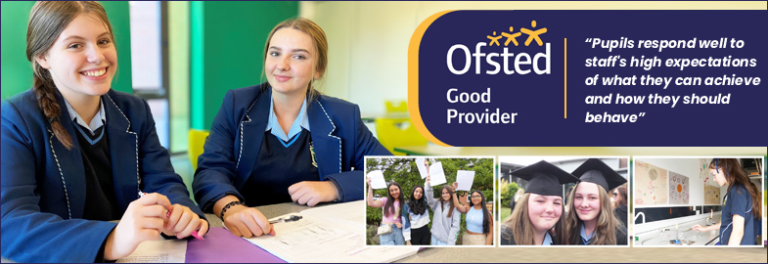

We work hard to ensure Broughton Hall Catholic High School remains a friendly and welcoming environment for all those who work, study or visit here and hope that you are the person we are looking for to bring creativity and innovation to the role.

The school actively supports the training of middle leaders through well-respected Teaching Leaders’ programme. Opportunities for promotion exist for suitable candidates. Our staff are passionate about teaching and are committed to develop exciting and stimulating lessons that not only engage students.

We look forward to hearing from you.

Gerard Preston
Head Teacher

Advert

The Governors wish to appoint a first rate, enthusiastic Teacher of Music with the ability to teach across the full age and ability range. The successful candidate will be a strong classroom practitioner, make a significant contribution to our music extra-curricular offer. The ability to support the Catholic life of the school or Drama would be advantageous.
If you are highly motivated, have a passion for Music and have the ability to inspire our pupils then we would love to hear from you. This is an exciting and innovative position. We are keen to see what you are able to offer our school in a classroom, extra-curricular and whole school context so please make this clear in your application. Applications from newly or recently qualified teachers are most welcome.
Music is taught across Key Stages 3 and 4. The subject has a strong music tuition programme, a range of extra-curricular activities and is very well resourced.
The successful candidate will be able to demonstrate:
- Outstanding classroom practice with a dedication and desire for excellent teaching and learning
- A passion for Music and the ability to inspire and foster a love of learning
- First-rate subject and pedagogical knowledge and understanding
- Strong musicianship and confidence modelling/leading high quality performing and composing, including use of music technology
- Commitment to the school’s vision, living compassion through our mission statement
- Dedication to ensuring students achieve the best outcomes

About Broughton Hall Catholic High School
Broughton Hall is a Catholic High School is an Ofsted rated Good provider (2022). We are proud of our strong Catholic ethos and values. The school has an excellent reputation and promotes an inclusive education which develops creativity, confidence and independence. The school is committed to the continuous professional development of all staff including Aspiring Leaders, NPQML and NPQSL programmes.

The Trustees are the Sisters of Mercy

For further information about the school and Application Pack please visit the school’s website www.broughtonhall.com

Broughton Hall Catholic High School is committed to safeguarding and promoting the welfare of children and we expect all staff and volunteers to share this commitment to keeping children safe. Any offer of employment will be subject to statutory pre-employment checks including satisfactory references and Enhanced DBS and Barred List checks. This post is exempt from the provisions of the Rehabilitation of Offenders Act 1974 (as amended in 2013 & 2020) and shortlisted candidates will be required to disclose any relevant criminal history prior to interview.

Job Description

TEACHER OF MUSIC

Purpose | To teach within the school at key stages 3 and 4 (as applicable) and contribute towards the development of the department team, ensuring the highest possible standards of pupil achievement, personal development and well-being both within the curriculum and beyond.  To work with the Director of Music and line manager of the subject to deliver an engaging and high quality extra-curricular programme.  The successful candidate will have many opportunities to build our extra-curricular programme and we are keen to hear more from applicants about what they can offer. Growth opportunities include our annual school musical, vocal and instrumental ensembles in a range of styles & facilitating rehearsals at breaks, lunches and after school each day.
Location | Broughton Hall Catholic High School, West Derby, Liverpool
Reporting to | Head of Department
Responsible for | Under the direction of the Head of Department, the post holder will be responsible for departmental teaching including KS3 and GCSE Music, as well as the management and delivery of agreed extra-curricular provision.
Working Time & Conditions | - As specified in the latest School Teachers’ Pay and Conditions Document.  - Work with the Director of Music to plan, lead and contribute to the school’s extra-curricular Music programme.  - Flexibility to attend school functions beyond the working day, including Awards’ Evenings and other school events as required.
Safeguarding children | The post holder must safeguard and promote the welfare of the children and young people at Broughton Hall Catholic High School
Salary | MPS/ UPS

OVERVIEW
At the heart of the role of the main scale teacher is the provision of high quality teaching and learning, effective use of resources, improving standards of achievement for students and the promotion of students’ personal development and well-being within this faith-based community. Main scale teachers work as members of a department to secure the highest possible standards in all aspects of school and departmental life and are required to carry out such duties as are reasonably assigned by the Head Teacher to ensure the effective operation of the school.

This is an innovative post and requires a teacher with a commitment to extra-curricular provision.

DIMENSIONS

The post holder will be responsible for the following, with reference to the national framework of teachers:
- Classroom teaching and learning
- Pupil progress and standards of achievement

ACCOUNTABILITIES

The strategic direction and development of the subject

- To support the production of an annual subject development plan, which contributes to the achievement of the School Improvement Plan, and which involves all the subject staff in its design and evaluation.
- To contribute to the setting expectations and goals for colleagues and pupils in relation to standards of achievement and behaviour.
- To as appropriate, represent the department in the wider school community and liaise with the rest of the school, governors, partner schools, the Local Authority, further and higher education, industry, outside agencies, examination boards etc.
- To keep up to date with national developments in the subject area and teaching practice and methodology.
- To help develop current systems with regard to health and safety, risk assessments, collection and storage of valuables and other key procedural requirements.
- To contribute to the development of the school’s extra-curricular Music education programme.

Teaching and learning

- To contribute to the development and implementation of effective teaching and learning strategies, including ICT-based developments and new technologies.
- To contribute to the development and implementation of effective department assessment policies, within the framework of those for the whole school.
- To promote and support extra-curricular activities which enrich and support the learning and experience of all pupils and increase their participation in school life.
- To ensure homework, where applicable, is set in line with school policy and recorded departmentally.

Leading and managing staff

- To support the professional development of staff, for example through the sharing of good practice; participating in the school’s programmes of staff training and development.
- To participate in Performance Management process according to school and national regulations, including lesson observations.
- To fulfil the Teaching Standards according to school and national expectations.

Pupil progress and standards of achievement

- Within the framework of whole-school policies, to set and monitor appropriately challenging subject targets for pupils, which will make a measurable contribution to the fulfilment of those for the whole school; to manage interventions to maximise pupil progress.
- To maximise achievement by ensuring that any examination entries are maximised and non-entries are minimised; to assist with the management and conduct of examinations.
- To ensure effective communication with parents/ carers, so they are kept up-to-date with curriculum developments and their children’s progress.
- Writing reports on students and attending meetings with parents.
- To track different groups of students’ progress and put in a clear intervention plan where gaps exist.

The efficient and effective deployment of staff and resources

- To manage assigned resources in order to create a safe, stimulating and positive learning environment, including maintaining the content of displays that promote interest, learning and achievement.

Other Specific Duties

- To undertake any other duty as specified by the School Teachers Pay and Conditions Document not mentioned in the above.
- Employees are expected to be courteous to colleagues, to be professional and punctual in the execution of their duties and responsibilities, model Gospel values and provide a welcoming, professional environment to visitors and external colleagues.
- Whilst every effort has been made to explain the main duties and responsibilities of the post, each individual task may not have been identified; therefore employees will be expected to comply with any reasonable request from a manager, including ad hoc projects, to undertake work of a similar level that is not specified in the job description.

The job description is current at the date shown, but, in consultation with you, may be changed by the Head Teacher to reflect or anticipate changes in the job commensurate with the grade and job title.

Person Specification

QUALIFICATIONS AND TRAINING
- University graduate
- Postgraduate teaching qualification/ QTS
- Relevant Music qualifications
- Evidence of continuing professional development
- Qualified First Aider/ willingness to be trained

TEACHING AND PASTORAL EXPERIENCE
- The role is open to both ECTs and colleagues with more years teaching experience
- Teaching experience in at least KS3 and 4
- Evidence of consistently good and outstanding teaching and learning
- Evidence of cascading outstanding teaching and learning practices in school or a range of schools
- Evidence of excellent classroom management skills
- Outstanding knowledge of Assessment Practice in the context of the National Agenda and where appropriate best worldwide practice
- Excellent subject knowledge, including music analysis, live performance, composing and the use of music technology
- Excellent knowledge of current curriculum and extra-curricular developments in your subject area.
- An understanding of how to use assessment to inform planning for good teaching and learning.
- A good understanding of progress data.
- The ability to differentiate to provide appropriate challenges for all learners.
- Evidence of using data to inform planning and put in place successful intervention strategies to raise achievement.
- Evidence of pastoral experience, including taking responsibility for a form group.
- An interest in the wider curriculum.
- Experience and passion for developing the extra-curricular experience.

LEADERSHIP AND MANAGEMENT
- The ability to inspire, enthuse, develop and support both students and colleagues.
- The ability to lead extra-curricular activities and events.

PERSONAL QUALITIES
- A willingness to learn and develop new skills
- A willingness and flexibility to work outside normal school hours
- The ambition to continue to progress in your career
- A desire to make difference to the lives of young people
- An excellent attendance record
- Resilience and a sense of humour.

EQUAL OPPORTUNITIES AND EDUCATIONAL COMMITMENT
- A proven commitment to inclusion
- A proven commitment to curriculum access and opportunity
- A proven commitment to comprehensive education
- A proven commitment to professional development
- Support the school unreservedly in its commitment to safeguarding and promoting the welfare of children, young people and vulnerable adults.

Broughton Hall Catholic High School: Music Department

There are 2 classroom teachers and 6 peripatetic tutors in the Music team. We have great facilities and dedicated leadership and are looking for an inspirational, dynamic practitioner to complement our team.
Accommodation and Resources
Music and Drama share fantastic facilities:

Music 1 large specialist teaching space (MU2), four practice rooms, a Music office and studio
Drama: Drama Studio (DR1) & Dance Drama performance space (DR1 also used for Music teaching)

MU2 has 14 iMacs (2012) with Logic Pro plus 16 touch sensitive, full-size keyboards. The teacher iMac (2022) connects to a Promethean board, visualiser, keyboard & amplifier.

DR1 uses 15 keyboards, laptops and BandLab.

We have class sets for ukulele, djembe and samba, with smaller numbers of guitar, drum kits, strings, woodwind and brass for tuition use.

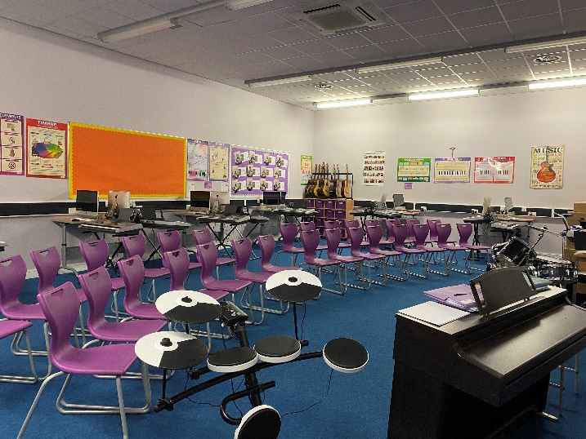
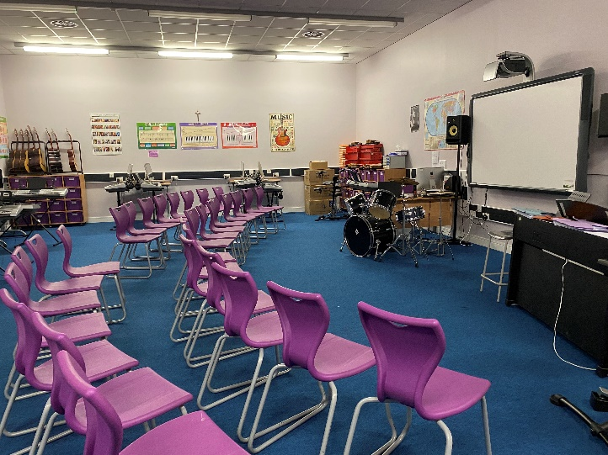

Key Stage 3 Music

Year 7-8: One hour lesson per week
Year 9: One hour lesson per fortnight

Key Stage 3 classroom music embraces listening, performing and composing, with high expectations and a love of live music at its core. Students learn to follow score, perform (with a strong focus on keyboard) and use Logic software. Liverpool is a UNESCO World City of Music and our scheme places high emphasis on raising student awareness of this fantastic musical setting, with all the audience, participation and career opportunities it provides. Lessons are rigorous but highly practical. Above all, we want students to love music-making!

We assess every 8 lessons or so, focusing on knowledge, skills, co-ordination and technique. Personalised verbal feedback plus regular formal grading is essential to our developmental approach. Homework is set when appropriate, with extra-curricular opportunities open to all.

Key Stage 4 Music: RSL Music Practitioners Level 2

Year 11: 7 students
Year 10: 6 students

Engaging students at KS4 is a development point for us; we want students to be confident about the personal, academic and professional benefits of studying Music as one of their KS4 qualifications. Some students have additional instrumental or vocal tuition prior to Key Stage 4 but many don’t. We don’t see this as a barrier to success, as high quality teaching should enable all to make good progress.
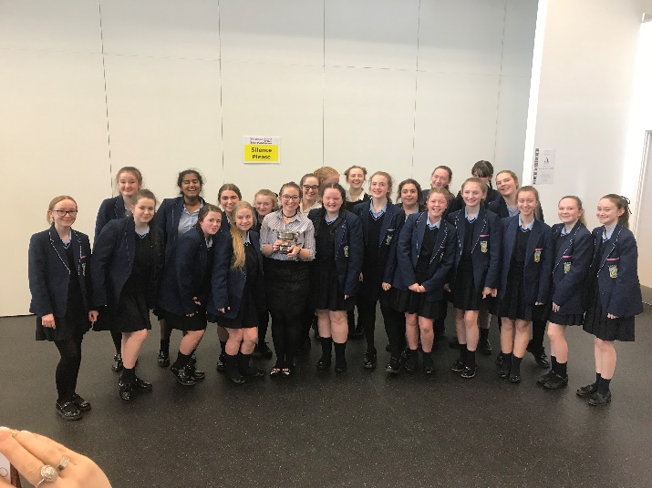
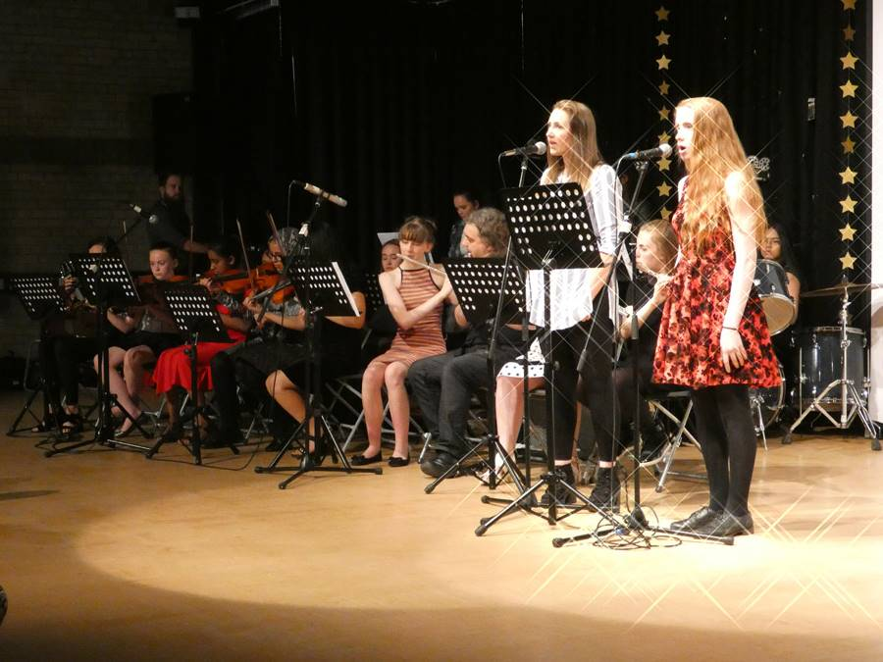
Extra-Curricular
- Music Tuition Programme (strings, woodwind, brass, drum kit, guitar, piano, voice)
- Band Night (running rock band rehearsals)
- Voices Choir (after school)
- Form Choir (two mornings a week)
- Practice rooms for student rehearsal
There is lots of scope for the successful candidate to help build our extra-curricular programme and we are keen to hear what you can offer. Growth opportunities include our annual school musical, instrumental ensembles & facilitating rehearsals at breaks, lunches and after school each day.

Events
- Performances at a variety of school and community events, e.g. masses/services, Awards Evening, carol singing
- Summer Concert (Summer Term)
- Art Night (Spring Term)

