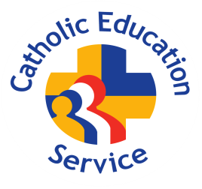
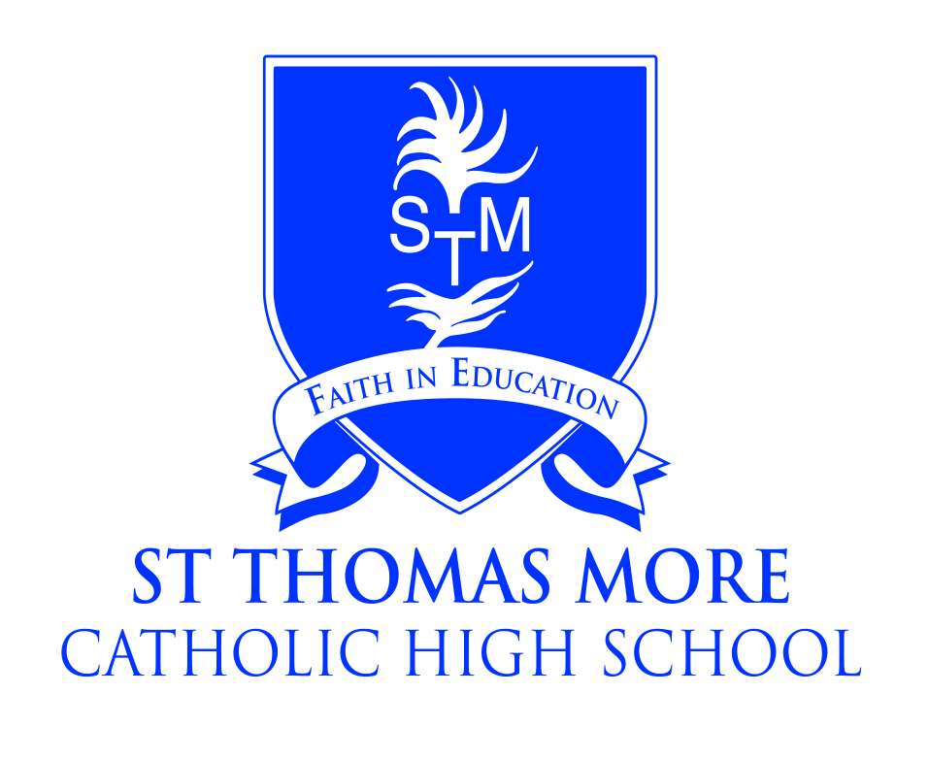

St Thomas More Catholic High School, Crewe
A Catholic Voluntary Academy

Teacher of Music
with potential for Personal Development Leader (TLR2 £3,391)
Salary: Teachers Pay Scale
Required 1st September 2025

The Governors of St Thomas More Catholic High School are seeking to appoint a creative, passionate and motivated teacher of Music who can deliver inspirational lessons across all aspects of Key Stages 3 and 4.

You will be joining a thriving and busy Performance department, which seeks to provide all students with a broad and enjoyable curriculum in a vibrant and imaginative learning environment.

This is an excellent opportunity to build and shape music across the school. The pupils at St Thomas More have energy and creativity which is a real strength to the way they approach their studies. There is a genuine love of music, both listening and playing. STM is looking for a dynamic and passionate teacher, to use this energy and love of the subject, to build music into the school curriculum and to guide them into learning about the impact of music on society and the joy of playing it. You will have a commitment to supporting extracurricular activities that will enable our students to explore their enjoyment of the subject and develop their creative skills further.

An excellent knowledge and understanding of the subject is essential. You must possess the skills and determination to make a significant difference to the lives of our students. We are a friendly and caring community placing the academic progress and welfare of our students at the heart of everything we do

The post would suit a committed and skilled musician who wants to make a difference and help all our students achieve the highest possible standards along with a real drive to build an outstanding music department. This is an exciting opportunity and would be suitable for an experienced teacher or an outstanding NQT.

Further details and a recruitment pack is available from the school website:
www.st-thomasmore.cheshire.sch.uk

or by e-mailing
recruitment@st-thomasmore.cheshire.sch.uk

Closing date: Thursday 22nd May 2025, 10:00am
Interview date: Friday 23rd May 2025

Please do not apply online or download Cheshire East’s Application Form.

The academy is committed to safeguarding children and successful candidates will be subject to an Enhanced DBS check. Our commitment to safeguarding is underpinned by robust processes and checks which are in place.

