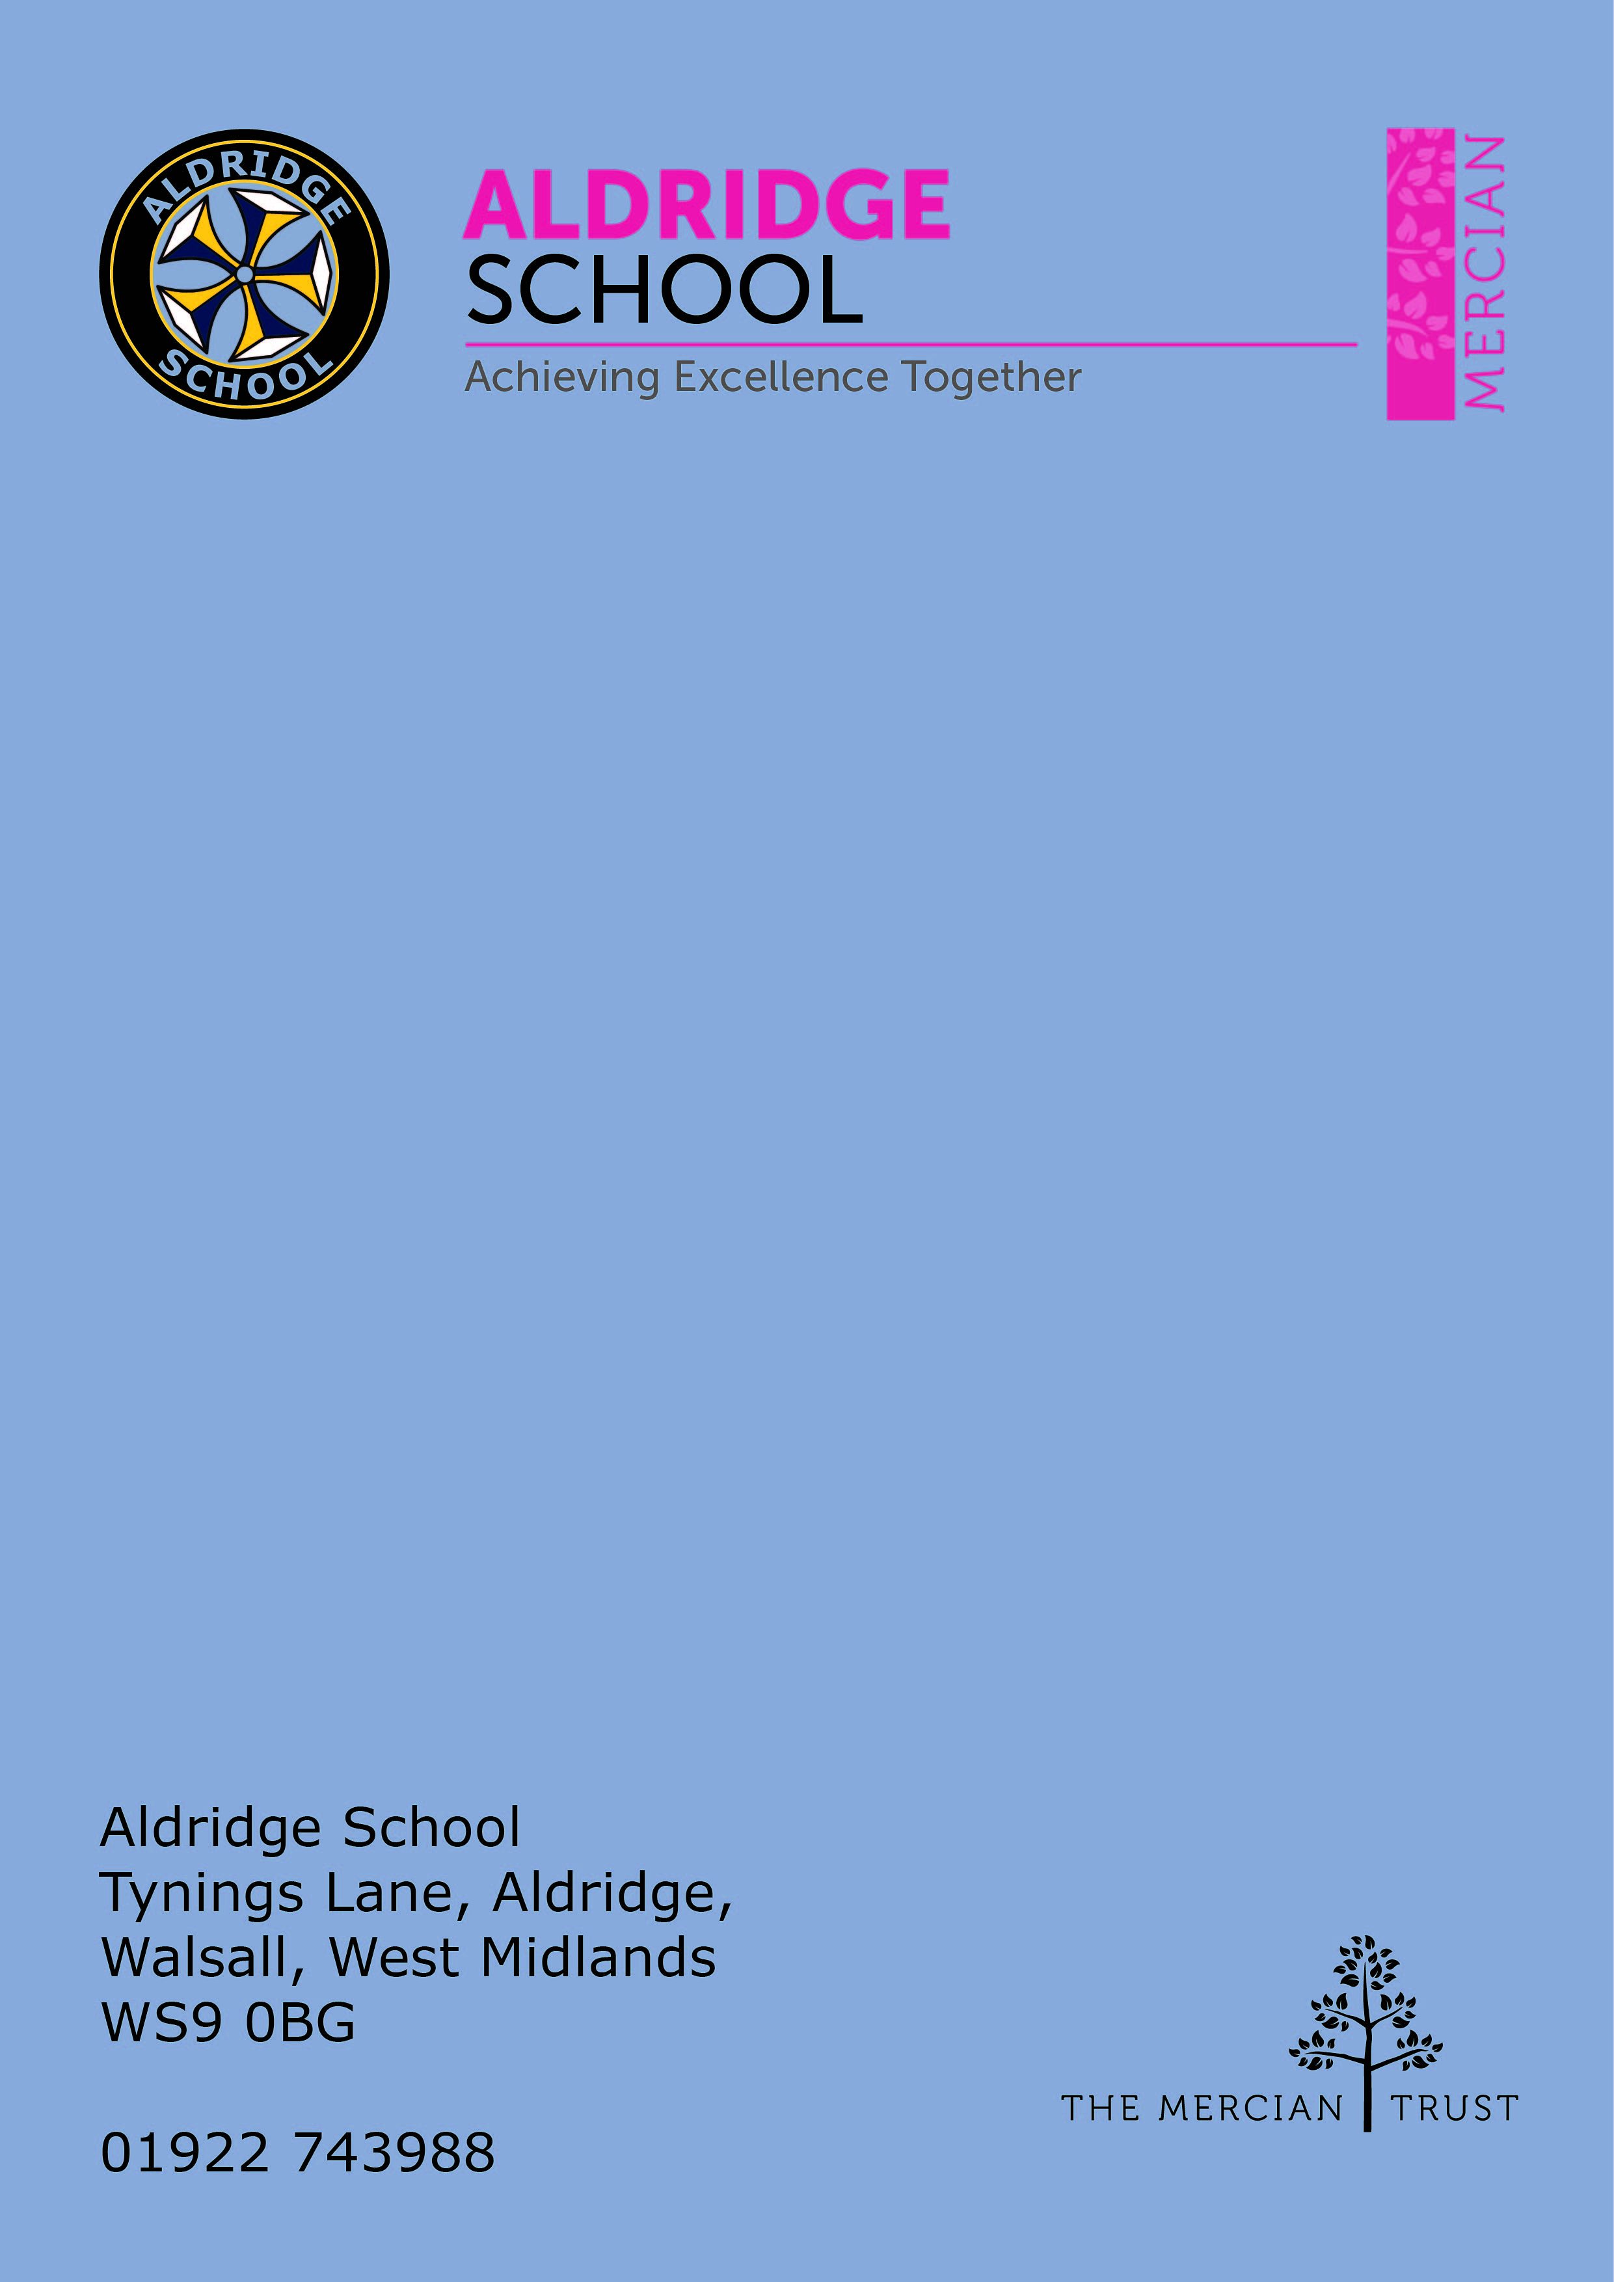

Application Pack

Teacher of PE
(full time, 1.0)



About Aldridge School – a Founder Academy of the Mercian Trust

About The Mercian Trust

Person Specification
How to Apply

Job Description

About Aldridge School

Thank you for taking the time to find out more about Aldridge School. This pack is intended to give you information about this role and our school's broader vision and ethos. Further background information is available in our Prospectus and Sixth Form Prospectus on our website.

We are a comprehensive school of over 1500 students situated near the centre of Aldridge village. We believe that it is our responsibility to work to meet the needs of every individual student, challenging them to achieve their best, supporting them to become responsible young adults and preparing them for their next steps into the world of work or further education.

Aldridge School is a good school (Ofsted 2022). It is a school which is proud of its traditions and successes which have been achieved through hard work and high expectations. In particular, we encourage our students to be Respectful, Responsible, Resilient and Ready to learn in order that they will be happy and successful at school and in the wider world beyond.

Aldridge School has a dedicated, talented and conscientious team of staff who work together to provide a high standard of teaching, excellent pastoral care and professional support services. Our broad curriculum is designed to meet national expectations, be relevant and interesting, support our students in achieving the best possible standards in external examinations and to equip them with the skills they need to be successful in adult life.

At Aldridge School we have a popular and thriving Sixth Form. We are very proud of our students' success with over 80% securing places at some of the top Universities and on Higher Apprenticeships last year. We offer a very broad range of both academic and vocational courses at level 3, ensuring that Aldridge School Sixth Form is an option for a wide range of students.

We also enjoy strong links with surrounding primary schools, working with students in Years 5 and 6 including work in Science, Maths, English, Performing Arts and Enterprise. We are proud of our community and we work hard to promote this pride in all our partnerships, so that we can make sure that future students from these schools enjoy an easy, enjoyable transition to Aldridge School.

Students at Aldridge School are friendly, polite and respectful. Strong relationships between staff and students contribute significantly to ensuring that students are happy and feel safe.

If you would like to find out more, please contact us to arrange a visit to see our school at work. We look forward to meeting you.

Benefits of Working at Aldridge School

- Teachers are all provided with a laptop to support their teaching
- 21/25 periods of teaching per week maximum, less as an ECT
- No pressure to "put on a show" in lessons. A culture of typicality is reinforced by no lesson grading (outstanding, good etc.)
- No need to write lesson plans of any kind
- Everyone has the highest expectations of behaviour, with all staff reinforcing those expectations
- A clear system of sanctions which is applied consistently so staff don't have battles with students
- Senior Leadership are very visible
- Excellent pastoral support offered through House Offices
- CPD tailored specifically to staff needs, based off their feedback
- Time for staff to put new things into action
- Non-hierarchical approach to professional development - there are things a senior leader can learn from an ECT and vice versa
- Targeted support plans for teachers who are struggling
- Regular Staff, Faculty and Pastoral briefings to support good communication
- Comprehensive support for NQTs with dedicated mentors and regular meetings
- Performance Management is tailored to faculty and individual needs. Data targets are not used punitively but aspirationally. We begin from the assumption that everyone will get the pay rise unless they haven't done all they can to improve student outcomes
- We are constantly streamlining all systems and processes so they take less time
- Open door Senior Leadership Team - no concern is ever too small
- Countless opportunities to get involved with the wider life of the school - Duke of Edinburgh, school performances, sports teams, music
- Contributions of staff recognised through 'Above and Beyond' draws each half term
- Contributions of staff recognised through 'Above and Beyond' draws each half term
- MAT ‘Employer of Choice’ opportunities such as Simply Health Healthcare plan, an electric car scheme and access to mylifestyle with a wide range of employee perks.

About the PE Department

The Physical Education department forms part of the Design and Performance
faculty, covering Art and Design subjects, Technology, Food, Drama, Music and
Physical Education.

Aldridge School’s PE department offers courses in Edexcel GCSE PE, Cambridge National Sports Studies and OCR A-Level PE at KS4 and KS5. It is an enthusiastic department, staffed by 8 specialist staff, skilled in a variety of disciplines teaching across all key stages. We are well resourced with a sports hall, two gymnasiums, cardio and weights fitness suites, swimming pool, tennis/netball courts, all weather courts, cricket nets and extensive field space.
We have developed links with industry, our relationship with students is excellent and we provide a well-rounded experience of sport and physical activity during curricular and extra-curricular time.

Physical Education Curriculum

Key stage 3 and 4 core PE

Students currently have 2 lessons a week dedicated to Physical Education. These are taught on a termly rotation with students experiencing a variety of sports, physical activity and aesthetic activities. These include: Football, Netball, Swimming, Rounders, Cricket, Tennis, Table tennis, HRE, OAA, Gymnastics, Dance, Badminton, Basketball and Rugby.

Key Stage 4

At key stage 4 students currently can opt to study GCSE PE or OCR Cambridge National Sports Studies.

Key stage 5

At key stage 5 students currently can opt to study OCR A-Level PE.

As a department, teachers also offer flexibility and when required support the department by teaching outside of their specialism.

Physical Education Extra-curricular

A wide variety of extra-curricular opportunities are offered for students by teachers within and outside of the PE department. These include:

Extra-curricular clubs – Fitness, table tennis, football, netball, rounders, cricket, tennis, basketball, climbing, dance, rugby.

Sport teams – Tennis, football, rugby, netball, swimming, badminton, table tennis, cricket, rounders, basketball, athletics.

Interhouse events – Football, rugby, netball, badminton, cross country, cricket, rounders, swimming, athletics, table tennis, basketball, dance, tennis.


The Mercian Trust

Aldridge School is an academy in The Mercian Trust.

The Mercian Trust brings nine very different and individual schools together as a single Multi-Academy Trust or MAT.

The nine schools are unique in their identity and united by their ambition to offer the best possible future for their students.

The nine schools are:
- Aldridge School
- Queen Mary's Grammar School
- Queen Mary's High School
- Shire Oak Academy
- The Ladder School
- Walsall Studio School
- Q3 Academy Great Barr
- Q3 Academy Langley
- Q3 Academy Tipton

Each School has its own distinct ethos and approach, but we have this over-arching aim in common: we prepare all our students to enjoy life to the full by inspiring them to:

- Realise their potential as learners
- Thrive in the world of work
- Make a positive contribution to the local, national and international community

The Mercian Trust respects the autonomy of its member schools but, through collaboration, fosters strengths that are greater than the sum of its parts. Working together as a Multi Academy Trust provides a framework for sharing expertise and enthusiasm, resources and ideas.


Job Description

Post: Teacher
Responsible to: Subject Leader of PE
Salary: MPS/UPS

The post-holder will be expected to undertake duties in-line with the professional
teacher standards for qualified teachers.

1 Set High expectations which inspire, motive and challenge pupils
- Establish a safe and stimulating environment for pupils, rooted in mutual respect
- Set goals that stretch and challenge pupils of all backgrounds, abilities and dispositions
- Demonstrate consistently the positive attitudes, values and behaviour which are expected of pupils

2 Promote good progress and outcomes by pupils
- Be accountable for pupils’ attainment, progress and outcomes
- Be aware of pupils’ capabilities and their prior knowledge, and plan teaching to build on these
- Guide pupils to reflect on the progress they have made and their emerging needs
- Demonstrate knowledge and understanding of how pupils learn and how this impacts on teaching
- Encourage pupils to take a responsible and conscientious attitude to their own work and study

3 Demonstrate good subject and curriculum knowledge
- Have a secure knowledge of the relevant subject(s) and curriculum areas, foster and maintain pupils’ interest in the subject, and address misunderstandings
- Demonstrate a critical understanding of developments in the subject and curriculum areas, and promote the value of scholarship
- Demonstrate an understanding of and take responsibility for promoting high standards of literacy, articulacy and the correct use of standard English, whatever the teacher’s specialist subject

4 Plan and teach well-structured lessons
- Impart knowledge and develop understanding through effective use of lesson time
- Promote a love of learning and children’s intellectual curiosity
- Set homework and plan other out-of-class activities to consolidate and extend the knowledge and understanding pupils have acquired
- Reflect systematically on the effectiveness of lessons and approaches to teaching
- Contribute to the design and provision of an engaging curriculum within the relevant subject area(s)

5 Adapt teaching to respond to the strengths and needs of all pupils
- Know when and how to differentiate appropriately, using approaches which enable pupils to be taught effectively
- Have a secure understanding of how a range of factors can inhibit pupils’ ability to learn, and how best to overcome these
- Demonstrate an awareness of the physical, social and intellectual development of children, and know how to adapt teaching to support pupils’ education at different stages of development
- Have a clear understanding of the needs of all pupils, including those with special educational needs; those of high ability; those with English as an additional language; those with disabilities; and be able to use and evaluate distinctive teaching approaches to engage and support them
6 Make accurate and productive use of assessment
- Know and understand how to assess the relevant subject and curriculum areas, including statutory assessment requirements
- Make use of formative and summative assessment to secure pupils’ progress
- Use relevant data to monitor progress, set targets, and plan subsequent lessons
- Give pupils regular feedback, both orally and through accurate marking, and encourage pupils to respond to the feedback

7 Manage behaviour effectively to ensure a good and safe learning environment
- Have clear rules and routines for behaviour in classrooms, and take responsibility for promoting good and courteous behaviour both in classrooms and around the school, in accordance with the school’s behaviour policy
- Have high expectations of behaviour, and establish a framework for discipline with a range of strategies, using praise, sanctions and rewards consistently and fairly
- Manage classes effectively, using approaches which are appropriate to pupils’ needs in order to involve and motivate them
- Maintain good relationships with pupils, exercise appropriate authority, and act decisively when necessary

8 Fulfil wider professional responsibilities
- Make a positive contribution to the wider life and ethos of the school
- Develop effective professional relationships with colleagues, knowing how and when to draw on advice and specialist support
- Deploy support staff effectively
- Take responsibility for improving teaching through appropriate professional development, responding to advice and feedback from colleagues
- Communicate effectively with parents with regard to pupils’ achievements and wellbeing

Personal and Professional Conduct
A teacher is expected to demonstrate consistently high standards of personal and professional conduct. The following statements define the behaviour and attitudes which set the required standard for conduct throughout a teacher’s career.
Teachers uphold public trust in the profession and maintain high standards of ethics and behaviour, within and outside school by:
- Treating pupils with dignity, building relationships rooted in mutual respect, and at all times observing proper boundaries appropriate to a teacher’s professional position
- Having regard for the need to safeguard pupils’ wellbeing, in accordance with statutory provisions
- Showing tolerance of and respect for the rights of others
- Not undermining fundamental British values, including democracy, the rule of law, individual liberty and mutual respect, and tolerance of those with different faiths and beliefs
- Ensuring that personal beliefs are not expressed in ways which exploit pupils’ vulnerability or might lead them to break the law
- Teachers must have proper and professional regard for the ethos, policies and practices of the school in which they teach, and maintain high standards in their own attendance and punctuality
- Teachers must have an understanding of, and always act within, the statutory frameworks which set out their professional duties and responsibilities.


Person Specification

Qualification Criteria
- Qualified to degree level or above
- Possesses QTS status or equivalent

Experience
- Evidence of successful practice as a teacher in a secondary school
- Experience of continually improving teaching practice to increase student achievement and progress
- Evidence of continually improving the teaching and learning of their subject through assisting with schemes of learning and extra-curricular/enrichment activities

Knowledge
- Up to date knowledge in the curriculum area (Inc. A Level/GCSE specifications: desirable)
- Understanding of the teaching strategies needed to establish high aspirations with regards to results and behaviour
- Evidence of working with educational research to facilitate learning
- Knowledge of the current legal requirements, national and school policies and guidance on the safeguarding and promotion of the well-being of children and young people

Leadership
- An ability to lead by example
- Effective team worker and leader
- Possesses high expectations for accountability and consistency
- Motivation to continually improve standards and inspire excellence
- Possesses an empathy and the ability to listen
- Commitment to the safeguarding and welfare of all students

Teaching and Learning
- Effective and adaptable ICT skills
- Numerate so that data analysis can be facilitated
- Effective communication skills
- Possesses energy, enthusiasm, resilience and perseverance
- A commitment to educational research in order to facilitate learning
- Excellent classroom teacher with the ability to reflect on lessons and continually improve their own practice
- Effective and systematic behaviour management, with clear boundaries, sanctions, praise and rewards
- Thinks strategically about classroom practice and tailoring lessons to student's needs
- Understands and interprets complex student data to drive lesson planning, achievement and progress
- Excellent planning and organisational skills
- The ability to produce correspondence/documents, appropriate for a specific audience and in well-written English, ensuring the tone is appropriate to the purpose


How to Apply

Salary
MPS/UPS

Start Date
September 2025

Visits to School
For further information, please contact the school either by email info@aldridgeschool.org or Head of Faculty Mr Bromley by email p.bromley@ALD.merciantrust.org.uk or by telephoning Mrs Knight on 01922 743988 ex 2224

Applying
Apply through Mercian Trust portal.
