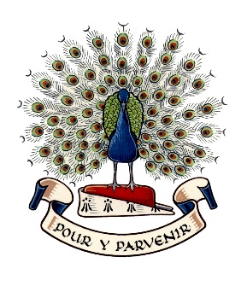
Lady Manners School

Teacher of Physical Education
September 2023

THE PHYSICAL EDUCATION DEPARTMENT

This post offers an outstanding opportunity to be part of this highly successful curriculum area renowned for the quality and range of opportunities it offers. The department is active, forward thinking and constantly seeing ways of developing links to build on the strong tradition of sport within the school.

The Physical Education Department is currently staffed by six specialist teachers of PE and is supported by additional staff. The members of the department complement each other in their interests and specialisms. All are highly committed to the extra-curricular programme offered to students.

The PE curriculum is managed by the Curriculum Leader. All other members of staff are encouraged to take on additional responsibilities to support the pupils and the continued development of the curriculum area.

FACILITIES

The PE Department has been through an exciting period of building development. The Department has use of a full size floodlit, 3G football pitch, dance studio, fitness suite, additional changing facilities, three classrooms, floodlit tennis courts and a 8 lane grass athletics track. The department also has use of a sports hall, gymnasium, extensive playing fields, two artificial cricket pitches, outdoor nets and several hard play areas.

CURRICULUM

The timetable is organised into a 25 period week.

Key Stage 3
This Key Stage consists of a balanced programme in line with the National Curriculum. It offers a comprehensive range of experiences to meet the needs of individual students and encourage active involvement in all as performers, observers and officials. Students have two periods of PE a week, each lesson 60 minutes long. The curriculum covers all major sports, including rugby, football, netball, hockey, basketball, badminton, volleyball, cricket rounders and athletics. Students also experience dance, gymnastics and orienteering.

Key Stage 4
Students follow a programme of core curriculum PE of one lesson a week with an additional period once a fortnight. This follows the National Curriculum with the opportunity of choosing optional activities in the latter part of Year 10 and Year 11. In addition, the department offers the popular GCSE PE as an option. In September 2023 we will have three groups in Year 10 and two groups in Year 11 studying GCSE (AQA). This is taught for 3 periods a week. Our students achieve high grades compared to national standards across the country. In September 2023, the faculty is introducing a new examination course. Students will now have an additional choice of OCR Sport Studies level 1/2 National qualification.

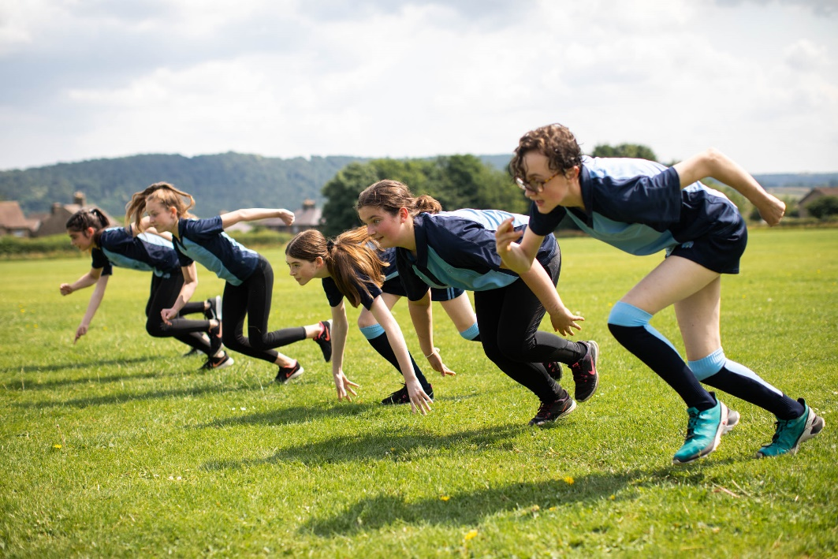

Sixth Form
OCR Cambridge National Technical in Sport and Physical Activity is offered as a level 3 qualification. This is taught over 5 lessons per week. The teaching is split between two members of staff. Many students continue into Higher Education in order to follow sports related courses.

ACCREDITED COURSES

Sports Leaders level 2
Students opt to undertake the Level 2 leadership qualification during their core Year 11 games lessons.

Higher Sports Leaders level 3
This Level 3 leadership Qualification is offered as an option in Year 12. The course is taught over 2 years.

EXTRA-CURRICULAR / EXTERNAL LINKS

The department offers a wide, varied and highly valued programme of extra curricular activities during lunchtimes and after school for all abilities. There is a thriving House system which includes competitions in all main curriculum sports for all ages allowing large numbers of participants to experience competition and team spirit.

The school competes frequently in a range of activities at inter school, district, county, regional and national levels with great success. Opportunities are provided for students to visit and appreciate foreign culture with sporting tours and fixtures against visiting sides. The department has also excellent links for local clubs, giving pupils additional opportunities to participate in competitive and recreational sport.

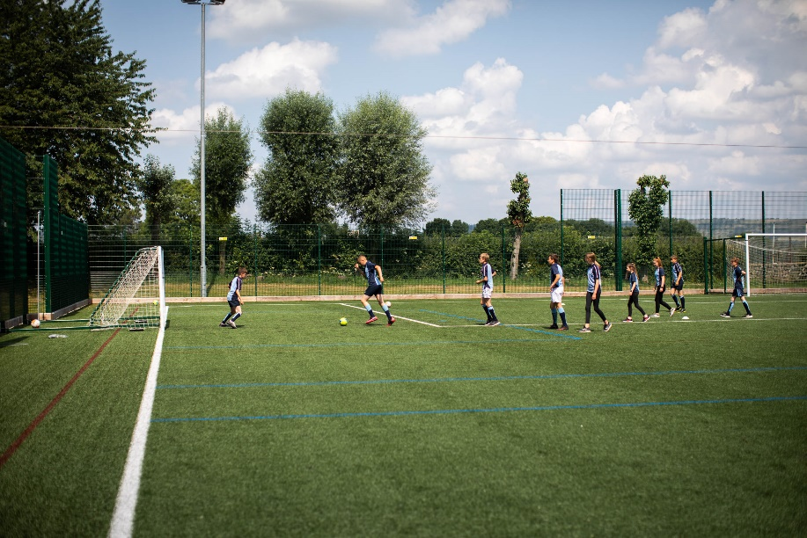

The PE department offers the opportunity to participate within a varied range of activities for all abilities. Clubs and practices are provided to develop students' skills and interests.

Extra Curricular Clubs include:

Athletics
Badminton
Basketball
Cricket
Dance
Fitness
Football
Gymnastics
Hockey
Indoor Cricket
Indoor Hockey
Netball
Orienteering
Rounders
Rugby
Sports Plus
Table Tennis
Tennis
Volleyball
Weight Training

CURRENT SUCCESS:

Rugby: U12, U13, U14, U15, U18 county champions
Football: U13, U16, U18 county semi-finalists
Cricket: U12 county runners-up
Athletics: Girls U15 and Boys U13 regional finalists
Indoor Athletics: Boys U13 County champions
Equestrian Team: Regular winners of national competition
Rounders: U13 and U14 County champions, U12 and U15 runners-up
Netball: U18 regional finalists

