TEACHER OF PE

Candidate Pack

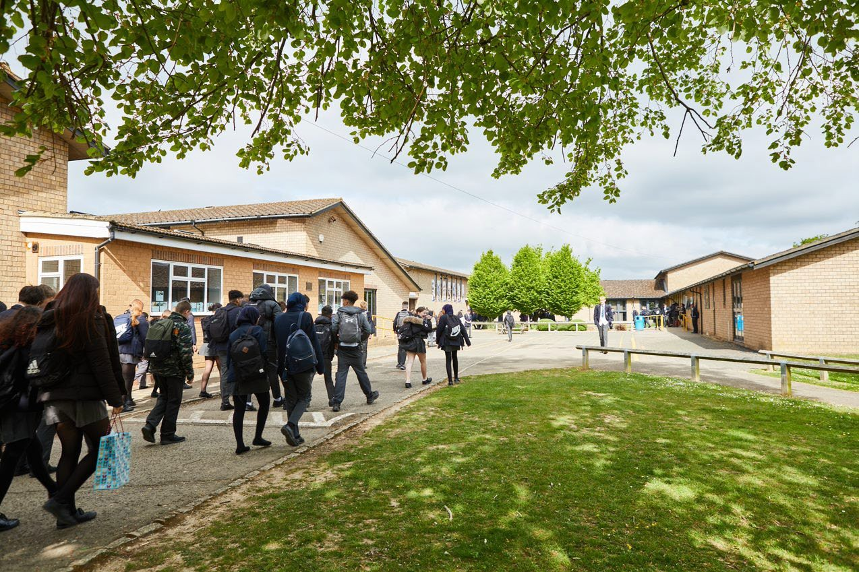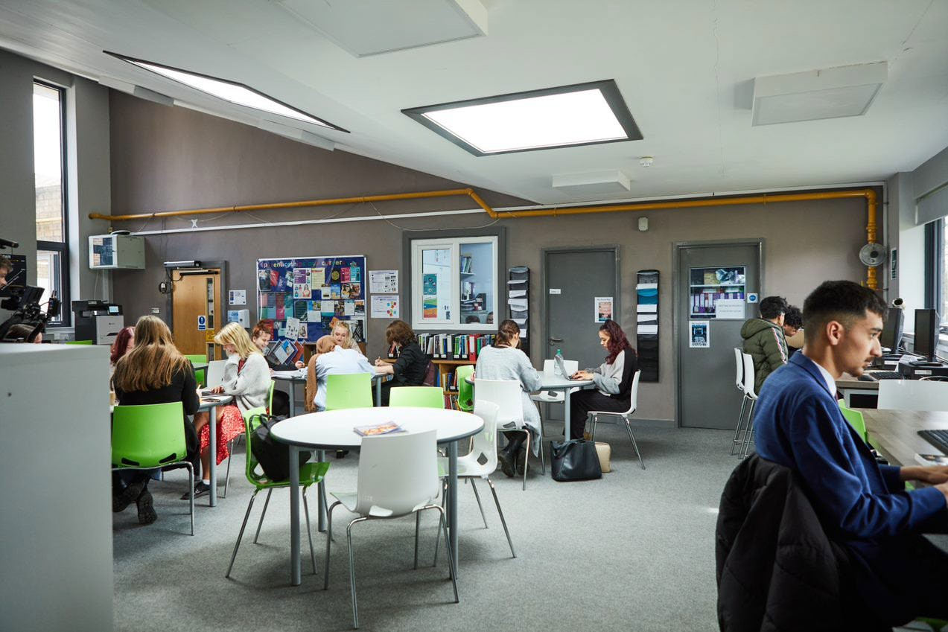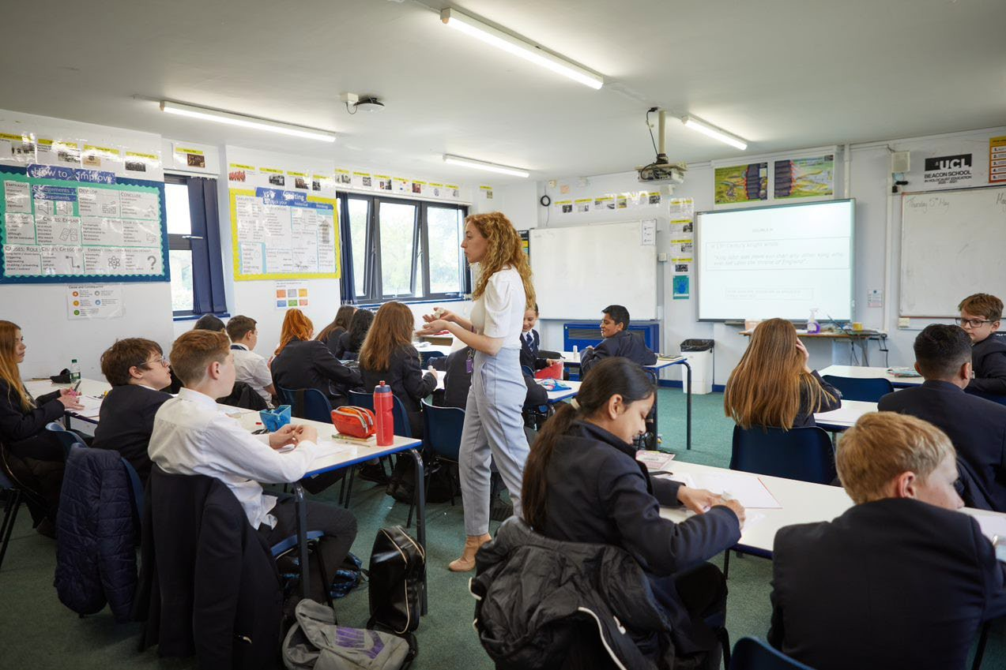
Welcome letter from the Headteacher

Dear Prospective Candidate,

Thank you for your interest in the position of Teacher of PE at Sir William Ramsay School.

I joined Sir William Ramsay School as the new Headteacher in May and am committed to getting the school back to ‘Good’ as quickly as possible. Clarity, consistency and rigour are central to our plans to ensure that all students enjoy learning and make good progress. Our plans include significant developments in high quality teaching and learning, the introduction of ambitious targets, a focus on developing excellent teaching, meaningful homework and improvements in behaviour for learning. We are also rolling out a digital learning 'One to One Device' strategy across the school to ensure that students can receive innovative teaching and access state of the art resources at both home and school.

We are looking to appoint a dynamic, highly motivated and committed Teacher of PE to contribute to the development of this successful area. For the right candidate there is also the opportunity of Departmental responsibility, negotiable on interview.

The ideal candidate will have a belief in the ability of all students to achieve and a passion for raising student achievement. You will have a desire to strive for continuous school improvement and a commitment to team work as well as a sense of fun.

If you would like to find out more about the role or to arrange a conversation with the Head of Faculty, please contact JCook@swr.school

I will hope to meet you in the near future.

Yours faithfully

Paul Ramsey
Headteacher

Vision and Values at Sir William Ramsay School

Empowering Everyone to Achieve

Vision
A community where every voice counts, where talent and creativity are brought to life, where students grow in confidence, build resilience and are prepared for the rest of their lives.

Values
- We are respectful – we always treat people, property and the environment with kindness and consideration
- We are ambitious – we ask for help when we need it and strive to be the best we can be
- We are reliable – we do what is asked of us and deliver on our commitments
- We are resilient – we prepare for the future and adapt and grow from challenges

Mission
We aim to achieve our vision by:
- Raising students above the ordinary by developing and delivering lifelong learning which transforms lives
- Ensuring every person feels valued, safe and happy
- Enabling students to feel proud of themselves, and to take pride in the success of others
- Promoting a culture of mutual respect where everyone is treated as a valued member of the school community
- Encouraging positive communication so that words and actions are thoughtful, supportive and motivational
- Placing parents and carers at the heart of the life of the school
- Having highly dedicated and well-qualified staff who are committed to continuous professional development
- Adopting an ethos of continuous improvement within all aspects of school life

Equality
Sir William Ramsay is an inclusive and diverse community. We work to eliminate all forms of discrimination on the grounds of ethnic origin, religion, sexual orientation, gender, disability or ability. This is achieved via the following principles:
- Ensure that students have the opportunity to reach their potential in all areas of school life
- Ensure that parents and students can make choices free from prejudice and stereotyping
- Oppose any form of racism, sexism, disability discrimination, homophobia or any other form of discrimination
- Value every student’s language and cultural background

Job Description

Job Title: | Teacher of PE  MPS/UPS
Aim and Main Job Purpose: | To teach, enthuse and inspire students about PE

Teaching and Managing Pupil Learning

Teacher of PE will:
- Be able to teach effectively across the full range of age and abilities.
- Possess high expectations of students in relation to standards of achievement and behaviour.
- Have an active input in the creation, consistent implementation and improvement of schemes of work which encapsulate key school learning strategies.
- Monitor the progress of students including those requiring additional support and challenge them to ensure students are engaged in their learning and achieve success.

Assessment and Self-Evaluation

Teacher of PE will:
- Implement policies and practices for assessing, recording and reporting on student achievement and to assist in setting targets for further improvement.
- In conjunction with the Head of PE, use data effectively to identify students who are underachieving and, where necessary, create and implement an effective intervention plan.

Relationships with Parents

Teacher of PE will:
- Establish a partnership with parents to involve them in their child’s learning of the subject, as well as providing information about targets and attainment.
- Communicate effectively, both orally and in writing, with parents.

Managing Own Performance

Teacher of PE will:
- Prioritise and manage their own time effectively.
- Take responsibility for their own professional development.
- Share good practice resulting in a tangible impact on student learning.
- Form constructive relationships with staff including team working and mutual support.
- Actively implement the key aspects of the school’s behaviour management policies.
- Be a form tutor.
- Make a contribution to the wider school life including specialist PE enrichment activities.
- Contribute to faculty planning and developments.

Strategic Leadership

Teacher of PE will:
- Contribute fully to the Faculty Development Plan which contributes positively to the achievements of the School Development Plan.

Other Responsibilities
- To promote the School’s vision, values and aims.
- To be aware of and comply with the codes of conduct, regulations, policies, procedures.
- To work as part of a team.
- To be generally responsible for safeguarding and promoting the welfare of students.
- To be responsible for own and team health and safety including well-being.
- To actively participate in the School’s appraisal system.
- To do Continued Professional Learning as agreed with the Line Manager.

This job description is current at the date indicated below but, in consultation with the postholder, it may be changed by the Headteacher to reflect or anticipate changes in the post commensurate with the grade or job title.

The Physical Education Department

Teacher Of PE

Team members share a commitment to raising standards of student achievement. We are keen to promote a department which accommodates a broad range of interests and abilities, whilst ensuring that every student is encouraged to reach their maximum potential. If you are enthusiastic, flexible, enjoy challenges and are committed to help us offer excellence in physical education, then you are the person to join our progressive and forward-thinking team, which has rapidly raised the profile of sport and PE at the school.

The Physical Education Curriculum

At KS3, students study a broad curriculum that offers breadth of activity to allow students to experience many different sports, whilst offering enough depth to enable students to excel in a range of activities. Students are taught Invasion Games, Creative Activities, Athletic Activities, Net Games, Striking and Fielding Activities, OAA and Health Related Exercise.

In KS4 Core PE students experience activities that promote lifelong involvement in sport and encourage awareness of the physical and mental benefits of an active lifestyle.

At KS4 we offer Cambridge National Sports Science for our students and the options of Level 1 Sports leaders is offered to our Year 10 students. We then develop their knowledge at KS5 through BTEC level 3 in Sport.

Students in the 6th Form also have the option to study the Level 2 or 3 Sports Leaders qualifications.

Physical Education Facilities

Indoors, a large sports hall is available for PE, a Performing Arts Centre with Dance Studio and a Fitness Studio. Outdoors, there are seven tennis courts, seven netball courts and a large field that accommodates one full size, one junior, two 9-a-side and two 7-a-side football pitches, one rugby pitch, a 400-metre running track with long jump run up and pit and an all-weather cricket wicket.

Extra Curricular Activities

The PE Department runs competitive squads in Netball, Football, Rugby, Cricket, Badminton, Tennis, Basketball, Handball, Cross-Country, Rounders, Cricket and Athletics.

Recent successes have seen the Football teams reach two county cup finals and achieve first place finishes in three Netball leagues.

How to Apply

If you wish to discover more about this exciting opportunity, need any further information or you wish to have an informal discussion, please contact James Cook (Head of Faculty) - JCook@swr.school or 01494 815211.

Please email your completed application form to: JoinTheTeam@swr.school

Closing Date: 9am, Monday 30th January 2023
Interviews: TBC

Sir William Ramsay School is committed to safeguarding and promoting the welfare of children and young people and expects all staff and volunteers to share this commitment. We will ensure that all our recruitment and selection practices reflect this commitment.

All successful candidates will be subject to DBS checks along with other relevant pre-employment checks.

