TEACHER OF PHILOSOPHY & ETHICS

Candidate Pack

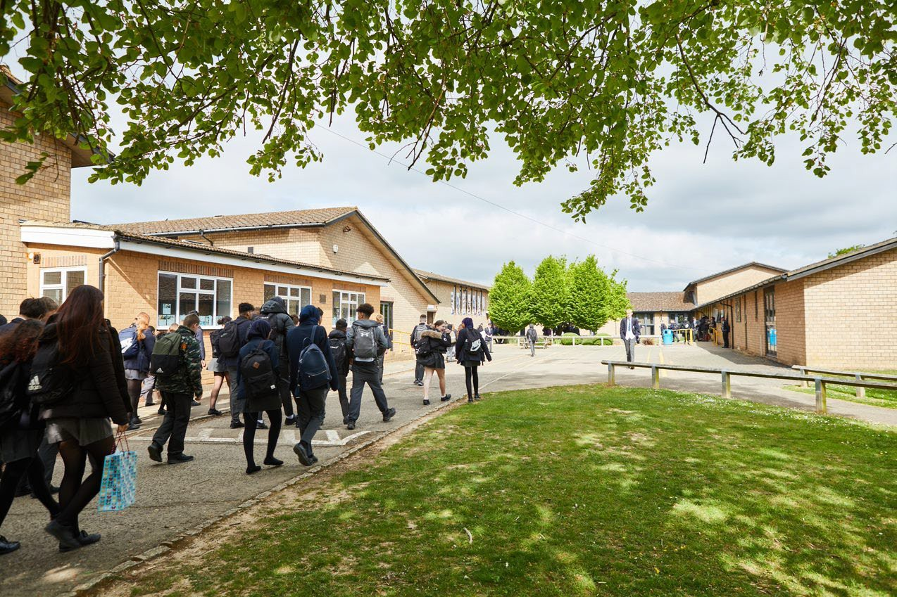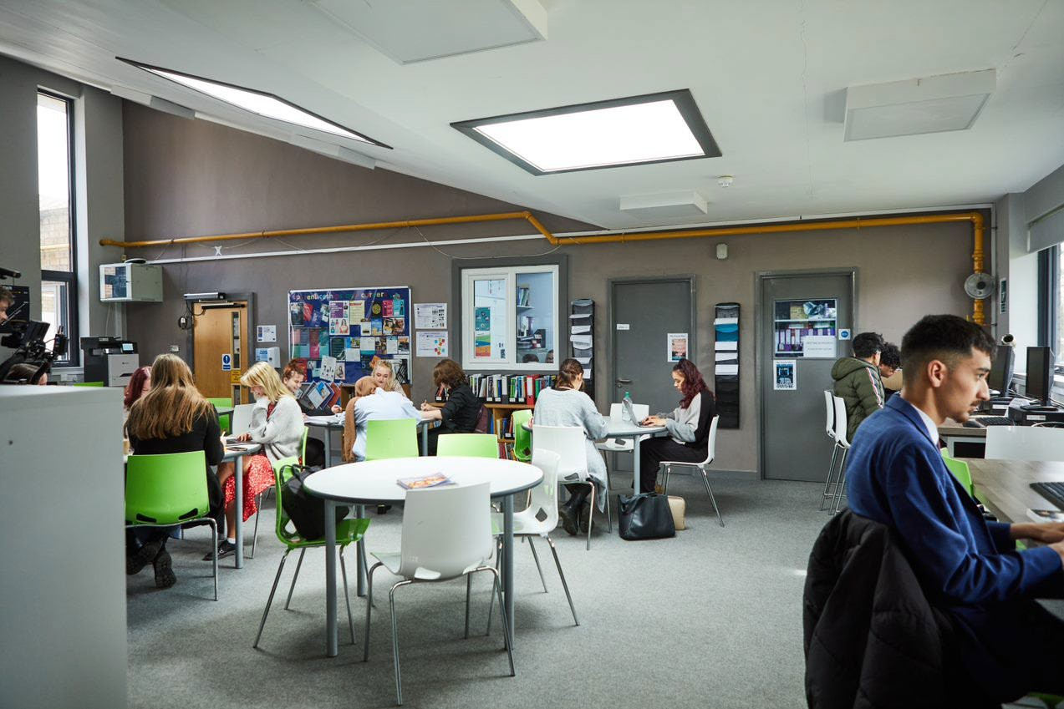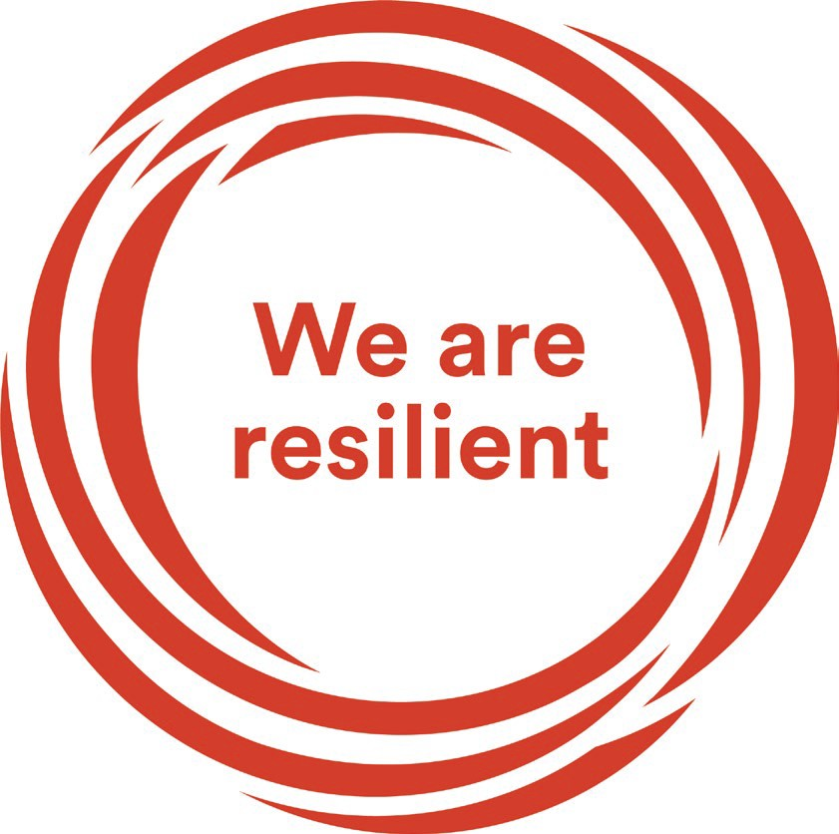
Welcome Letter from the Headteacher

Dear Prospective Candidate

Thank you for your interest in the position of Teacher of Philosophy & Ethics at Sir William Ramsay School.

I joined Sir William Ramsay School as the new Headteacher in May 2022 and am committed to getting the school back to ‘Good’ as quickly as possible. Clarity, consistency and rigour are central to our plans to ensure that all students enjoy learning and make good progress. Our plans include significant developments in high quality teaching and learning, the introduction of ambitious targets, a focus on developing excellent teaching, meaningful homework and improvements in behaviour for learning. We are also rolling out a digital learning 'One to One Device' strategy across the school to ensure that students can receive innovative teaching and access state of the art resources at both home and school.

We are looking to appoint a talented, enthusiastic and dynamic Teacher of Philosophy & Ethics to join our team from September 2023. The ideal candidate will have a belief in the ability of all students to achieve and a passion for raising student achievement. You will have a desire to strive for continuous school improvement and a commitment to team work as well as a sense of fun.

If you would like to find out more about the role or to arrange a conversation with the Head of Faculty, please contact jwolfenden@swr.school.

I will hope to meet you in the near future.

Yours faithfully
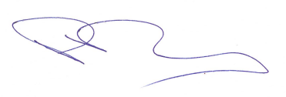
Paul Ramsey
Headteacher

Vision and Values at Sir William Ramsay School

Empowering Everyone to Achieve

Vision
A community where every voice counts, where talent and creativity are brought to life, where students grow in confidence, build resilience and are prepared for the rest of their lives.

Values
- We are respectful – we always treat people, property and the environment with kindness and consideration
- We are ambitious – we ask for help when we need it and strive to be the best we can be
- We are reliable – we do what is asked of us and deliver on our commitments
- We are resilient – we prepare for the future and adapt and grow from challenges

Mission
We aim to achieve our vision by:
- Raising students above the ordinary by developing and delivering lifelong learning which transforms lives
- Ensuring every person feels valued, safe and happy
- Enabling students to feel proud of themselves, and to take pride in the success of others
- Promoting a culture of mutual respect where everyone is treated as a valued member of the school community
- Encouraging positive communication so that words and actions are thoughtful, supportive and motivational
- Placing parents and carers at the heart of the life of the school
- Having highly dedicated and well-qualified staff who are committed to continuous professional development
- Adopting an ethos of continuous improvement within all aspects of school life

Equality
Sir William Ramsay is an inclusive and diverse community. We work to eliminate all forms of discrimination on the grounds of ethnic origin, religion, sexual orientation, gender, disability or ability. This is achieved via the following principles:
- Ensure that students have the opportunity to reach their potential in all areas of school life
- Ensure that parents, carers and students can make choices free from prejudice and stereotyping
- Oppose any form of racism, sexism, disability discrimination, homophobia or any other form of discrimination
- Value every student’s language and cultural background
Job Description

Job Title: | Teacher of Philosophy & Ethics
Aim and Main Job Purpose: | To strengthen Sir William Ramsay’s position as a diverse community school, where all students achieve  To contribute to the improvement of student examination outcomes  To contribute to the development of outstanding teaching across the school  To share a vision, sense of purpose and pride in the school

Teaching and Managing Student Learning
Teacher of Philosophy & Ethics will:
- Be able to teach effectively across the full range of age and abilities.
- Possess high expectations of students in relation to standards of achievement and behaviour.
- Have an active input in the creation, consistent implementation and improvement of schemes of work which encapsulate key school learning strategies.
- Monitor the progress of students including those requiring additional support and challenge them to ensure students are engaged in their learning and achieve success.

Assessment and Self-Evaluation
Teacher of Philosophy & Ethics will:
- Implement policies and practices for assessing, recording and reporting on student achievement and to assist in setting targets for further improvement.
- In conjunction with the Head of Humanities, use data effectively to identify students who are underachieving and, where necessary, create and implement an effective intervention plan.

Relationships with Parents/Carers
Teacher of Philosophy & Ethics will:
- Establish a partnership with parents and carers to involve them in their child’s learning of the subject, as well as providing information about targets and attainment.
- Communicate effectively, both orally and in writing, with parents and carers.

Managing Own Performance
Teacher of Philosophy & Ethics will:
- Prioritise and manage their own time effectively.
- Take responsibility for their own professional development.
- Share good practice resulting in a tangible impact on student learning.
- Form constructive relationships with staff including team working and mutual support.
- Actively implement the key aspects of the school’s behaviour management policies.
- Be a form tutor.
- Make a contribution to the wider school life including specialist Humanities enrichment activities.
- Contribute to faculty planning and developments.

Strategic Leadership
Teacher of Philosophy & Ethics will:
- Contribute fully to the Faculty Development Plan which contributes positively to the achievements of the School Development Plan.

Other Responsibilities
- To promote the School’s vision, values and aims.
- To be aware of and comply with the codes of conduct, regulations, policies, procedures.
- To work as part of a team.
- To be generally responsible for safeguarding and promoting the welfare of students.
- To be responsible for own and team health and safety including well-being.
- To actively participate in the School’s appraisal system.
- To do Continued Professional Learning as agreed with the Line Manager.

This job description is current at the date indicated below but, in consultation with the postholder, it may be changed by the Headteacher to reflect or anticipate changes in the post commensurate with the grade or job title.
The Department

Philosophy and Ethics
The aim of the Philosophy and Ethics curriculum is to expand students’ knowledge of the world’s diversity and open their minds to the different values, ideas and cultures around them. Our curriculum aims to challenge students' moral points of view and to develop respect and appreciation of how to live in a diverse and inclusive society. We do this by valuing different perspectives through the study of different cultures and religions. Our department aims to promote an awareness of the usefulness of the subject to everyday living, to encourage enthusiasm and interest in the study of other people’s beliefs and cultures.

Department members share a commitment to raising standards of student achievement and attainment. We are committed to offering a high standard of teaching and learning.

As a department, we are looking for someone who is dynamic, creative, a team player, innovative and dedicated. A successful candidate will help us to raise the profile of the subject within the school.

If you are dedicated to delivering an interesting and thought provoking subject to a high standard and have ideas to share, you would be an ideal candidate.

Philosophy and Ethics Curriculum
We offer a wide range of engaging topics at Key Stage 3 which are currently being developed to ensure students acquire the skills required at GCSE level, in order to ensure a positive transition into Key Stage 4.

We offer OCR GCSE Religious Studies 1-9 and OCR A Level Religious Studies. Philosophy and Ethics is a popular subject and we have a few classes in Key Stage 4 and 5.

How to Apply

If you wish to discover more about this exciting opportunity, need any further information or you wish to have an informal discussion, please contact James Wolfenden jwolfenden@swr.school or 01494 815211.

Please email your completed application form to: jointheteam@swr.school

Closing Date: Noon – Thursday 22nd June 2023
Interviews: Week commencing Monday 26th June 2023

Sir William Ramsay School is committed to safeguarding and promoting the welfare of children and young people and expects all staff and volunteers to share this commitment. We will ensure that all our recruitment and selection practices reflect this commitment.

All successful candidates will be subject to DBS checks along with other relevant pre-employment checks.

