INFORMATION PACK
Teacher of Physical Education
Part time approximately 0.5 FTE, required from September 2023

Overview of the Role

At Altrincham Grammar School for Girls, we see PE as a vehicle for developing wellbeing, resilience and leadership skills. We are looking for an inspirational teacher who can develop our students physical literacy, instil in our students a love of sport, and ensure they understand the value of physical activity and sport throughout their lives. Students from AGGS are highly successful in a range of competitive sports. We are therefore also looking for an individual with the skills to foster students’ ambitions, develop their skills and to create strong teams.

The full job description and person specification are at the end of this pack.

Contents of this pack
Bright Futures Educational Trust | Page 1-2
Altrincham Grammar School for Girls/central team | Page 3
Why work for us? Terms and conditions and how to apply | Page 4
Job Description | Page 5
Person Specification | Pages 6-7

Bright Futures Educational Trust
Bright Futures Educational Trust (The Trust) is a multi-academy trust set up in 2011. The Trust is made up of a richly diverse group of schools in Greater Manchester and Blackpool. We are passionate about working together within and beyond the Trust to achieve our aspirational vision: the best for everyone, the best from everyone. We are an organisation that is underpinned by values of: community, integrity, and passion. In everything we do, we remember that we are accountable to the children, families, and communities that we serve.
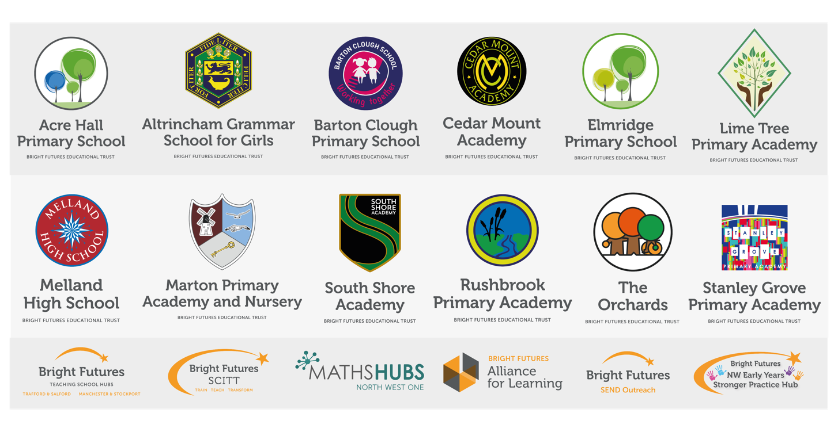
Our schools have their own identities, form one organisation and have one employer, Bright Futures Educational Trust. Bright Futures’ Board of Trustees maintains strategic oversight of the Trust and delegates some of its responsibilities to the Executive Team, Heads of School and local governing bodies. We place a high value on integrity and probity and take seriously our accountabilities for making the best use of public money. How decisions are made is described in our delegation framework. You can find out more about the Trustees and the Executive Team on our website: About Us - Bright Futures Educational Trust (bright-futures.co.uk)
The central team includes the Executive Team: John Stephens, CEO; Edward Vitalis, Chief Operating Officer; Gary Handforth, Director of Education; Lisa Fathers, Director of Development, Partnerships and Teaching School Hubs and Lynette Beckett, Director of People & Strategy. The focus of these roles is to work with schools, providing high quality and timely guidance, leadership, challenge, and support. In addition to the executive team, we have central operations for finance, communications and marketing, HR, educational psychology, and digital technologies. Please see our website brochure which explains our central operations: Why-Join-Bright-Futures

Bright Futures Professional Development Institute is an important part of the Trust. The Institute is the home of all professional development and school improvement resource in Bright Futures. The Institute is also where all of our outward facing work happens. Underneath this umbrella we have several hubs. The Alliance for Learning (AFL) which provides school improvement services and CPD to over 700 schools, a North West Maths’ Hub NW1 Maths Hub, providing mathematics training and coaching to 500 schools, and a SCITT (School Centred Initial Teacher Training) Bright Futures SCITT, which is the largest in the North West. Within the Institute, Bright Futures also has two Teaching School Hubs, serving Manchester, Stockport, Salford, and Trafford. Bright Futures Send Outreach is another service which we provide across the Northwest. We have also been designated as an Early Years Stronger Practice Hub under the name of Bright Futures North West Early Years Stronger Practice Hub providing guidance and support to settings across the region.

Collaboration and strong relationships form one of the ‘commitments’ in our Strategy and all components of the Bright Futures’ family work closely together. Our Strategy was developed collaboratively and can be found on our website: Our Strategy.

Altrincham Grammar School for Girls
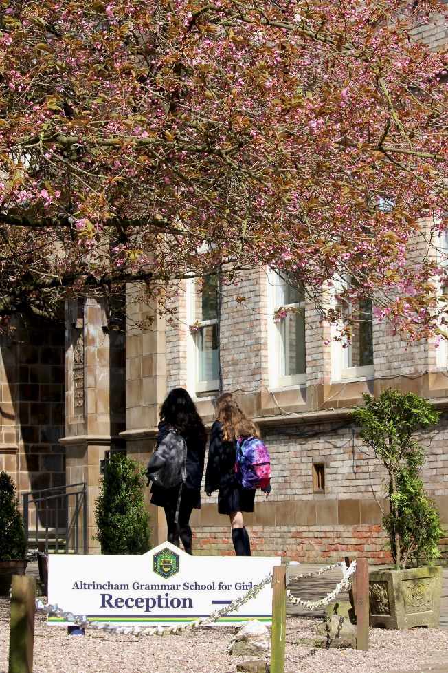
Altrincham Grammar School for Girls (AGGS) is a highly successful single sex 11 -18 academy in the South Trafford area. AGGS was in the first cohort of schools to be designated a national teaching school in 2011. AGGS is the lead school in ‘The Alliance for Learning’, which comprised schools of every type and phase, plus universities, throughout a wide geographical area. The impact of teaching school activities has been felt within the Trust and far beyond. We have a reputation for excellence regionally and nationally, of which we are very proud.

AGGS is committed to providing equal opportunity in recruitment and employment to all individuals. We will consider candidates without regard to race, ethnicity, gender, religion, sexual orientation and identity, national origin, age, military or veteran status, disability or any other legally protected status; and without discrimination based on socioeconomic, marital, parental or caregiving status, or any of the previously listed characteristics or statuses.

We value the diversity of our staff and reject any form of harassment, discrimination or victimisation. The Bright Futures Educational Trust vision is: ‘the best for everyone, the best from everyone’. To achieve this, we create and maintain a work environment and culture where people from different backgrounds, and with varying lifestyles, interests, opinions and responsibilities, treat each other with dignity and respect. It is a climate in which our staff feel safe and are inspired and motivated to be their best.

Our school is dedicated to sustaining and promoting diversity with respect to recruitment, promotion, training and general treatment during employment. We are actively seeking to extend the diversity of our staff. Furthermore, we welcome candidates who have not had previous experience of working in a grammar school.

We aim to ensure that our recruitment processes set up all candidates for success. At interview our aim is to provide a positive experience. We don’t want to catch anyone out, but rather to provide the opportunity for all candidates to be themselves and show us what they are capable of.

WHY WORK FOR US?

We offer a great opportunity to join an organisation which really lives its values. Our working environment is very inclusive and whilst you can expect to be challenged in your role, you will be supported through professional learning, treated fairly and with dignity and respect. Please see the Equality,
Diversity, an Inclusion statement on our website.

Terms and Conditions
Salary: School Teachers Terms & Conditions pay range, dependent upon experience.
Hours: Part Time, approximately 0.5 FTE
Pension: Please take a look at the website: Teachers Pension Scheme: https://www.teacherspensions.co.uk/

Other: We offer salary sacrifice schemes for purchasing bikes used for travel to work and technology for personal use, through monthly interest free salary deductions.
We also offer opportunities for professional development.

For a full explanation of our employment offer please see the booklet on our website:
Our-Employment-Terms-November-2022.pdf (bright-futures.co.uk)

How to Apply
We can only accept completed application forms, rather than CVs. This is because the regulatory guidelines of
Keeping Children Safe in Education (2021), require us to check various details of job applicants and an identical
application format for each candidate enables us to do this. We use a process that does not identify personal
characteristics to the shortlisting panel. This is part of our commitment to equalities and diversity.
NO AGENCIES PLEASE.

Our application form is available online, along with the disclosure of criminal background form. The portal link is HERE. Alternatively, you can click Apply Now on this role via the current vacancies page of our website Current Vacancies - Altrincham Grammar School for Girls (bright-futures.co.uk). Please upload the forms by 9 am on Monday 5 June 2023.

The selection will take place on Thursday 8 June 2023. You will be notified after the closing date whether you have been shortlisted.

Keeping Children Safe in Education
Bright Futures Educational Trust is committed to safeguarding and promoting the welfare of children and young people and we expect all staff and volunteers to share this commitment. This post is exempt from the Rehabilitation of Offenders Act 1974; pre-employment checks will be carried out and references will be sought for shortlisted candidates and successful candidates will be subject to an enhanced DBS check and other relevant checks with statutory bodies.

Data Privacy
You can read the details of how we use the personal data that you provide us with in our Job Applicants’ privacy notice on our website: Applicant Privacy Notice
JOB DESCRIPTION
Teacher of Physical Education

JOB SUMMARY
At present, the PE department at AGGS consists of two full time and two part-time members of staff. The curriculum at key stage 3 is structured so that students have three hours of PE over a two-week cycle. The activities delivered during these lessons include netball, hockey and gymnastics in the winter and spring terms and athletics, rounders and tennis in the summer term. Two hours of dance are also allocated to key stage 3 students per cycle; these lessons are delivered by specialist dance teachers.

At key stage 4 students are allocated two lessons per cycle. In Year 10 and 11, the activities become a little more varied to ensure that students continue to develop their physical and mental wellbeing. Activities include badminton, volleyball, lacrosse and basketball.

GCSE PE with the Edexcel examination board is offered at key stage 4. Results have been outstanding with students demonstrating the highest levels of commitment to both the practical and theoretical aspect of the course. Under the new specification, in 2022, 100% of students achieved grades 9 – 8.

As a school, we firmly believe in students experiencing competition at the highest level and as such, we enter local, county and national competitions in the sports we offer. The extra-curricular sporting life of the school is one which is highly valued and all PE staff are expected to contribute fully.

We have an extensive fixture programme after school and at weekends, including playing netball and hockey matches most Saturday morning during the winter and spring term. We are therefore looking for an individual who can support this provision. The successful candidate will be expected to commit to supporting weekly fixtures on Saturday mornings throughout the year.

KEY RESPONSIBILITIES AND ACCOUNTABILITIES
School-wide Responsibilities
- Being aware of and acting upon relevant school policies and, in particular, those associated with child protection/safeguarding children and health and safety issues.
- Being responsible for maintaining a clean and tidy environment.
- Attending relevant meetings as required.
- Acting as a role model for the pupils in school.
- Acting as an ambassador for school and ensuring that the school’s high standards are promoted at all times.

Additional Specific Responsibilities
- Carry out the duties of a form tutor
- Support the school in its open evenings and award evenings.
- Support the school in its entrance examination.

General Duties
- Carry out a share of supervisory duties in accordance with published schedules. Fulfil the conditions of employment of school teachers as laid down in the Pay and Conditions Document.
- Any other relevant duties requested by the Principal.

Other
- Attend relevant meetings as required, acting as a role model consistently promoting the Trust’s vision, values and commitments.
- Acting as an ambassador ensuring that the Trust’s high standards are promoted at all times.
- A commitment to maintaining confidentially and discretion inside and outside work.
PERSON SPECIFICATION
Category | Essential | Desirable | Method of assessment
Qualifications, Education, training | - A good honours degree in a relevant subject.  - QTS  - Recent relevant in-service training | - Relevant sports coaching qualifications. | - Application form  - Certificates
Relevant Experience | - Successful teaching experience of PE at KS3 and KS4.  - Contributions to the work of a PE department, including lesson planning.  - Experience in developing whole-school policies and strategies. | - Experience of being a form tutor. | - Application form  - Lesson observation  - Interview
Knowledge, skills, and abilities | - Ability to coach and umpire one of the main school sports to a high standard.  - Very good oral and written communication skills.  - Ability to exercise control and encourage good behaviour.  - Ability to generate enthusiasm for the subject and for learning in general.  - Ability to work as part of a team.  - Ability to motivate others.  - Ability to plan, organise, review and adapt.  - Good ICT skills. | - Knowledge of SIMS or similar. | - Application form  - Interview  - Task
Personal Qualities/Other | - A commitment to further training and a willingness to participate in the relevant CPD  - A passionate commitment to develop the best in young people.  - Involvement in school working parties or research groups.  - Willingness to be engaged in partnership and community activities.  - Commitment to the aims and ethos of the school and Trust  - A commitment to maintaining confidentiality and discretion inside and outside school.  - Commitment to pastoral care.  - Willingness to be involved in extra-curricular activities including trips abroad.  - A positive approach to challenges, which seeks solutions to problems and addresses difficulties with cheerfulness and good humour.  - To be prepared to work flexibly, outside the usual school hours, including Saturday mornings. |  | - Application form  - Interview
Safeguarding | Commitment to demonstrating a responsibility for safeguarding and promoting the welfare of young people |  | - Application form  - Interview  - Task
Our Values | Community: Evidence of working together for a common purpose and encouraging diversity |  | - Interview  - Tasks
 | Integrity: Evidence of doing the right things for the right reason |  | - Interview  - Tasks
 | Passion: Evidence of taking personal responsibility, working hard and having high aspirations |  | - Interview  - Tasks

Bright Futures Educational Trust is committed to safeguarding and promoting the welfare of children and young people and we expect all staff and volunteers to share this commitment. This post is exempt from the Rehabilitation of Offenders Act 1974; pre-employment checks will be carried out and references will be sought for shortlisted candidates and successful candidates will be subject to an enhanced DBS check and other relevant checks with statutory bodies.

