Teacher of Physical Education

We are looking for a forward thinking, dynamic and energetic PE teacher to join our well-established team of four specialists.

PE and school sport are very important in this school, and we have bright and able pupils who love the subject. We are a boys’ selective grammar school from 11-16, and then welcome girls into our large selective sixth form. GCSE Physical Education is a popular subject for our students to choose, and we attain excellent results in that subject. We have the highest standards of behaviour, kit and participation.

We also have a wide range of extra-curricular activities for our pupils, including football, basketball and cricket teams, badminton, table tennis, handball, basketball and athletics. Our sporting success is celebrated in the school, and we place great value on our pupils displaying high standards of sportsmanship.

We compete successfully in a number of sports in Birmingham and the West Midlands, and are part of the Aston Schools Sports Association.

Our facilities include a large sports hall, a large full-size 3G astro pitch, as well as two smaller multi use Astro pitches, and our own off-site playing fields.

The department consists of four full time male PE teachers. This team is supported by a number of other staff for Key Stage 4 Games.

We work closely with the University of Birmingham, TITAN and other ITT providers to offer placements for trainee teachers in the department. Our PE trainees always comment on the support which they receive from the PE department.

In recent years we have seen ex pupils sign for a number of professional clubs on leaving the school, including Aston Villa, Wolverhampton Wanderers and Birmingham City.

We are looking for:
•A committed and knowledgeable practitioner
•Someone who is still regularly involved in sport themselves
•Someone who can inspire and challenge our fantastic pupils
•Someone who is prepared to contribute to our excellent extra-curricular programme
•Someone who will be a committed member of staff and who will be able to work independently and as part of a team
•Someone with the sense of humour and personality that all children respond to
•Someone who is prepared to make a real contribution to the school as a tutor and as a valued member of staff.

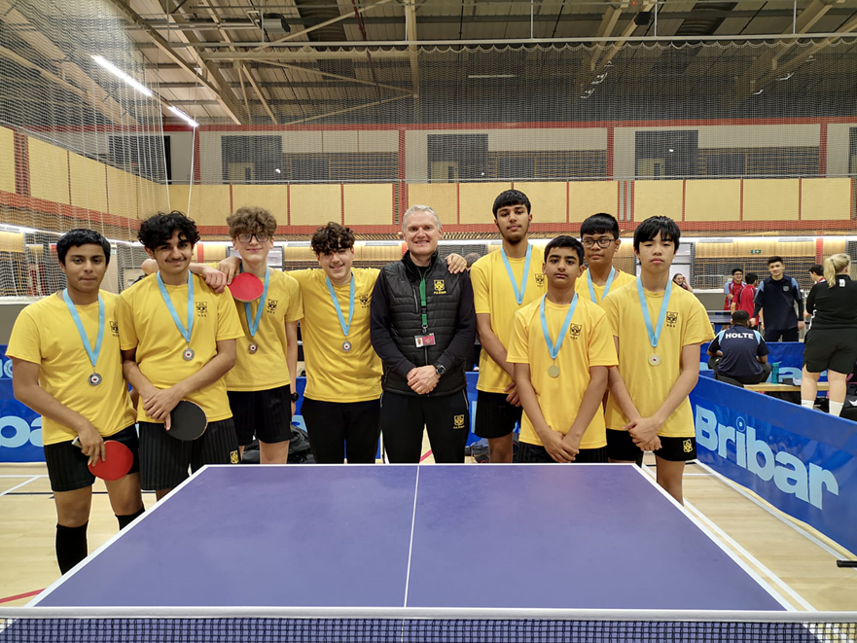
Person Specification
Essential
- A degree that is relevant to the delivery of Physical Education through to A level
- A PGCE or equivalent teaching qualification
- Excellent subject knowledge and the ability to teach Physical Education from Year 7 to Year 13
- Strong interpersonal and communication skills with students, parents and staff
- A commitment to giving regular and effective verbal and written feedback to students in order to facilitate their development as learners
- A willingness to share ideas, experience and resources
- High standard of written and verbal communication
- Good ICT skills
- Ability to work to deadlines
- A commitment to high standards, including working with the department to continually evaluate and improve teaching and learning
- A commitment to contribute fully to the wider school life including extra curricular sports teams and clubs, school trips and House sport.

Desirable
- An interest in education that goes beyond the delivery of a specific subject
- Experience of teaching GCSE PE and A level PE

Additional Requirements
- Be committed to safeguarding and promoting the welfare of children and adhere to and ensure compliance with the schools child protection policy
- Promote fundamental British Values
- Comply with the requirements of the Health and Safety at Work regulations.
- Duty of confidentiality towards the school. To acknowledge that, in the course of employment you will have access to confidential information. You agree that you will not divulge or communicate to any person, corporation, company or other organisation; use for your own purposes other than those of the school; or otherwise disclose or make use of any confidential information relating to or belonging to the school.
Job Description

Post Title: Teacher

1. Purpose of Post

The post holder is responsible for:

a. implementing and delivering an appropriately broad, balanced, relevant and differentiated curriculum for students and to support those departments within which the teacher teaches
b. monitoring and supporting the overall progress and development of students as a teacher/form tutor
c. facilitating and encouraging a learning experience which provides students with the opportunity to achieve their individual potential
d. contributing to raising standards of student attainment
e. sharing and supporting the School’s responsibility to provide and monitor opportunities for personal and academic growth
f. responding as directed to issues related to Every Child Matters

2. Main Duties and Responsibilities

a. Operational/Strategic Planning
- assist in the development of appropriate syllabi, resources, schemes of work, marking policies, teaching and learning and assessment strategies in the department
- contribute to the development of the Departmental Development Plan and its implementation
- plan and prepare courses and lessons
- contribute to the whole school planning activities
- through the work and activity of the individual and in liaison with external groups and organisations or otherwise, promote positively the School and its activities
- ensure a Health and Safety ethos, complying with School policy

b. Teaching and Learning
- teach those classes allocated by the Head of Department, Deputy Headteacher or Headteacher
- assist in the development of a Departmental Handbook and the policies and procedures contained therein
- monitor student learning through effective assessment strategies and implement effective teaching and learning strategies (see Staff Handbook)
- assist in the development of teaching and learning methodology, including with regard to learning styles, use of ICT and assessment
- implement such areas as are required for the distributed teaching of enterprise education, work related learning, and other areas as directed

c. Resources
i) assist the monitoring and use of the resources, advising the HoD as necessary
ii) follow the requirements of the School’s finance department when requisitioning new resources
iii) help to ensure an attractive and stimulating learning environment is developed and maintained

d. Staff Development
- take part in School staff development programmes
- continue with personal development in relevant areas
- engage actively with the Performance Management process
- work as a member of a designated team, contributing positively to effective working relations within the School

e. Quality Assurance
i) help to implement School quality assurance procedures
ii) contribute to the process of monitoring and evaluation in the area
- review from time to time methods of teaching and programmes of work
- participate in the School’s monitoring, tracking and target setting systems for the students
- participate in Parents’ Evenings, Report writing and the provision of grades

f. Pastoral System
i) act as form tutor for a designated group
ii) promote the general progress and well-being of individual students and of the Form Tutor group as a whole
iii) liaise with the Head of Year to ensure the implementation of the School’s pastoral system
iv) register students, accompany them to assemblies, encourage full attendance at school and lessons and participation in other aspects of school life
v) evaluate and monitor the progress of students, keeping up-to-date student records as may be required
vi) contribute to the preparation of action plans, progress files and other reports and to case conferences
vii) alert appropriate staff to problems faced by students and make recommendations as to their resolution
viii) contribute to the citizenship, enterprise and other such areas in line with School policy
ix) ensure registration time is used effectively and developmentally through a structured programme, which may include citizenship, enterprise or other such activities
x) apply the behaviour management systems such that effective teaching and learning can take place
xi) assist in the formation of references, including for jobs, FE and HE (e.g. UCAS)

3. Undertake other duties commensurate with the grading of the post occupied as may be required from time to time.

4. Supervisory Responsibility

The student in the teacher’s care

5. Responsible to

Head of Department (subject teaching)
Head of Year / Key Stage Co-ordinator (pastoral)

HGS Person Specification – Teacher (Generic)

Criterion | Essential
Education and Qualifications | Degree or better in specialist or related subject  L2 English and Maths  Teaching qualification  Qualified Teacher Status
Specialist Knowledge | Clear understanding of the National Curriculum and its application to the specialist subject.  Understanding of strategies to improve learning and student enjoyment of learning.  Effective use of classroom management skills.  Effective use of assessment for learning in the classroom.  Good literacy, numeracy and ICT skills.
Teaching Experience | Evidence of consistent successful teaching at KS3, KS4 & KS5.  Evidence of effective use of ICT in the classroom to enhance learning.  Contribution to the pastoral development of students.  Experience of being a Form Tutor.
Skills and Aptitudes | Ability to relate to teachers, other professionals, parents and students.  Willingness to learn from others and to contribute own experience and understanding to enhance the practice of others.  Ability to work as a member of a team and on own initiative.  Ability to apply current teaching techniques well.  Willingness to help move the Department forward.  Willingness to improve own pedagogy to keep up with the latest ideas in L&T.  Hard working and with a sense of humour.  Reliability and integrity  Tact and diplomacy  Confidence (but not arrogance) with colleagues and students.  Developed ability to understand self and others.
Other | Willingness to undertake training as required.  Willingness to take a full part in the life of the school.  Excellent attendance and punctuality record.
