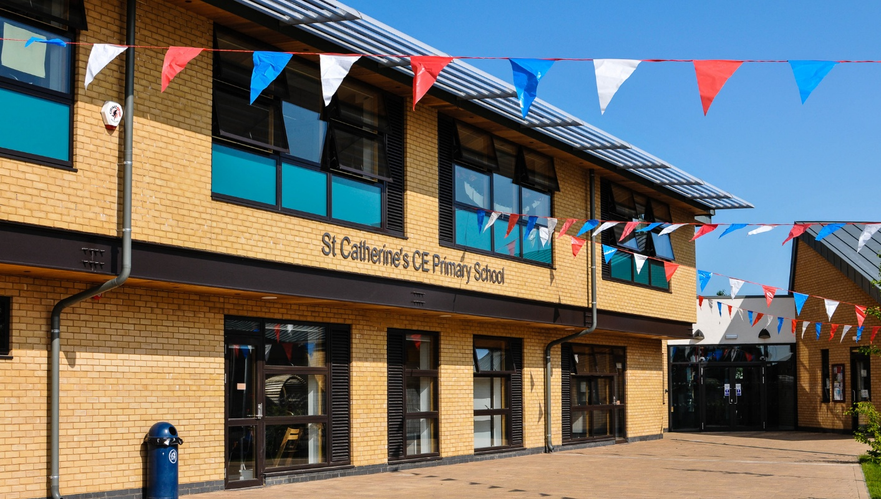
Teacher of Physical Education
St Catherine’s CE Primary School, Kidderminster
Permanent – Main Pay Range (suitable for ECT’s)
Start Date: 1st September 2026

St Catherine’s CE Primary School is a welcoming and inclusive Church of England school. Our Christian vision shapes all that we do as we seek to nurture every child so they can flourish academically, socially, physically and spiritually.

We are seeking to appoint an inspirational Teacher of Physical Education who believes passionately in the power of sport and physical activity to support children’s development, confidence and wellbeing.
This is an exciting opportunity for a dynamic and creative practitioner to help deliver high-quality physical education across the school, working alongside our PE Curriculum Leader to develop sport, outdoor learning and active play opportunities for all pupils. The successful candidate will deliver engaging PE lessons across the primary age range and will also support the school by delivering other subject areas to provide PPA cover where required. We welcome applications from both Early Career Teachers (ECTs) and experienced teachers.

The ideal candidate will demonstrate:
- A strong knowledge of high-quality physical education within a primary setting.
- Passion and dedication for delivering high standards of teaching and learning.
- The ability to plan and deliver engaging, inclusive and challenging lessons.
- The ability to inspire pupils to develop a lifelong love of sport and physical activity.
- Strong classroom management and the ability to motivate pupils.
- The ability to work effectively as part of a supportive and collaborative team.
- A commitment to supporting the Christian ethos and values of the school.
- A willingness to contribute to extra-curricular sport, clubs, competitive fixtures and enrichment activities.
- An interest in developing outdoor playtime provision and adventurous outdoor activities.
- A desire to support school residential visits and outdoor learning experiences.

In return we offer:
- A welcoming and supportive Christian school community.
- A beautiful and spacious school building with extensive grounds and plentiful resources.
- Enthusiastic and well-behaved pupils who enjoy learning and being active.
- A committed and collaborative staff team who are passionate about supporting pupils to succeed.
- Opportunities to work alongside the PE Curriculum Leader to develop sport across the school.
- Opportunities to develop outdoor play provision and adventurous outdoor activities.
- Opportunities to support school residential visits, helping pupils experience enriching outdoor learning.
- A strong ECT induction programme and mentoring support.
- Excellent opportunities for professional development and career progression.
- Supportive families.

Visits to the School:
Prospective candidates are warmly encouraged to visit the school to learn more about our community and vision.

Please contact our HR Manager, Julie Cook to arrange a visit with myself or a senior member of staff.
hr@stcatherines.worcs.sch.uk or call: 01562 823614 for further details and an application form.

Closing Date: Friday 17th April 2026
Lesson observations: Thursday 23rd April 2026
Interviews: Friday 24th April 2026

Safeguarding Statement
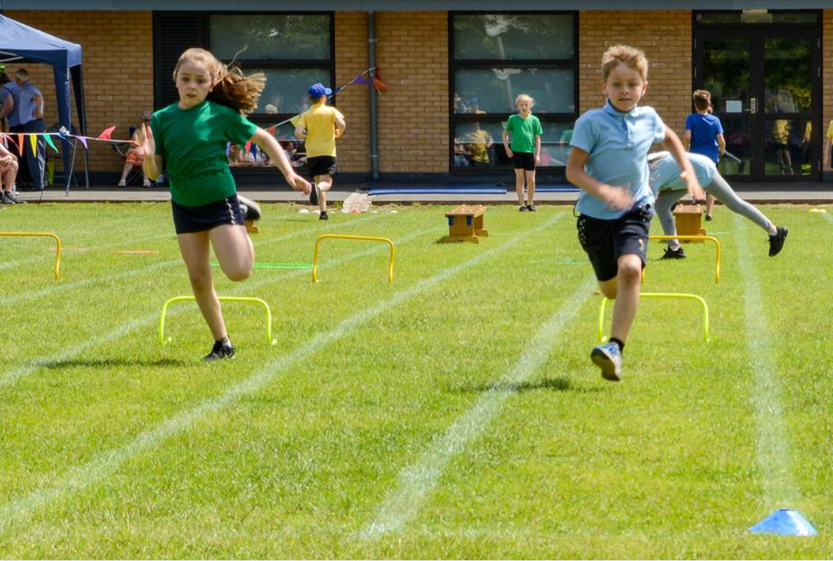
St Catherine’s CE Primary School is committed to safeguarding and promoting the welfare of children and young people and expects all staff and volunteers to share this commitment. This post is subject to an enhanced Disclosure and Barring Service (DBS) check and satisfactory references.

