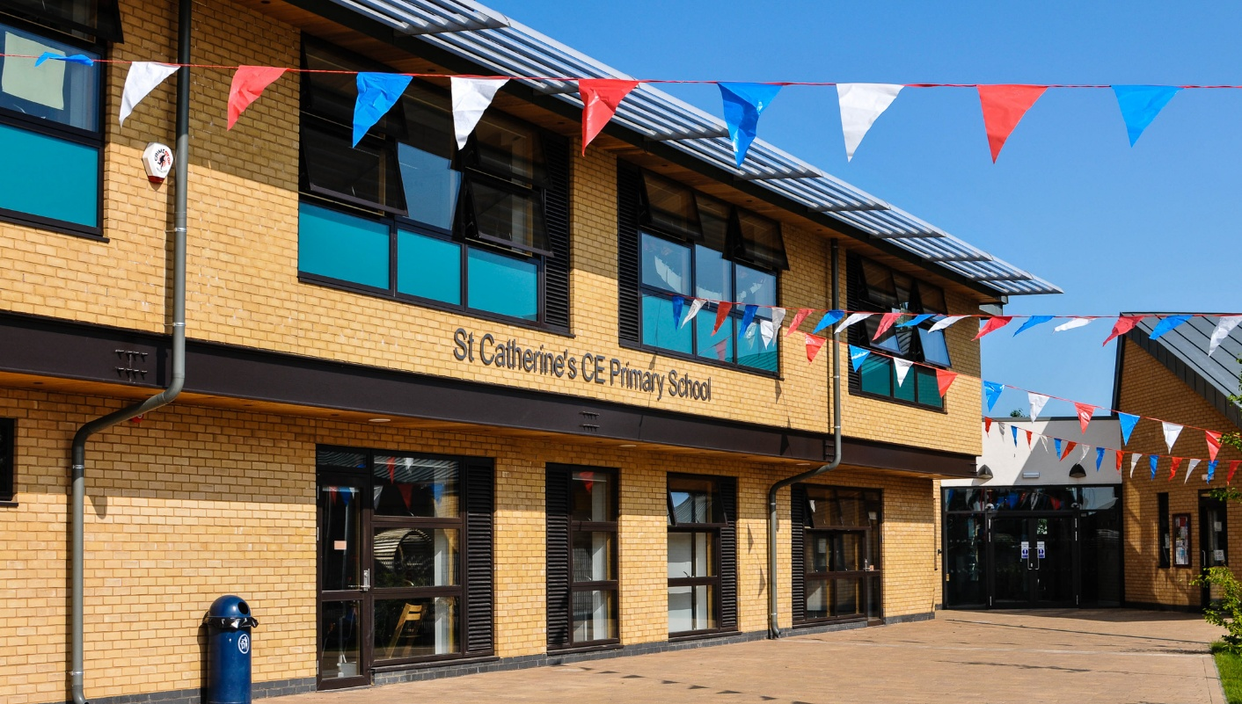
Teacher of Physical Education
St Catherine’s CE Primary School, Kidderminster
Permanent – Main Pay Range (suitable for ECT’s)
Start Date: 1st September 2026

Job Description
Job Purpose:
- To deliver high-quality Physical Education across the primary age range at St Catherine’s CE Primary School, enabling pupils to develop skills, confidence and enjoyment in sport and physical activity.
- In addition to PE, the role will also include delivering some planned lessons across the primary curriculum to provide PPA cover for teaching staff.
- The successful candidate will work alongside the PE Curriculum Leader to support the implementation and development of the school’s PE curriculum and will contribute to the wider life of our Christian school community.
Key Responsibilities:
Teaching and Learning
- Plan and deliver high-quality PE lessons across EYFS, Key Stage 1 and Key Stage 2.
- Create engaging lessons that encourage pupils to develop skills, confidence and enjoyment in sport and physical activity.
- Adapt teaching to ensure PE is inclusive and accessible for all pupils.
- Deliver planned lessons across the wider curriculum to support teachers’ PPA time.
- Monitor pupil progress and provide feedback to support development.
- Maintain high expectations for behaviour, participation and achievement.

School Sport and Enrichment
- Work alongside the PE Curriculum Leader to support the delivery and development of the PE curriculum.
- Promote a positive culture of sport and physical activity throughout the school.
- Support the organisation of sports clubs, competitions, whole-school events, residential visits and outdoor learning opportunities.
- Encourage pupils to demonstrate teamwork, resilience and sportsmanship.
- Contribute to initiatives that promote healthy and active lifestyles.
Safeguarding and Wellbeing
- Ensure the safety and wellbeing of pupils during all lessons and activities.
- Follow school safeguarding policies and procedures.
- Promote positive physical and mental wellbeing.
Professional Responsibilities
- Work collaboratively with colleagues across the school.
- Contribute to staff meetings and professional development.
- Support and uphold the Christian vision and values of St Catherine’s CE Primary School.
- Contribute to the wider life of the school community.

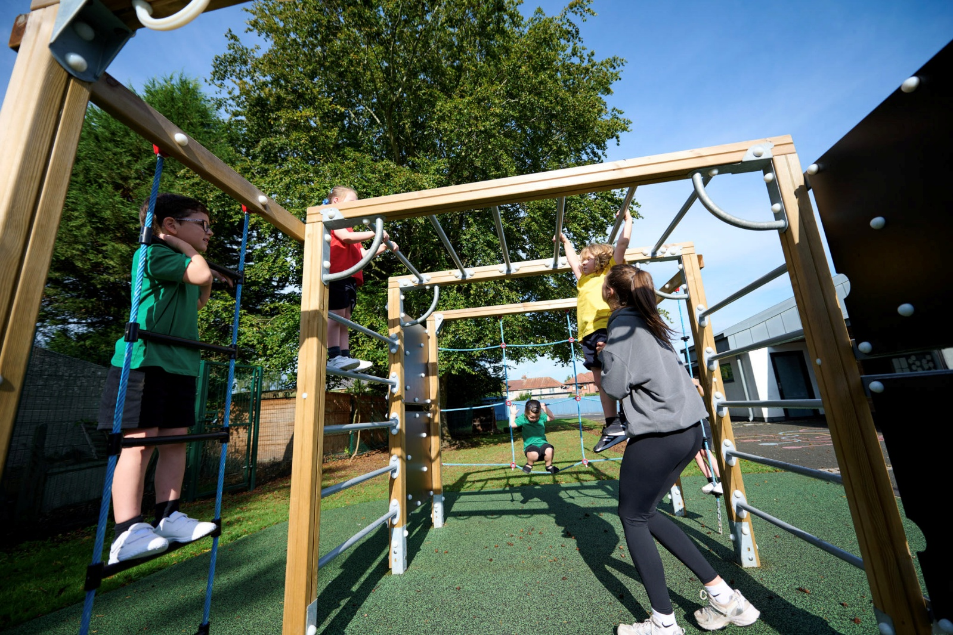
Person Specification

 | Essential Criteria | Desirable
Qualifications | - Qualified Teacher Status (QTS) or working towards QTS (ECTs welcome). | - Sports coaching qualifications  - Swimming teaching qualifications
Knowledge and Understanding | - Understanding of effective teaching and learning within primary education.  - Knowledge of the primary PE curriculum.  - Understanding of assessment and pupil progress.  - Awareness of safeguarding responsibilities in schools. | - Experience of teaching PE during training or previous roles.  - Knowledge of inclusive sports provision.
Skills and Abilities | - Ability to deliver engaging and inclusive PE lessons.  - Ability to teach across the primary age range.  - Ability to support pupils with additional needs.  - Strong classroom and behaviour management skills.  - Good communication and organisational skills.  - Ability to work collaboratively with colleagues, including the PE Curriculum Leader. | - Experience of organising sports clubs or competitions.  - Experience of leading whole school sports events  - Experience of assisting and planning sports trips and/or residential activity visits
Personal Qualities | - Enthusiastic and passionate about sport and physical activity.  - Committed to supporting the Christian ethos and values of St Catherine’s CE Primary School.  - Positive, reflective and motivated to develop professionally.  - Able to work effectively as part of a team.  - Committed to supporting all pupils to flourish and achieve their full potential.  - Committed to the safeguarding of all pupils. | - Interest in supporting wider school sport initiatives.  - A desire to develop cluster school competitions and events.

