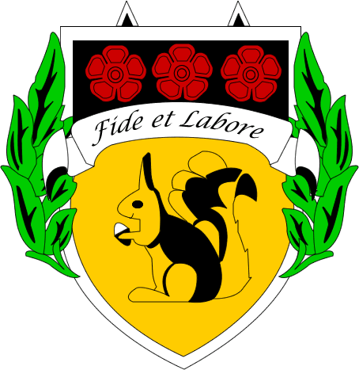

**TEACHER OF PHYSICS**

This is an exciting opportunity for an outstanding, enthusiastic graduate teacher of Physics to join a high achieving science faculty at Bacup & Rawtenstall Grammar School, a highly oversubscribed and successful 11–18 grammar school in the Manchester commuter belt.

This full time position requires you to be a motivated, team player who is able to consistently deliver high quality lessons to Year 7 to 13 students in this selective grammar school. This is an excellent opportunity both for a hardworking NQT or an experienced colleague wishing to move to a role which will give them scope to develop their teaching and learning skills in a different context.

The Physics, Biology and Chemistry Departments are staffed by a strong team of specialists and results in external examinations are consistently very good. The Science Faculty is led by Andrew Wilkinson, Head of Science and Physics, alongside Claire Black who is Head of Biology and Thomas Heaton who is Head of Chemistry. There are two further teachers of Physics; Lynette Morris and Ryan Stringer. There is a sound working relationship between science staff which is based on mutual respect and good humour.

The departments have well-equipped laboratories, with fixed or portable digital projectors, and enjoy excellent support from the Science Faculty Manager, Sandra Harris. She has responsibility for the laboratories, ordering and maintenance of equipment, and is in charge of two laboratory technicians.

At KS3, we teach science over Year 7 and Year 8 and all science teachers share in the teaching of science (3 hours per week), based on the National Curriculum. In Year 9 we begin teaching the GCSE course, following the AQA specification for all three GCSE sciences. In Year 10, the year groups are divided into seven sets, with a total of 5 hours of teaching in each subject per fortnight with the two top ability sets moving at a more rapid pace than the other five sets. GCSE Physics results are particularly good with a 100% grade 9-4 pass rate in the last set of external exams in August 2019. 45% of students achieved a grade 8 or 9.

A-level Physics is a popular choice in our Sixth Form and 117 students are currently following the AQA Physics course across Year 12 and 13. Results are typically very good, with 65% of students achieving an A* to B grade in recent years. Currently there are three Year 12 classes and three Year 13 classes studying AQA Physics. At present, each A-level class has two teachers who share 9 hours teaching per fortnight. A popular extra-curricular activity is our trip to Geneva, Switzerland, which has taken place since 2014.