WISDOM  
HOPE  
COMMUNITY  
DIGNITY  
EQUALITY



Information pack for candidates

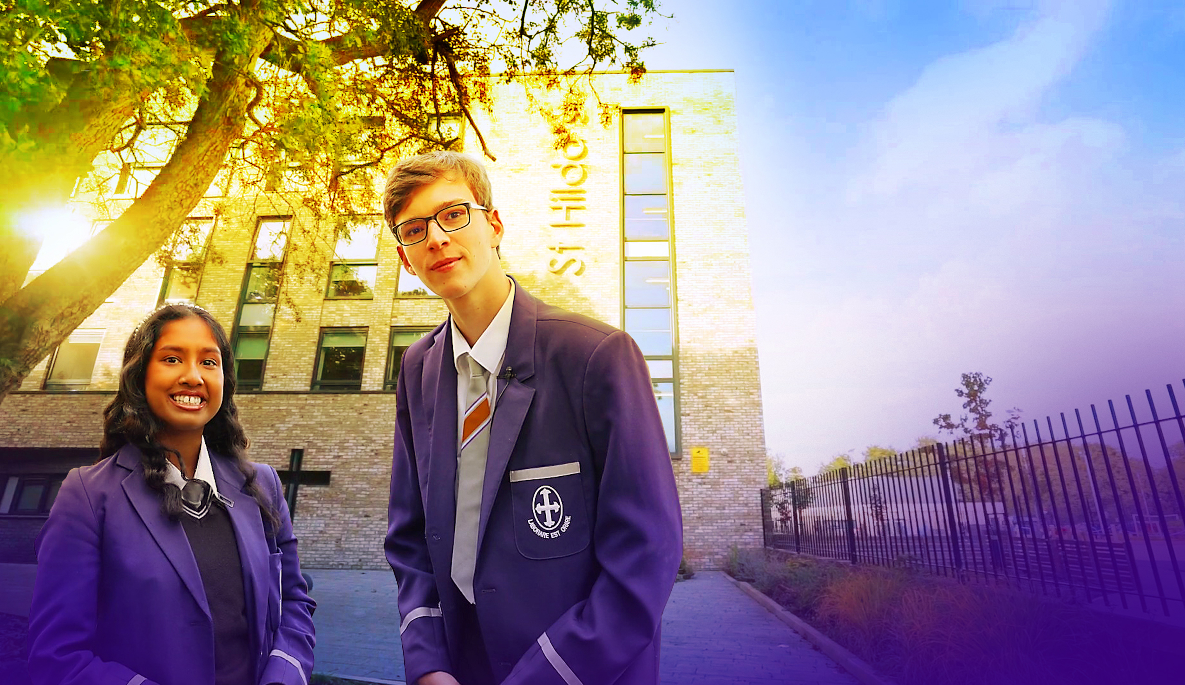

Welcome

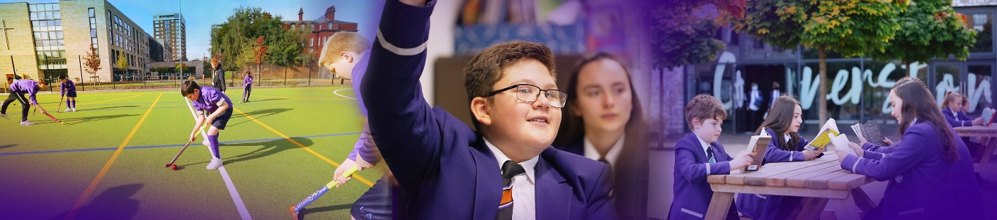

Dear Candidate

Many thanks for your interest in St Hilda's and the post of Teacher of Physics.

St Hilda's is unique. St Hilda’s is a family. We are the only co-educational Church of England school in Liverpool in key stages 3 and 4. We welcome students and their family from a Christian background, from other faiths and those who have no faith. Each individual is precious.

Although our reputation in the community is excellent, this does not mean that we do not look for opportunities to improve who we are and what we do. We live by our values and are educating for 'wisdom, hope, community, dignity and equality'. Students helped to choose our 5th value of equality. We changed to a house system to promote a sense of belonging in each of our students and members of staff. Our smaller House families come together to form the larger St Hilda’s family. We chose our 5 Houses very carefully. Each one of these inspirational people embody our values and have helped to shape Liverpool. We speak in more detail about Margaret Aspinall, Gee Walker, Kitty Wilkinson, John Brodie and William Roscoe on our website.

We believe in student voice, in student leadership and in high expectations. Our behaviour systems focus on a Chance to Change and we work hard in ensuring we support our students in making the right decisions, ready to take their place in our society. Our SlAMS Report in March 2017 graded us as outstanding across all areas, and our more recent Keeping on Track report in December 2019 states’ *The strong, vibrant and inspirational vision, which proudly celebrates Christ as the cornerstone of this nurturing, inclusive and flourishing school, genuinely lies at the heart of this Christian community.’* We are unashamedly a Christian school. Our most recent Ofsted report graded us as Good in 2015.

We are heavily oversubscribed, but this does not mean that we do not recognise that we can become even better. We are looking for someone who will join the St Hilda's family in the key position as Teacher of Physics who champions all of our students, challenges where necessary and celebrates at every opportunity. You will support the people in your team, ensuring all opportunities are taken to lead and share excellent practice and teaching and learning and strategies to support those students who need additional support. Your vision to support St Hilda's Science department to the next level is paramount.

Academically, St Hilda's intake above is national average. However, our aspiration is that every single one of our students achieves or exceeds their potential, has exceptional pastoral support and has a wealth of opportunities to support their development. In this role, we are looking for a very special person with the vision and experience to help our vision become a reality. Is this you?

We welcome visits from prospective candidates, but this will not form part of the selection process. Please contact Tracey Cain by email should you wish to arrange a visit [tcain@st-hildas.co.uk](mailto:tcain@st-hildas.co.uk)

I look forward to receiving your application if you believe that St Hilda's suits your career aspirations and you meet our criteria for selection. We are looking for a very special Teacher of Physics whose vision can take the department to the next level.

Thank you for your time,

**Mrs Jo Code**, Headteacher

St Hilda’s CE High School

St Hilda’s CE School is an 11-18 co-educational Church of England school that sits on the fringe of Sefton Park in Liverpool. The school currently has 1066 Students. Due to parental demand for places at the school, from September 2018 we increased our Year 7 PAN from 150 to 170. We pride ourselves in being a fully inclusive school that serves our Diocese and beyond. Our vision encapsulates who we are as a school:

We are the St Hilda’s family, with Jesus Christ as our cornerstone.   
Building on foundations of **wisdom**, **hope**, **community**, **dignity** and **equality**, we nurture and support each other to be or very best. We rejoice in our diversity and celebrate our many achievements.

St Hilda’s also has a sixth form. St Hilda’s College is an integral part of the school and last year, over 88% of Year 11 chose to continue their education at St Hilda’s. The College is growing year on year.

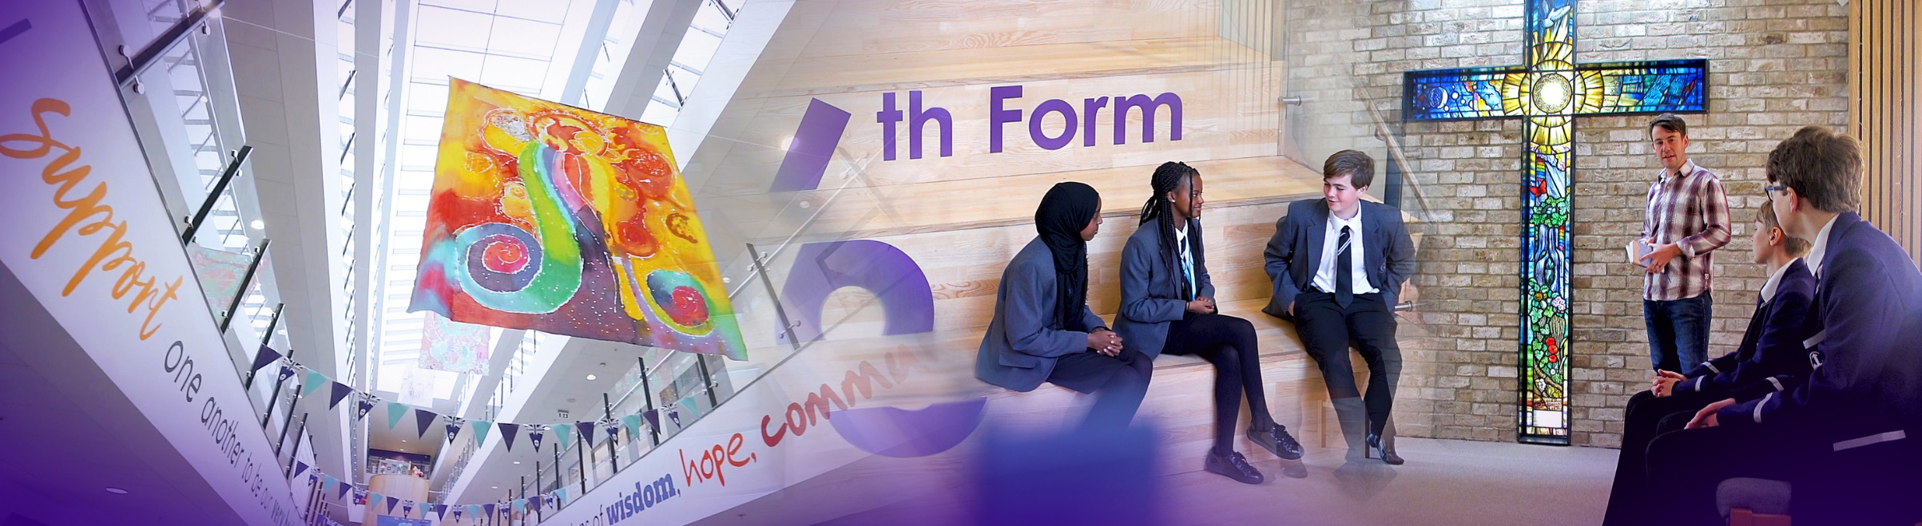

The new school buildings were opened in September 2015. We are incredibly proud of the excellent facilities we have, including excellent sports facilities. St Hilda’s College have dedicated areas in the school, including their own study rooms and café.

Our greatest asset at the school is our staff. St Hilda’s staff are incredibly generous with their time and support of each student. We have an incredibly low turnover of staff and we retain many of our NQTs and former students return to work here.

This is an exciting time to join the school and become part of a hard-working and committed team who embody our vision and values.

_________________________________________________________________________________

Senior Leadership Team

**Jo Code,** Headteacher   
Vision and values, curriculum, data, SEP, SIP, admissions, monitoring and tracking, QA systems policies.

**Lynne Noon,** School Business Manager  
Strategic Finance, Premises; Maintenance, Development and staffing, Health & Safety, School Calendar, Service Contracts and performance, Catering, Lettings.

**Roy Bellmon,** Deputy Headteacher  
DSL, St Hilda’s College, post-16 learning and standards, IT strategy, HAP programme, enrichment, Year 11 transition.

**Suzanne Harrison,** Deputy Headteacher  
Behaviour and Inclusion. Deputy DSL, Attendance, PP and Catch-up, Director of STEM, Head of Science

**John Martin,** Assistant Headteacher  
Deputy DSL, Behaviour support, Student Welfare, House System, Rewards and celebration, Student Leadership, Friends of St Hilda’s, parent engagement, transition.

**Liz Cowdell,** Assistant Headteacher  
Head of mathematics, Teaching and Learning. Staff Appraisal; Teacher Targets; Mentoring/Support; T & L innovation and development, CPD, Development Thursdays.

**Andrea Howard,** Assistant Headteacher  
Teaching and Learning, Data, ARR, Examinations and Options.

**Katie Pritchard,** Assistant Headteacher  
SENCo, SEND, Looked after Children.

**________________________________________________________________________________**

Liverpool

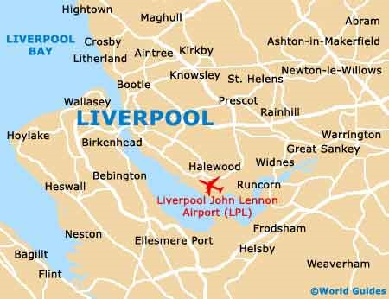Liverpool is a city with unique attractions, exciting events, world class sport offerings, unrivalled musical heritage and a famously warm welcome!  
  
  
**Location and Transport Links**  
Liverpool enjoys superb communication links.   
St Hilda’s CE School is located close to the M62 and other major roads. There are train and bus links to   
St Hilda’s. Liverpool Lime Street train station is the main station serving the city of Liverpool. Liverpool Airport is less than 30 minutes away.

©Marketing Liverpool, Liverpool Docks 2

**Facilities and Amenities**St Hilda’s CE School is close to the 3 universities in Liverpool. We are also close to Liverpool One;   
a range of shops, bars, restaurants, cafes and a cinema. Speke Retail Park and Edge Lane Retail Park are also close by.

Liverpool has the largest collection of museums and galleries anywhere outside London. The city also has several hospitals, theatres, cinemas and numerous other cultural and leisure facilities. St Hilda’s CE School lies in South Liverpool, overlooking Sefton Park.

**Housing and Accommodation**  
A range of accommodation options are available in the local area and there is a thriving rental market. The excellent transport links allow many staff at the school to live in outside of Liverpool. Help and advice can be given by the school if accommodation is required.

_________________________________________________________________________________

Job Description

Whilst every effort has been made to explain the main responsibilities and duties of the post, each individual task to be undertaken will not be identified. Employees will be expected to comply with any reasonable request from a manager to undertake work of a similar level that is not specified in this job description. The job description is current to the date shown but, in consultation with you, it may be changed by the Headteacher to reflect or anticipate changes in the job commensurate with the grade and job title.

TEACHER OF PHYSICS

|  |  |
| --- | --- |
| Working time: | Full time |
| Grade: | MPS/UPS |
| Disclosure level: | Post is subject to a current enhanced disclosure |
| Reporting to: | Headteacher  SLT Line Manager  Head of Science  Head of Physics |
| Working with: | Science department  Teaching and support staff  Students  Parents |

Teacher of Physics

PURPOSE OF POST

1. To plan and teach a broad, balanced, relevant and differentiated curriculum within a designated subject area(s) such that all students are included, challenged and supported, and so that all can progress and achieve.
2. To monitor, review and support the overall progress and development of students as a teacher and as a pastoral tutor.
3. To seek to inspire in students, as teacher and tutor, a love of learning and to foster imagination, creativity, confidence, independence and respect for others.
4. To share and support the school’s ethos of faith, vision and nurture and to commit to the highest standards of achievement and personal growth and development for students - mind, body and soul.

GENERIC RESPONSIBILITIES

***Teaching and Learning***

* To maintain a thorough and up-to-date knowledge of the teaching of Physics and the wider curriculum developments in Science which are relevant to the teacher’s work.
* To consistently and effectively plan lessons to meet students’ individual learning needs, using a range of appropriate strategies for teaching and classroom management.
* To consistently and effectively use information about the prior attainment of students to set well-grounded expectations for students, and monitor progress to give clear and constructive feedback.
* To ensure that the learning environment is organised, attractive and stimulating.
* To maintain high standards of behaviour, attendance and punctuality, in accordance with school policy and procedures.
* To prepare and update subject materials.
* To set and mark homework according to school policy.
* To comply with Health and Safety policy and undertake risk assessments as appropriate.

***Marking, assessment and reporting***

* To mark and assess students’ progress according to whole-school policies and as requested by external examination bodies.
* To maintain appropriate records and provide relevant accurate and up-to-date information to support the overall monitoring of students’ progress according to school policy.
* To complete accurately reports on students’ progress for parents according to school policy and the school calendar.
* To communicate with parents of students about their progress as appropriate and according to school policy.
* To take part in liaison activities including Parents’ Evenings, Open days/evenings etc

***Departmental***

* To assist in the development of curriculum, schemes of work, assessment policies and teaching and learning strategies in the department.
* To support the department’s effective organisation and management.
* To contribute to the department’s improvement planning.
* To liaise professionally with other colleagues across the school, and external agencies as necessary.
* To contribute to the department’s STEM enrichment and extra-curricular opportunities for students.

***Wider professional responsibilities***

As a member of the St Hilda’s family, you will be expected to

* support our 5 values of Wisdom, Hope, Community, Dignity and Equality.
* be sympathetic to the teachings of the Church of England.
* operate at all times within the stated policies and practices of the school.
* establish effective working relationships and set a good example through their presentation and personal and professional conduct.
* participate professionally in the school’s performance management systems.
* take responsibility for personal professional development.
* take part in professional development activities and inset organised by the school.
* co-operate with other staff to ensure a sharing and effective usage of resources to the benefit of the school, department and students.
* contribute to the corporate life of the school through effective participation in meetings.
* take part in marketing and liaison activities such as parents evenings, review days and other appropriate school events.
* be a form tutor and deliver high-quality PSHE and Careers Guidance.
* recognise health and safety is a responsibility of every employee, to take reasonable care of self and others and to comply with the school’s Health and Safety policy.
* promote the welfare of children and to support the school in safeguarding children though relevant policies and procedures. Establish a purposeful and safe learning environment which complies with current legal requirements, national policies and guidance on the safeguarding and well-being of children and young people so that learners feel secure and sufficiently confident to make an active contribution to learning.
* undertake any other duty as specified by STPCB not mentioned.
* support the school’s Health, Safety and Welfare policy and be aware of the responsibility for

personal Health, Safety and Welfare and that of others reporting any hazards

__________________________________________________________________________________

Person Specification

**In your letter of application under section 8 Person Specification, please  *demonstrate* how you meet these criteria.**

**Do not include a curriculum vitae.**

**Candidates failing to meet any of the essential criteria will automatically be excluded.**

**[A] Qualification requirements**

|  |  |  |  |
| --- | --- | --- | --- |
|  | **Essential** | **Desirable** | **Source** |
| Qualified teacher status | **E** |  | **A** |
| Recognised degree or equivalent. | **E** |  | **A** |
| Further professional development: post-entry qualification |  | **D** | **A** |

1. **Experience**

|  |  |  |  |
| --- | --- | --- | --- |
|  | **Essential** | **Desirable** | **Source** |
| Relevant experience of teaching Physics and General Science in a comprehensive school (as a teacher or student teacher) | **E** |  | **A/I/R** |

1. **Knowledge/Understanding**

|  |  |  |  |
| --- | --- | --- | --- |
|  | **Essential** | **Desirable** | **Source** |
| A good or better teacher who can establish good relationships with students to motivate and inspire them to do their best. | **E** |  | **A/I/R** |
| A desire to continually improve as a teacher, driving towards excellence in the classroom | **E** |  | **A/I/R** |
| Flexible and perceptive classroom practitioner in own subject area who can engage students and enable them to learn and make effective progress | **E** |  | **A/I/R** |
| Knowledgeable about best practice in Physics and General Science , understanding the implications of changes to the curriculum | **E** |  | **A/I** |
| Experience and/or a desire to teach Physics at Key Stage 5 |  | **D** | **A/I/R** |
| Ability to use data to enable students to make the best progress they can | **E** |  | **A/I/R** |
| A understanding of SEN and vulnerable groups and how to address their needs through your teaching and assessment | **E** |  | **A/I/R** |

1. **Personal Qualities and Skills**

|  |  |  |  |
| --- | --- | --- | --- |
|  | **Essential** | **Desirable** | **Source** |
| Outstanding communicator | **E** |  | **A/I** |
| Outstanding interpersonal skills | **E** |  | **A/I** |
| Professional reliability re attendance, punctuality and deadlines | **E** |  | **A/I** |
| Team player | **E** |  | **A/I** |
| Ability to meet deadlines/manage time | **E** |  | **A/I** |
| Resilient | **E** |  | **A/I** |
| ICT literate | **E** |  | **A/I** |
| Commitment to the school Christian values and vision | **E** |  | **A/I** |

1. **Pre-Employment Checks**

|  |  |  |  |
| --- | --- | --- | --- |
|  | **Essential** | **Desirable** | **Source** |
| Positive recommendation from all referees, including current employer/ITT trainer | **E** |  | **R** |
| DBS Clearance post appointment | **E** |  | **N/A** |

*(Source: A=Application (form+letter); I=Interview; R=Reference)*

1. **Application Form and Person Specification – Essential Criteria (Section 8)**

The form must be fully completed and legible.

There should be no unexplained gaps in career history.

Please provide clear examples of your ability, experience and qualifications against the criteria on the person specification, focusing on the essential criteria. This should be clear, concise and related to the specific post. No more than 2 sides of A4, font size 12.

Whilst every effort has been made to set out the main duties and responsibilities of the post, each individual task undertaken may not be identified.

**This job description is a guide to the duties and should be read in conjunction with the accompanying person specification.**

**This post is subject to an enhanced DBS disclosure check through the Disclosure & Barring Service**

_________________________________________________________________________________

How to apply and the Selection Process

**Deadline for applications: 12TH April 2021**

Applications should be sent to: recruitment@st-hildas.co.uk

All candidates, both those shortlisted and those who are not successful, will be contacted by email. Details of the date and time of final interviews will be given to successful candidates. Candidates will also be given a topic to prepare for their lesson observation prior to interview.

**Formal interview at the school: 21st April 2021**

Candidates will be asked to demonstrate and outline, in a variety of ways, their ability to successfully lead change at St Hilda’s CE School.

Details of this will be sent out in advance. All candidates will be contacted following the interviews.

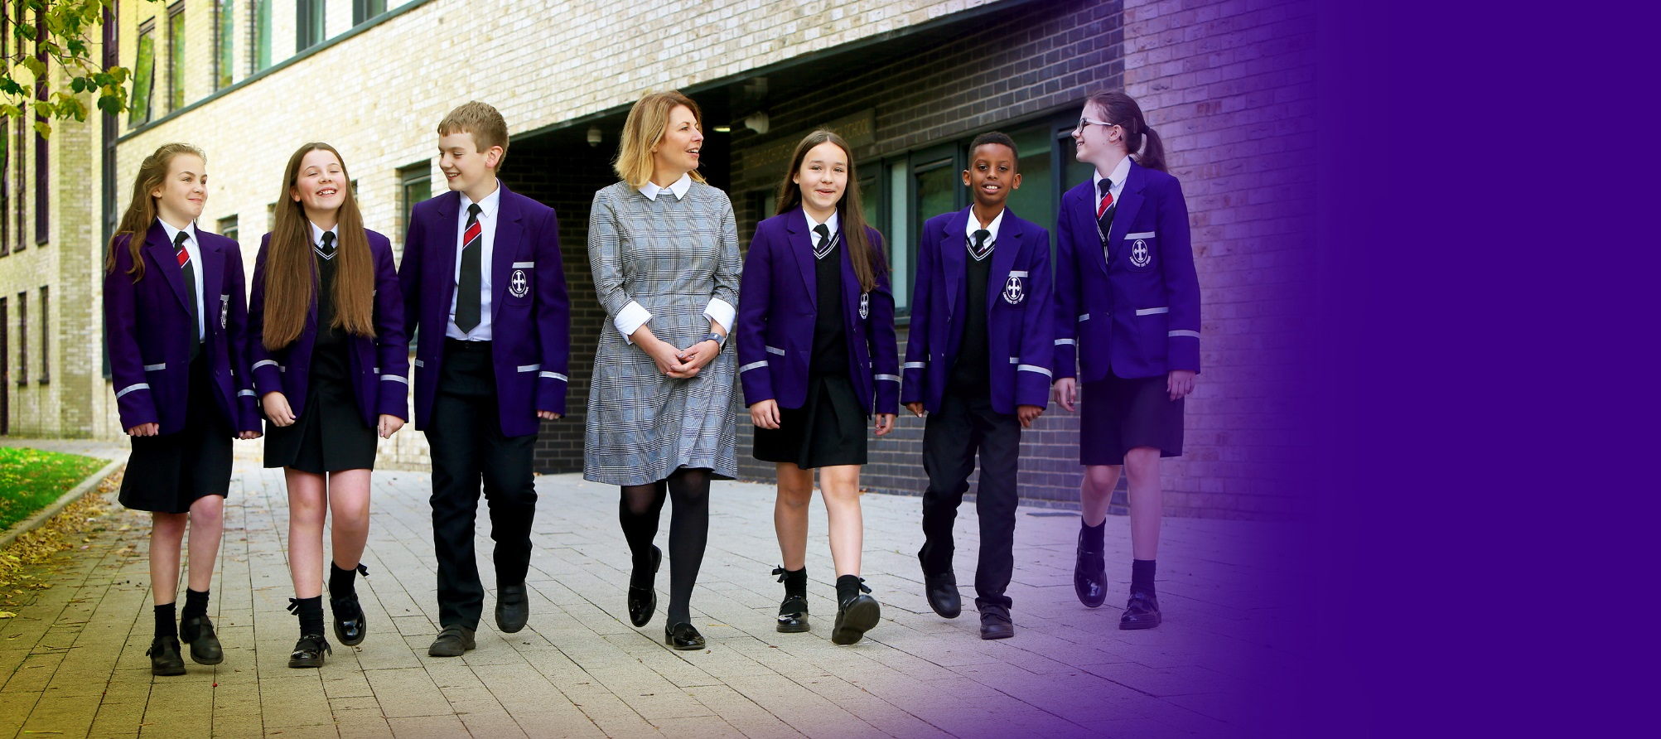

**St Hilda’s CE High School**

Croxteth Drive, Sefton Park, Liverpool L17 3AL

T: 0151 733 2709 E: info@st-hildas.co.uk I: www.st-hildas.co.uk

**Mrs J Code**  
BA (Hons), NPQH, FCCT

Headteacher

WISDOM  
HOPE  
COMMUNITY  
DIGNITY  
EQUALITY

