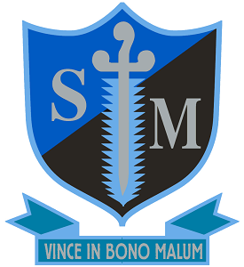

Diocese of Southwark
St Michael’s Catholic College
Llewellyn Street, Bermondsey, London SE16 4UN
11–18 Single Academy Trust.
Required for June or September 2023
Roll: 930
Teacher of Physics
(MPS+UPS if applicable)
St Michael’s Catholic College is an outstanding school which offers exceptional opportunities for a talented, committed and enthusiastic teacher of Physics and Science. You will be joining an excellent department that regularly achieves results well above national average results and has a high uptake of Physics at A’ Level. As part of this team you will have the opportunity to teach Science across the ability range in KS3 and Physics at GCSE and A level, within modern state of the art buildings. This is the ideal post for a candidate who wants to broaden their experience within a supportive environment which will allow them to excel. Applications will also be considered for candidates who wish to teach Physics and Maths.

This position would suit either an experienced teacher or an exceptional ECT.

St Michael’s has been judged outstanding by Ofsted on two successive occasions and is an outward looking school with an excellent reputation in the local area. It is a strategic partner in the Catholic Schools’ Partnership and works as part of the Southwark School’s Learning partnership with other schools in the Borough including private schools. Alongside these opportunities to work with professionals from a range of other establishments, the college was awarded transforming status by SSAT reflecting the outstanding professional development and wellbeing support we offer to staff. The college’s excellent location by Tower Bridge facilitates a large number of business partnerships and enrichment opportunities.

St Michael’s College is committed to safeguarding and promoting the welfare of children and young people and expects all staff to share this commitment. This post is subject to a Disclosure and Barring Service (DBS) check.

For an application form and information pack please contact Mrs Valerie Ferguson, email: v.ferguson@stmichaelscollege.org.uk

Closing Date: 9am Wednesday 22nd March - Interviews week beginning 27th March

Early applications are advised as the College reserves the right to appoint at any stage during the application process. 

