job description
teacher of psychology.
reports to: Head of Psychology
hours: Full Time Permanent
salary: £25,570 - £41,732
start date: 23rd August 2021
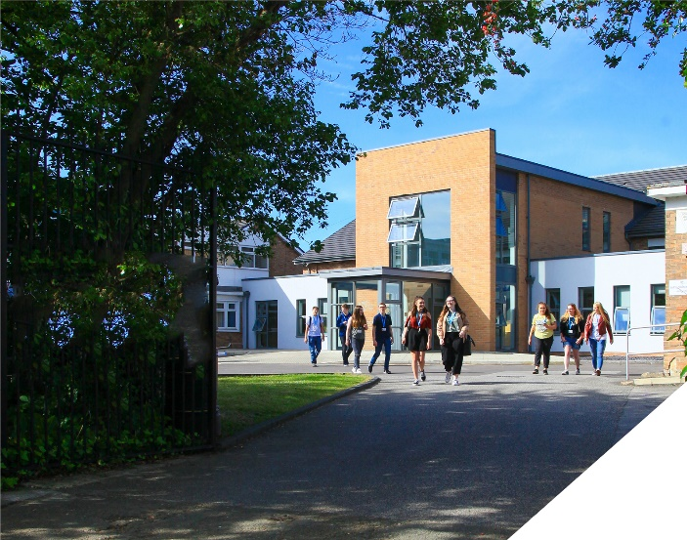
This is a exciting opportunity to teach Psychology at Post 16.
about the role.
This is an fantastic opportunity to teach solely Psychology at a highly regarded Sixth Form College. We seek to appoint an experienced and outstanding Psychology teacher who has a strong track record in terms of student outcomes. The successful candidate will be an excellent classroom practitioner and uses science of cognition and learning to inform their teaching. Psychology is very a popular course at the College with over 500 students studying either A Level or BTEC qualifications in the subject. The role will be to teach A Level Psychology (AQA Specification)and/or BTEC Extended Certificate Applied Psychology.
The Psychology team are highly dedicated and hardworking group of teachers. We are looking to appoint someone who will become an integral part of the team and who will contribute to the high quality educational experience of learners. Within the department there is a real team ethos of supporting each other and regular opportunities for collaboration.
about the College.
You will be joining a highly successful, innovative and nationally recognised sixth form college. The College was awarded the UK Sixth Form College of the Year by the TES in 2018 and this followed being graded outstanding in all areas by OFSTED in December 2016. All staff play a vital role in the experience that students have with us and ultimately their success.

The College currently has a 16 to 19-year-old student population of 1400 and is oversubscribed. Consequently, the College is embarking on an expansion project for 2020/2021 as student applications continue to increase year on year. Due to this high demand for places, work is being completed on a 1.7m new state of the art teaching facility which will be opened in September 2021.

In response to the pandemic and disruption to the learning of students the college is introducing a new timetable to combat the deficits that students will have. This includes teaching time increasing by 60 minutes and also the number of classes a full time teacher has at 4. This will enable teachers to give their students more attention and tailored support to make up for any loss of learning during the past 12 months.

The College is committed to its core values of Positivity, Ambition, Resilience and Thoughtfulness, and these values shape everything we do. Our ethos is centred on the scientific evidence that tells us that everyone can achieve success through purposeful hard work as opposed to the talent myth, and this enables learners to make rapid progress unshackled by any limits previously placed upon them.

new building for the Psychology Department.
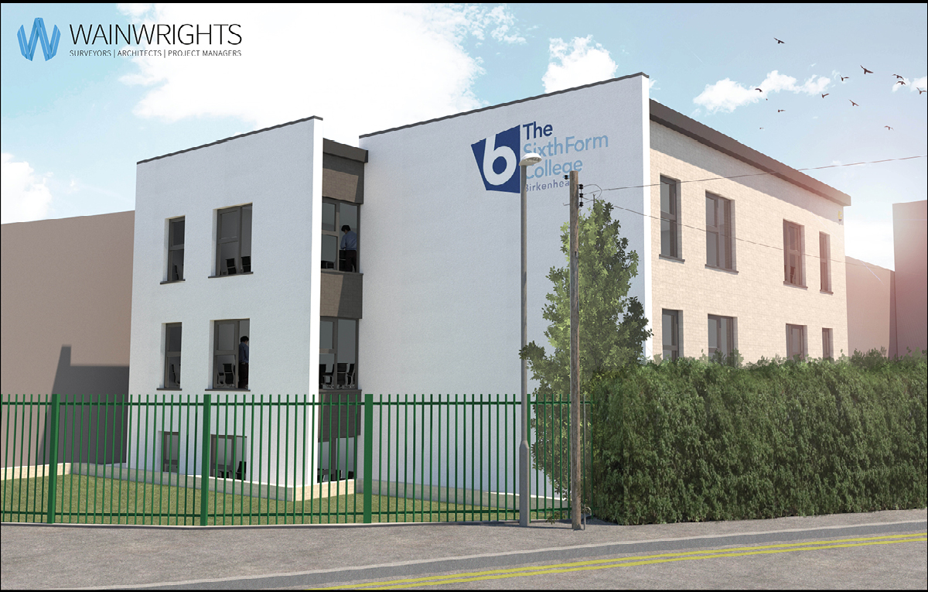
This is an exciting time to join the Psychology team as they move into a brand new, three storey classroom block in September as part of the College’s expansion project. Due for completion by May, the new building is being constructed on the corner of Shrewsbury Road and Upton Road, the £1.7m investment houses nine state-of-the-art, extra large classrooms in a modern and spacious setting.

person specification.
Qualifications | essential | desirable
Degree in Psychology or an equivalent qualification | 
Qualified Teacher Status | 
Experience
Experience of teaching A-level Psychology or BTEC Applied Psychology | 
Experience of teaching AQA |  | 
Experience of working in a demanding environment where high levels of organisation are required | 
Strong historical student outcomes | 
Knowledge / Skills / Abilities
Ability to teach Level 3 Psychology | 
Up to date knowledge & understanding of educational developments relating to the curriculum area | 
Ability to work flexibly as part of a team | 
Ability to form & maintain appropriate relationships & personal boundaries with young people | 
Ability to respond flexibly & creatively to new challenges & opportunities | 
Ability to prioritise & meet deadlines | 
Ability to use Information Technology effectively | 
Excellent communication, interpersonal & organisational skills | 
To demonstrate a commitment to
The Colleges values of Positivity, Ambition, Resilience & Thoughtfulness | 
Personal development and training | 
Safeguarding & promoting the welfare of students | 
Equality & diversity | 
how to apply.
If you are ambitious and determined to make a meaningful difference in one of the country’s leading sixth form colleges then we would be thrilled to have you join our team.

- Please complete the Teacher Application Form which is available on the College website: www.bsfc.ac.uk
- Last 3 years of examination results (if appropriate – if you are an NQT please skip this part of the application procedure)
- On a separate document, answer the following specific questions (each question should be answered separately with each answer being no more than 150 words):

- Please outline why you have applied for this position and what you believe makes you academically suited to the position.
- The College does not currently operate a gifted and talented programme. What is your view on this approach?
- Please identify one or two skills or techniques you have used in the classroom to drive learning.
- Select one of the college values and describe ways you demonstrate this in your day to day work.
- You should have provided an accompanying sheet summarising the results you have achieved over the last three years. Is there any context or background you would like to give to these?

There are currently two positions one permanent and one fixed term contract please make clear on your application whether you would like to be considered for both positions.

Please email these to: hrdept@bsfc.ac.uk

closing date: Monday 10th May - 12 Noon

Application Form can be downloaded from the College website: www.bsfc.ac.uk

