job description
Teacher of Psychology
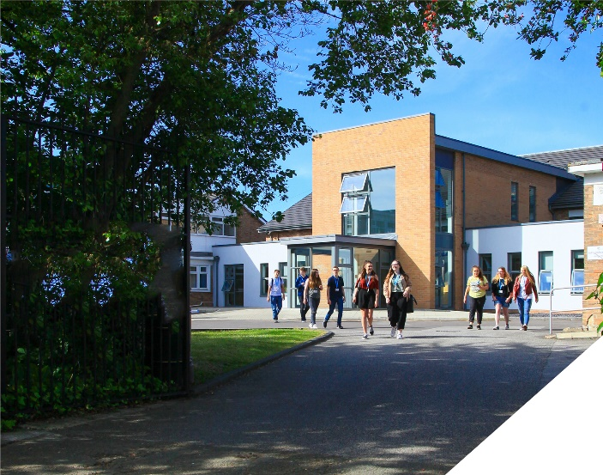
This is an exciting opportunity to teach A-level Psychology in one of the leading sixth form Colleges in the country.
reports to: Head of Psychology
hours: Full time, Permanent
salary: T1-T9 £30,500- £47,133 (FTE)
start date: 20th August 2024
about the role.
This is an exciting opportunity to teach Psychology at a highly regarded Sixth Form College. We seek to appoint a committed and hardworking Psychology teacher who is keen teach exclusively at Post 16 level. The role is to teach A-level Psychology, AQA Specification. You will join a large department where over 500 students study Psychology over the 2 year groups. The benefits of being part of a large department is that you will only teach your specialism and will also have the opportunity to collaborate with colleagues who are Psychology specialists. Numerous members of the team are also examiners and share their insight and knowledge regularly.
The Psychology department have recently moved into a new building which is a modern 3 storey suite of classrooms with a computer room on the ground floor and a staff work area on the top floor. All classrooms are very spacious and benefit from large interactive screens. In this role you would be expected to support the department with extra-curricular opportunities including visits and guest speakers. The department currently host a brain day where a neuroscientists delivers an engaging talk on the faulty brain linked with deviancy.
Both experienced teachers and NQTs are encouraged to apply. Whatever your experience you will be supported in a way that best supports your development in a College renowned for its innovation as well as the exceptional progress of its students.
about the College.
You will be joining a highly successful, innovative and nationally recognised sixth form College. The College has received numerous awards for innovation, social mobility and student experience. The most recent being in November 2023 where the College won ‘Most inspiring Sixth Form’ at the Educate North Awards.

In response to the pandemic and disruption to the learning of students, the College introduced a new timetable in 2021/2022 to combat the deficits that students have. This timetable has huge benefits to both students and teachers. Students receive an additional 60 minutes teacher each week, meaning that students will receive 5.5 hours of teaching in each of their subjects. Whilst student contact time has increased, the new timetable has reduced the overall teaching time for teachers each week. Full time teachers will teach a maximum of 4 classes, 4 times a week and teachers have their own groups. This is designed to give teachers the time to plan, assess and monitor their students. The timetable change has been a major success.

The College currently has a 16 to 19-year-old student population of 1500. Demand for places for places at the College is very high and as a result the College has recently expanded with the opening of a 1.7m new state of the art teaching facility in September 2021. A further brand new 3 storey classroom block was opened in April 2023 as part of the College’s expansion project.

The College is committed to its core values of Positivity, Ambition, Resilience and Thoughtfulness, and these values shape everything we do. Our ethos is centred on the scientific evidence that tells us that everyone can achieve success through purposeful hard work as opposed to the talent myth, and this enables learners to make rapid progress unshackled by any limits previously placed upon them.

person specification.
Qualifications | essential | desirable
Degree in Psychology or an equivalent qualification | 
Qualified Teacher Status | 
Experience
Experience of teaching A-Level Psychology | 
Experience of teaching AQA Psychology |  | 
Experience of working in a demanding environment where high levels of organisation are required | 
Knowledge / Skills / Abilities
Ability to teach A-level Psychology | 
Up to date knowledge & understanding of educational developments relating to the curriculum area | 
Ability to work flexibly as part of a team | 
Ability to form & maintain appropriate relationships & personal boundaries with young people | 
Ability to respond flexibly & creatively to new challenges & opportunities | 
Ability to prioritise & meet deadlines | 
Ability to use Information Technology effectively | 
Excellent communication, interpersonal & organisational skills | 
To demonstrate a commitment to
The Colleges values of Positivity, Ambition, Resilience & Thoughtfulness | 
Personal development and training | 
Safeguarding & promoting the welfare of students | 
Equality & diversity | 

how to apply.
If you are ambitious and determined to make a meaningful difference in one of the country’s leading sixth form Colleges then we would be thrilled to have you join our team.

There are 3 parts to your application please ensure you submit all three to be considered:-

- Complete Application form
Please complete the Teacher Application Form which is available on the College website: www.bsfc.ac.uk

- Summarise your results
Please submit a summary of the last 3 years of examination results this can be included in the appropriate section in the application form or as a separate document (if appropriate – if you are an NQT please skip this part of the application procedure)

- Complete personalised questions
On a separate document, answer the following specific questions (each question should be answered separately with each answer being no more than 150 words):

- Aside from your stated qualifications, please outline what you believe makes you academically suited to the position applied for.
- The College does not currently operate a gifted and talented programme. What is your view on this approach?
- Please identify one or two skills or techniques you have used in the classroom to drive learning.
- Select one of the College values and describe ways you demonstrate this in your day to day work.
- You should have provided an accompanying sheet summarising the results you have achieved over the last three years. Is there any context or background you would like to give to these?

Please email these to: hrdept@bsfc.ac.uk

closing date: 12 noon on Tuesday May 7th 2024

Application Form can be downloaded from the College website: www.bsfc.ac.uk

General Information
Birkenhead Sixth Form College has a commitment to safeguarding and promoting the welfare of students and expects all staff and volunteers to share this commitment. If you are invited for interview, your suitability to work with children will be explored as well as your suitability for the post.
All posts are subject to Enhanced Disclosure Clearance through the Disclosure & Barring Service.
The College is an Equal Opportunities employer and all members of the College have a personal responsibility to implement the policy, to carry out their responsibilities in accordance with it and to maintain an equality of opportunity for all.
The Governors and staff of the College take their duties under the Disability Discrimination Act (as amended by the Special Educational Needs Act 2001) very seriously. They will ensure that all reasonable adjustments are made to ensure that disabled people are treated fairly and that they are not placed at any substantial disadvantage. The College is committed to interview all applicants with a disability who meet the minimum criteria for the post and to consider them on their abilities.

Reference Checking

On the application form, you are asked to provide details of two employment referees (preferably your line manager from your current and previous or most recent employer/s), who can comment on your suitability for the post. References from relatives or individuals writing in the capacity of friends will not be accepted.

The College will seek references on short-listed applicants before interview, and will approach previous employers for information to verify suitability for the post, dates of employment, particular experience or qualifications, attendance / punctuality history and details of any disciplinary offences.

In addition, if you are currently working with children or young people, on either a paid or voluntary basis, your current employer will be asked about your suitability to work with children and any disciplinary offences relating to children or young people. This will include any offences for which the penalty is time expired (that is where a warning could no longer be taken into account in any new disciplinary hearing for example) and whether you have been the subject of any child protection concerns, and if so, the outcome of any enquiry or disciplinary procedures. If you are not currently working with children but have done so in the past, that previous employer will be asked about those issues. Please note providing false information is an offence and could result in your application being rejected, or dismissal without notice if you have been appointed and possible referral to the police.

