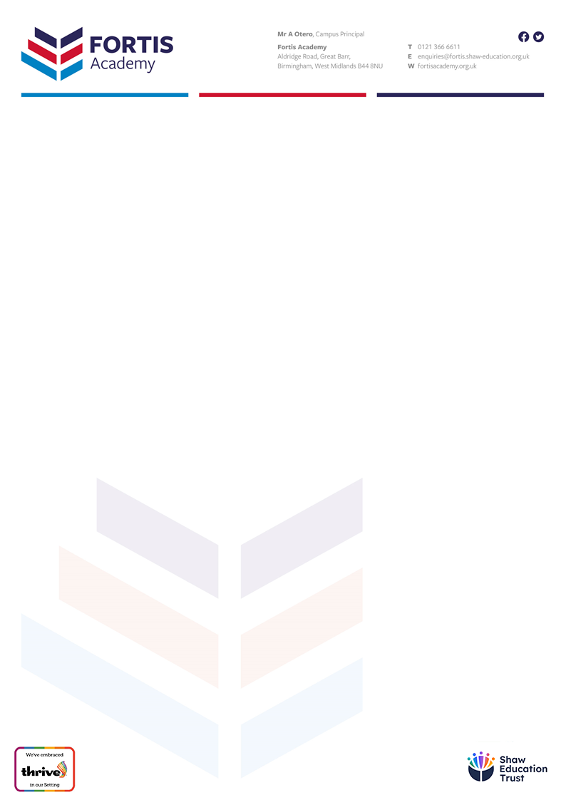

Dear Colleague,

A very warm welcome to Fortis Academy and thank you for considering us as a prospective employer. I hope that you find all the answers to your questions as you consider joining us.

It is an exciting time to be working here at Fortis. Following our inception in September 2022, we have been working hard to create a progressive and forwards-thinking school of the future, evidenced by our firm commitment to digital technology. Our Year 7 students in September 2022 will be learning with iPads as our first phase of our Digital Transformation Strategy. We plan to roll this out to other year groups too in the coming months and years.

We have a very supportive Trust, who care deeply about their employees. Our CPD opportunities, from Trust-wide INSET days to Masters degrees are all on offer to all employees. Working with The Shaw Education Trust will allow you to flourish and develop into the teacher you want to be, with support and guidance at every step.

Working at Fortis will develop you professionally, culturally and spiritually; our students have a lot to give and will work hard with you to develop their own life chances. Our parents and carers trust us, are supportive and allow the partnership between home and school to develop.

I urge you to come and see what we are doing here, and I very much hope you choose us as your next step in your teaching career.

I look forward to meeting you.

With every good wish,

**Christopher Czepukojć**

**Headteacher**

**Senior Academy**