

Role: Teacher of Psychology Full/Part Time
Starting date: 1st September 2026
Closing date for applications: Monday 18th May 2026 - Midday
Thank you for your interest in Sandbach High School and Sixth Form College. We hope that our website will help you to find out more information about what it is like to be a member of staff at our school.

We are a community in which our students and staff strive for excellence. Our values are at the core of our school; they are our promise to our families that within the school we will: Create Opportunities, Shape Futures, Learn with Passion, Nurture Ambition and Respect Difference. Our students want to make a difference in the world and our Curriculum is the springboard that enables them to achieve their ambitions.
We care about our students. We care about their wellbeing, their personal development and them as people. They are the heart of what we do as educators. We are teachers of children first, subjects second.

Standards of uniform, behaviour, attendance, punctuality and attitudes to learning are high here. We believe that the small things matter. Students are safe here in the knowledge about the clear expectations around these standards as they see visible consistency in the application of them.
Our parents/carers know that we ensure that the very best potential is realised for all of our
students because we have the highest standards. We are here to ensure that the very best life chances are achieved by our students. We have a track record of students attending the very best universities, securing sought after Apprenticeships and making a real difference in our community and further afield.

Sandbach High School and Sixth Form College has a rich culture of the Arts, STEM, Sport and our impressive extended Curriculum. We know that a well- rounded school experience should be diverse and offer a wealth of opportunity and that is offered here in abundance. You can be confident in the knowledge that students are attending a school with consistently high academic achievement within a warm community who are kind and compassionate to each other.
Our success as a school is a combined effort of dedicated staff, supportive families and our hardworking students.
If you would like to know more, we would welcome you to contact us.

Ellen Walton
Headteacher
Sandbach High School and Sixth Form College


Teacher of Psychology

Appointment Type | Permanent
Start Date | 1st September 2026
Salary Scale | MPS/UPS
Closing Date | Monday 18th May 2026 Midday
Interview Date | TBC
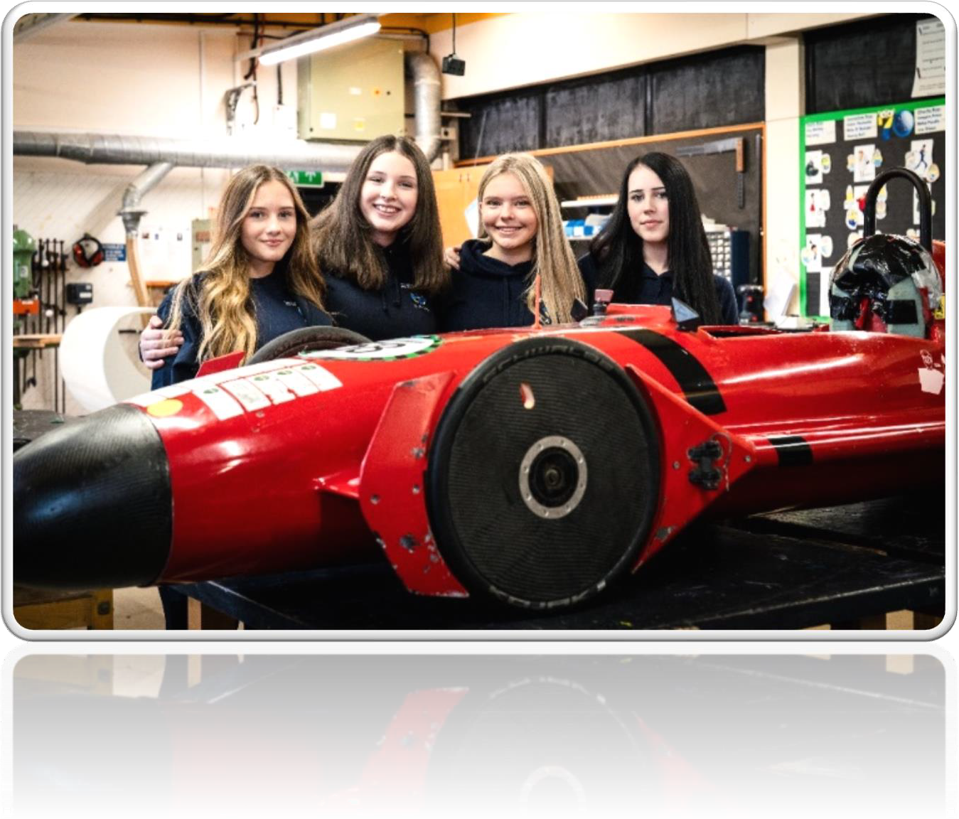

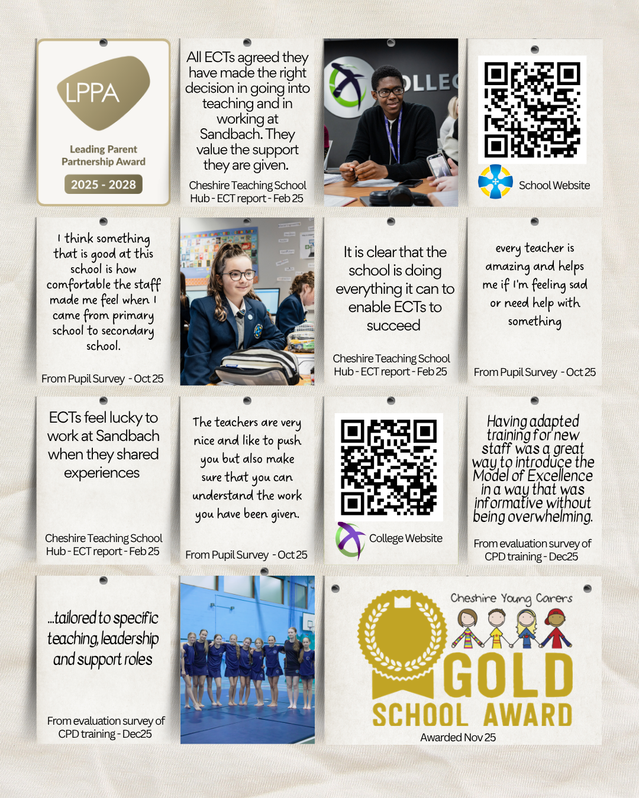

Who we are
Sandbach High School and Sixth Form College are proud to be registered with ‘Investors In People’ and continue to support the development of our teachers and support staff. We offer regular training programmes as well as staff well-being activities. Our school offers an exciting, rewarding and supportive environment for all our staff enabling them to grow and build on their skills.

We take pride in being a caring and well-ordered community where everyone is encouraged to develop self-awareness and personal responsibility and play a full part in the life of the school. Our Code of Conduct is based on respect, courtesy and consideration. We make sure that students who work hard, help others and show responsibility in their behaviour are properly recognised through our awards system. Commitment and success in sport or music are celebrated in the award of distinctive colours badges.

Our extensive curriculum is broad and balanced, giving all students the opportunity to develop their potential. A wide range of learning and teaching strategies is used to actively involve students in the learning process. Progress is carefully assessed and monitored.

Vision
An ambitious school with positive role models at every level across the school community. We strive for excellence in academic achievement and personal development. A school with visible consistency and kindness in its high standards of behaviour and attitudes. A school with research-led Quality First Teaching ensuring that all children from all backgrounds can achieve the very best life chances through creativity and a passion for learning.

Key Priorities
Key Priorities for 2025-2026

- To embed a culture of high expectations and our Model of Excellence across our whole school community.
- Securing assessment of knowledge for all including those who are disadvantaged or SEND
- To develop a positive culture amongst students and staff where we lead for legacy and in the service of others.

Values
  - Shaping Futures ♦ Learning with Passion ♦ Respecting Difference
    - Nurturing Ambition ♦ Creating Opportunity ♦THIS is our Community

Who are we looking to appoint?
The Board of Trustees are seeking a well-qualified, enthusiastic and inspiring graduate to join our Social Sciences department as Teacher of Psychology.

The successful candidate will be creative, imaginative and an excellent team player with a proven record of excellence in the classroom.
Applications from experienced and recently qualified teachers are welcomed.

The ideal candidate will:
- Be a well-qualified Psychology teacher with a record of planning and delivering lessons that are engaging challenging and enjoyable to pupils of all ability levels.
- Have a PGCE qualification (or will have obtained one by September 2026) and QTS.
- Have the ability to teach pupils throughout KS4 and KS5.
- Be able to inspire and make positive relationships with students to encourage great learning.
- Have evidence of supporting students to reach their full potential.
- Be a resilient character with a strong personal drive.

We can offer you:
    - The opportunity to work in an Ofsted rated ‘Good’ school.
    - The opportunity to develop and grow as a leader beyond the signposted role.
    - The opportunity to work with a supportive and forward-thinking Curriculum Leader.
    - The opportunity to hold a whole school responsibility to develop strategic thinking and leadership skills.
    - The opportunity to work alongside a collaborative, forward thinking Headteacher and Senior Leadership Team whose priority is to support and develop you.
    - Friendly and highly motivated students who are keen to learn and take pride in their achievements.
    - A comprehensive induction programme when joining the school
    - An Investors in People approved school where staff are supported and encouraged to take part in professional development programmes with the opportunity to share best practice within your own department and with staff from other specialisms.

    - A fantastic school to gain a wealth of experience to grow your career.

Job Description – Teacher of Psychology

Job Title: Teacher of Psychology

Accountable to: Curriculum Leader of Business, Computing and Social Science
Job Purpose:
To contribute to raising standards of student achievement in Psychology by teaching a timetable of lessons and supporting the Curriculum Leader in the achievement of whole school and department goals as stated in the department’s strategic plan.

Key Responsibilities
Teaching
- To have high expectations of all students and ensure that they are stretched and challenged.
- To use effective teaching and learning strategies to promote student-led learning and develop independent, resilient and confident students.
- To assess, record and report on the attainment, attendance and progress of students.
- To be aware of the needs of all students and groups and to make provision for this in lesson planning.
- To provide or contribute to oral and written assessments, reports and references relating to individual or groups of students.
- To prepare and update subject resources.
- To maintain discipline in accordance with the school’s procedures and encourage good practice with regard to punctuality, behaviour and standards of work.
- To assess students’ work in line with school policies and procedures, with reference to student performance targets.

Curriculum Provision & Development
- To assist the Subject Leader in the development of appropriate syllabuses, resources, schemes of work and teaching strategies.
- To contribute to the development and implementation of the subject’s strategic plan.
- To plan and prepare courses and lessons.
- To attend and contribute to subject meetings.
- To contribute towards the planning and implementation of Enrichment days.

Monitoring & Evaluation
- To use external and internal data to assess student performance and to develop appropriate courses of action.
- To regularly review teaching methods.
- To produce termly effort and attainment monitoring grades for all students taught.
Pastoral
- To be a form tutor to an assigned group of students.
- To liaise with Senior Leadership Team in implementing the school’s pastoral policies.
- To register students and mentor them during assembly time.
- To enable, encourage and support a form’s participation in the Student Voice.
- To communicate with parents and outside bodies as appropriate.
- To attend form tutor meetings.

Other Responsibilities
- To participate in the school’s CPD programme.
- To continue personal development in relevant areas, especially subject knowledge and teaching methods
- To engage actively with the school’s performance management programme.
- Where appropriate, ensure the effective deployment of classroom support.
- To work as a member of a team, positively contributing to effective working relations within the school.
- To communicate, where necessary with parents and external bodies, following school policies.
- To attend Open Evenings, Parents’ Evenings and Presentation Evenings.
- To report to the school’s Health and Safety Co-ordinator regarding any Fire, Health & Safety issues undertaking risk assessments where necessary.
- To undertake appropriate supervision of pupils on a rota basis, before school, at break and lunch.

All teaching staff are responsible for promoting and safeguarding the welfare of students they are responsible for or with whom they come into contact.

Person Specification
The Trustees are seeking to appoint a graduate who is able to demonstrate the following qualities and experience:
Key: AF Application Form I Interview LO Lesson observation R References

CRITERIA | ESSENTIAL |  | DESIRABLE
Qualifications | - Well qualified graduate in Psychology.  - Qualified teacher, or expect to gain QTS by the start of the contract.  - Secure subject knowledge |  | - Ability to teach another relevant subject  - Evidence of continuing professional development. | AF  LO  I
Experience | - Excellent classroom teacher across 11-18 age range.  - Evidence of ambition and contribution to the development of teaching and learning.  - Proven record or evidence from teaching practice of potential to help students reach high standards of learning and achievement. |  | - Understand the importance of the pastoral role of every teacher.  - Experience in the use of ICT in the classroom. | AF  LO  I
Knowledge | - High standard of subject knowledge.  - Knowledge of current developments in Teaching & Learning.  - Understanding and use of strategies to raise achievement. |  | - Experience and understanding of helping low achievers. | AF  I  R
Personality | - Demonstrate a positive & enthusiastic outlook.  - Ambitious with a drive to succeed.  - Ability to inspire & motivate students and peers.  - Commitment to safeguard & promote the welfare of children.  - Pleasant manner. |  | - Self confidence  - Flexibility/adaptability | AF  LO  I  R
Special Aptitudes | - Professionalism/integrity.  - Excellent classroom practitioner with the ability to inspire in students a desire to learn and participate both inside and outside the classroom  - Passion and commitment to developing students’ skills alongside your own  - Play full role in departmental development, especially contributing to teaching & learning materials. |  | - Ability to motivate and inspire others  - Understanding of the importance of assessment and tracking in achieving the best outcomes for every student  - Ambitious and keen to undertake continuing professional development.  - Flexible and innovative | AF  LO  I  R
Interpersonal Skills | - A good communicator  - Work with energy, commitment and good humour  - Be an effective team member, proactive at contributing to departmental activities |  |  | AF  I  R  R
Personal Attributes |  | Desire to contribute to and be involved in the wider life of the school.  Good record of attendance and punctuality.  Have a passionate commitment to our school’s ethos  Organised with excellent time management and planning skills |  | AF  I  R

The Rehabilitation of Offenders Act

The Rehabilitation of Offenders Act allows for a person who has been convicted of a criminal
offence involving a sentence of not more than 2½ years imprisonment and who has since lived trouble free for a specified period of time (related to the severity of the offence) to be treated as if the offence, conviction or sentence had never occurred. This is known as a spent conviction.* This job is one of those to which the provisions of the above Act in relation to spent convictions*, do not apply. Applicants must therefore disclose whether they have any previous convictions*, whether or not they are spent.
Should an applicant have a criminal conviction*, this will be discussed in confidence at interview. However only convictions* that are relevant to the job in question will be taken into account.
Failure to disclose any conviction could lead to an application being rejected, or, if appointed, may lead later to dismissal.
Certain spent convictions* are ‘protected’ and are not subject to disclosure to employers, and cannot be taken into account by a recruitment manager. Guidance and criteria on the filtering of these convictions* can be found at the following link:
http://www.legislation.gov.uk/uksi/2013/1198/pdfs/uksi_20131198_en.pdf
*including cautions, reprimands or warnings.
People who have convictions will be treated fairly and given every opportunity to establish their suitability for the job, all applicants will be considered on merit and ability.
Any information that you give will be kept in strict confidence and will be used only in respect of your application for the job.

Disclosure & Barring Service (DBS)
Successful applicants will be asked to apply for an Enhanced Criminal Record Check (Disclosure) from the Disclosure and Barring service.
A copy of the Disclosure and Barring Service Code of Practice is available on request.
Further information about the Disclosure scheme can be found at
https://www.gov.uk/government/organisations/disclosure-and-barring-service

Safeguarding Children
Sandbach High School and Sixth Form College is committed to safeguarding and promoting the welfare of children and young people and expects all staff and volunteers to share this commitment.

All staff at Sandbach High School and Sixth Form College are expected:
- To adhere to the school’s corporate standards, policies, systems and procedures in relation to Safeguarding and Child Protection, and health and safety
- To set a personal example that contributes to the positive ethos of the school
- To be committed to the life of the school and to support its distinctive mission and ethos
- To behave at all times in accordance with the school’s values
- To agree annual performance targets with their Line Manager
- To promote the school favourably in the community
- To engage actively in the performance review process, addressing appraisal targets set in conjunction with the line manager each autumn term.
- To participate in training and other professional development learning activities as required.
- To promote equal opportunities and celebrate diversity in all aspects of the school.
- To play a full part in the life of the school community, to support its distinctive aim and ethos and to encourage staff and students to follow this example.
- To adhere to the school’s Staff Code of Conduct and the Dress Presentation Code.
- To comply with the school’s Health and Safety policy and undertake risk assessments as appropriate.
- To be familiar with and promote safeguarding requirements, demonstrating adherence to the DfE Guidance ‘Keeping Children Safe in Education’ and the school’s Safeguarding/Child Protection policies.
- To be aware of and comply with all school policies and procedures, in particular those relating to conduct, child protection (as above), health, safety and security, confidentiality and data protection, reporting all concerns to an appropriate person.

Safeguarding
Sandbach High School and Sixth Form College is committed to keeping children, young people and vulnerable adults safe. The post holder is responsible for promoting and safeguarding the welfare of the children, young people and vulnerable adults for whom she/he is responsible or comes into contact with.

Health & Safety
The post holder will be responsible for his/her own health and safety. All duties and responsibilities must be carried out in line with the specific requirements detailed in the school Health and Safety policies.

Policies & Procedures
The post holder will be accountable for ensuring that he/she is aware of relevant school policies and that all duties and responsibilities are carried out in line with the appropriate policies and procedures.

Equality Act 2010
The school will endeavour to make any necessary reasonable adjustments to the job and the working environment to enable access to employment opportunities for disabled job applicants or continued employment for any employee who develops a disabling condition (as defined in the Equality Act 2010).

Applications
We promote applications from all sections of the community, irrespective of background, belief, or identity, recognising the benefits that a diverse organisation can bring.
To apply for this post, please complete an application form with a supporting statement of no more than two sides of A4 on your suitability for the post and the school, with reference to your areas of expertise. Please send completed forms to recruitment@sandbachhigh.co.uk

