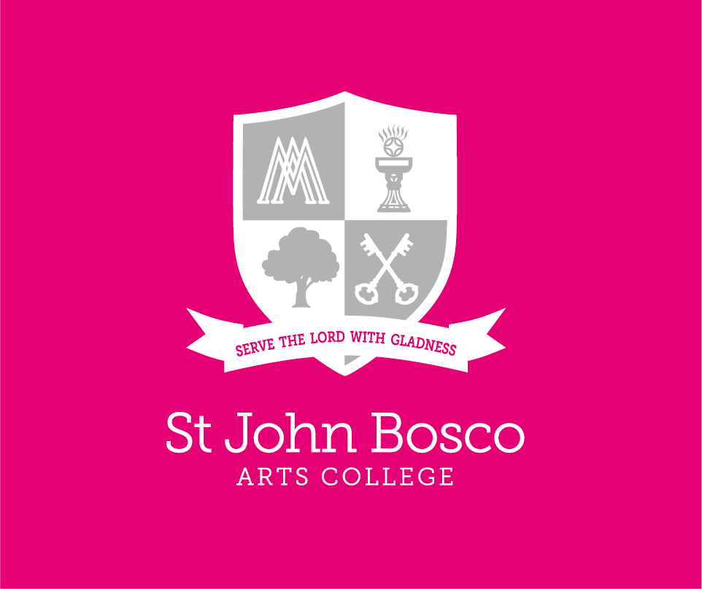

Teacher of RE and KS4 Coordinator

May 2024

# VISION AND VALUES



# Contact details:

[www.stjohnboscoartscollege.com](http://www.stjohnboscoartscollege.com)

St John Bosco Arts College, Storrington Avenue, Liverpool L11 9DQ

Tel: 0151 330 5142

Email: enquiries@stjohnbosco.org.uk

**Table of Contents**

**LETTER FROM THE HEADTEACHER 3**

VISION AND VALUES 2

Contact details: 3

Letter from the Headteacher 4

Job Advertisement 5

Our Curriculum 6

Bosco Benefits 7

JOB DESCRIPTION 8

Person Specification 10

# Letter from the Headteacher

May 2024

Dear Prospective Candidate,

I am delighted to invite you to join the dedicated teaching staff at St John Bosco Arts College as the Second in Department/KS4 Lead in Religious Education. This vital role offers you the chance to profoundly shape the spiritual and moral development of our students during a crucial phase of their education and personal development.

At St John Bosco Arts College, our mission is rooted in a deep commitment to Catholic values—love, faith, community, respect, and hope. We strive to create a nurturing environment that not only supports academic success but also fosters spiritual growth and character formation.

**The Role:**  
As the KS4 Lead in Religious Education, you will oversee the delivery and development of our Key Stage 4 RE curriculum. Your leadership will be pivotal in enhancing the quality of our teaching and enriching the learning experiences of our students. In collaboration with the RE team and the Senior Leadership Team, you will spearhead initiatives that nurture both academic excellence and spiritual depth.

**About You:**  
We are seeking a candidate with a robust background in teaching RE at the GCSE level, who embodies our ethos of educational excellence infused with faith. Your innovative approach, drive, and inspirational nature will be crucial in motivating both staff and students. Your dedication to ongoing professional development and curriculum enhancement will be key to our collective success.

**Next Steps:**  
To discover more about how you can contribute to and benefit from our vision, I warmly encourage you to arrange a visit to our school. Please contact Caroline Waters, our Executive Officer, at 0151 330 5142 or via email at watersc@stjohnbosco.org.uk to schedule your visit.

**Join Us:**  
If you are passionate about making a significant impact in a faith-centered educational environment, we would be honoured to receive your application. We look forward to the possibility of you joining our community to help us live out our motto: together we inspire each other to flourish.

We eagerly await your response to join us in this mission.

With every good wish,

Darren Gidman  
Headteacher  
St John Bosco Arts College

# Job Advertisement

## Teacher of RE and KS4 Coordinator

**Reports to:** Head of RE and Catholic Life

**Start Date:** 1st September 2024

**Salary:** MPS/UPS plus TLR 2B

**The Governors of St John Bosco Arts College, an 11-18 Girls Catholic Specialist Arts College, are on the lookout for a highly skilled, motivated, and dynamic KS4 RE Coordinator. This pivotal role focuses on elevating the standards of KS4 RE provision, requiring a candidate who is not only proficient in their field but also passionate about enhancing educational outcomes for our students.**

We are seeking an experienced individual who can effectively translate educational policies into impactful teaching practices. The ideal candidate will have a vision for advancing RE education, demonstrating the ability to lead, inspire, and motivate both staff and students. Strong interpersonal, organisational, and communication skills are paramount.

Candidates are invited to reflect on the job description/person specification, expressing how they meet the outlined criteria and the unique qualities and experiences they can bring to this role.

If you're driven by a desire to make a significant difference in the lives of students at St John Bosco Arts College, we would love to hear from you. This role offers a fantastic opportunity to join our team and contribute to shaping the future of RE education within our community.

Potential applicants are encouraged to contact Mrs Caroline Waters, Executive Officer, for a more in-depth discussion. Join us in our mission to inspire and elevate the next generation of scientists.

As part of the shortlisting, we will carry out an online search as part of due diligence on the shortlisted candidates. This may help identify any incidents or issues that have happened, and are publicly available online, which the college might want to explore with the applicant at interview.

Our school is committed to safeguarding children and has safer recruitment procedures in keeping with DFE statutory guidance. All posts are subject to the required DFE preemployment checks being completed including an Enhanced DBS Certificate [including a Children’s Barred List Check]. Our recruitment pack contains key safeguarding policies including our code of conduct for staff and volunteers which everyone must adhere to.

# Our Curriculum

Find out more about our [RE curriculum here](https://www.stjohnboscoartscollege.com/students/curriculum/re/).

We believe our students should be provided with a broad, balanced, rich, coherent, progressive curriculum with the EBacc at the core. This curriculum should promote spiritual, moral, cultural, mental and physical development of the pupils and prepare them for the opportunities, responsibilities and experiences of adult life.

The curriculum aims to enable all pupils to become:

* Creative learners – who enjoy learning, make progress and achieve well
* Confident individuals – who are able to lead safe and healthy lives
* Caring citizens – who make a positive contribution to society

Equality of access and opportunity is central to our curriculum provision for all.

We have an effective governing body who alongside the leadership team, encourage collaboration, promote a coaching culture, and build capacity across the whole school. Our innovative curriculum is developed and delivered by expert staff.

We provide excellent CDP opportunities.

**Learn more about St John Bosco and his story…**

<https://www.youtube.com/watch?v=5rXZxoLCkes>

<http://www.donboscowest.org/saints/donbosco>

# Bosco Benefits

At St John Bosco Arts College, we pride ourselves on offering our staff a range of benefits that help them to thrive both in and out of work. Here are just some of the benefits of being an employee at our school:

* Outstanding CPD opportunities and development, facilitated by our in-house Teacher Development Partnership and our role as part of a Teaching School Hub, which provides a broad network of connections across the city region.
* Pupils who are a joy to work with and for, as well as colleagues who are fully committed and go above and beyond to serve the pupils and support each other.
* A Communications Policy that promotes better work-life balance, allowing you to maintain a healthy equilibrium between your professional and personal life.
* A state-of-the-art building, featuring modern facilities and a well-designed workspace.
* Beautiful gardens and excellent facilities that help to create a positive and vibrant learning environment.
* Dedicated working parties that support staff in areas such as appraisal, teaching and learning, workload, and diversity.
* Opportunities for dedicated career conversations, which can help you to plan your professional development and identify new areas of growth.
* Dedicated collaborative time, enabling you to work alongside your colleagues and share ideas and expertise.
* We are proud to be a cornerstone and pilot of establishing the DfE workload reduction toolkit, demonstrating our commitment to reducing teacher workload and improving well-being.
* A range of Salary Sacrifice Schemes, enabling you to access cost savings on a variety of purchases and expenses.
* A Cycle to Work Scheme, allowing you to save money and stay healthy by cycling to work.
* Access to Medicash, providing valuable health and well-being benefits to all employees.
* Free tea and coffee, as well as delicious and healthy food available at school canteen prices.

We are proud to offer our staff a range of benefits that help them to thrive both in and out of work. If you join us, we believe you will find a welcoming and supportive community that will help you to achieve your professional goals while maintaining a healthy balance in your personal life.

# Key Stage 4 Coordinator: RE

JOB DESCRIPTION

# Job Description

**Second in RE with specific responsibility for Key Stage 4**

**SALARY GRADE:**  TLR 2B

**RESPONSIBLE TO**: i] Headteacher

1. Deputy Headteacher
2. Line Manager
3. Subject Leader

This job description is additional to the basic duties outlined in the latest School Teachers’ Pay and Conditions Document in accordance with the school’s policies and under the direction of the Headteacher. A summary of the key accountabilities is included below. The school is managed through a network of inter-related teams.

The Second in RE with specific responsibility for Key Stage 4 provides professional leadership and management within the subject area but specifically for Key Stage 4 to secure a high-quality curriculum, quality first teaching, effective use of resources and improved standards of learning and achievement for all pupils. Alongside the subject leader, the Second in RE has responsibility for the intent, implementation and impact of the KS4 RE curriculum within and beyond the classroom.

All sections of this Job Description that follow are subject specific. Although the specific aspects relate to key stage 4, it is expected that Second in RE would deputise for the subject leader as required and thereby have oversight of key stage 3 also.

**Have knowledge and understanding of:**

* The college’s aims, priorities, targets and action plans;
* The relationship of Key Stage 4 RE to the curriculum as a whole;
* Any statutory curriculum requirements and the requirements for assessment, recording and reporting of pupils’ attainment and progress within Key Stage 4;
* The characteristics of high-quality teaching and the main strategies for improving and sustaining high standards of teaching, learning and achievement for all pupils within RE, focussing particularly on Key Stage 4;
* Management, including employment law, equal opportunities legislation, personnel, external relations, finance and change within Key Stage 4;
* The implications of the code of practice for special educational needs for teaching and learning within Key Stage 4.

**Planning and setting expectations:**

* Set expectations and targets for staff and pupils within Key Stage 4 in relation to standards of pupil achievement and the quality of teaching.
* Work with the SENDCO and any other staff with Special Educational Needs expertise, to ensure that individual education plans are used to set subject specific targets and match work well to pupils’ needs.
* Establish, with the involvement of relevant staff, short, medium and long term plans for the development and resourcing of Key Stage 4 RE which:
* contribute to whole-school aims, policies and practices including those in relation to behaviour, discipline, bullying and racial harassment;
* are based on a range of comparative information and evidence, including the attainment of pupils;
* identify realistic and challenging targets for improvement;
* are understood by all those involved in putting the plans into practice;
* are clear about action to be taken, timescales and criteria for success.

**Teaching and managing pupil learning in Key Stage 4**

**Ensure:**

* Curriculum coverage, continuity and progression in the Key Stage 4 RE for all pupils, including those of high ability and those with special educational or linguistic needs.
* Teachers are clear about the teaching of objectives in lessons, understand the sequence of teaching and learning in the subject, and communicate such information to pupils.
* Guidance is provided on the choice of appropriate teaching and learning methods to meet the needs of the subject and of different pupils.
* Effective development of pupils’ literacy, numeracy and information technology skills through the subject.
* Teachers of the subject are aware of its contribution to pupils’ understanding of the duties, opportunities, responsibilities and rights of citizens.
* The curriculum is diverse and inclusive. Teachers of the subject are supported in developing their knowledge and understanding of cultural literacy and that they know how to ensure their classrooms are inclusive and no place for discrimination.
* Effective development of pupils’ individual and collaborative study skills necessary for them to become increasingly independent when out of school.

**Assessment and evaluation within Key Stage 4:**

* Analyse and interpret relevant national, local and school data, research and inspection evidence to inform policies, practices, expectations, targets and teaching methods.
* Establish and implement clear policies and practices for assessing, recording and reporting on pupil achievement, and for using this information to recognise achievement and to assist pupils in setting targets for further improvement.
* Ensure that information about pupils’ achievements in previous classes and schools is used effectively to secure good progress in the subject.
* Monitor the progress made in achieving subject plans and targets, evaluate the effects on teaching and learning, and use this analysis to guide further improvement.
* Evaluate the teaching of the subject in the school, use this analysis to identify effective practice and areas for improvement and take action to improve further the quality of teaching.

**Pupil Achievement** **within Key Stage 4:**

* Establish clear targets for pupils’ achievement, and evaluate progress and achievement by all pupils, including those with special educational linguistic needs.
* Use data effectively to identify pupils who are underachieving and, where necessary, create and implement effective plans of action to support those pupils.

**Relations with parents and wider community [Key Stage 4]:**

* Establish a partnership with parents to involve them in their child’s learning of the subject, as well as providing information about curriculum, attainment, progress and targets.
* Develop effective links with the local community, including business and industry, in order to extend the subject, enhance teaching and develop the pupils’ wider understanding.
* Communicate effectively, orally and in writing, with parents, governors, external agencies and the wider community, including business and industry.

**Managing own performance and development:**

* Prioritise and manage own time effectively, particularly in relation to balancing the demands made by teaching, subject management and involvement in school development.
* Achieve challenging professional goals.
* Take responsibility for own professional developments.

**Managing and developing staff and other adults:**

* Help staff to achieve constructive working relationships with pupils.
* Establish clear expectations and constructive working relationships among staff, including through team working and mutual support; devolve responsibilities and delegate tasks, evaluate practice, and develop an acceptance of accountability.
* Appraise staff as required by the school policy on Performance Management and use the process to develop the personal and professional effectiveness of the teacher.
* Lead professional development through example and support, and co-ordinate the provision of high-quality professional development by methods such as coaching, drawing on other sources of expertise as necessary, e.g.: higher education, subject associations, LAs and subject associations.

**Managing resource [Key Stage 4]:**

* Establish staff and resource needs and advise the Subject Leader and senior managers of likely priorities for expenditure and allocate available resources with maximum efficiency to meet the objectives of the school and subject plans and achieve value for money.
* Advise the Subject Leader on the deployment of staff involved in working with pupils with SEND to ensure the most efficient use of teaching and other expertise.
* Organise and co-ordinate the deployment of learning resources, including information and communications technology, and monitor their effectiveness.
* Maintain existing resources and explore opportunities to develop or incorporate new resources from the wide range of sources inside and outside the school.
* Ensure the effective and efficient management and organisation of learning resources, including information and communications technology.

**Strategic leadership:**

* Develop and implement policies and practices to ensure governors are well informed about subject priorities, plans and policies, the success in meeting objectives and targets, and subject-related professional development plans.

* Create a climate which enables other staff to develop and maintain positive attitudes towards the subject and confidence in teaching it.

# Person Specification

|  |  |  |
| --- | --- | --- |
|  | Essential | Desirable |
| **Qualifications** | * University graduate * Post graduate teaching qualification * Qualified teacher status | * Evidence of continuing professional development, e.g., attendance at relevant INSET |
| **Teaching Experience** | * At least two years’ successful teaching experience * Teaching experience across KS3/4/5 * Evidence of sustained positive value added at KS4 and KS5 * Evidence of consistently good teaching and learning * Excellent subject knowledge * Good knowledge of current curriculum development in your subject area * The ability to use ICT effectively to engage students * A good understanding of the principles of Assessment for Learning * An understanding of how to use assessment to inform planning for good teaching and learning * The ability to adapt the curriculum to meet the needs of learners * The ability to use data to inform planning * Evidence of pastoral experience, including taking responsibility for a form group * An interest in the wider curriculum. * A proven track record of strong examination results | * Successful teaching experience in an urban school * Evidence of outstanding teaching and learning                                * Evidence of using data to put in place successful intervention strategies to raise achievement * The ability to offer extra-curricular activities |
| **Leadership and Management** | * A good knowledge of curriculum initiatives impacting RE in schools * The ability to inspire and enthuse colleagues * The ability to improve the practice of others * The ability to evaluate standards of teaching and learning within your department | * A good knowledge of curriculum initiatives impacting schools at KS3, KS4 and KS5 * Evidence of using data to challenge underperformance and raise standards * Experience of the Performance Management Process |
| **Personal Qualities** | * A willingness to learn and develop new skills * The ambition to continue to progress in your career * A desire to make a difference to the lives of young people * To work proactively within the Catholic ethos of the college * An excellent attendance record * Resilience and a sense of humour |  |

[www.stjohnboscoartscollege.com](http://www.stjohnboscoartscollege.com)

Storrington Avenue, Liverpool L11 9DQ

Tel: 0151 330 5142

Email: enquiries@stjohnbosco.org.uk

|  |  |  |  |  |
| --- | --- | --- | --- | --- |
| **Contact Us** | Telephone | 0151 330 5142 | Internet | [www.stjohnboscoartscollege.com](https://www.stjohnboscoartscollege.com/)  [enquiries@stjohnbosco.org.uk](mailto:enquiries@stjohnbosco.org.uk) |