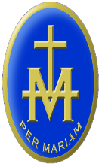

ST MARY’S RC HIGH SCHOOL

LUGWARDINE HEREFORD HR1 4DR

Archdiocese of Cardiff

Telephone: 01432 850416 email: admin@st-maryshigh.hereford.sch.uk

Headteacher: Mr S Wetson BA (Hons) PGCE NPQH

WELCOME TO RELIGIOUS EDUCATION
Our Departmental Prayer
"Heavenly Father,
May I live this day,
Compassionate of heart,
Gentle in word,
Kind in deed,
Gracious in awareness,
Courageous in thought,
Generous in love.
Amen

RE Staff: Mrs Bray (Head of Department), Mr Cook, Mr Coyne, Mrs Crowley, Mrs Surman
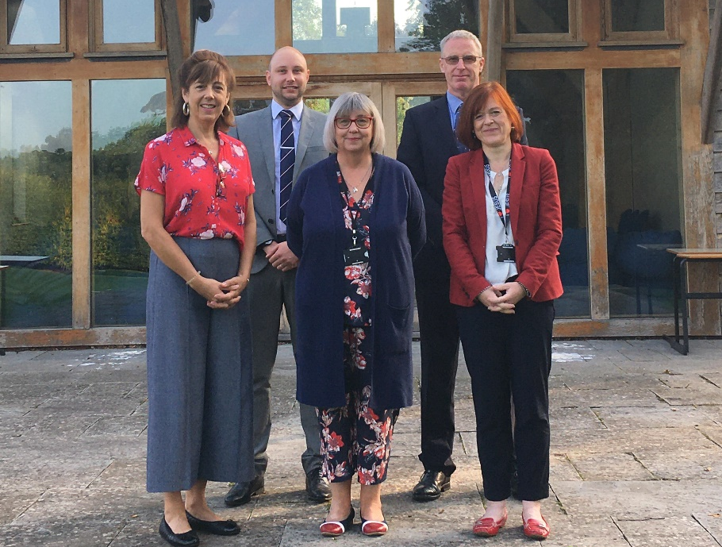
The R.E. Department in St. Mary’s is a thriving and challenging department in which to work. Our aim is the all-round development of the young people at the school, helping them to grow intellectually, spiritually and morally. This is a complex task, which involves striving for academic excellence, creating a safe place for the young people, and supporting them in their growth, as they develop a close, personal relationship with Christ.
Our Vision
Religious Education provokes challenging questions about the ultimate meaning and purpose of life, beliefs about God, the self and the nature of reality, issues of right and wrong and what it means to be human. It develops pupils’ knowledge and understanding of the nature of religion and belief including Christianity, other principal religions, other religious traditions, and world views that offer answers to these challenging questions. Religious Education offers opportunities for personal reflection and spiritual development. It enhances awareness and understanding of religions and beliefs, teachings, practices and forms of expression, and of the influence of religion on individuals, families, communities and cultures.

Teaching Staff
The Department has five members at present: A. Bray (Head of RE), Mr D Coyne (full time specialist), Mrs R Surman (full time specialist), Mr J Cook (part time specialist) and Mrs S Crowley (part time teacher of RE).
Curriculum
In line with the Archdiocese of Cardiff guidelines, St Mary’s teaches the “People of God” scheme of work at Key Stage 3. At Key Stage 4 all student are entered for GCSE and study the AQA Religious Studies B syllabus, focusing on the Catholic Christianity, Judaism and Ethics Theme B & C.
Trips & Activities in RE: Our biannual pilgrimages to Lourdes and Rome.
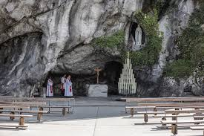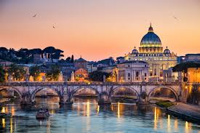

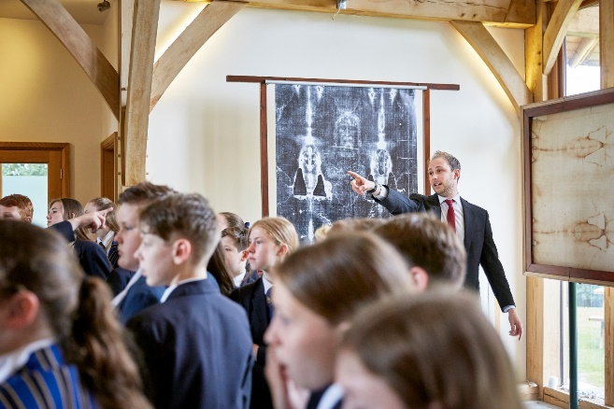
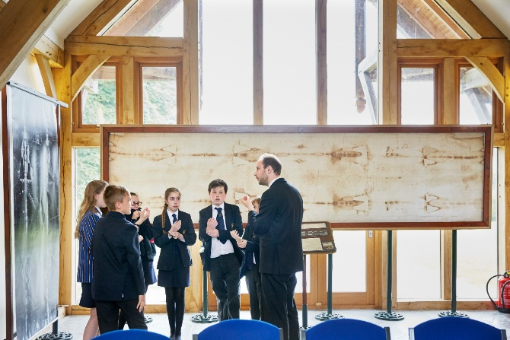
The Turin Shroud Exhibition in our chapel.
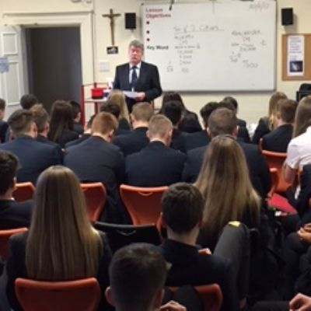
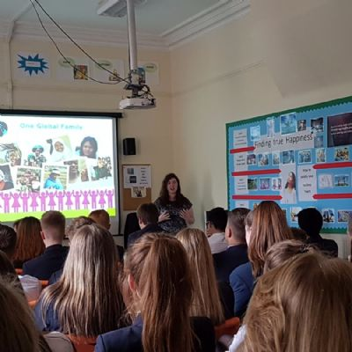
Outside speakers CAFOD trustee Charlotte Bray & Danny West from Life
talking about the work of their charities.

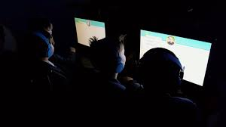
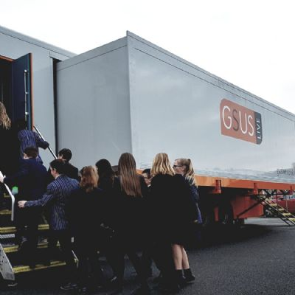
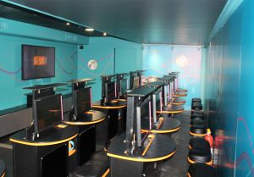
The GSUS Bus visits St Mary’s

Student Quotes about the R.E. Department
“R.E. is a relaxing and peaceful place where we work on charity and community.”
“R.E. is a brilliant subject. Meditation relaxes me and I feel well during the lesson!”
“When we talked about CAFOD and people who live in developing countries it makes you appreciate the things you have.”
“R.E. helps me to think about something away from my own life.”

The teaching of RE at St. Mary’s provides opportunities for:
Group work
Paired work
Whole class teaching
Individual work

Key personal, learning and thinking skills in Religious Education:
INVESTIGATE
gather information
ask relevant questions
use different sources
INTERPRET
draw meaning from artefacts, symbols, stories, poems and art.
REFLECT
ponder on feelings, relationships, experience, ultimate questions, beliefs and practices
EMPATHISE
consider the thoughts, feelings, experiences, beliefs, values of others
see the world through someone else’s eyes.
ANALYSE
draw out essential ideas, distinguish between opinion, belief and fact
distinguish between key features of different Faiths.
SYNTHESISE
make connections between ideas, beliefs, values, practices
EVALUATE
refer to different views and use reason to support one’s ideas
APPLY
apply what has been learnt about a religion to a new situation
EXPRESS
explain concepts, rituals, and practices
identify and express matters of deep concern by a variety of means – not only through words
respond to religious issues through a variety of media

