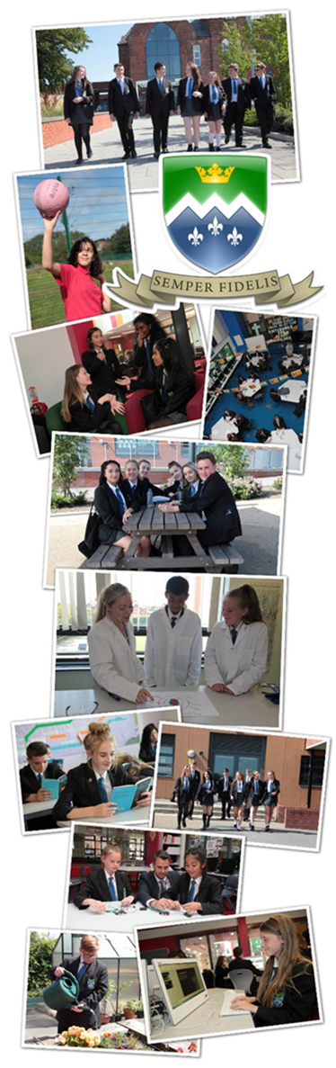

Subject Leader History

Information to Candidates

April 2022

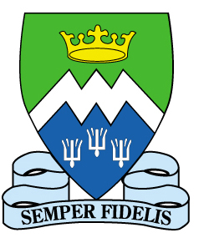
St Mary’s Catholic Academy
St Walburga’s Road
Blackpool. FY3 7EQ
Tel: 01253 396286
Email: admin@st-mary.blackpool.sch.uk
Web: www.st-mary.blackpool.sch.uk
Head Teacher: Mr. S. Eccles B.Sc. (Hons) MEd
Dear Colleague,

Thank you for considering St. Mary's Catholic Academy for the next stage in your career.
Governors are seeking to appoint a Subject Leader of History. The post is a full time, permanent role from 1st September 2022. The salary is main or upper pay scale plus TLR 2a. The role would be a fantastic opportunity for an outstanding, talented teacher with emerging leadership to develop their leadership skills in a thriving department and Academy. The successful candidate would have the opportunity to teach A Level History in our thriving Sixth Form should they wish, although previous experience of teaching A Level is not essential for the role. You will support an experienced Head of History and Geography in leading our talented History staff This is an exciting opportunity to be involved in shaping and developing our curriculum to continue to improve History for students at St Mary’s.

Applications must be sent electronically to admin@st-mary.blackpool.sch.uk by 12pm on Monday 25th April 2022.

St Mary's is a highly regarded oversubscribed Catholic Academy in Blackpool in the Diocese of Lancaster. The school is very much a Catholic family where everyone works together to support and challenge one another to be the best they can be.
Our Catholic Ethos, founded on the hallmarks of:
Catholic Caring Community Challenge
is key to our success. Students and staff are all encouraged, as our mission statement states, to grow in wisdom, understanding, self-esteem and closeness to God. Many of our staff and students are Catholic or Christian, we are joined by a number of staff and students who aren’t, anyone is welcome to come and be part of our family as long as they are willing to support and contribute to the ethos and success of the Academy.
As Head Teacher, I believe that a happy, highly trained and well supported staff is the key to our success. Staff at St Mary's receive a full induction programme and access our outstanding weekly professional development. All teaching staff also have 90 minutes of additional non-contact time per fortnight to focus on their own area of interest in enhanced professional development. New staff are also supported by regular, weekly coaching meetings and support from their subject areas; a range of leadership development programmes is also available.
St Mary's is designated as Blackpool's research school and provides staff with the opportunity to benefit from the latest research and evidence in education. Everything we do, whether that be our innovative key stage 3 reading programme; our approach to revision and practice homework; or the design of our professional development curriculum for teachers; is research evidence based.
Staff wellbeing is also a key part of our success as a school. A hard-working staff should be well supported and cared for to allow them to meet the demands made of teachers in a modern context. All staff are provided with their own personal laptop and extensive training and the support of colleagues. A well-resourced support team of ICT technicians, admin staff, chaplaincy staff and site staff work hard to make sure the Academy runs smoothly and that teaching staff are well supported to focus on our core business of teaching. Workload issues are regularly discussed with our staff committee and policies around marking, assessment, reporting and homework are carefully designed to try and manage the workload for staff. An email protocol ensures staff are not disturbed by emails in an evening and small gestures like free tea, coffee and biscuits served by our amazing housekeepers; free access to the school fitness suite; free annual flu jabs; a car valet service and regular staff social events including a free Christmas “do” and a Trust summer ball all help to make our Academy and Trust a rewarding place to work. All of this work takes place in state of the art facilities. St. Mary's was lucky enough to benefit from a 22.5 million pound partial rebuild and refurbishment, we are so lucky to work in one of the best school buildings in the region.
Staff retention is high at St Mary’s because staff are valued and in return work hard to ensure our students achieve the best possible outcomes. If what you have read so far is exciting and you feel that St Mary’s is a community in which you will thrive and make a positive contribution to our ethos and journey, then we would love to receive your application. You will find more information about St Mary’s and information specific to this role and the application process in the rest of this document. You can also find out further information about the Academy on our website.
Yours sincerely
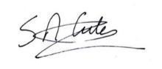
Mr Simon Eccles
Headteacher
What others say about St Mary’s
OFSTED
A short Ofsted Inspection of St Mary’s in March 2017 was extremely positive and confirmed that St Mary’s Catholic Academy continues to be good. A copy of the full inspector’s letter is available on the Academy website. The following quotes are taken from the body of the inspector’s letter:
- The leadership team has maintained the good quality of education in the school since the inspection of your predecessor school.
- Pupils spoken to during the inspection showed great pride in their school and parents wholeheartedly appreciate the efforts made by staff.
- Comments from parents such as ‘The staff go above and beyond what is expected’ and ‘The staff clearly have the best interests of the children at heart’ were typical.
- Staff were equally positive; their comments portray a school where people are valued and supported. One member of staff put this very clearly: ‘Each and every pupil knows there are people in school who care deeply for them…who will go the extra mile for them…that is something of which I am incredibly proud.’
Diocesan Section 48 inspection
Our Diocesan Inspection Report in March 2017 graded us as “outstanding”. A copy of the full report is available on the Academy website. Some of the inspector’s findings were:
- This is an outstanding Catholic Academy. Christ is at the centre of all it does and Gospel values permeate throughout.
- The leadership of the academy is outstanding as Directors and leaders are totally committed to the Church’s mission of high quality Catholic education for all.
- Staff are authentic witnesses to Gospel values and endeavour to live these out in their work with pupils, especially the most vulnerable. The quality of the pastoral care is outstanding with all pupils and staff expressing the caring community that exists in all aspects of the life of the academy. Pupils care deeply about their school with one Year 11 pupil saying, “I feel lucky to come here.”
- The prayer and liturgical life of the academy is outstanding. There is a very strong Chaplaincy team whose work permeates the whole of the academy and supports and encourages the work of all staff. Pupils are actively engaged in the prayer life of the academy and take part and lead prayer and liturgy on a regular basis.
- Pupils are attentive and want to achieve. They show confidence in their teachers and enjoy positive relationships with them.
Investors in People Report
Our Investors in People status was renewed in April 2018. The latest report is available on our website and contains the following comments:
“The sense of team is very strong in the Academy, everyone pitches in to get the job done. As a result there is a strong culture of everyone learning and sharing together. In addition everyone is clear about the standard of work required.”
“People described a ‘family’ culture where staff work collaboratively for the benefit of the Students and the community.”
“High levels of staff retention; people do not leave St Mary’s Catholic Academy.”
“People unanimously commented on the Academy as being a ‘great place to work’ referring to the environment as being hardworking but friendly, supportive and flexible.”
“People said that they appreciated the extra treats they received e.g. refreshments, breakfasts/ buffets at end of term, 100 minute extended CPD, opportunities to undertake research/ projects/ qualifications to list but a few.”

Public examination results:

In our last set of data prior to the pandemic in 2018-19 our GCSE attainment passed 60% grade 4-9 in English and History for the second time. Our progress 8 score was -0.25. Results in centre assessed grades in 2019-20 showed further improvement with 67.5% of students achieving a grade 4 or better in English and History. We continue to focus on closing the gap between Pupil premium and non-Pupil premium students, there is still much work to do here.

At A level results were the best we have ever achieved in 2018-19 with 100% pass rate and 50% of grades at A or B. This year students achieved 100% pass with 62% of grades at A or B. All of our Y13 students were successful in moving on to employment or education.

COMPLETING YOUR APPLICATION

INFORMATION FOR CANDIDATES

Application process:

Candidates should complete a CES application form (attached to the advert on the Academy website) and a letter of application, the details of which can be found below. Please do not include a CV as this will not be considered as part of the process. Evidence will be drawn from:

- Letter in support of application.
- Application Form.
- Lesson observation & task.
- Response to questions during interview.
- References.

Letter of application should:

- Be clear, concise and well presented.
- Demonstrate how you meet the person specification.
- Describe your vision for leading teaching and learning in the History department at St Mary’s Catholic Academy in the 21st Century.
- Be no more than two sides of A4 in length.

Applications can only be accepted in electronic format via email to admin@st-mary.blackpool.sch.uk the closing date is 12pm on Monday 25th April.

HISTORY DEPARTMENT

INFORMATION FOR CANDIDATES

PERSONNEL

The staffing from January 2022 is:

Mr Mark Sergeant – Senior Assistant Headteacher & Senior Line Manager

Mrs Rhea Stephenson - Head of Department (Assistant Headteacher)
Mr Stephen Conway - Teacher of History/Politics
Mr Paul Gillespie - Teacher of History (Assistant Headteacher)
Mrs Susannah Pearce - Teacher of History
Mrs Hannah Mooney - Teacher of History/Politics
Miss Roisin Salter - Teacher of History

CURRICULUM
The post will involve teaching History to KS3 and KS4, with the possibility of teaching KS5 (this will depend on the candidates experience and expertise).
We are working closely with our Trust primary schools to develop a cross phase Scheme of Learning which will prepare our students effectively for the new style GCSE. All staff have access to a bank of excellent resources and as a department we meet regularly to plan for engagement, challenge and high quality questioning.
At KS4 we follow the Edexcel Specification and at KS5 the AQA Specification
ACCOMMODATION
The new accommodation consists of an eight classroom learning house, along with a covered outside area. The rooms are bright and well-resourced with fixed projectors in each learning space. There is some variety in the learning spaces available which would allow for different approaches to the teaching of History to be explored.
PLANNED DEVELOPMENTS
Develop a strategy to provide an appropriate curriculum and pedagogy for students in KS3.
Develop use of research based pedagogy within the History department.
To improve outcomes for our most disadvantaged learners.

ST. MARY’S CATHOLIC ACADEMY

SUBJECT LEADER HISTORY

Person Specification

The Governors of St Mary's Catholic Academy are seeking to appoint a highly skilled teacher with some leadership and management experience. S/he will demonstrate a clear commitment to promoting the highest possible standards of achievement and developing excellent relationships with staff and students across the full age and ability range at St. Mary's. Candidates should be aware that the History Department at St Mary’s also includes Government and Politics A-Level. The successful candidate does not necessarily need subject expertise in this area, but there could be an opportunity to teach A- Level politics. The person appointed will have a professional and personal profile that most closely matches the specification given below:

- QUALIFICATIONS
- Qualified teacher status at graduate level.
- History Degree/Degree containing substantial History element.
- Recent professional development relevant to the post.

- EXPERIENCE
- Some leadership & management of curriculum, people and resources within a History Department or educational setting.
- Substantial involvement in initiatives/developments that have shown significant impact/sustained excellence with respect to the standards of attainment achieved by students.

- SKILLS, KNOWLEDGE and APTITUDE
- A clear philosophy for the teaching of History.
- Successful classroom practitioner with a record of very good examination results.
- Ability to use ICT in the planning and delivery of History.
- The ability and desire to teach History and or Politics to A-level.
- Understanding of some aspects of effective leadership and management and the ability to apply them.
- Knowledge and understanding of the different ways in which students learn and evidence of having successfully applied them to raise student attainment.
- Knowledge of current issues affecting 11-18 schools.
- Effective communicator – verbally and in writing.

- PERSONAL QUALITIES
- Ability to form good relationships with both colleagues and students.
- Commitment to actively supporting the distinctive ethos of the school.
- Commitment to assisting with the development of extra-curricular activities.
- Resilience, commitment, ability to work under pressure and a sense of humour.
- An excellent attendance and punctuality record. (Please note that excellent attendance is considered to be 95% attendance over the past two academic years. Directors will take note of one off illnesses/absences and individual circumstances).
- High expectations of all students.
- Enthusiasm for career development.

The standard contact time for this role is 32 periods out of 40 including a period of PSHE with your form.

JOB DESCRIPTION: SUBJECT LEADER HISTORY

SALARY SCALE: TLR 2A

CONTACT RATIO: 32 out of 40 periods per fortnight

RESPONSIBLE TO: HEAD OF DEPARTMENT

The Second in History has a key leadership role across the Academy and within History. S/he has a responsibility for helping preserve the existing strengths of St. Mary’s Catholic Academy and providing day to day leadership in order that History can fully contribute to the Academy’s Mission & Vision. These duties must be discharged in such a manner as to actively enhance the Catholic nature of the Academy and further develop its distinctive mission with the Catholic Church.

This job description should be read alongside and in full understanding of the document “What Makes an Outstanding Leader at St. Mary’s”.

The key ideas guiding a Key Stage Leader are:

Connectedness
S/he gets everyone in History into the St. Mary’s boat in pursuit of the Academy’s stated Mission and Vision. S/he realises and ensures everyone in History understands that the whole is always more important than and takes precedence over the needs of the individual subject or department. We are interdependent, connected and no team is an island.

Authority
S/he is persistent and insistent that policies and procedures are consistently, properly and fully implemented. Within the authority given s/he leads and guides the staff in History and further distributed leadership within it. S/he is a powerful people developer.

Accountability
S/he holds History to account for high standards of learning and achievement, enriching relationships, personal development and the well being of all. S/he has an “abundance mentality” believing that very high academic achievement, outstanding pastoral care and enriching faith and personal development are powerful allies.

Capacity Building
S/he maximises and fully engages the resources available - people, technology, learning spaces, capitation – to build the capacity within History that enables it to contribute to the delivery of the Academy’s stated Mission and Vision.

The key terms included in a Subject Leader’s role are:

Leading
This identifies the person with the ultimate responsibility, accountability and decision making powers within a specific area for the identified issue in accordance with the Academy’s mission, vision, policies, systems, procedures or norms. The leader will be responsible for co-constructing the vision, policies, systems and procedures, with History staff, students and senior leaders as appropriate. The term also includes the management of the specified issue as described below.

Managing
This requires the planning, implementing, monitoring and evaluating of the specified issue in accordance with the Academy’s policies, systems, procedures or norms. The issue will have a designated leader usually at a more senior level.

Co-ordinating
Ensuring that staff with the designated responsibility lead and manage the specified issue in accordance with the Academy’s policies, systems, procedures or norms. There is also a requirement to ensure there is coherence across the History staff.

Implementing

Ensuring that the specified issue is put into practice in accordance with the Academy’s policies, systems, procedures or norms.

ST. MARY’S CATHOLIC ACADEMY

CORE RESPONSIBILITIES

Key Outcomes

- A caring, Catholic ethos built on high quality relationships.

- A shared vision throughout History.

- A positive learning culture and consistently high standards of attainment and achievement throughout the learning house and its departments.

- Independent and interdependent learners.

- Elimination of all unsatisfactory teaching and increased proportions of excellent and very good teaching.

- Elimination of all poor behaviour and increased proportions of excellent and very good behaviour.

- An oversubscribed Academy with high numbers of post-16 students studying subjects within the learning house.

- A well-disciplined and stimulating learning environment in which the unique talents and contributions of each individual is recognised and celebrated.

- Promotion and safeguarding of the welfare of all students

These key outcomes will be achieved by:

A. Developing a Common Mission and Shared Vision through:

- Managing the continuous development of History through contributing to the learning house annual development planning process that is fully congruent with the Academy’s Development Plan.

- Managing effective formal and informal communication systems within History.

- Managing the active promotion of the Academy’s Sixth Form to students taught within History who would benefit from a high quality post-16 advanced level education within a caring, Christian community.

- Implementing the Academy’s agreed policies, systems and processes (for example Curriculum, Teaching & Learning, Assessment, Marking, Reporting, Gifted & Talented, SEN, Discipline, Rewards, Detention, Promoting Positive Behaviour, Activities & Events) as line manager to History teaching and support staff.

- Assisting, Senior Leaders/Headteacher, with the implementation of the Academy’s agreed Personnel Policies (for example Performance Management, Disciplinary, Capability, Grievance and Sickness Absence Management) as line manager to History teaching and support staff as required.

- Implementing the Academy’s Safeguarding Policies and procedures.

B. Developing a commitment to learning in History by:

- Leading the development of transformational learning and teaching that produces consistently high levels of achievement for all, aspirational attitudes from staff and students and independent and interdependent learners (4Cs Learner).

- Managing the development of programmes of study, schemes of work and lesson plans, within History, which fulfil and enrich the requirements of the national curriculum, examination specifications requirements and assist in the development of students spiritually, morally and socially for a specific key stage.

- Leading the development of/maintaining an exciting extra-curricular provision within History.

- Managing student discipline within History through recognising and rewarding positive student behaviour and dealing appropriately with unacceptable behaviour using the Academy’s agreed systems and procedures.

- Leading the Development of History staff by:

- Assisting the Head of History and Geography with managing high quality professional development opportunities for History staff, including mentoring and coaching staff, newly qualified teachers and students on teaching practice.

- Assisting with the implementation of procedures for appointing staff to History.

- Implementing Performance Management Policy & procedures as the reviewer to members within History in the Performance Management Cycle and making pay progression recommendations as required.

D. Monitoring, Evaluating and Challenging the work of History by:

- Supporting the Head of History with the process of validated self-review including:

  - The annual review of examination results.
  - The production and analysis of data sets and subsequent remedial actions required.
  - The monitoring and evaluation of the quality of teaching and learning.
  - The monitoring and evaluation of student progress.
  - Student voice opportunities to enrich the data set available for evaluation.

ADDITIONAL RESPONSIBILITIES

- Deputising for the Head of History and Geography.

- Assisting the Head of History and Geography with the effective and efficient deployment of History staff during the timetabling process.

- Co-ordinating all necessary administration with respect to examinations and departmental functioning to ensure it is carried out correctly and promptly.

- Managing the work to be completed by attached support staff.

In addition, to the specific duties outlined above you will be expected to carry out the duties of a Teacher as stated in the current School Teachers’ Pay and Conditions Document.

This post is subject to the CES (Catholic Education Service) form of contract and also to a satisfactory CRB (Criminal Records Bureau) Enhanced Disclosure Certificate, medical clearance and verification of qualifications and National Insurance number.

These responsibilities will be reviewed in the light of the Academy’s development plan and changing needs.

Mr Simon Eccles
March 2022

WHAT MAKES AN OUTSTANDING LEADER AT ST. MARY’S?
In essence they get everyone into the St. Mary’s boat, all rowing in the same direction!
Outstanding leaders act at the pivotal point of the Academy’s Catholic Mission ensuring that our vision and goals are implemented - minute by minute, day by day, week in and week out - through working effectively with people in their teams and beyond. They lead others and conduct themselves, at a personal and professional level, within the Catholic ethos of St. Mary’s. Holding those students with greatest needs “closest to their heart” they provide an educational option for the poor and disadvantaged we are called to serve.
Seeing the big picture, they engage with complex whole Academy issues and understand that our strength as a Academy lies in our connectedness and being “one body”. They are able to bring a departmental or pastoral perspective to discussions and decision-making, where relevant, whilst seeing well beyond their individual team goals and aspirations. Their words and actions show that they understand the whole is always more important than and takes a precedent over the individual parts. We are interdependent, connected and no team is an island.
Operating both laterally and vertically to support and co-construct the future success of our Academy, outstanding leaders, alongside other middle and senior leaders, are a power house of innovation and organisation and act as standard bearers within the Academy. They think creatively, are open to radical ideas and willing to seek mandates to act on them, enjoying solving problems before other people even realise there is one!
Their no excuses approach starts with themselves and extends to holding their teams and individuals accountable for high standards of learning and achievement, enriching relationships, personal development and the well being of all. They have an “abundance mentality” believing that very high academic achievement, outstanding pastoral care and enriching faith and personal development are powerful allies. Like the best parents they appreciate the need to find time for their colleagues, showing a unified public face whilst putting the needs of the students first.
Their personal and professional standards, passion for their subject, service and work ethic and ability to build enriching relationships act as an example to others within their team and beyond. They inspire trust and respect from the staff they work with on a “day to day” basis. Their significant influence is due to a personal and professional credibility with staff who value their input and appreciate that when a difficult situation arises they are the first to take responsibility and assume control of the situation. They manage administration effectively ensuring things run smoothly and the job gets done. Put simply they teach well, achieving better than expected progress with their classes, have excellent attendance, actively engage in promoting student and staff well-being and personal development and support students and staff on their faith journey.
Our outstanding leaders have a curiosity and desire for their own learning, supporting and using innovation as a source of learning in addition to other effective forms of CPD. They encourage others within their team and beyond to do the same and have a profound pedagogical and pastoral understanding based upon models, principles and research as well as their own experience. As powerful people-developers, the induction of staff new to the Academy, continuous professional development of colleagues and generation of new leaders are all matters of the highest importance and priority. They invest time in coaching, knowing that it is a time investment that will be paid back many times over and appreciated by colleagues and the students who will benefit from it.
Highly emotionally intelligent, literate and resilient our outstanding leaders are able to perform effectively in difficult, pressurised situations taking their team with them through the challenging times. They achieve this by explaining and emphasising the vision and goals; coaching colleagues to help develop their skills; involving staff in decision making; leading by example; putting an arm around someone’s shoulder or, on occasion, doing some straight talking. They are adept at choosing the right leadership style for the context they find themselves in, often using a combination of these approaches as appropriate. At difficult times they act as a “reservoir of hope and optimism”, maintaining high morale, positive relationships and a sense of togetherness in the team and more widely in the Academy as a whole. They keep a focus on the goals to be achieved and ensuring a sense of well proportioned perspective by individuals.
Being an outstanding leader at St. Mary’s is a challenging role.
Let’s not pretend otherwise!
Academy Raising Achievement Plan Long Term Objectives

Academy Raising Achievement Plan Long Term Objectives

New Objectives |  | Academic year
 |  | 2021/22 | 2022/23 | 2023/24 | 2024/25
1 | Develop and implement a broad and ambitious curriculum at St Mary’s. | Implement | Implement | Embed | Embed and review
2 | Improve outcomes and opportunities for disadvantaged students. | Embed | Embed and review | Embed and review
3 | Further develop the St Mary’ Sixth Form provision (including recruitment and retention of numbers). | Embed and review
4 | Further develop the CPD curriculum for staff to include stage appropriate training, improved training for support staff and better use of enhanced CPD time. | Implement | Embed
5 | To further develop and implement wellbeing strategies for all staff and pupils at St Mary’s. | Embed | Embed and review
6 | To further develop an understanding of ethos for all stakeholders at St Mary’s. | Implement | Embed and review
7 | Implement and embed a clear quality assurance framework to ensure clear leadership of the Academy. | Embed | Embed and review
8 | Plan and prepare the Academy for a potential OFSTED inspection in the next 12 months. | Develop and implement

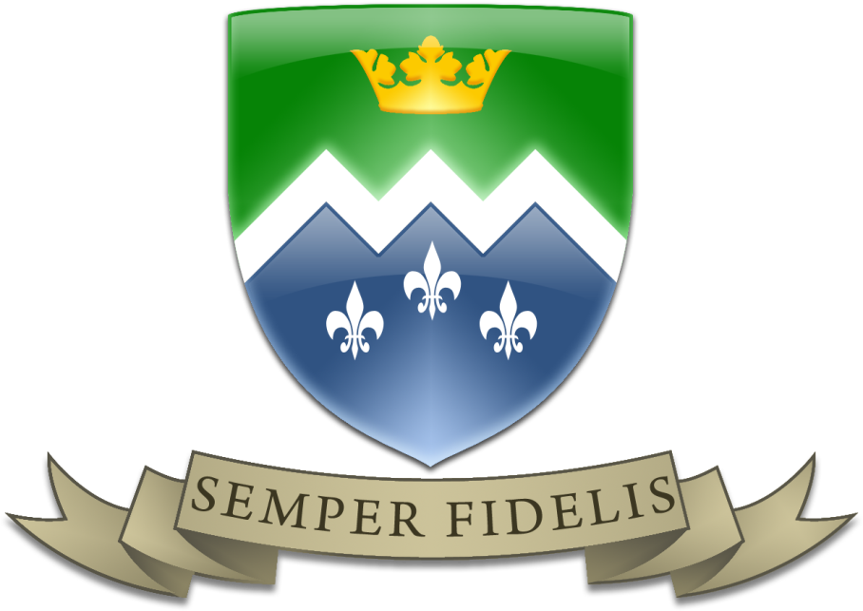

The Saint Mary’s Way
The distinctive ethos or “St Mary’s Way” is based on the four dimensions of the pastoral mission of the church:
- Kerygma (Announcing – distinctiveness of witness, religious contribution to every aspect of our education. The Proclaiming School).
- Leitourgia (Liturgy – Grace builds on nature but must acknowledge the sphere beyond the natural world. The work of the Christian assembly to adore God in prayer, thanksgiving and penitence. The Worshipping School).
- Diakonia (Ministry - Culture has to be changed and transformed by the Christian Gospel. This emphasises social activism and the service of the poor. The Serving School).
- Koinonia (Community – Christian community existing in reasonable harmony with the surrounding society. Christian school plays a part in the country’s general education provision. One mission of all Christians is the creation of community which inevitably involves at times compromise and creating common ground with the surrounding culture. The Civic School).

All of these elements are part of the Mission of the Church and all these elements will be found in an authentically Catholic school. Kerygma and Leitourgia give the essential “roots” to the community and help define our distinctiveness. They provide the opportunities to gather and centre ourselves around a core of beliefs. The Trust will be respectful of parents as the first and foremost educators of their children and seek to engage them in their child’s education.
Both Diakonia and Koinonia give the opportunity for our faith to take “wings” and reach out beyond our own community in order to have a positive impact on other communities, particularly those suffering from poverty, and society in general. The service and civic nature of our schools helps give witness and richness to our distinctive way of living. This will include an education rich in the spiritual, moral, social and cultural and supportive of British Values.
Proclaiming, worshipping, service and civic duty are essential elements of the Catholic school. We need both roots and wings to ensure we deliver an education in faith and wisdom which is the hallmark of a Catholic school.
These four dimensions of the mission of the church are reflected in our Academy mission statement:
St. Mary’s Catholic Academy is a caring faith community. Our mission is to provide an outstanding whole-person education through which all are challenged to grow in wisdom, understanding, self-esteem and closeness to God.
The hallmarks of St. Mary’s are:
Catholic Caring Community Challenging
St. Mary’s is a Catholic academy where prayer and reflection are woven into the fabric of the academy’s life. The universal message of the Church and its call to new life encourages us to value every individual as precious in God’s sight. The distinctive education offered at the academy includes the continuing development of morals and Christian values.
Respecting the uniqueness of each person is central to the caring nature of the academy and a reflection of the Gospel message of love. A strong and supportive pastoral system continues to care for all and helps build people’s self-esteem.
The academy strives to be a community where high quality and enriching relationships are built. Tolerance and the valuing of others are key points of daily life. We seek to manage every aspect of academy life, with justice, for the common good of all.
We challenge all people to use their God-given gifts to achieve excellence and make significant progress in their learning. Opportunities exist for aesthetic, performing and creative talents to be nurtured.

The St Mary’s Way:

The St Mary’s Way is based on the mission of the church and academy and is built around a way of living and working together as a community centred on Pope Francis modern day beatitudes:

IMAGO DEI – RESPECTING GOD IS IN EVERYTHING WE SEE
- We see the value of every member of our community
- How we speak to others is a reflection of our care for them
- We will leave no member of our community feeling alone or that they don’t belong
- As people made in the image of God, we act with honesty and integrity
- Each day represents a chance to grow in wisdom

A SERVING COMMUNITY
- We look out for the needs of others
- Our behaviour should not harm the learning of others
- We try to empathise and understand those who may be struggling
- We see our role in the community as being there to help and encourage each other

A COMMUNITY OF GRATITUDE
- Staff and students thank each other at the end of each lesson
- We show appreciation for all that is done for us in the Academy, whoever has done it
- We recognise the expertise of those who work in the academy
- We recognise that education is a privilege not enjoyed by everyone around the world
- We appreciate the people we share this place with and from whom we can learn

A COMMUNITY OF STEWARDSHIP
- We look after the things we need to help us learn
- We regard all of the academy as ours to look after
- We cultivate our talents and use them for the good of ourselves and others
- We play all of our roles with our best efforts
- We respect the academy environment and enable it to be enjoyed by everyone

A FORGIVING COMMUNITY
- We avoid unnecessary conflict, often by talking it through
- We are not quick to take offence or to ‘hit back’
- We know the power of words to heal arguments and rebuild relationships
- We work hard to forgive each other and ourselves

A PROPHETIC COMMUNITY
- We recognise the power of our words
- We speak the truth with compassion
- We ensure that everyone is treated fairly
- We keep a special eye out for those who may feel vulnerable

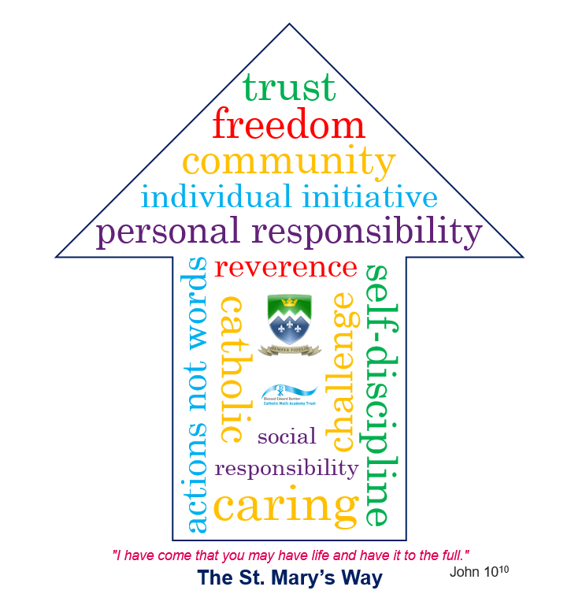

OUR HANDBOOK
TABLE OF CONTENTS
Message from our Headteacher 3
1. Our history 4
2. Cornelia Connelly 6
3. What has formed our values? 7
4. Our mission 7
5. The St Mary’s Way 8
6. Our expectations of you 9

A message from our Headteacher
Welcome to our family and to our handbook for “The St. Mary’s Way.” You are very welcome to our community. As our mission statement says: “St. Mary's Catholic Academy is a caring faith community. Our mission is to provide an outstanding whole-person education through which all are challenged to grow in wisdom, understanding, self-esteem and closeness to God.”
St. Mary’s is not just about exam results and academic success; it is also about walking with you and your family on your faith journey through our school, helping you to develop your whole character and “Live life to the full”.
As you will read in this handbook, our school is built on 150 years of tradition. This started with Blessed Cornelia Connelly and the Society for the Holy Child Jesus. They set up the first Catholic School for Girls in Blackpool in 1870. The Society believed in a caring and Christian approach to school which challenged their students to be the best they could possibly be. We still follow the key principles of this in our own St. Mary’s Way, which you will read about in this handbook. This “Way” helps us to understand who we are as a community and how we live and work together as a family. Please read it carefully it is the most important information you will read as you start St. Mary’s.
I will see many of you in assemblies and around the Academy but I want to take this opportunity to wish you every success at our Academy. This is a new start in your education journey and a fantastic opportunity to live life to the full by following our St. Mary’s Way.
Kind Regards
Mr Eccles
Head teacher

Our history

St Mary's school for girls founded

1860

The original school was founded for girls by Cornelia Connelly's Society of the Holy Child Jesus. The site chosen was Raikes Hall, which is now a public house called The Raikes Hotel.

Move to Layton Hill

1870

After a period of rapid growth, a new site was required. The school moved onto the site where our current school still stands today. You can still see the original building at the front of our academy.

A change to the intake

1880

For the first time, boys were admitted to the school.

The boys are moved

1900

The boys were moved off the Layton Hill site and a new school, St Joseph's, was set up. This was located on Park Road.

St Joseph's on the move

1918

A new site was needed for St Joseph's. A move to Layton Mount, on Newton Drive, took place in 1918.

The Diocese of Lancaster

1924

The formation of the Diocese of Lancaster saw them take over the running of our schools.

Catholic Church opts for co-ed

1975

The Catholic Church implemented a requirement for co-education, so the boys from St Joseph's were on the move again. It was time to move back to the original site at Layton Hill and form St Mary's Catholic Academy.

Further expansion

1982

Further expansion occurred in 1982, when St Mary's was merged with All Saints RC High School, a school formed by an earlier merger of two Catholic former secondary modern schools, St Thomas of Canterbury's and St Catherine's. Originally still over two sites, the All Saints' site closed in 1992, with the school at Layton Hill finally accommodating all pupils.

Building Schools for the Future funding

2010

A successful application to BSF enabled one of the biggest changes in the school's long history. The multi-million pound build would blend the old buildings on Layton Hill with new, modern buildings.

Building work finally completed

2014

2014 saw the building work finally completed and Christ the King Primary and Church moved onto the Layton Hill site.

A new trust is formed

Sept 2014

The formation of the Blessed Edward Bamber Catholic Multi Academy Trust brought St Mary's Catholic Academy, Christ the King Catholic Primary and St Cuthbert's Catholic Primary together.

Where did the new name come from?

Important

Edward Bamber was a Catholic martyr from our local area of Blackpool. The board decided to recognise his life achievements and name the trust after him.

The St. Mary’s Way
"I have come that you may have life and have it to the full."

Cornelia Connelly
Cornelia Connelly, an American-born wife and mother and a zealous convert, founded the Society of the Holy Child Jesus in England in 1846.
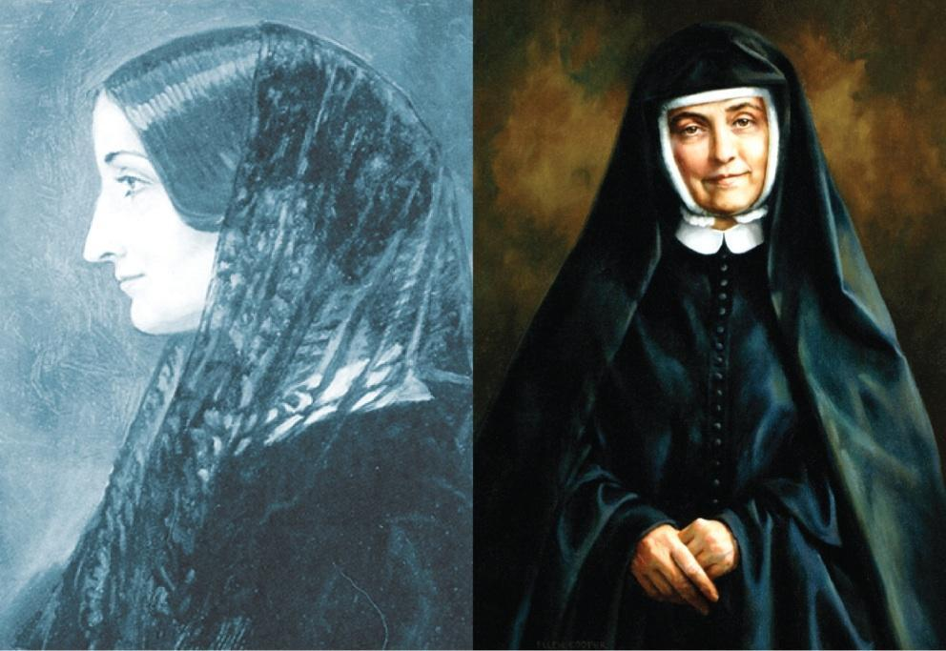
Her sisters were primarily trained as educators, and her educational system was praised for its innovative and effective methods.
Cornelia imbued her community with the value of respect for the dignity of every human being, and this spirit of trust and reverence for all God’s people has been handed down through the generations.
In 1862, six sisters from England took the Society to the United States. Various initiatives by European and North American sisters followed over the next century. In 1930, three sisters brought the Society to Nigeria, and in 1967, four sisters established the Society in Chile.
Today the Society has a presence in North America, Africa, Europe and South America, and the Sisters of the Holy Child Jesus live according to the Society’s motto, “Actions Not Words”, in a variety of ministries living out religious life in the third millennium.

What has formed our values?
Holy Child schools around the world are rooted in the educational tradition of the Society of the Holy Child Jesus, sharing in its mission to help others believe that God lives and acts in them and in our world.
Cornelia Connelly developed an educational system based on trust and reverence for the dignity of every human being. She wanted Holy Child educators to carry this spirit to students of diverse backgrounds as they sought to respond to the wants and needs of the age in which they lived.
Since 1846, those educating in the tradition of Cornelia Connelly’s spirituality and philosophy of education have helped students to grow strong in faith and lead full lives, educating their students according to the following core values:
- Freedom
- Creativity
- Self-discipline
- Individual initiative
- Personal and social responsibility.

Our MISSION
At St Mary’s we are a caring faith community. Our mission is to provide an outstanding whole-person education through which all are challenged to grow in wisdom, understanding, self-esteem and closeness to God. As a result, we have developed four hallmarks, which look to build upon the spirituality and philosophy set out by Cornelia Connelly.
Our hallmarks are often referred to as the 4Cs:
- Catholic
- Caring
- Community
- Challenge

The St Mary’s way
The St Mary’s Way is the term we use to bring everything together. It provides a structure, gives clarity, and points our young people and our staff in the right direction. St Mary’s Catholic Academy not only provides our young people with the opportunity to achieve academic success, but also the chance to grow and develop as an individual.

We believe that if a young person can live their life according to the values of the St Mary’s Way, they will go on to be a happy, successful and positive member of their community.

The values of the St Mary’s Way are the same core values that laid the foundation for the early work that Cornelia Connelly began. In modern society, they seem to have even more relevance than they did 1846, and that is why they form an integral part of our St Mary’s Way today.

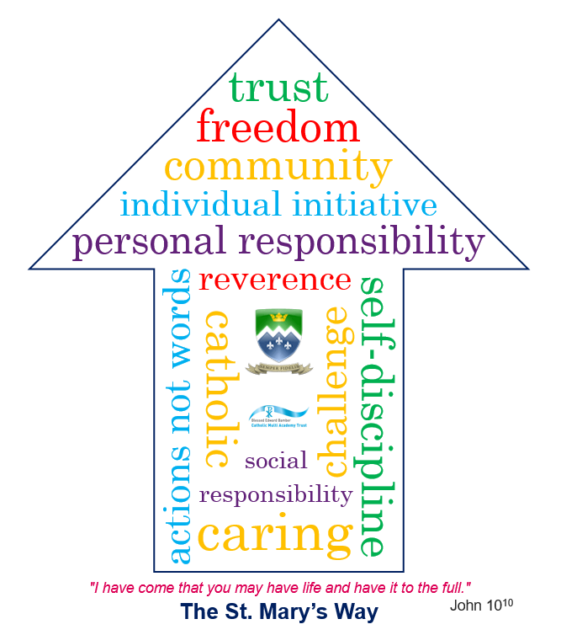

Our expectations of you
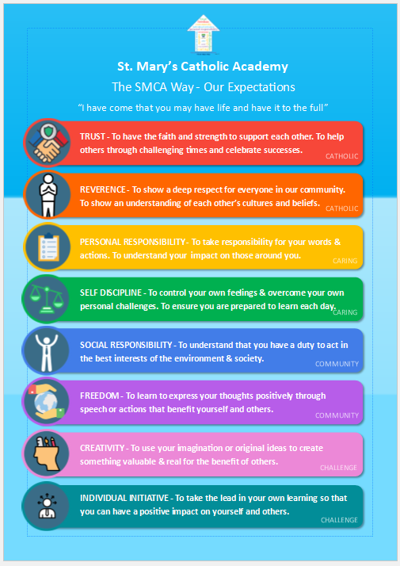

The St. Mary’s Way

