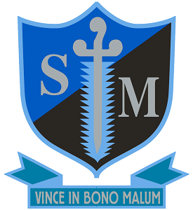

Diocese of Southwark
St Michael’s Catholic College
Llewellyn Street, Bermondsey, London SE16 4UN
11–18 Single Academy Trust.
Required for September 2023
Roll: 930
Teacher of Religious Education
(MPS+ UPS if applicable)

St Michael’s Catholic College is an outstanding school which offers exceptional opportunities for a talented, committed and enthusiastic teacher of Religious Education. You will be joining an excellent department that regularly achieves results well above national average results and as part of this team you will have the opportunity to teach across the age and ability range up to and including A level Philosophy and Ethics, within modern state of the art buildings. The successful candidate will be a motivated individual with a keen interest in encouraging and inspiring students to flourish both academically and in faith. The RE department has core subject status at St Michael’s and is supported by a dedicated staff and student chaplaincy team who work together to promote the Catholic ethos and contribute to the wider life of the college.

This position would suit either an experienced teacher or an exceptional ECT.

St Michael’s Catholic College was judged Outstanding in its most recent Denominational Section 48 inspection in March this year and has been judged outstanding by Ofsted on two successive occasions and is an outward looking school with an excellent reputation in the local area.

The college is a Catholic community, underpinned by a strong Salesian ethos with the Salesian values of Respect, Understanding, Affection and Humour informing all that we do. We are a strategic partner in the Catholic Schools’ Partnership and are members of the Southwark Schools’ Learning partnership with other schools in the Borough including private schools. Alongside these opportunities to work with professionals from a range of other establishments, the college was awarded transforming status by SSAT reflecting our outstanding curriculum and the exceptional professional development and wellbeing support we offer all staff. The college’s excellent location by Tower Bridge, The Most Holy Trinity Church and close to St George’s Cathedral facilitates faith formation, a large number of business partnerships and enrichment opportunities.

St Michael’s College is committed to safeguarding and promoting the welfare of children and young people and expects all staff to share this commitment. This post is subject to a Disclosure and Barring Service (DBS) check.

For an application form and information pack please contact Mrs Valerie Ferguson, email: v.ferguson@stmichaelscollege.org.uk

Deadline: Monday 5th June at 9am - Early applications are advised as the College reserves the right to appoint at any stage during the application process.

