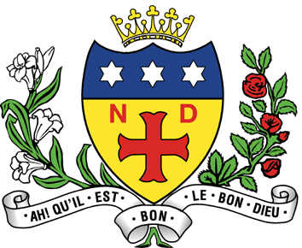

NOTRE DAME HIGH SCHOOL
11-18 Mixed Catholic Comprehensive School
FULWOOD ROAD, SHEFFIELD, S10 3BT

Tel: 0114 2302536

We are looking to appoint to the following posts:

1. Teacher of RE
Full-time/permanent
(£25,714 - £41,604 p.a. pro-rota)
Start date: after Easter 2022 or from September 2022

2. Teacher of RE
Full time/Maternity Cover
(£25,714 - £41,604 p.a. pro-rota)
Start date: after Easter 2022

We will consider part time applications.

The successful candidate will be required to be able to teach KS3, KS4 and Core RE at KS5.

Notre Dame is a Catholic school with a strong ethos at its heart. All staff are expected to uphold and contribute to the ethos of the school, which is what makes it a special place to work.

For further details and an application pack please visit our website: www.notredame-high.co.uk or telephone the school.

Please state on your personal statement which post(s) you are applying for and your preferred start date.

Closing date for receipt of completed applications: 9am on Monday 17th January 2022

Notre Dame High School is committed to safeguarding and promoting the welfare of children & young people and expects all staff to share this commitment. The successful applicant will be required to complete an Enhanced DBS Disclosure. In addition, this post is exempt from the Rehabilitation of Offenders Act and a self-disclosure is required for applicants shortlisted for interview.

