INFORMATION PACK
Altrincham Grammar School for girls
Teacher of Religious Studies
0.4-0.45 FTE
Required February 2022
Fixed-term maternity cover until February 2023 in the first instance

Teacher of Religious Studies
The Religious Studies department is currently seeking an enthusiastic and driven Teacher of religious studies for a fixed term role to support to teaching of key stage 3 and 4.

The full job description and person specification are on pages 4-6 of this pack.

Bright Futures Educational Trust
Bright Futures Educational Trust (The Trust) is a multi-academy trust set up in 2011. The Trust is made up of a richly diverse group of schools in Greater Manchester and Blackpool. We are passionate about working together within and beyond the Trust to achieve our aspirational vision: the best for everyone, the best from everyone. We are an organisation that is underpinned by values of: community, integrity, and passion. In everything we do, we remember that we are accountable to the children, families, and communities that we serve.
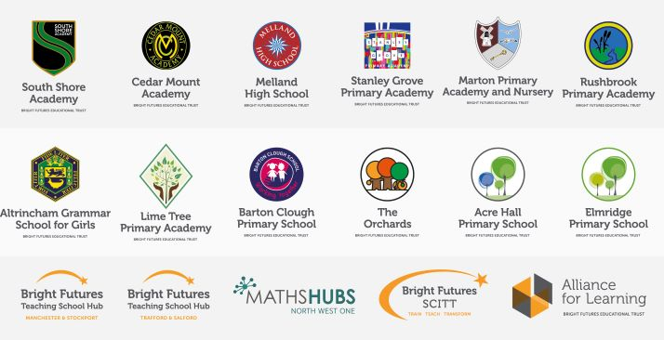
Our schools have their own identities, form one organisation and have one employer, Bright Futures Educational Trust. Bright Futures’ Board of Trustees maintains strategic oversight of the Trust and delegates some of its responsibilities to the Executive Team, Principals, and local governing bodies. We place a high value on integrity and probity and take seriously our accountabilities for making the best use of public money. How decisions are made is described in our delegation framework. You can find out more about the Trustees and the Executive Team on our website: http://bfet.co.uk/about-us/.

The central team includes the Executive: John Stephens, CEO; Edward Vitalis, Chief Operating Officer; Gary Handforth, Director of Education; Lisa Fathers, Director of Development, Partnerships and Teaching School Hubs and Lynette Beckett, Director of HR & Strategy. The focus of these roles is to work with schools, providing high quality and timely guidance, leadership, challenge, and support. In addition to the executive team, we have central operations for finance, communications and marketing, HR, educational psychology, and digital technologies. Please see our website brochure which explains our central operations: Working together for a Bright Future.
Bright Futures Development Network is another important outward facing component of our organisation. Underneath this umbrella we have 5 network hubs. ‘The Alliance for Learning’ (AFL) which provides school improvement services and CPD to over 700 schools (http://allianceforlearning.co.uk/), a North West Maths’ hub providing mathematics training and coaching to 500 schools and a SCITT (School Centered Initial Teacher Training) which is the largest in the North West. After significant national reforms to the teaching school policy, Bright Futures was designated with two new large-scale Teaching School Hubs in 2021. The areas we serve are Manchester, Stockport, Salford, and Trafford. Our two Blackpool schools benefit significantly from the Trust’s wide range of strategic partnerships, having priority access to high quality CPD, professional expertise and bespoke learning opportunities.

Collaboration and strong relationships form one of the ‘commitments’ in our Strategy and all components of the Bright Futures’ family work closely together. Our Strategy was developed collaboratively and can be found
on our website: Our Strategy.
Altrincham Grammar School for Girls
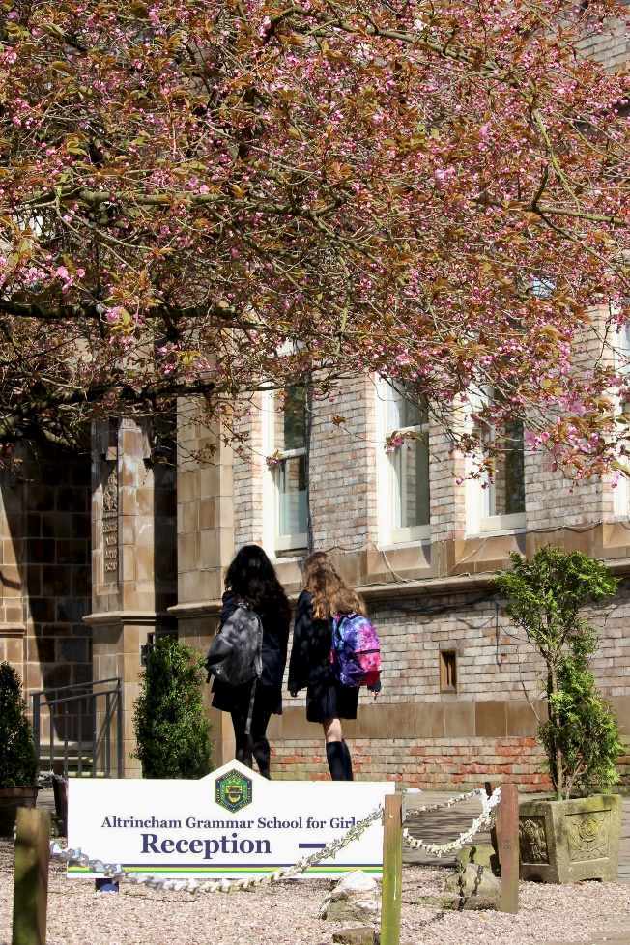
Altrincham Grammar School for Girls (AGGS) is a highly successful single sex 11 -18 academy in the South Trafford area. AGGS was in the first cohort of schools to be designated a national teaching school in 2011. AGGS is the lead school in ‘The Alliance for Learning’, which comprised schools of every type and phase, plus universities, throughout a wide geographical area. The impact of teaching school activities has been felt within the Trust and far beyond. We have a reputation for excellence regionally and nationally, of which we are very proud.

AGGS is committed to providing equal opportunity in recruitment and employment to all individuals. We will consider candidates without regard to race, ethnicity, gender, religion, sexual orientation and identity, national origin, age, military or veteran status, disability or any other legally protected status; and without discrimination based on socioeconomic, marital, parental or caregiving status, or any of the previously listed characteristics or statuses.

We value the diversity of our staff and reject any form of harassment, discrimination or victimisation. The Bright Futures Educational Trust vision is: ‘the best for everyone, the best from everyone’. To achieve this, we create and maintain a work environment and culture where people from different backgrounds, and with varying lifestyles, interests, opinions and responsibilities, treat each other with dignity and respect. It is a climate in which our staff feel safe and are inspired and motivated to be their best.

Our school is dedicated to sustaining and promoting diversity with respect to recruitment, promotion, training and general treatment during employment. We are actively seeking to extend the diversity of our staff. Furthermore, we welcome candidates who have not had previous experience of working in a grammar school.

We aim to ensure that our recruitment processes set up all candidates for success. At interview our aim is to provide a positive experience. We don’t want to catch anyone out, but rather to provide the opportunity for all candidates to be themselves and show us what they are capable of.
Why work for us?

We offer a great opportunity to join an organisation which really lives its values. Our working environment is very inclusive and whilst you can expect to be challenged in your role, you will be supported through professional learning, treated fairly and with dignity and respect. Please see the Equality, Diversity, and Inclusion statement on our website: http://bfet.co.uk/vacancies/.

Salary: MPR/UPR. School Teachers Terms & Conditions pay range, dependent upon experience
Hours: 0.4 – 0.45 FTE

Location of work: Altrincham Grammar School for Girls
Pension: Teachers Pension Scheme: https://www.teacherspensions.co.uk/

Other: We offer salary sacrifice schemes for purchasing bikes used for travel to work and technology for personal use, through monthly interest free salary deductions.
We also offer opportunities for professional development.

For a full explanation of our employment offer please see the booklet on our website:
Great-Place-booklet.pdf (bfet.co.uk)
How to Apply
We can only accept completed application forms, rather than CVs. This is because the regulatory guidelines of Keeping Children Safe in Education (2021), require us to check various details of job applicants and an identical application format for each candidate enables us to do this. We use a process that does not identify personal characteristics to the shortlisting panel. This is part of our commitment to equalities and diversity.

NO AGENCIES PLEASE.
Our application form is available on line, along with the disclosure of criminal background form. The portal link is: Teacher of RS application form. Please complete the application by midday on Thursday 9th December 2021.
The selection will take place on Thursday 16th December 2021.

Keeping Children Safe in Education
Bright Futures Educational Trust is committed to safeguarding and promoting the welfare of children and young people and we expect all staff and volunteers to share this commitment. This post is exempt from the Rehabilitation of Offenders Act 1974; pre-employment checks will be carried out and references will be sought for shortlisted candidates and successful candidates will be subject to an enhanced DBS check and other relevant checks with statutory bodies.

Data Privacy
You can the details of how we use the personal data that you provide us with in our Job Applicants’ privacy notice on our website: http://bfet.co.uk/wp-content/uploads/2018/07/BFET-Applicant-privacy-notice-002.pdf

JOB DESCRIPTION
Teacher of Religious Studies
Bright Futures Educational Trust is committed to safeguarding and promoting the welfare of children and young people and expects all staff and volunteers to share this commitment. Any successful applicant will be required to undertake an Enhanced Disclosure by the Criminal Records Bureau. The post is exempt from the Rehabilitation of Offenders Act 1974.

The Religious Studies Department currently consists of three full time teachers. This is a part-time post covering teaching to Key Stages 3 and 4 and will offer scope for professional development, such as teaching to A level.

The Religious Studies Department takes an academic approach to the subject and hopes to inspire an intellectual interest in, and appreciation of, the variety of religious issues facing people in the 21st century, whilst enabling students to apply their knowledge to their own lives.

Knowledge of the major faiths practised in Britain today and of philosophical, theological and ethical issues will be an advantage, although full training can be given. Students are taught in mixed ability classes within the grammar school system and the school operates a ten day timetable. Students in Year 7 have two one-hour lessons per cycle, Year 8 and Year 9 have three one-hour lessons per cycle. Information on what is taught at Key Stage 3 can be found on the subject page of the school’s website.

Religious studies is taken at GCSE level by a good proportion of students (typically two teaching groups) who have 5 lessons per cycle. At GCSE the department follows the AQA course in Buddhism and Christianity. Results are generally higher than national averages with over 80% of candidates achieving a grade 8 or above.

For A level, the department follows the AQA religious studies course focusing on philosophy, ethics and Buddhism. A prospective candidate would be expected to teach to GCSE and would benefit from having a sound knowledge in Buddhism, although training and resources can be provided. Students generally achieve a 100% pass rate with excellent grades.

The Religious Studies Department is housed in three specialist classrooms. All rooms are equipped with computer, projector and visualiser.

This is a forward-thinking department, committed to the study of religion in all its aspects and respected within the school by both students and colleagues. An enthusiasm for the subject and a willingness to help with extra-curricular activities and departmental initiatives would be expected of the successful candidate.

School-wide Responsibilities
- Being aware of and acting upon relevant school policies and, in particular, those associated with child protection/safeguarding children and health and safety issues.
- Being responsible for maintaining a clean and tidy environment.
- Attending relevant meetings as required.
- Acting as a role model for the pupils in school.
- Acting as an ambassador for school and ensuring that the school’s high standards are promoted at all times.

Additional Specific Responsibilities
- Carry out the duties of a form tutor
- Support the school in its open evenings and award evenings.
- Support the school in its entrance examination.

General Duties
- Carry out a share of supervisory duties in accordance with published schedules. Fulfil the conditions of employment of school teachers as laid down in the Pay and Conditions Document.
- Any other relevant duties requested by the Principal.

PERSON SPECIFICATION

 | Essential | Desirable
Qualifications, Educational, Training | Good honours degree in theology or religious studies or similar and a suitable teaching qualification.  QTS
Relevant Experience | Successful teaching experience up to GCSE in a temporary or permanent post or on teaching practice. | Successful teaching experience up to A level.
Knowledge, skills, abilities | Excellent, up to date, religious studies knowledge and understanding.  Tolerance of others’ beliefs and ideas, regardless of personal faith.  An enthusiasm for religious studies and the ability to generate this in others.  High standards of religious studies teaching and learning in the classroom.  Excellent oral and written communication skills with pupils, parents and colleagues.  Ability to show initiative.  Ability to exercise control in the classroom and encourage good behaviour.  Good organisational and record keeping skills.  Excellent IT skills.  Ability to work as part of a team.  Ability to plan, organize, review and adapt.  Willingness to contribute to extra-curricular religious studies department activities. | Willingness to learn new aspects of the subject.  Experience of the role form tutor.
Safeguarding | Commitment to demonstrating a responsibility for safeguarding and promoting the welfare of young people.
Others | Commitment to the aims and ethos of the school.  Involvement in school working parties or research groups.  Willingness to be involved in extra-curricular activities including trips abroad.  Commitment to pastoral care.  A commitment to maintaining confidentiality and discretion inside and outside school.  Flexibility and a willingness to be involved in change.  Commitment to staff development.  A positive approach to challenges, which seeks solutions to problems and addresses difficulties with cheerfulness and good humour.
Professional development | A commitment to further training and a willingness to participate in the relevant CPD.  Willingness for lessons to be observed as part of our school monitoring processes and for sharing good practice (e.g. learning walks).

