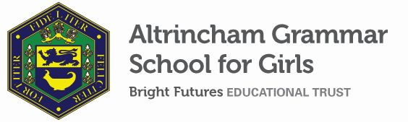


Teacher of Religious Studies
Required from February 2022
Part-time (0.4-0.45 FTE)
Fixed-term until February 2023 in the first instance
MPR/UPR

The Bright Futures Educational Trust is a partnership of schools based in the North West. The Trust’s vision is the best for everyone, the best from everyone. Our values of community, passion and integrity are at the heart of everything we do. There are currently twelve schools within the Trust. The Trust is committed to providing all staff with the training and support they need to be the best in their profession. Benefits include: working cross-phase, knowledge exchange between our schools and the opportunity to work with some of the most inspiring colleagues in their profession.

Altrincham Grammar School for Girls is currently seeking an enthusiastic and well-qualified Teacher of Religious Studies for a fixed term role to support the teaching of key stages 3 and 4.

Further information about the Religious Studies Department can be found on the school website.

Our portal contains an on-line application form and disclosure of criminal background form. Please click on the link HERE, or find it on our website. Please complete the forms by 12.00 pm midday on Thursday 9th December.

Closing date for applications is Thursday 9th December at midday.
Interview date – Thursday 16th December 2021.

ADDITIONAL INFORMATION
Further information about the school, a copy of the school’s prospectus and the most recent OFSTED inspection are available from the school’s website.

Bright Futures Educational Trust is committed to safeguarding and promoting the welfare of children and young people and expects all staff to share this commitment. Any successful applicant will be required to undertake an Enhanced Disclosure check by the DBS. This post is exempt from the Rehabilitation of Offenders Act 1974.

