INFORMATION PACK
Altrincham Grammar School For Girls
Teacher of Religious Studies
Part-time (0.7 FTE)
Required from 1 September 2021
Fixed-term maternity cover until July 2022
Bright Futures Educational Trust
Bright Futures Educational Trust (The Trust) is a multi-academy trust set up in 2011. The Trust is made up of a richly diverse group of schools in Greater Manchester and Blackpool. We are passionate about working together within and beyond the Trust to achieve our aspirational vision: the best for everyone, the best from everyone. We are an organisation that is underpinned by values of: community, integrity and passion. In everything we do, we remember that we are accountable to the children, families and communities that we serve.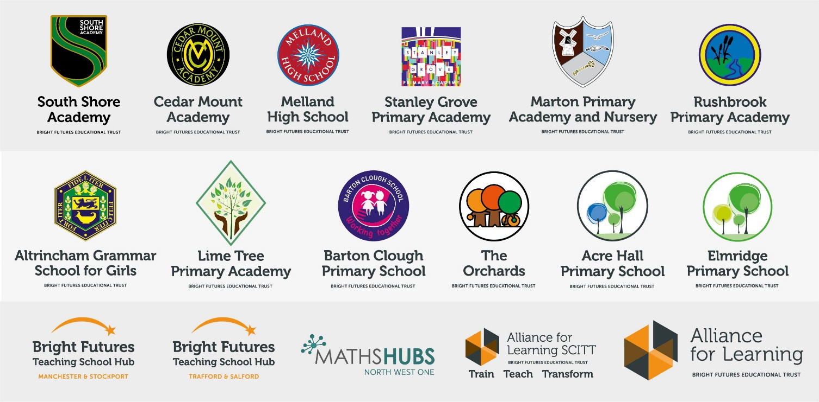
Our schools have their own identities and form one organisation and one employer, Bright Futures Educational Trust. Bright Futures’ Board of Trustees maintains strategic oversight of the Trust and delegates some of its responsibilities to the Executive Team, Principals and local governing bodies. We place a high value on integrity and probity and take seriously our accountabilities for making the best use of public money. How decisions are made is described in our delegation framework. You can find out more about the Trustees and the Executive Team on our website: http://bfet.co.uk/about-us/.

The central team, comprises the Executive Team: John Stephens, CEO; Edward Vitalis, Chief Operating Officer; Gary Handforth, Director of Education; Lisa Fathers, Director of Teaching School and Partnerships and Lynette Beckett, Director of HR & Strategy. The focus of these roles is to work with schools, providing high quality and timely guidance, leadership, challenge and support. In addition to the executive team, we have central operations for finance, HR, educational psychology and Digital Technologies. Please see our website brochure which explains our central operations: Working together for a Bright Future.

Collaboration and strong relationships form one of the ‘commitments’ in our Strategy and all components of the Bright Futures’ family work closely together. Our Strategy was developed collaboratively and can be found on our website: Our Strategy.

Bright Futures Development Network is another important outward facing component of our organisation. Underneath this umbrella we have 5 network hubs. ‘The Alliance for Learning’ (AFL) which provides school improvement services and CPD to over 700 schools (http://allianceforlearning.co.uk/); a North West Maths’ hub providing mathematics training and coaching to 500 schools: a SCITT (School Centered Initial Teacher Training) which is the largest in the North West. After significant national reforms to the teaching school policy, Bright Futures was designated with two new large-scale Teaching School Hubs in 2021. The areas we serve are Manchester, Stockport, Salford and Trafford.

Altrincham Grammar School for Girls
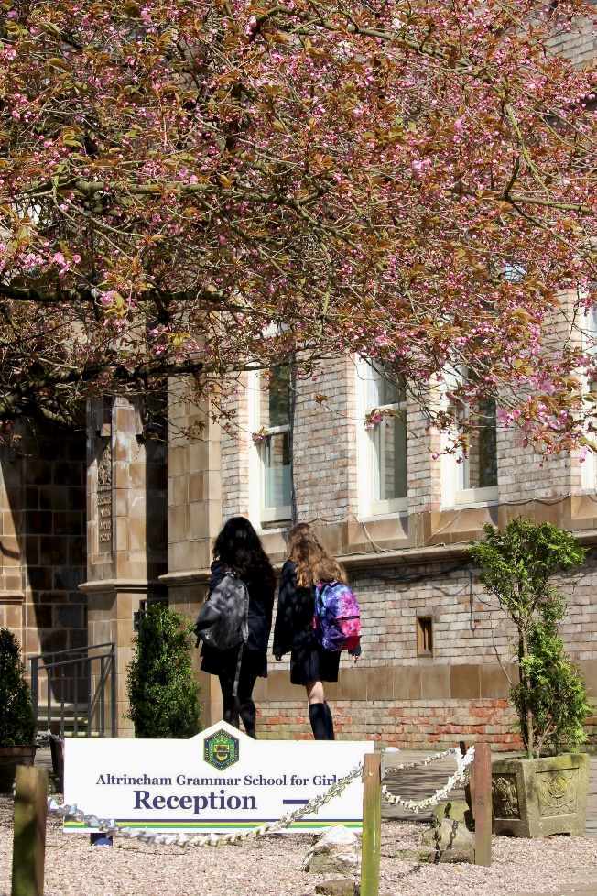
Altrincham Grammar School for Girls (AGGS) is a highly successful single sex 11 -18 academy in the South Trafford area. AGGS was in the first cohort of schools to be designated a national teaching school in 2011. AGGS is the lead school in ‘The Alliance for Learning’, which comprised schools of every type and phase, plus universities, throughout a wide geographical area. The impact of teaching school activities has been felt within the Trust and far beyond. We have a reputation for excellence regionally and nationally, of which we are very proud.

AGGS is committed to providing equal opportunity in recruitment and employment to all individuals. We will consider candidates without regard to race, ethnicity, gender, religion, sexual orientation and identity, national origin, age, military or veteran status, disability or any other legally protected status; and without discrimination based on socioeconomic, marital, parental or caregiving status, or any of the previously listed characteristics or statuses.

We value the diversity of our staff and reject any form of harassment, discrimination or victimisation. The Bright Futures Educational Trust vision is: ‘the best for everyone, the best from everyone’. To achieve this, we create and maintain a work environment and culture where people from different backgrounds, and with varying lifestyles, interests, opinions and responsibilities, treat each other with dignity and respect. It is a climate in which our staff feel safe and are inspired and motivated to be their best.

Our school is dedicated to sustaining and promoting diversity with respect to recruitment, promotion, training and general treatment during employment. We are actively seeking to extend the diversity of our staff. Furthermore, we welcome candidates who have not had previous experience of working in a grammar school.

We aim to ensure that our recruitment processes set up all candidates for success. At interview our aim is to provide a positive experience. We don’t want to catch anyone out, but rather to provide the opportunity for all candidates to be themselves and show us what they are capable of.

Why work for us?

We offer a great opportunity to join an organisation which really lives its values. Our working environment is very inclusive and whilst you can expect to be challenged in your role, you will be supported through professional learning, treated fairly and with dignity and respect. Please see the Equality, diversity and inclusion statement on our website: http://bfet.co.uk/vacancies/.

Terms and Conditions
Salary: MPR/UPR (School Teachers Terms and Conditions)
Location of work: Altrincham Grammar School for Girls
Pension: Teachers Pension Scheme: https://www.teacherspensions.co.uk/

Other: We offer salary sacrifice schemes for purchasing bikes used for travel to work and technology for personal use, through monthly interest free salary deductions.
How to Apply
We can only accept completed application forms, rather than CVs. This is because the regulatory guidelines of Keeping Children Safe in Education, require us to check various details of job applicants and an identical application format for each candidate enables us to do this.
Our website www.aggs.trafford.sch.uk contains our application form and disclosure of criminal background form. Both completed forms should be emailed to vacancies@aggs.bfet.uk by 12 midday on 27 April 2021.

The selection will take place in the week commencing 3 May 2021.

Keeping Children Safe in Education
Bright Futures Educational Trust is committed to safeguarding and promoting the welfare of children and young people and we expect all staff and volunteers to share this commitment. This post is exempt from the Rehabilitation of Offenders Act 1974; pre-employment checks will be carried out and references will be sought for shortlisted candidates and successful candidates will be subject to an enhanced DBS check and other relevant checks with statutory bodies.
Data Privacy
You can the details of how we use the personal data that you provide us with in our Job Applicants’ privacy notice on our website: http://bfet.co.uk/wp-content/uploads/2018/07/BFET-Applicant-privacy-notice-002.pdf

JOB DESCRIPTION
Teacher of Religious Studies

The Religious Studies Department currently consists of three full time teachers. This is a part-time post covering teaching to Key Stages 3 and 4 and will offer scope for professional development, such as teaching to A Level.

The Religious Studies Department takes an academic approach to the subject and hopes to inspire an intellectual interest in, and appreciation of, the variety of religious issues facing people in the 21st century, whilst enabling students to apply their knowledge to their own lives.

Knowledge of the major faiths practised in Britain today and of philosophical, theological and ethical issues will be an advantage, although full training can be given. Students are taught in mixed ability classes within the grammar school system and the school operates a ten day timetable. Students in Year 7 have two one-hour lessons per cycle, Year 8 and Year 9 have three one-hour lessons per cycle. Information on what is taught at Key Stage 3 can be found on the subject page of the school’s website.

Religious studies is taken at GCSE level by a good proportion of students (typically two teaching groups) who have 5 lessons per cycle. At GCSE the department follows the AQA course in Buddhism and Christianity. Results are generally higher than national averages with over 80% of candidates achieving a grade 8 or above.

For A level, the department follows the AQA religious studies course focusing on philosophy, ethics and Buddhism. A prospective candidate would be expected to teach to GCSE and would benefit from having a sound knowledge in Buddhism, although training and resources can be provided. Students generally achieve a 100% pass rate with excellent grades.

The Religious Studies Department is housed in three specialist classrooms. All rooms are equipped with computer, projector and visualiser.

This is a forward-thinking department, committed to the study of religion in all its aspects and respected within the school by both students and colleagues. An enthusiasm for the subject and a willingness to help with extra-curricular activities and departmental initiatives would be expected of the successful candidate.

School-wide Responsibilities
- Being aware of and acting upon relevant school policies and, in particular, those associated with child protection/safeguarding children and health and safety issues.
- Being responsible for maintaining a clean and tidy environment.
- Attending relevant meetings as required.
- Acting as a role model for the pupils in school.
- Acting as an ambassador for school and ensuring that the school’s high standards are promoted at all times.

Additional Specific Responsibilities
- Carry out the duties of a form tutor
- Support the school in its open evenings and award evenings.
- Support the school in its entrance examination.

General Duties
- Carry out a share of supervisory duties in accordance with published schedules. Fulfil the conditions of employment of school teachers as laid down in the Pay and Conditions Document.
- Any other relevant duties requested by the Principal.

Other

We will always consider a flexible approach to working –just ask at interview
- Attend relevant meetings as required, acting as a role model consistently promoting the Trust’s vision, values and commitments.

Acting as an ambassador ensuring that the Trust’s high standards are promoted at all times.
- A commitment to maintaining confidentiality and discretion inside and outside work

If invited for interview, candidates are required to bring original copies of the following documents which we need to have sight of on the interview day:
- Degree certificate
- QTS Certificate
- Photo ID (passport and driving licence)
- Two other forms of identification that verify your name, address and date of birth. e.g. birth certificate, marriage certificate, bank or credit card statement, utility bill.
- Evidence of MPS - recent payslip and school salary notification letter stating where you are on the pay scale (if applicable)
- Evidence of threshold/UPS (if applicable)

Please return your application to Mrs C Williams at the school by midday on 27 April 2021. Interviews are to be held in the week beginning 3 May 2021. Applicants who are not contacted during this period may assume that they have not been successful but are thanked for their interest. Unfortunately, we are unable to provide feedback to unsuccessful applicants who are not called for interview.

Please note that due to equal opportunities and safeguarding regulations, applications will be accepted by application form only. Please do not send CVs. Supporting documents/letters of application are welcomed.

PERSON SPECIFICATION
Category | Essential | Desirable | Method of assessment
Qualifications, Education, Training | Good honours degree in theology or religious studies.  Qualified teacher status.  Recent relevant in-service training. |  | Application form  Certificates
Relevant Experience | Successful teaching experience, up to GCSE in a temporary or permanent post or on teaching practice.  Experience of teaching Religious Studies at KS3 and KS4. | Successful religious studies teaching to A level | Application form  Lesson  Interview
Knowledge, skills and abilities | Excellent up to date religious studies knowledge and understanding.  Tolerance of others’ beliefs and ideas, regardless of personal faith.  An enthusiasm for religious studies and the ability to generate this in others.  High standards of religious studies teaching and learning in the classroom.  Excellent oral and written communication skills with pupils, parents and colleagues.  Ability to show initiative.  Ability to exercise control in the classroom and encourage good behaviour.  Good organisational and record keeping skills.  Excellent IT skills.  Ability to work as part of a team.  Ability to plan, organize, review and adapt.  Willingness to contribute to extra-curricular religious studies department activities. | Willingness to learn new aspects of the subject.  Experience of the role of form tutor. | Application form  Lesson  Interview
Safeguarding | Commitment to demonstrating a responsibility for safeguarding and promoting the welfare of young people. |  | Application form  Lesson  Interview
Teaching School | A commitment to further training and a willingness to participate in the relevant CPD e.g. facilitation/mindfulness programmes.  Willingness for lessons to be observed as part of our school monitoring processes and teaching school brief (e.g. learning walks)  Willingness to be engaged in school to school support.  Positive view/ideas on contributions to language college status/teaching school status.
Other | Commitment to the aims and ethos of the school.  Commitment to pastoral care.  Commitment to maintaining confidentiality and discretion inside and outside school.  Positive approach to challenges, which seeks solutions to problems and addresses difficulties with cheerfulness and good humour.
Our Values | Community: Evidence of working together for a common purpose and encouraging diversity. |  | Application form  Interview  Lesson
 | Integrity: Evidence of doing the right things for the right reason. |  | Application form  Interview  Lesson
 | Passion: Evidence of taking personal responsibility, working hard and having high aspirations |  | Application form  Interview  Lesson

