

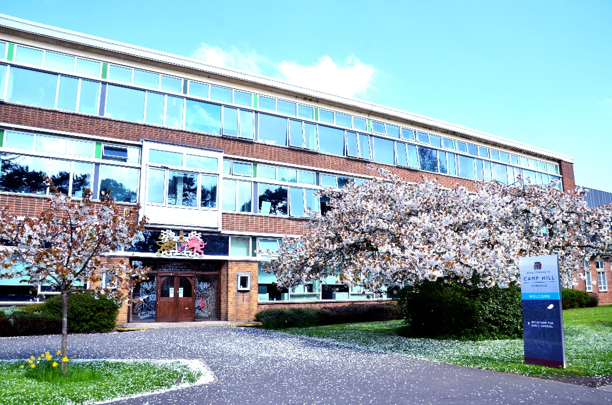

**Teacher of Religious Studies**

0.8 Part Time (F/T may be considered)

Fixed Term for One Year

*Would consider a permanent appointment for the right candidate. Ability to teach History at KS3 would be advantageous, but not essential.*

From September 2025

**Information Pack**

*Dear Candidate,*

*Thank you for requesting information about our Teacher of Religious Studies post, from September 2025.*

*We are a forward thinking, selective state grammar school with academy status, and belong to the King Edward VI Foundation of schools and Multi Academy Trust. We are incredibly proud to have been named as the* ***Sunday Times State Secondary School for 2025****, alongside the* ***State Secondary School for Academic Excellence in the West Midlands, 2025****. These accolades are borne out of the dedication of each and every member of our school community: staff, students, governors, parent and carers. This is an inspirational place to work and learn, and we hope you are inspired to consider applying for a position in our school.*

*Aside from our desire for our students to excel academically at KEVI Camp Hill School for Girls, we place great importance on their happiness and the development of them as individuals. By providing a full range of quality experiences both in and outside of the classroom, our students develop confidence, resilience and learn to make healthy choices - all of which helps to prepare them for life beyond school. Every single member of staff and the student body play their part in adding to the history of the school. I am very privileged to lead an outstanding team of colleagues. Their hard work, extensive subject knowledge and commitment to ensuring the academic results are outstanding, enabling our students to make excellent progress as they move through the school.*

*Our challenging, well-structured curriculum is designed with able students in mind, and encourages them to develop their intellectual curiosity and use higher level thinking skills. We are extremely proud of the breadth of our Curriculum at all Key Stages, and believe it offers students genuine choice. Whilst Maths, Biology and Chemistry are very popular subjects at A Level, we have thriving Arts, Languages and Humanities subjects which are also popular choices for our students. Our extra and supra-curricular offerings are wide and varied, and cater to all manner of tastes. Our school House System is weaved through all aspects of school life, and is just one example of the way in which we both support students pastorally and also develop student leadership.*

*A major strength of our school is the level of pastoral care. Students are extremely well supported by their Teachers, Form Tutors and Heads of Year.* *At Camp Hill Girls, we deeply value wellbeing and recognise that good mental health, along with a safe and supportive environment, are essential for building resilience and helping our young people thrive. We are committed to deepening our understanding of trauma and attachment theory and are proud to be a Trauma Informed Attachment Aware (TIAAS) school. Our students demonstrate excellent behaviour and attendance and are highly motivated, eager, and engaged in all aspects of school life.*

*Camp Hill Girls is culturally rich and diverse, welcoming students from an extraordinary range of backgrounds. As a school community we recognise, celebrate, respect and delight in our differences, and use them as opportunities to learn and become more tolerant about the world around us. This is a caring school which Ofsted recognised, making reference to the fact that “understanding of equality, diversity and inclusion permeates all aspects of school life”. We truly believe in the experience we have on offer at Camp Hill.*

*We believe KEVI Camp Hill School for Girls is an inspirational place to be, and invite you to come and see for yourselves. We very much look forward to welcoming you to our school.*

*Karen Stevens*

*Headteacher*

**THE RELIGIOUS STUDIES DEPARTMENT**

**STAFFING**

Ms Antonia Woodward - Subject Leader for Religious Studies

Miss Vicki Jones – Teacher of Religious Studies (Part-time)

Ms Emma Lamb – Teacher of Religious Studies & Head of Year

**ADMINISTRATIVE SUPPORT STAFF:** There is administrative support for the department.

**ACCOMMODATION AND RESOURCES**

There are 3 specialist classrooms, resourced to a high standard with modern facilities. There is a large Religious Studies office which provides an excellent work area for members of the department.

All departments in school receive an allocation for resources and there are additional funding strands to bid for specific projects.

**CURRICULUM**

Religious Studies is taught as a discrete subject throughout main school. All students study GCSE Religious Studies and achieve outstanding results.

* In Key Stage 3 we deliver schemes of work which incorporate the six world religions. We also include some thematic topics including one on rites of passage and on moral and ethical issues such as wealth and poverty.
* In Key Stage 4, we are currently delivering the full course AQA GCSE syllabus. The two year AQA GCSE 8062 syllabus A, includes an in-depth study of Christianity and Sikhism. The course also includes a range of philosophical and ethical issues with reference to a range of religious views including Christian and Muslim beliefs and teachings.
* In Key Stage 5, we have large A Level numbers and teach AQA with the focus on Buddhism.

We are very proud of the Religious Studies department’s record of achievement in public examinations.

**ENRICHMENT ACTIVITIES**

The department organises visits to local places of worship for Key Stage 4 students. At Key Stage 5, there is an annual trip to Rome. A variety of extracurricular societies are run through the department, and students regularly participate in competitions such as the Philosothon, where they have successfully won regional finals.

**STUDENTS:**

We are most fortunate in the skills, talents and qualities which our students possess. Their responsive nature and willingness to learn and succeed provide an exceptional teaching and learning environment. They offer an enthusiastic secondary teacher a fulfilling opportunity to truly enjoy the teaching of their subject at an intellectual level. There are currently nearly 400 students in the Sixth Form, drawn from our Year 11 and from other local schools.

# REQUIREMENTS AND RESPONSIBILITIES IN THE POST:

We wish to appoint a well-qualified graduate who can actively contribute to the department and who can teach their subject up to and including A Level. Recently qualified colleagues and ECTs with relevant experience are very welcome to apply. There is a clearly articulated and detailed programme for ECTs, as well as induction arrangements for all colleagues joining the school.

# MAKING AN APPLICATION:

Applicants should complete the application form which includes the names, addresses, telephone numbers and e-mail addresses of two referees. A concise but comprehensive letter of application is expected. The details should reach the Headteacher by **9.00am,** **Monday 9th June 2025.**  Applicants will be able to tour the school on the day of interview. Please contact Toni Woodward, Subject Leader at [t.woodward@kechg.org.uk](mailto:t.woodward@kechg.org.uk) if you have any specific questions.

# INTERVIEW ARRANGEMENTS:

On the day of interview, applicants will have an opportunity to tour the school and speak to students.

It is our regular practice to ask short-listed candidates to teach a short lesson of 20-25 minutes. The group to be taught will be determined to some extent by the background and experience of the candidate, and the school’s timetable on the day of interview. Candidates will find our students accepting and welcoming.

**TRAVEL EXPENSES AND REIMBURSEMENTS:**

Normal second-class travel is payable to all applicants who attend for interview, plus reasonable overnight expenses where this applies. Candidates from abroad receive travel expenses paid from the port of entry or airport.

**We look forward to receiving your application.**

Karen Stevens

Headteacher

April 2025

**Job Description: Qualified Teacher:**

***Core purpose:***

To provide a high quality educational experience for all students.

***General duties and responsibilities:***

To carry out the duties of a schoolteacher as set out in the “School Teacher Pay and Conditions” document.

To continue to meet the required National Standards for Qualified Teacher status.

***Knowledge and understanding:***

* Be familiar with the school’s current systems and structures as outlined in policy documents including Health and Safety, Safeguarding and Child Protection Policies, Behaviour Policy and implement them.
* Have a secure knowledge and understanding of the concepts and skills in specialist subject(s) and a detailed knowledge and understanding of the National Curriculum programmes of study.
* Understand specialist subject(s) framework of 14-19 qualifications and the routes of progression through it.
* Select and make good use of IT where appropriate within subject teaching.
* Understand and know how national, local comparative and school data can be used to set clear targets for student’s achievement.
* Understand how students’ learning in the subject is affected by their physical, intellectual, emotional and social development.
* Be familiar with subject-specific health and safety requirements, where relevant, and plan lessons to avoid potential hazards.

***Planning, teaching and class management***

* Plan and deliver in relation to the examination boards and with regard for the school’s aims and objectives, own policies and schemes of work, the teaching programme for all students within the class.
* Provide clear structures for lessons and for sequence of lessons, which maintain pace, motivation and challenge.
* Make effective use of assessment information on students’ attainment and progress and in planning future lessons.
* Ensure effective teaching of whole classes, groups and individuals, establishing high expectations of behaviour and attainment, so that teaching objectives are met.
* Ensure coverage of the relevant examination syllabuses and School Programmes of

Study.

* Exploit opportunities to improve students’ basic skills in literacy, numeracy and IT.
* Monitor and intervene when teaching to ensure sound learning and discipline and maintain a safe environment in which students feel confident, both in the classroom and around school.
* Use a variety of teaching and learning styles to keep all students engaged.
* Be familiar with Codes of Practice and identification, assessment and support of students with special educational needs.
* Evaluate own teaching critically to improve effectiveness.

***Monitoring, Assessment, Recording, Reporting and Accountability***

* Assess and record each student’s progress systematically with reference to the school’s current Assessment Policy and use the results to inform planning.
* Mark and monitor class work and homework, providing constructive feedback and setting targets for future progress.
* Provide reports on individual progress to the Headteacher and parents as required.

***Other Professional Requirements***

* Establish and maintain effective working relationships with professional colleagues and parents.
* Participate effectively and appropriately in meetings with professional colleagues and parents in respect of the duties and responsibilities of the post.
* Be aware of the need to take responsibility for your own professional development.

*This job description may be amended at any time, following consultation between the Headteacher and member of staff and will be reviewed annually.*

*King Edward VI Camp Hill Girls’ School is committed to safeguarding and promoting the welfare of children and young people and expects all staff and volunteers to share this commitment. The successful applicant will be required to undergo an enhanced Disclosure and Barring Service check.*

**Person Specification: Qualified Teacher**

|  |  |  |
| --- | --- | --- |
|  | **Essential** | **Desirable** |
| Qualifications | * Appropriate subject degree * Qualified teacher status/PGCE. | * Strong honours degree (2:1 or above). |
| Experience | * Experience of teaching in the secondary phase. | * Pastoral experience * Some Sixth form teaching experience. |
| Classroom teaching skill | * Record of successful teaching * Meeting national standards. | * Innovative and creative approaches to teaching and evidence of strong performance * Confident use of IT. |
| Knowledge and understanding | * A clear philosophy about the teaching of the specialist subject * Knowledge of appropriate teaching methods for delivering the specialist subject * Subject knowledge sufficient to challenge able students and achieve high outcomes. | * Ability to take responsibility for own professional development * Awareness of strategies for supporting wellbeing, learning and achievement for high ability students. |
| Curriculum | * Familiarity with the nature and purpose of assessment and reporting * Understanding of how to support students to make academic improvements. | * Familiarity with current national educational initiatives and strategies. |
| Personal attributes | * Ability to work under pressure and meet deadlines * Good personal organisation * Good interpersonal skills * Ability to work independently and cooperatively as a member of a team * Reliability and integrity * Ability to demonstrate suitability to work with children – this will include motivation, ability to maintain appropriate relationships, emotional resilience to challenging behaviour. | * Range of interests and willingness to participate in and lead extra-curricular activities * Pragmatism, humour and optimism when dealing with other members of staff. |

Last updated: April 2025