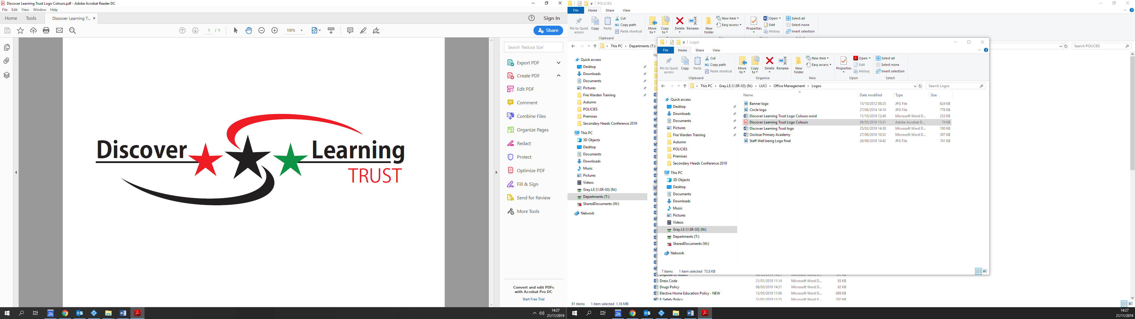

**JOB SUMMARY**

**Position: Teacher of Science**

**Contract Type: Fixed Term**

**Salary: MPS/UPS**

**Hours Per Week: One Day Per Week – 6.5 Hours**

**Location: Oxclose Community Academy**

Oxclose is a school that “grows from strength to strength. Staff feel supported and believe they receive support and development needed. All staff are happy to work at the school.” (Ofsted January 2020)

We seek from September 2024 an enthusiastic teacher, who is passionate about Science. A teacher who has the ability to motivate students through creative and dynamic teaching within a large friendly and supportive Science department.

You would join our very successful Science department in September who are all passionate about delivering a high quality engaging science curriculum incorporating all areas of Biology, Chemistry and Physics to our pupils in both Key Stage 3 and Key Stage 4.

The science department has excellent facilities with well-equipped modern laboratories. This role would suit an NQT or experienced teacher.  All specialisms welcome.

Oxclose Community Academy is a successful and heavily over-subscribed mixed, 11-16 school constantly in the top schools in Sunderland & Washington.

If you would like an application pack please contact Laura Fittes on [Fittes.l@oxclose.net](mailto:Fittes.l@oxclose.net) or information about the department please contact the head of science Natalie Hewitt on [Hewitt.n@oxclose.net](mailto:Hewitt.n@oxclose.net)

Oxclose Community Academy is fully committed to safeguarding and promoting the welfare of children and young people and expects all staff and volunteers to share in this commitment. As part of our due diligence and to comply with our obligations in line with Keeping Children Safe in Education, an online search of publicly available information will be undertaken for all shortlisted candidates. The successful applicant will be subject to provide an enhanced DBS disclosure.

**Closing Date: Midday Wednesday 14th February 2024**

**Interviewing W/C: 26th February 2024**