Teacher of Science

INFORMATION PACK

Details of the post of
Teacher of Science

Are you interested in joining a school and department:

- That is committed to excellent teaching and learning
- That demands high standards from students and staff
- That is extremely popular and over-subscribed
- Which is forward thinking, innovative and creative
- That is at the heart of its community and enjoys excellent links with parents
- That believes well-motivated and highly skilled staff are key to a school’s success
- Where students feel safe and happy.

If so, then please consider applying for this challenging and rewarding post.

Message from the Headteacher

Wales High School is a happy, popular and highly successful school which provides an excellent education for over 1,800 children and young people and I am immensely proud to be the headteacher of this vibrant learning community.

Our aim is for all of our students to achieve their potential and to prepare them to thrive in a rapidly changing world. Pupils are valued as individuals and we are passionately committed to their achievement, personal growth and excellence in everything we do. We have a hugely talented and committed staff team, with a range of well qualified and dedicated professionals to make sure that our curriculum, guidance, care and support meets the different needs of every young person, and we pride ourselves on having high expectations which ensures that our students are well organised, caring and supportive of each other and also personally ambitious.

Our strong tradition of success is built on a firm foundation of pastoral care, and we ensure a climate for learning which is well ordered, safe, calm, and focused on achievement and success.

We are particularly proud of the care and guidance we provide for all of our students, from the most academically gifted who win places at Oxbridge to those who have significant additional needs.

All of our students are expected and encouraged to become independent learners and to develop their leadership skills, so they can fully participate in our rich extra-curricular programme. Across the school, teachers and students work in a collaborative and orderly atmosphere of mutual respect and trust. This gives the students a sense of belonging and a pride in our school and in themselves. Above all, we are committed to working together as a team.

We believe that by working together we can ensure opportunity and success for everyone. Every young person has unlimited potential, together we can make sure that this potential is realised and fulfilled.

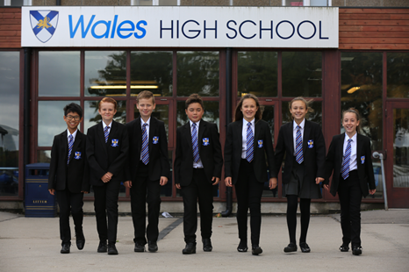
We pride ourselves on very close, open and positive relationships with parents and carers and expect them to be fully involved in supporting the learning of their son or daughter.

We are very active in our local and wider community, and have developed very close links with our Business and Enterprise partners.

I have pleasure in inviting you to visit the school to judge for yourself what makes this such a special community in which to learn.

Mr. G. Di'Iasio
Headteacher

WALES HIGH SCHOOL
Storth Lane, Kiveton Park, Sheffield S26 5QQ
Tel: 01909 775711

Headteacher: G. Di’Iasio, B.Ed. (Hons)
11-18 Mixed Comprehensive
1833 on roll (Sixth Form 234)

We welcome applications for the following temporary post
with an anticipated start date of January 2022, tbc at interview.

TEACHER of science

An exciting opportunity has arisen for the appointment of a Teacher of Science
in this extremely successful school, which has a first class reputation
for producing excellent results at GCSE and A-Level.

The successful candidate will demonstrate vision, passion,
leadership and commitment to teaching
to complement this vibrant and forward-thinking department.
We welcome applications from both experienced and newly qualified teachers
to join this successful and expanding team.

Further details and a Wales High School application form can be found online,
via the school’s website www.waleshigh.com.
PLEASE NOTE we operate Safer Recruitment and we do not accept CVs -
all applicants must complete our application form in full.
Applications can be posted to the school or e-mailed to vacancies@waleshigh.com

Deadline for applications is: 5 pm on Monday 29th November 2021
Interviews have been scheduled for: Monday 6th December 2021

If you would like to discuss the role or would like to arrange a visit to the Science department, please contact Mrs Hannah Feerick on
01909 771291 or by email on hf@waleshigh.com

Mrs Hannah Feerick
Head of Science

Wales High School is committed to safeguarding
and promoting the welfare of children, young people and vulnerable adults.
Successful candidates will be required to apply for a disclosure of criminal records check at an enhanced level. Further information about the Disclosure Scheme can be found at www.gov.uk/disclosure-barring-service-check.

Teacher of Science
~ Job Description ~

Responsible to: Head of Science

Hours: 32.5 hours per week (52 weeks p.a.)

Main Purpose

To teach Science as directed by the Head of Department.

Duties and Responsibilities

To plan, prepare and deliver stimulating and imaginative lessons to classes of different age groups and abilities - incorporating differentiation, as appropriate.

To develop appropriate Schemes of Work.

To mark, check and assess students’ work and provide feedback.

To routinely track and monitor students’ progress in accordance with school procedures and Assessment Points.

To prepare students for qualifications / examinations.

To manage pupil behaviour within lessons and the wider school premises.

To attend staff and department meetings, as appropriate.

To manage and co-ordinate extra-curricular interventions and activities.

To liaise with parents and carers, as appropriate.

To maintain up-to-date subject knowledge and keep up with changes in the National Curriculum.

To engage in continuous professional development, including INSET opportunities.

Teacher of Science
~ Person Specification ~
Essential | Desirable
- QTS and suitable experiences or qualifications as a teacher of Science.  - Proven IT skills.  - To like children and have high expectations of them, with good standards of discipline.  - To be efficient, well organised and able to work to deadlines.  - To have shown a strong interest and success in dealing with young people and their pastoral welfare.  - To demonstrate effective communication skills - written and verbal.  - To have a strong public presence.  - To be able to deal with pupils, parents, staff and the wider community.  - To have a ‘whole school’ perspective.  - To be reliable, have the ability to work hard and give freely of your time.  - People focused with a friendly, yet professional, and respectful approach - which demonstrates support and mutual respect.  - Flexibility and willingness to work unsociable hours occasionally. | - To have a good honours degree in Science or related subject.  - Experience of teaching Science.  - To have participated in extra-curricular activities.  - Experience of being a form tutor.  - Managerial / leadership skills.  - To have a good sense of humour.  - To have taught the full ability range in a mixed comprehensive school.  - To have experience of working in more than one school.  - Smart appearance / dress.

The Science Department
The Science Department at Wales High School is highly enthusiastic, dynamic and committed to driving high standards whilst developing the potential of our students.

Our department is constantly striving to improve the attainment of every student and we regularly adapt our teaching, curriculum and intervention strategies to ensure that our curriculum is bespoke and students’ learning is personalised. We work hard to support and challenge individuals so they make the best possible progress in Science.

We are a large, supportive department who welcomes new colleagues and new challenges. The Department consists of over twenty teaching staff with a range of experience including an Assistant Headteacher. The Department is led by Miss Hannah Feerick, Head of Science, who is supported by additional members of the department in key roles, including Lead Teachers for KS3 and KS4 Biology, Chemistry and Physics, and KS5 Biology, Chemistry and Physics as well as KS5 Applied Science Lead. In addition to this we also have Progress Leaders for KS3 and KS4 and a Year 6/7 Transition Co-ordinator. The department is strengthened by a team of five support staff including three technicians who enable the teaching of engaging lessons and practical work.

We are proud that the majority of staff in the department are subject specialists with a great deal of outstanding practice evident. We are also a lead school for the Institute of Physics and enjoy having our own IOP Lead Coach within the department. Some members of the department also work with a range of exam boards as examiners, moderators and team leaders.

Science is taught in a suite of twelve laboratories and three classrooms, all of which are equipped with smart boards and multimedia projectors. The Department also has three IT rooms which are equipped with wired, networked computers.

At KS5 we deliver AS and A Levels in AQA Biology, Chemistry and Physics. BTEC Level 3 Applied Science is currently offered as a vocational alternative. The subjects at KS5 are taught by subject specialists.

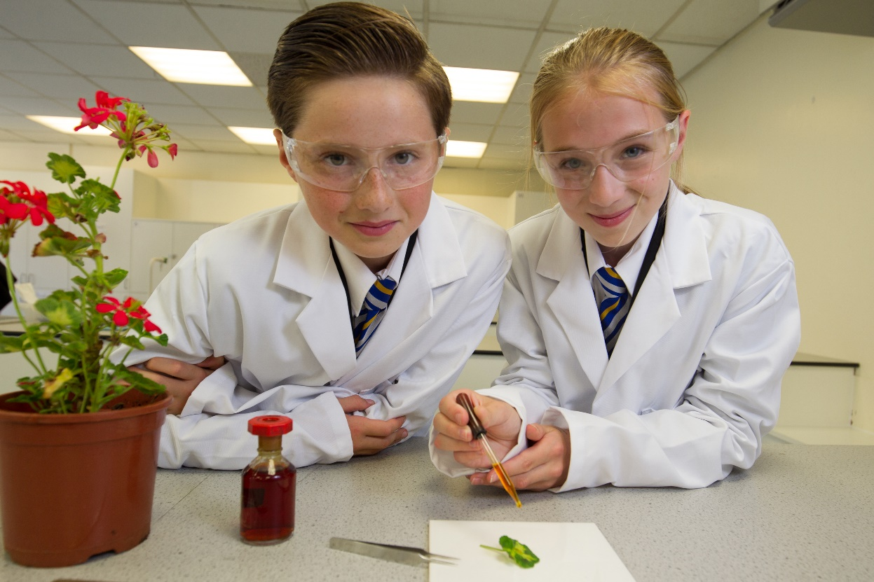

In Year 11 we currently deliver separate Sciences and the Trilogy syllabus from AQA, which our Y9 students start in the spring term. In the majority of cases, KS4 is taught by subject specialists.

At KS3 all students study our own in-house thematic scheme of work. The scheme draws on the wide range of science topics including How Science Works. Students are given regular feedback and are formally assessed through tests. Students are set by ability in the autumn term and adjusted if necessary at key assessment points throughout the year.

This post would suit an enthusiastic individual with drive, energy and commitment, and will give the successful applicant the opportunity to work in a happy, thriving and well-respected school. We look forward to you joining our team.

Mrs Hannah Feerick
Head of Science

Wales High School – Stake Holder Comments

Parents/Guardians:

- ‘My daughter enjoys coming to this school’
- ‘Fantastic - child extremely happy. He loves the school.’
- ‘Wales high is a fantastic school: nurturing and caring’
- ‘When your son walks into school saying he is worried about scraping through a particular subject and walks out with a 9 in it! Priceless!’
- ‘What an amazing teacher. Thank you’
- ‘Very supportive teachers and approachable’

Students:

- ‘I'm happy with everything - love the school’
- ‘This is a lovely school to be at and it makes me feel grown up. So glad I came to this school’
- ‘Teachers care and help me’
- ‘Thank you so much for being the best teacher ever and making exams less stressful’
- ‘Proud of myself’
- ‘Over the moon with my results - the hard work has finally paid off’

Wales High School – Ofsted

During the last two inspections of Wales High School, Ofsted were impressed with “the schools drive to provide strong pastoral care and ensure a climate for learning which is well ordered, safe, calm and focused on achievement is a reality at this ‘good school.’” They also commented that “the leadership team has maintained the good quality of education in the school…Together with governors, you are resolutely committed to the school’s further improvement. You are not complacent about any of the school’s successes and strengths.”

We are proud of all our staff, pupils, parents, governors and community who have made this possible.

Among the points highlighted by the Inspectors in the School's recent short inspection they say:

- ‘the leadership team has maintained the good quality of education in the school since the last inspection’
- ‘leaders have worked with persistence and diligence to maintain and improve levels of attendance and persistent absence, which are better than the national averages’
- ‘there is evidence of very effective teaching’
- ‘a significant number of middle leaders are now nationally recognised as leaders in their subject areas, and they provide support to other schools’
- ‘acted decisively in responding to the needs of your pupils, such as training 18 staff as mental health first aiders’
- ‘pupils told us that the school is a tolerant place, and that they feel safe there. They told us that bullying is rare, but that if it happens, the school deals with it’.

Wales High School
Founded 1970
Wales High School Academy Trust
Storth Lane, Kiveton Park, SHEFFIELD, S26 5QQ

Tel: 01909 771291
Email: vacancies@waleshigh.com

