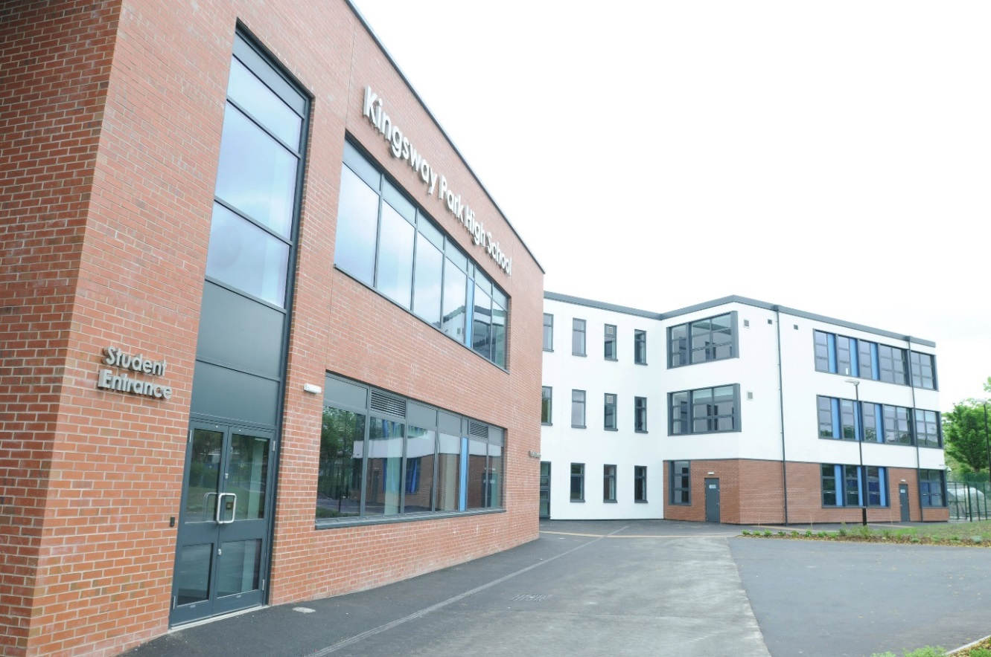

**Title:** Teacher of Science

**Application deadline:** Tuesday 15th October 2024 at 9am

**Interview:** Week Commencing 21st October 2024

Candidate Information Pack

Dear Applicant

We would like to extend a warm welcome to you in applying for the post of Teacher of Science at Kingsway Park High School.

The school has recently undergone a period of transition and change in its Senior Leader Team resulting in the appointment of a new Headteacher and other key roles. There has also been a number of promotions within the area of Social Sciences which has meant that we are in the exciting position to recruit to this key role.

As part of the Altus Education Partnership, the mission and values that underpin the direction for our school are clear and form a key area of alignment that will be needed for the role. I would encourage you to review these alongside our statement of intent.

“We Co-operate, We Pioneer, We Belong” on our website, as they will tell you all that you need to know as to whether this school is the right place for you. This is so important that we are a right fit for you as much as you are for us.

Kingsway Park High School is proud to be a vibrant, inclusive and diverse comprehensive school. We provide an individualised curriculum offer for all students regardless of their starting point, gender, ethnicity, faith or need. We seek to nurture and develop the whole child not just ensuring each students academic potential, but also preparing them as a socially responsible citizen who can flourish in society and give back to their local community. We seek to remove those barriers of inequity that prevent equality of opportunity so that all students can aspire and be inspired to realise their dreams. We also respect and recognise that success feels and looks different for each and every one of our students.

This school has soul and a true “family feel.” The staff here work relentlessly in the pursuit of excellence for this community and the students we serve.

Our challenge is to continue to develop the school’s culture and unique offer while improving aspirations, learning and achievement. This is not something that is possible for any one individual but requires a team of passionate, dedicated and committed staff, supported by a strong and principled senior leadership team. It is only through this collective responsibility and partnership working, that we can achieve a world-class learning experience for all.

If you are excited by what you have read and feel that you can support in elevating Kingsway Park High School, during its next stage of its journey, we look forward to receiving your application.

Yours sincerely



Mr Simon Ward - Headteacher

# Application

1. Complete the Altus Education Partnership application form
2. Provide a cover letter of no more than two sides of A4 paper
3. Send your application by email to recruitment@altusep.com

# Deadline

The deadline for the post is Tuesday 15th October 2024 at 9:00am

Interview is scheduled to be on the week commencing 21st October 2024.

# Shortlisting

We will unfortunately be unable to notify candidates who are not on the shortlist, therefore, if you do not hear from us, your application has been unsuccessful on this occasion.

# For an Application Pack

1. Visit [www.kingswaypark.org](http://www.kingswaypark.org) or [www.altusep.com](http://www.altusep.com/)
2. Telephone: 01706 716 761

# Reward Package & Additional Benefits

We offer a comprehensive package, including membership of our outstanding Teachers’ Pension Scheme; our ‘Employee Benefits Programme’ which provides a range of options including:

* + Our Cycle to Work Salary Sacrifice Scheme
  + Free access to Employee Assistance Programme, offering guidance, support, and counselling on a range of subjects.

# Background Information

# Kingsway Park High School

Kingsway Park High School was established in 2010 and joined the Altus Education Partnership in February 2022. We are now a very popular oversubscribed school (1350 students in years 7-11 and 190 staff) located in central Rochdale. We are very proud of the high-quality facilities, resources, and environment that we provide for both staff and students.

At Kingsway Park High School we strive to transform students’ lives. Through our relationships, we endeavour to instil both resilience and an intrinsic motivation to become confident, creative, and highly skilled students, capable of meeting tomorrow’s challenges head on. We strive to establish a culture rooted in achievement and progress that encourages our students to grow academically, personally and socially; equipping them with the values of equality, fairness and openness. We pride ourselves on our relentless drive to achieve outstanding, high-quality teaching that provides a safe, supportive and encouraging environment for all our students to be able to realise their academic potential in pursuit of educational excellence.

# Altus Education Partnership

The Altus Education Partnership is a Multi Academy Trust and was established in April 2017 by the Governing Body of Rochdale Sixth Form College, an outstanding A-Level provider founded in 2010. The college was awarded Outstanding status by Ofsted in 2013 and has developed a national reputation for excellence, having been used in Ofsted case studies for sharing best practice. The development of the Trust stemmed from a commitment to raising aspirations and improving the life chances of young people throughout the borough of Rochdale. In 2019 the Trust was successful in its application to open a new free school, the Edgar Wood Academy, which serves the local community in Middleton and Heywood.

We are committed to supporting all children in their academies to progress to a successful career, life, and employment path of their choice.

All our academies will share a collective identity as providers of the highest quality teaching with high expectations of learners, coupled with effective assessment and intervention. Young people in our academies will engage with opportunities to develop their own skills and aptitudes to support their progression, while making valuable contributions to their communities. Leaders and teachers will take a collaborative approach, sharing best practice at a local, regional and national level, to continuously improve the performance and outcomes of all academies in the Trust.

# Altus Education Partnership Values

The values of the Altus Education Partnership will be embedded and visible throughout all the academies. Each will have its own unique identity built around the core Trust values. These are:

* Unrelenting commitment to improve the quality of our provision and enhance the lives of our students.
* Openness in the way we build trust and bring purpose to our work as a Multi Academy Trust.
* Accountability through the rigorous, transparent and forensic analysis of all aspects of our performance.
* Commitment to the principles of inclusion and equality.
* Dedication to the borough of Rochdale and its surrounds.
* Collective responsibility for one another and the results of all our students – ‘if one fails, we all fail’.

# The Ambition is that by the time students leave they will:

* Have achieved their personal academic potential giving them a greater choice in life.
* Have the highest aspirations and developed the self-esteem, confidence, and emotional resilience to exploit their potential.
* Be contributing members of the community and have compassion for others.
* Be able to celebrate their success and that of others.
* Have developed the confidence to overcome barriers to success.
* Be articulate, creative, and prepared for future growth and learning.
* Be happy!

# Shared Objective for all Staff

"To maximise students' achievements"

* At Altus Education Partnership we do this through engaging our students in their subjects and inspiring them to enjoy their studies in a totally positive atmosphere.
* Our students are challenged to achieve through a culture of high expectations and a belief in their ability.
* Above all, staff at Altus Education Partnership are committed to their students and demonstrate this through their daily conduct and interaction.

**Role Description:**

|  |  |
| --- | --- |
| **Job Title:** | Teacher of Science |
| **Reports to:** | Faculty Lead of Science |
| **Staff Responsibility:** | N/A |
| **Additional:** | As Assigned |
| **Remuneration:** | Main Teacher Pay Scale |
| **Contract:** | Permanent – Full Time |
| **Start Date:** | January 2025 |

**Primary Purpose:**

We are currently looking to appoint a new Teacher of Science who has a real passion for their subject and is equipped with the skills to maximise outcomes for students in Science at both KS3 and KS4. Science at KPHS follows the AQA specification where we teach both Trilogy Combined and Triple Science. At KS3 we have a sequenced curriculum which enables students to build their knowledge and skills sequentially leading into KS4 following a bespoke curriculum using the AQA specification.

The science team is a warm and welcoming team, with a wealth of experience across all three sciences. We take great pride in our support of ECTs and equally in providing in-house CPL for staff to constantly develop. We currently run our own CPL sessions to increase capacity to teach at grade 7-9 and enable staff to deliver content outside of their specialism. We are a large team with currently 13 full time teachers, two part time teachers and two technicians. Due to the popularity of Triple Science, we are now looking to expand our team further. We have developed a strong ethos around developing staff whether that be in their pedagogy or in increasing opportunities for responsibilities for those looking for career progression.

The team also offer extensive extracurricular sessions for students which we always encourage new staff to get involved with whether it be science club, games club or starting something new around a personal passion.

**Teaching Duties and Responsibilities:**

* Effectively contribute to the Science department at KPHS by seeking to continuously maximise the achievements of outcomes of students at both KS3 and KS4.
* Encourage the use of a variety of teaching strategies, which involve planned formative assessment and active learning strategies across the department.
* Ensure lessons across the department are differentiated for the individual needs of students.
* Seek to ensure students are engaged and sustained through provision of clear structure for lessons, maintaining pace, motivation, and challenges within the science curriculum.
* Encourage staff within your department to allow students to think and talk about their learning, develop self-control and independence, concentrate, persevere, and listen.
* Work actively to create an ethos that promotes equality, celebrates cultural and academic diversity, and ensures the inclusion of students of all abilities, including those with special educational needs.
* Display sound knowledge and understanding of their subject area and communicate this effectively with staff and students.
* Establish good relationships with both staff and students that promote the achievement of learning, whilst maintaining a purposeful and positive atmosphere in the classroom
* Set the learning in lessons and schemes of work in the context of what has gone before and make it clear what it is intended to achieve.
* Monitor and intervene when teaching and leading to ensure effective learning and maintain a safe environment in which students feel confident.
* Self-evaluate teaching of self and others critically to improve effectiveness.
* Keep full attendance records sending electronic class attendance data promptly.
* Plan and prepare lessons and schemes of work in accordance with school policy, ensuring a variety of learning opportunities for the development of key skills.
* Maintain individual records of all student experiences and achievements within the department and use data to inform future planning.
* Prepare, implement, and monitor Individual Learning Plans for students in accordance with school policy. Quality assure these plans whilst leading the team.
* Work collaboratively with colleagues, parents/carers, educational psychologists, therapists, social services, and other outside agencies who may be involved with students for whom you have a responsibility.
* Have a thorough awareness of, and regard for, the confidential nature of many aspects of school information relating to individual students, groups of students and year group analysis.
* Promote positive student behaviour in line with school policies within the Science department.
* Assess academic performance in the light of previous achievement to enhance the value-added results of all students.
* Assess how well learning outcomes have been achieved and use them to improve specific aspects of learning and teaching.
* Assess and record students’ progress systematically and keep accurate records to check work is understood and completed. Ability to monitor strengths and weaknesses, inform planning and recognise the grade/level at which all classes and overall year groups are achieving.
* Set sufficient work for formal assessment, such that students understanding can be regularly checked and so that students can be fully prepared for the demands of public examinations and/or coursework.
* Mark, monitor and return work within a reasonable and agreed time span providing constructive oral and or written feedback that clearly indicates strategies for improvement. Ensure students are very clear as to how to move specifically to the next grade/level.
* Attend parent’s evenings according to the school calendar to keep students’ families and/or

their carers

**Other Responsibilities**

* Participate in arrangements for professional development as outlined in the school development plan or identified through the appraisal process and take responsibility for own development.
* Ensure the activities in which students are engaged are conducted in a disciplined, safe and healthy environment and in line with school policy.

informed about their progress.

**General Responsibilities**

* To be an ambassador for the school and consistently embody the school intent of ‘We Cooperate. We Pioneer. We Belong.’
* To model the core values of the school in your professional life and to promote and develop the

school’s vision, ethos, aims and objectives.

* To establish a culture that promotes excellence, equality, and high expectations for all students.
* To respond professionally to unplanned situations, crises, and emergencies whenever they arise to ensure the safety and efficiency of staff and students of the school and to maintain good discipline.
* To attend meetings with external agencies and organisations.
* To foster and support extra-curricular activities in the interest of the school community e.g. school productions, concerts, sports activities, trips, and excursions.
* To take on additional responsibilities as directed by the curriculum leader.

**Whole-School Organisation, Strategy and Development**

* Contribute to the development, implementation and evaluation of the school’s policies, practices and procedures, so as to support the schools’ values and vision.
* Make a positive contribution to the wider life and ethos of the school.
* Participate in KPHS daily duty rota.

**Health and Safety**

* Promote the safety and wellbeing of students and help to safeguard students’ well-being by following the requirements of Keeping Children Safe in Education and our school’s child protection policy.

**Professional Development**

* Help keep their own knowledge and understanding relevant and up to date by reflecting on their own practice, liaising with school leaders, and identifying relevant professional development to improve personal effectiveness
* Take opportunities to build the appropriate skills, qualifications, and/or experience needed for the role, with support from the school.
* Take part in the school’s appraisal procedures.

**Personal and Professional Conduct**

* Uphold public trust in the education profession and maintain high standards of ethics and behaviour, within and outside school.
* Have professional regard for the ethos, policies and practices of the school, and maintain high standards of attendance and punctuality.
* Demonstrate positive attitudes, values and behaviours to develop and sustain effective relationships with the school community.
* Any other reasonable duties as requested by the Line Manager, Headteacher or member of the Senior Leadership Team that are not specified in this job description.
* Respect individual differences and cultural diversity.

**Person Specification**

|  |  |  |  |  |  |  |
| --- | --- | --- | --- | --- | --- | --- |
|  | | **Assessed by:** | | | | |
| **No.** | **CATEGORIES** | **App Form/**  **Letter** | **Interview** | **Lesson** | **Refs** | **Results Sheet** |
| **ESSENTIAL CRITERIA** | | | | | | |
| 1. | A high-quality degree with Science as a key focus | √ |  |  |  |  |
| 2. | PGCE with QTS/ QTLS and membership with DfE or IfL or willingness to work towards | √ |  |  |  |  |
| 3. | A passion for teaching the subject | √ | √ | √ | √ |  |
| 4. | Ability to engage with students, inspiring learning & promoting success | √ | √ | √ | √ |  |
| 5. | Exceptional classroom practitioner | √ | √ | √ | √ |  |
| 6. | Ability to devise, adapt and differentiate new resources for learning | √ | √ | √ | √ |  |
| 7. | Knowledge sand application of active learning and teaching styles | √ | √ | √ | √ |  |
| 8. | Evidence of dynamic and innovative practice | √ | √ | √ | √ |  |
| 9. | Either – successful teaching placement (*applicants currently in training) OR* successful record of teaching including quality KS4 results. | √ |  |  | √ | √ |
| 10. | Commitment to leading quality teaching and learning within department | √ | √ |  | √ |  |
| 11. | Competence in the use of ICT | √ | √ |  | √ |  |
| 12. | Ability to contribute positively to teams, share ideas & develop resources co- operatively | √ |  |  | √ |  |

|  |  |  |  |  |  |  |
| --- | --- | --- | --- | --- | --- | --- |
| 13. | Ability to be adaptable & flexible | √ | √ |  | √ |  |
| 14. | Effective inter-personal & communication skills | √ | √ | √ | √ |  |
| 15. | Commitment to valuing the individual and boosting their self-belief and worth | √ | √ |  | √ |  |
| 16. | Commitment to high standards & expectations – no accepting of second best in students and staff | √ | √ |  | √ |  |
| 17. | Commitment to professional learning & institutional improvement | √ | √ |  | √ |  |
| 18. | Commitment to high professional & personal standards of work & conduct | √ | √ |  | √ |  |
| 19. | Determination to promote equality of opportunity |  | √ |  | √ |  |
| 20. | Ability to offer enrichment & contribute to wider college life | √ | √ |  | √ |  |
| 21. | Commitment to professionalism, sharing, teamwork & collaboration | √ | √ |  | √ |  |
| **DESIRABLE CRITERIA** | | | | | | |
| 23. | Able to use interactive ICT systems for learning and teaching | √ | √ |  | √ |  |
| 24. | Experience of examining subject | √ |  |  |  |  |
| 25 | Experience of contributing/ developing whole school experiences | √ |  |  |  |  |