Primary, Secondary & Sixth Form

“A SCHOOL FOR EVERYONE…” Ofsted 2020
Science Teacher
Main Scale/UPS

An Introduction to Washwood Heath Academy
Primary, Secondary, Sixth Form
Washwood Heath Academy is an oversubscribed All-through school educating children from Reception to Sixth Form. Our new purpose built primary school facility was opened in March 2019 and provides a fantastic teaching and learning environment for our younger pupils. Visitors to the school are always impressed by the high standards in lessons and around the Academy and how welcoming and polite our young people are.
At Washwood Heath Academy, we believe in creating and sustaining a positive and uplifting culture for all of our children and we also do this for each other as well. We are a caring and nurturing environment which aims to develop all of our core HEARTS values: Happiness, Excellence, Achievement, Respect, Resilience, Tolerance and Self-Belief. We go above and beyond to ensure that everybody within our school community feels respected, challenged, supported and safe. We believe in being: Ready, Respectful and Safe. We aim to equip our pupils with the right tools for them to achieve and we aim to provide them with the most effective environment that ignites curiosity and wonder.
We believe that every one of our pupils has potential to go on and become outstanding members of society and our caring and supportive school environment is the perfect place for them to grow in confidence. We strive to provide the best for every child by understanding, respecting and providing for each and every young person in our care. Our excellent relationships with parents and carers promote a shared understanding and belief in the school’s values and aims, working in partnership for their child’s education.
In March 2020, Washwood Heath Academy experienced its first Ofsted inspection as an All-through Academy and was graded ‘Good’ in all categories. Ofsted reported that ‘Leaders have a clear and ambitious view of what pupils should learn. They have reviewed the curriculum, and made changes in the short and longer term’. In September 2019, Washwood Heath Academy embarked on its journey to develop and implement a knowledge-rich curriculum across all phases of the Academy. To date, we have embedded a knowledge-rich curriculum into Key Stage 3 and Key 4 subject areas and work is still very developmental in Primary and Post 16 phases. In addition, we have embedded Direct Instruction into Key Stage 3 and we are keen to introduce it into the Primary phase as a catch-up strategy. Staff at Washwood Heath Academy use research to help improve teaching and learning, curriculum and pastoral care.
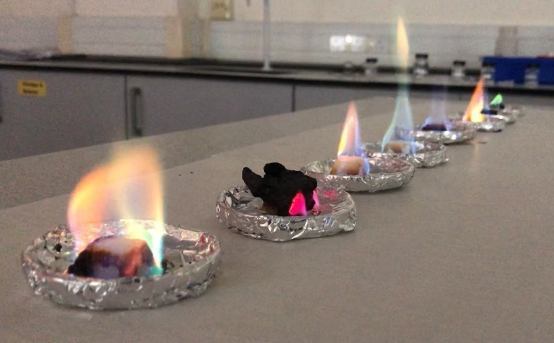
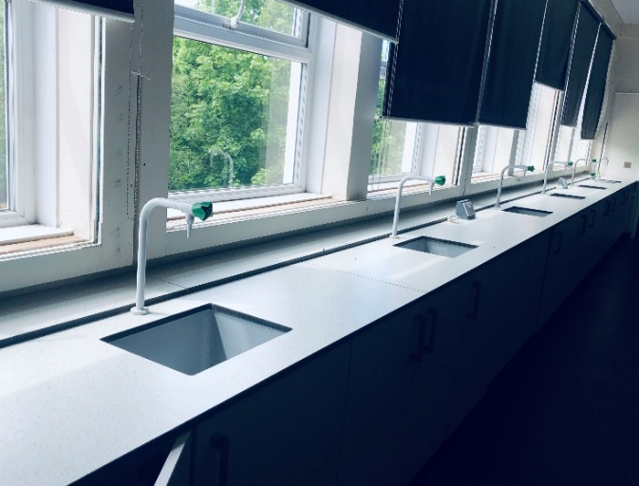

An Introduction to the Science Faculty
The successful candidate will become part of an effective, passionate and aspirational team of science professionals. It is a large yet inclusive department with many years of combined expertise both in teaching and examining for the AQA science Syllabi. Alongside the KS3/4 provision the department offers a full spectrum of Science A’ levels and BTEC L3 Applied Science at KS5, allowing teachers to impart knowledge at the depth and specialism they are most passionate about.

The Science Department is currently taking part in an exclusive Teaching and Learning pilot directly spearheaded by the Curriculum Department within the DfE. As part of a select collegiate of schools across the West Midlands, the Science Department is researching and embedding the benefits of adopting a Science Knowledge Rich Curriculum and has already presented its progress to the DfE at the ministerial offices in London. The school is now in its third year of the DfE Pilot Scheme and will continue to reap the benefits long after the Pilot closes for review. In the most recent OFSTED inspection the Department was selected to be more closely scrutinised, it was successful in demonstrating the vision, the journey and the progress it is making.

The Science floor itself houses 12 fully equipped science laboratories, 5 of which were completely refurbished recently and a P16 theory room. It is supported by 3 experienced Science Technicians and considers practical experiments and scientific enquiry to be an integral part of successful science learning.

The Science Department is ambitious, forward-looking and seeks to welcome like-minded science teachers into its fold. We offer an array of CPD with internal experts and established links with RSC, RSB, IoP, ASE and regional STEM. In the near future, the science department is seeking to join a leading group of science departments across the country with the official Science STEM Mark accreditation.

Finally, Washwood Heath Academy really is ‘a school for everyone’ and a significant number of staff have remained at Washwood for many years because they enjoy being part of a family and working in a caring and supportive community that wants the best for all of its young people and staff.

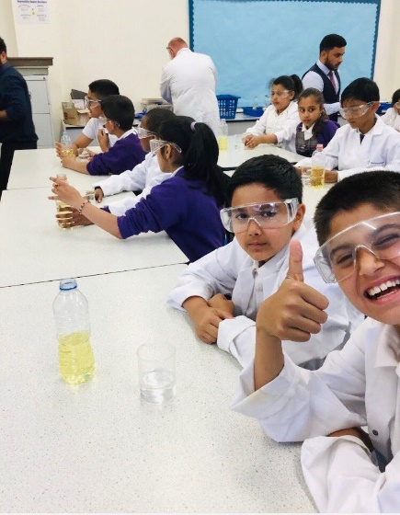

JOB DESCRIPTION

Post Title | Science Teacher- Main Scale/UPS
Purpose | - To implement and deliver an appropriately broad, balanced, relevant and knowledge-rich curriculum for students and to support the assigned science curriculum area as required.  - To monitor and support the overall progress and development of students as a teacher and Form Tutor  - To facilitate and encourage a learning experience which provides students with the opportunity to achieve their individual potential  - To contribute to raising standards of achievement and maximising student attainment  - To share and support the school’s responsibility to provide and monitor opportunities for personal and academic growth  - To be committed to the safeguarding of children
Reporting to | Head of Faculty
Liaising with | Headteacher/Senior Leadership Team, teaching and support staff, Multi Academy colleagues, external agencies and parents.
MAIN (CORE) DUTIES
Teaching: |  | - To teach students according to their educational needs, including the setting and marking of work to be carried out by the student in school and elsewhere  - To use teaching strategies which will stimulate learning appropriate to student needs and demands of the syllabus and curriculum  - To assess, record and report on the attendance, progress, development and attainment of students and to keep such records as are required  - To provide, or contribute to, oral and written assessments, reports and references relating to individual students and groups of students  - To ensure that ICT, Literacy, Numeracy, cross-curricular aspects and school subject specialism(s) are reflected in the teaching/learning experience of students  - To undertake a designated programme of teaching  - To ensure a high quality learning experience for students which meets internal and external quality standards  - To prepare and update subject materials  - To maintain good order, discipline and respect for others; to promote understanding of the school’s rules and values; to encourage good practice with regard to punctuality, behaviour, standards of work and homework. To safeguard health and safety and to develop relationships with and between students conducive to optimum learning  - To undertake assessment of students as requested by external examination bodies, departmental and school procedures  - To mark, grade and give written and verbal and diagnostic feedback to students of individual work and group work they have undertaken
Operational/ Strategic Planning |  | - To plan and prepare courses, schemes of work and individual lessons, appropriate to the needs, interests, experience and existing knowledge of students  - To assist in the development of appropriate syllabuses, resources, schemes of work, marking policies and teaching strategies in the Faculty  - To contribute to the Faculty’s Improvement Plan and its implementation.  - To contribute to the whole school’s planning activities  - To contribute to the faculty process of self-review and evaluation and Improvement Plan activities  - To contribute to faculty and whole school enrichment opportunities  - To contribute to faculty intervention and revision opportunities
Curriculum Provision and Development: |  | - To assist the Head of Faculty, to ensure that the curriculum area provides a range of teaching which complements the school’s strategic objectives  - To assist in the process of curriculum development and change so as to ensure the continued relevance to the needs of students, examining and awarding bodies and the school’s Strategic Commitment, Purpose and Intent.
Staffing  Staff Development:  Recruitment/ Deployment of Staff |  | - To take part in the school’s staff development programme by participating in arrangements for further training and professional development  - To continue personal development in the relevant areas including subject knowledge and teaching methods  - To engage actively in the Performance Appraisal Review process  - To ensure the effective/efficient deployment of classroom support  - To work as a member of a designated team and to contribute positively to effective working relations within the school
Quality Assurance: |  | - To adhere to and to help to implement school quality procedures  - To contribute to the process of monitoring and evaluation of the faculty in line with school procedures, including evaluation against quality standards and performance criteria. To implement modifications and improvement where required  - To review from time to time methods of teaching and programmes of work  - To take part, as may be required, in the review, development and management of activities relating to the curriculum, organisation and pastoral functions of the school
Management Information: |  | - To maintain appropriate records and to provide relevant accurate and up-to-date information for the school’s management information system  - To complete the relevant documentation to assist in the tracking of students  - To track the progress of your assigned students and use this information to inform your teaching and learning
Communication: |  | - To communicate effectively with the parents of students as appropriate  - Where appropriate, to communicate and co-operate with persons or bodies outside the school  - To follow agreed policies for communications in the school  - Attend meetings according to the school’s Directed Time Policy
Marketing and Liaison: |  | - To take part in marketing and liaison activities such as Open Evenings, Parents’ Evenings and liaison events with other schools in the Multi Academy Trust  - To contribute to the development of effective subject links with external agencies/schools
Management of Resources: |  | - To contribute to the process of the ordering and allocation of equipment and materials.  - To assist the Head of Faculty to identify resource needs and to contribute to the efficient and effective use of resources  - To co-operate with other staff to ensure a sharing and effective usage of resources to the benefit of the school, faculty and the students  - To co-ordinate and manage the work of other staff, such as support staff, participating in the teacher designated lessons
Pastoral System: |  | - To be a Form Tutor to an assigned group of students  - To promote the general progress and well-being of individual students and of the Form Tutor Group as a whole  - To liaise with a Head of House and Guidance Manager to ensure the well-being and educational development of your assigned students  - To register students, accompany them to assemblies, encourage their full attendance at all lessons and their participation in other aspects of school life  - To evaluate and monitor the progress of students and keep up-to-date student records as may be required  - To contribute to the preparation of action plans, progress files, individual education plans, and other reports  - To alert the appropriate staff to problems experienced by students and to make recommendations as to how these may be resolved  - To communicate as appropriate, with the parents of students and with persons or bodies outside the school concerned with the welfare of individual students, after consultation with the appropriate staff  - To contribute to PSHE and Citizenship and Enterprise according to school procedures  - To apply the behaviour management procedures so that effective learning can take place  - To support with the Whole School Reading and Literacy Programme
Other Specific Duties:
- to play a full part in the life of the school community, to support its Strategic Commitment, Purpose and Intent and to encourage staff and students to follow this example
- to promote actively the school’s policies
- to continue personal, professional development
- to actively engage in the school’s self-review and evaluation processes
- to actively engage in the school’s Appraisal of Performance processes
- to comply with the school’s Health and Safety Policy and undertake risk assessments as appropriate
- to attend meetings as determined in the meetings policy and as directed by the Executive Principal
- to undertake any other duty as specified by School Teachers’ Pay and Conditions Document, not mentioned in the above
- to comply with the school’s procedures concerning safeguarding and to ensure that training is accessed

Whilst every effort has been made to explain the main duties and responsibilities of the post, each individual task undertaken may not be identified. Employees will be expected to comply with any reasonable request from a manager to undertake work of a similar level that is not specified in this job description. Employees are expected to maintain a standard of dress conducive to their position as professionals and in setting an example to students.
This job description is current at the date shown, but following consultation with you, may be changed by Management to reflect or anticipate changes in the job which are commensurate with the salary and job title.
May 2023

PERSON SPECIFICATION
Job Title: Science Teacher Main Scale/UPS
 | Essential | Desirable
Qualifications
Educated to Degree level or equivalent in Physics, Chemistry or Biology or a related discipline | √
Qualified Teacher status | √
Experience
Ability to teach one of Biology, Chemistry or Physics to GCSE level  and Key Stage 5 | √
Experience of successfully teaching science across the secondary age and ability range | √
Ability to use IT effectively. | √
Use IT to raise achievement and as a management tool. |  | √
Demonstrate experience of effective performance management and quality improvement within a school environment | √
Collaborative teaching methods and working with colleagues in the preparation, assessment and monitoring work | √
Demonstrable experience of improving student outcomes | √
High quality outcomes | √
A record of continuous professional and career development |  | √
Experience as a form Tutor and or/ Pastoral work | √
Strategies to raise standards and achievement of students | √
Skills
Must be well organised | √
Must be well presented | √
Excellent communication and organisational skills | √
Ability to analyse data effectively to assess performance | √
Ability to work hard under pressure while maintaining a positive, professional attitude | √
Ability to organise and prioritise workload and work on own initiative | √
Good Interpersonal skills and the ability to work collaboratively, leading to professional development of staff, to the achievement of the Academy aims and to the efficient running of all departments | √
Excellent creative teaching ability | √
Commitment to personal career development |  | √
Willingness to engage with parents in order to encourage their close involvement in the education of their children | √

Knowledge and Understanding
Developments in the National Curriculum | √
Understanding of the principles of a Knowledge-rich curriculum | √
Developing appropriately challenging Schemes of Work and Resources | √
Effective strategies for supporting students to improve outcomes | √
Have a good understanding of positive effective strategies for whole school behaviour management | √
A thorough understanding of the intervention packages available to support accelerated learning |  | √
Knowledge and understanding of the needs and care of students with SEN | √
Must be able to teach Physics, Chemistry or Biology to KS5. | √
Understanding of assessment systems | √
Equal Opportunities
Understanding of different social backgrounds of students |  | √
Understanding the needs of students and the appropriate policies and strategies to support them | √
Understand the needs of EAL students |  | √

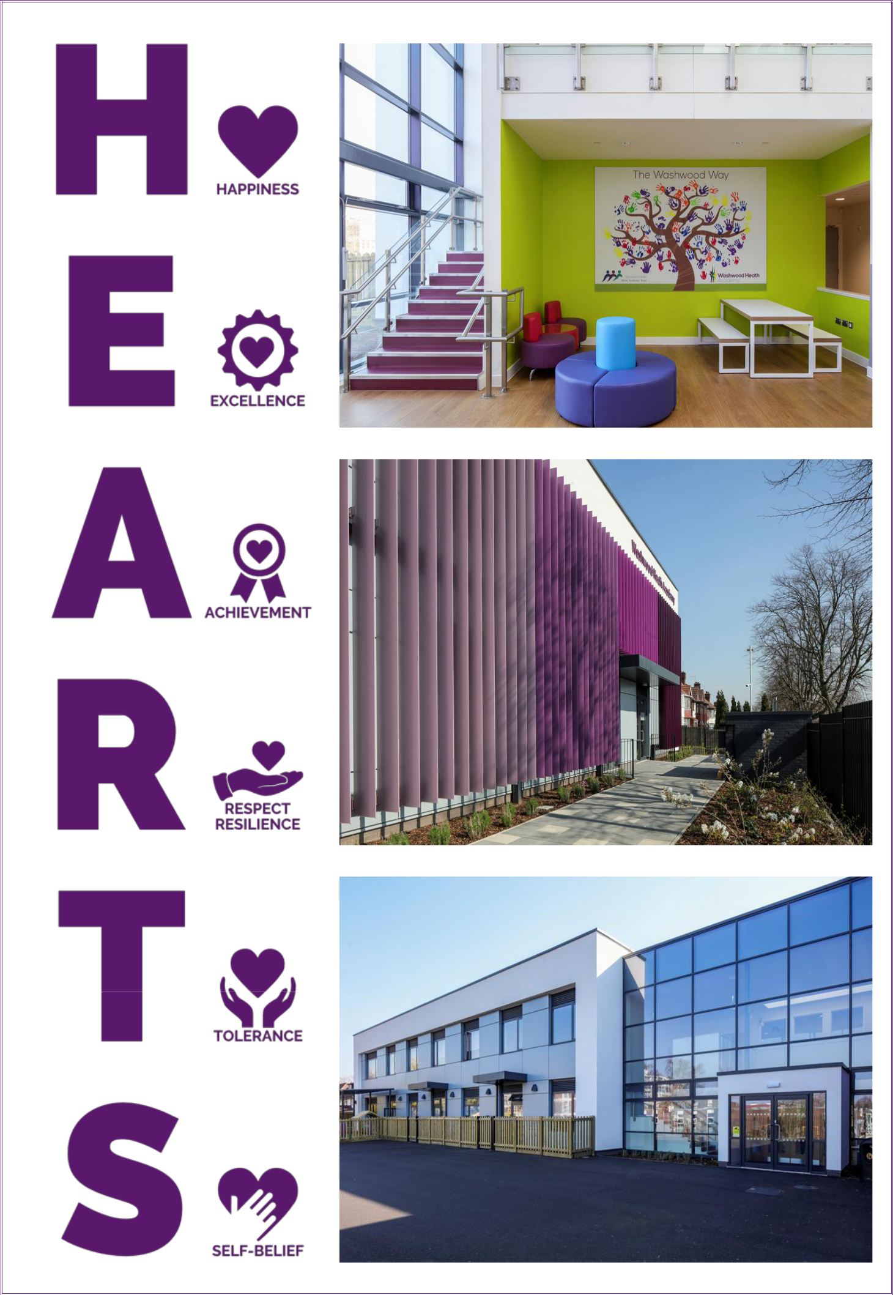
Primary, Secondary & Sixth Form

