07 September 2022

Dear Candidate

RE: Permanent, full-time Teacher of Science
Post to commence January 2023

Thank you for your recent enquiry in respect of the above vacancy.

Enclosed/attached is an application form and recruitment pack setting out the duties and responsibilities of the post, which I hope you will find helpful. Please note to be considered for this post you must fully complete the application form and Recruitment and Monitoring form and return them to me by noon, Monday 3rd October 2022.

In addition write a letter in support of your application which includes a brief description of your educational philosophy and your approach to teaching Science within a 13-18 High School. Your letter should be no more than two sides of A4.

If you require any further clarification or information relating to this post please do not hesitate to contact my P.A., Mrs M Barnes on 01785 337400.

Yours sincerely
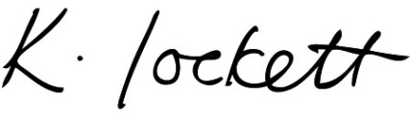

Ms K Lockett
Headteacher

