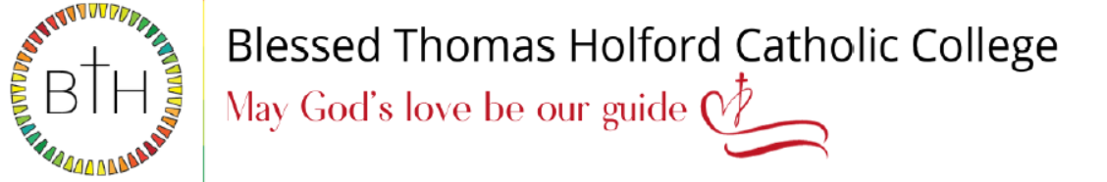

Teacher of Science
Required for September 2024
Salary: MPR/UPR

We are an 11-18 Catholic College with 1,600 students on roll, including 220 in the Sixth Form. GCSE and A level results have been consistently excellent over several years and we are determined to make ourselves an exceptional educational provider. Our college is highly popular with parents/carers, and we are oversubscribed every year.

We are looking to appoint an enthusiastic teacher of Science, who is committed to ensuring student enjoyment and progress within the Science department. This is an exciting opportunity for a highly motivated and ambitious person to develop their career in a forward-thinking college with high standards of achievement and care.

The successful candidates will have:
- A love of their subject
- A sound and detailed knowledge of Science
- The ability to inspire, engage and enthuse students

We offer:
- A supportive and committed college family
- Continuous Professional Development and formation
- Opportunity to teach A-Level

To Apply:
The job description and application forms are available on the college website: https://www.bthcc.org.uk/vacancies

All applications should be made using the CES application form

Completed application forms should be sent to: recruitment@bthcc.org

Closing date for applications is: 9.00 a.m. on Monday 26th February 2024

Our college is committed to safeguarding and promoting the welfare of children and young people and we expect all staff and volunteers to share this commitment. In line with Keeping Children Safe in Education (KCSIE) on line/social media checks may be undertaken for shortlisted applicants. An enhanced Disclosure and Barring Service (DBS) disclosure will be sought, along with other relevant pre-employment clearances, for the successful applicant.

