
SCIENCE TEACHER

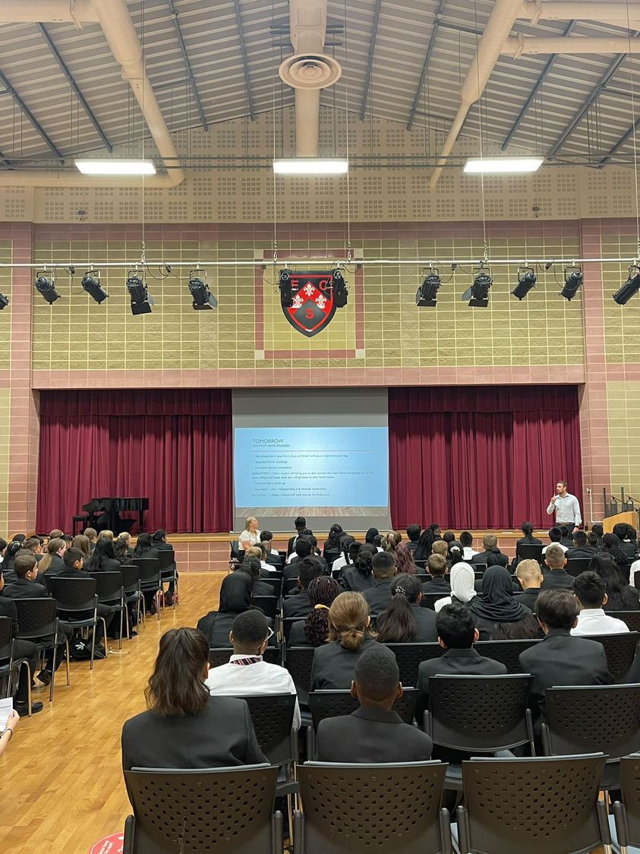

Contents
Headteacher’s Welcome. 4
The Recruitment Process. 5
Advertisement. 6
Department Information. 10
Job Description. 11
Person Specification. 15
Our Ethos and Strategic Direction. 17

Headteacher’s Welcome
Welcome to Eastbury Community School, and thank you for expressing an interest in applying for the position of Science Teacher.
For me, our school is where our young people are given the opportunities to allow them to realise their potential, and that potential can and does manifest itself in a range of ways.
Our young people need to see that success comes in a range of different forms, and ECS is where they can explore where and how they can and will be successful. Our pupils get some of the best progress results in GCSEs in the local area, our 6th Form- judged outstanding (March 2024) achieves some of the best results in the Barking and Dagenham, and over half of these young people go on to attend Russell Group universities.
Our young people need to have a voice in the school, the local community and the wider world. As part of our commitment to this belief we are a Rights Respecting School – Silver award at the moment, but we are confident that within the next year we will achieve Gold – one of the only 3-19 schools in London to do so.
Sir Tim Brighouse said “If a teacher makes the weather the school creates the climate.” and I firmly believe this. It is our role as a leadership team to create the best possible learning environment for our teachers to teach in. In return we expect the best possible teaching from them and our results show this over time. We have created systems and structures that support high quality learning, whilst minimising workload and maximising impact.
Our recent Ofsted report – March 2024 stated:
“Pupils are proud to be part of this inclusive community where people respect and care for each other. They appreciate the support they receive from staff if they have a concern” .
“Leaders are ambitious for all pupils to achieve well”
“The school takes effective steps to address behaviour that does not meet its high expectations. Pupils conduct themselves well and enjoy their time at school. Low level disruption in lessons is rare”
“Staff, including early career teachers, said that leaders have carefully considered their workload and well-being. They value the many opportunities to improve their professional practice.”
If you share our ethos and values and absolutely believe in the potential of all young people then we can offer you the chance to make a difference and change our community for the better, and look forward to receiving your application form and welcoming you to our school.
 Sharon Gladman – Executive Headteacher

The Recruitment Process

We are proud of our school, the staff and pupils and in normal times we would warmly welcome prospective applicants to visit us prior to application to learn more about the role and view the school in action.

Key Dates
Closing Date for Applications 17 March 2026
Interviews commencing 25 March 2026
Please note all dates are subject to change.
To arrange your visit please email: kdunnell@eastbury.bardaglea.org.uk

Completed applications should be sent to: kdunnell@eastbury.bardaglea.org.uk
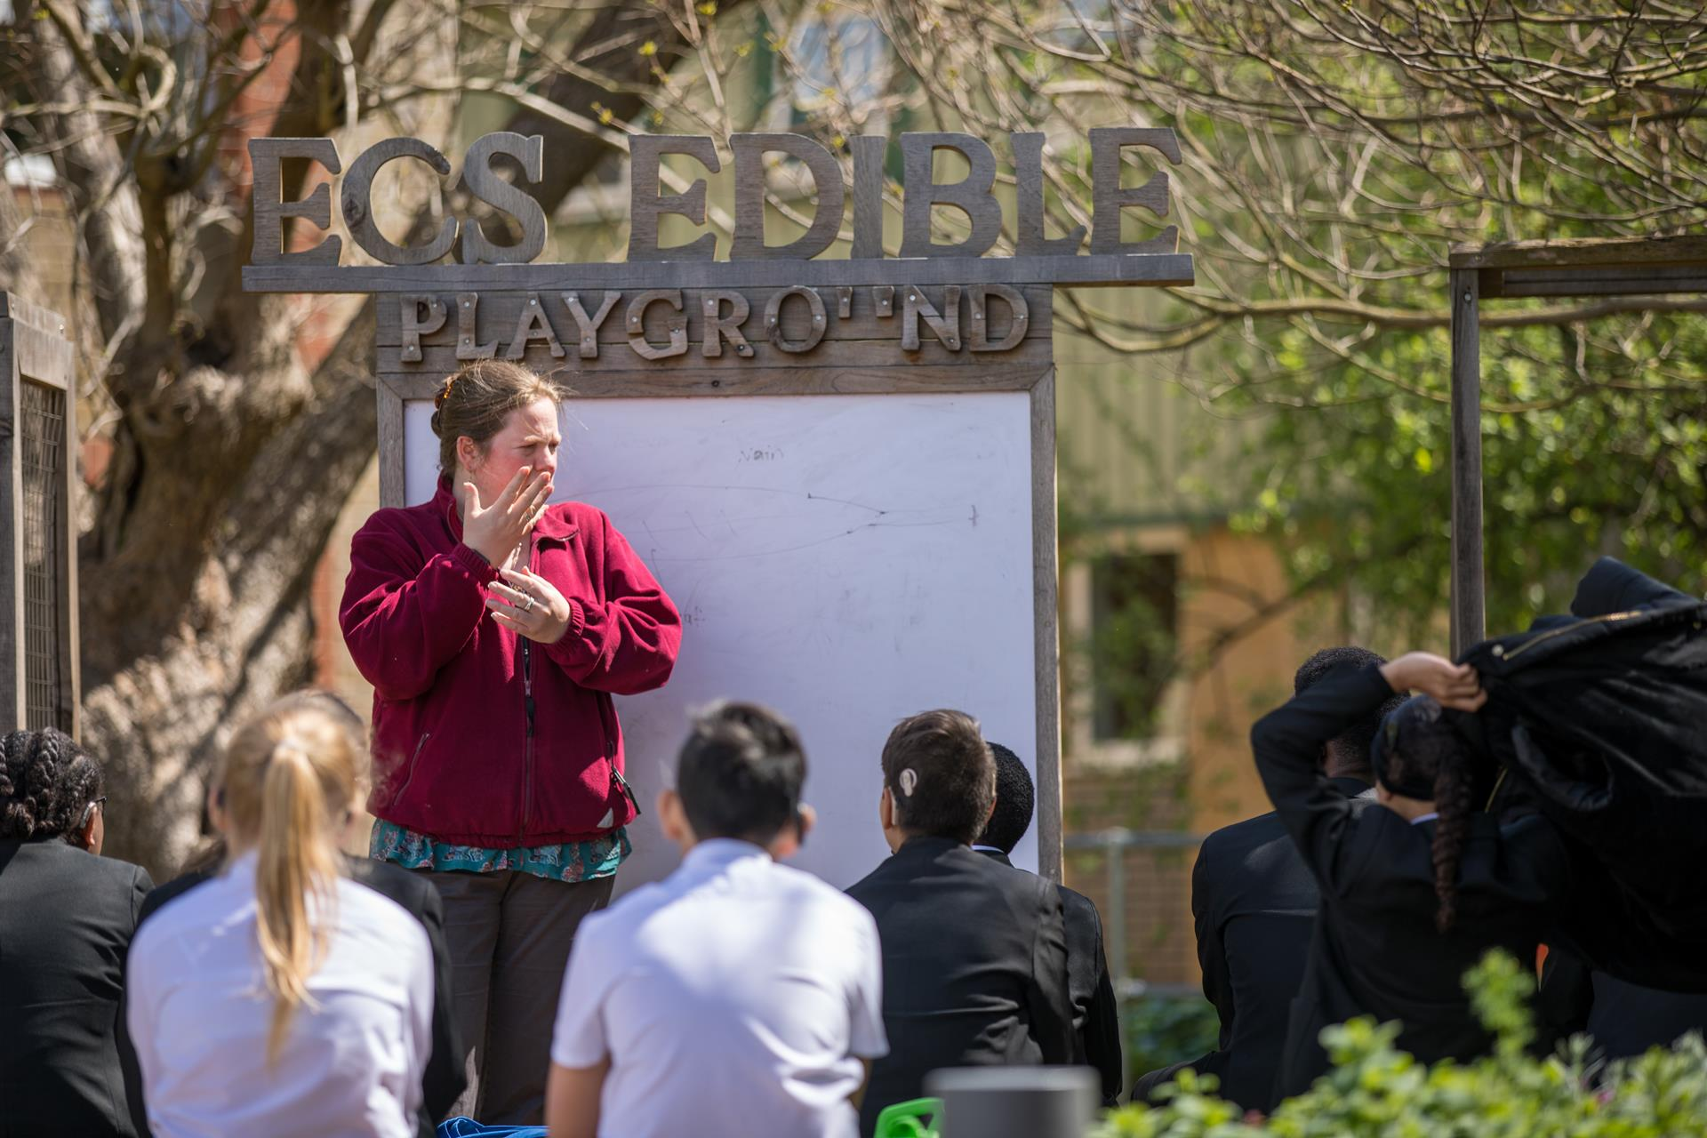
Advertisement

Advertisement

SCIENCE TEACHER

Permanent/Fixed Term Contract

April or Flexible start date can be arranged

SALARY UPS/MPS Including Inner London Weighting £40,314 - £62,496

This is an excellent opportunity for a committed and innovative individual, in a successful, well ordered, and inclusive 3-19 all through school. We are at the heart of an ethnically diverse community in London East, an area undergoing significant regeneration and building affordable homes. We are a successful school, where academic outcomes and character development are at the heart of everything we do. We believe our students can achieve and give them the opportunities to realise their potential.

We foster a collaborative culture where talented individuals are empowered to produce their best work in brand new purpose built accommodation.

Find out more about a career at ECS here: Join Our Community

About The Role:

We are seeking a well-qualified, ambitious professional who is motivated to make a difference to the life chances of our young people. The successful candidate will:

- Be a dedicated team player who is committed to the happiness, well-being, self-esteem and progress of everyone at the school
- Be able to teach students of all abilities and demonstrate passion and enthusiasm
- Be able to and willing to make contributions to both the department and to the wider school community

ECS celebrates its diversity, and we positively welcome applications from all sections of the
community. If you are interested in making a difference in young people’s lives, whatever your background or history please apply.
In return we can offer:
- A pupil centred, progress focused ethos.
- A welcoming and supportive community.
- The opportunity to work with a passionate, hardworking and supportive staff.
- A commitment to develop your skills through continued professional development.
- A supportive and committed Leadership Team and Governing Body.
- A cohort of pupils with high aspirations and a willingness to learn.
- A school which understands the importance of staff well-being and workload management

“Pupils value the opportunities that they have to work with leaders to further improve the
school, for example through the school council. Older pupils, and students in the sixth
form, help pupils in the primary phase with their reading. Pupils benefit from a range of
extra-curricular clubs, both at lunchtime and after school.” (Ofsted March 2024)
Please click here to find out more information about what it is like to work at ECS:
https://www.eastbury.bardaglea.org.uk/
The school is located less than 10 minutes’ walk from Upney tube and 15 minutes from Barking mainline station.

ECT Teachers are warmly encouraged to apply for this post.

For full details of the post and an application form, please visit the school website www.eastbury.bardaglea.org.uk and return the application form to the Headteacher’s PA, Karen Dunnell kdunnell@eastbury.bardaglea.org.uk. The closing date for applications is 17 March 2026 and interviews will be held on 25 March 2026.

ECS is committed to safeguarding and promoting the welfare of children and is an Equal Opportunities Employer.
This post is exempt from the Rehabilitation of Offenders Act 1974 and a comprehensive screening process, including Disclosure check, will be undertaken on all successful applicants.

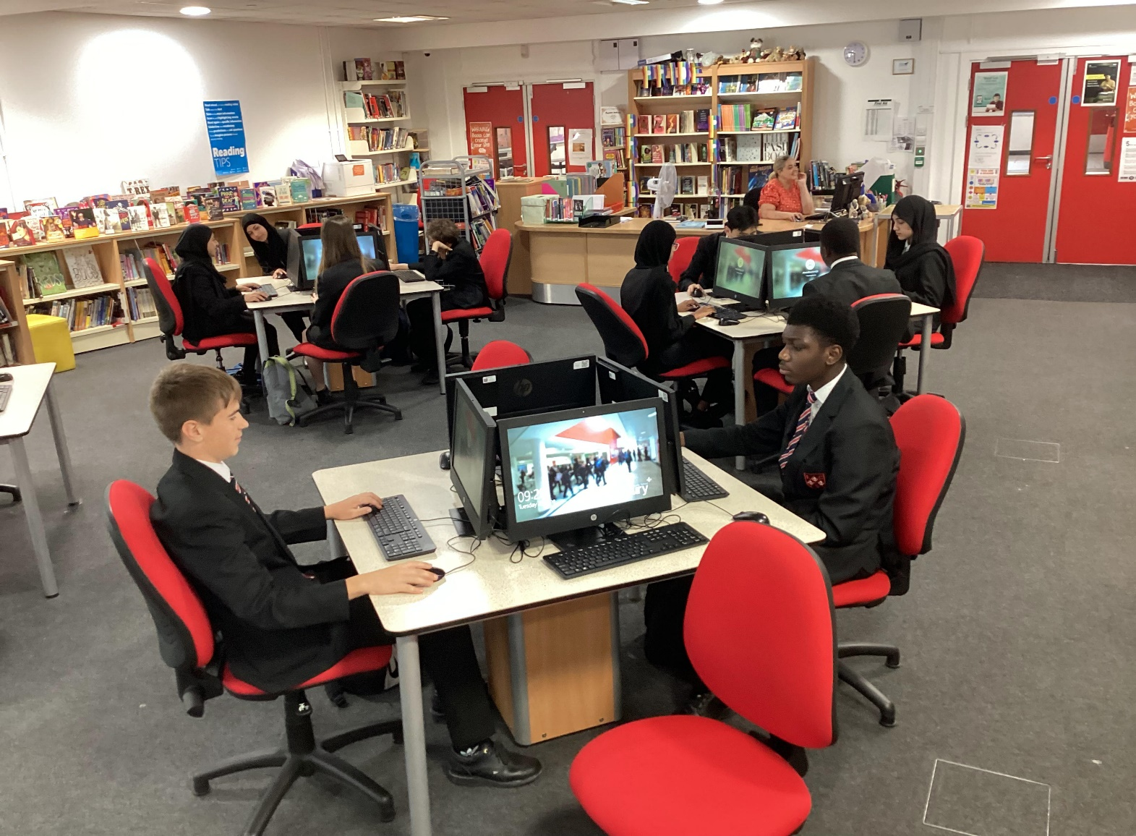




Department Information

Job Description

SCIENCE DEPARTMENT

The Science curriculum at Eastbury Community School is designed to develop the skills needed for our students to become successful learners, curious individuals and confident scientists. At Eastbury, our teaching ethos stems from the idea that all our learners have the potential to be scientists of the future. Through practical work, scientific inquiry and the continuous exploration of vital links between the science curriculum and everyday life, we endeavour to ignite a passion for discovery in our students that will last a lifetime. We educate our students about the importance of future advancements and discoveries to enable them to engage with an increasingly technical world and encourage them to explore the possibility of pursuing a career in science.

- At Key Stage 3, all students study science – learning about the fundamentals of biology, chemistry and physics

- At Key Stage 4, students follow the AQA GCSE trilogy specification. Students are given the opportunity to choose separate or combined science

- At Key Stage 5, the faculty offers A-levels in all three subjects, following the AQA syllabus for Biology and the OCR syllabus for Chemistry and Physics.

Job Description

Job Description

Job Description
Post Title: | Classroom Teacher – Main Professional Grade
School Context | Eastbury Community School (ECS) is an All-through school for pupils aged 3 -19 in the London Borough of Barking & Dagenham (LBBD).
Purpose: | - To implement and deliver an appropriately broad, balanced, relevant and differentiated curriculum for pupils and to support a designated curriculum area as appropriate.  - To monitor and support the overall progress and development of pupils as a teacher/ Form Tutor  - To facilitate and encourage a learning experience which provides pupils with the opportunity to achieve their individual potential.  - To contribute to raising standards of pupil attainment.  - To share and support the school’s responsibility to provide and monitor opportunities for personal and academic growth.  - To become an increasingly effective practitioner, leading to improved and sustained standards of teaching and learners’ attainment.  - To be responsible for the continuing review and development of their professional practice, providing evidence of their improving skills and the ability to work with colleagues, and of their potential capacity to meet the performance threshold/ senior teacher standards.  - To work as directed by the HoD/ SLT, meeting department and School standards.  - To personalise learning for the pupils under your care so that achievement is accessible to all.  - To be accountable for the progress of the pupils in your classes.  - To share good practice with colleagues and be willing to undergo INSET to develop and enhance your own good practice.  - To support the Department in all initiatives that it undertakes.  - To ensure provision of an appropriately broad, balanced, relevant and differentiated curriculum for pupils studying in the classes assigned to you, in accordance with the aims of the school and the curricular policies determined by the Governing Body and Headteacher of the school.  - As part of the department to help develop and enhance the teaching practice of others.  - To monitor and support the overall progress and development of pupils in your classes and as a Form Tutor.  - As a member of the department to embody the strategic direction of the subject / area in the school and community.  - To assist the Subject Leader in the essential liaison and collaboration with B&D CIAS; HMI; Consultants and other inspectors.  - To contribute to keeping the school informed of the characteristics of high quality teaching and learning, and the main strategies for improving and sustaining high standards of teaching, learning and achievement for all pupils with particular reference to the area of responsibility.  - To use comparative data, together with information about pupils’ prior attainment to establish benchmarks and set targets for pupil improvement within your classes  - To act as an advocate for the subject / area both outside and inside school  - To contribute to the department in developing systems for behaviour for learning and thus contribute to whole school strategies.  - With the department to provide quality assurance for the subject / area by monitoring progress towards meeting targets and developing / adopting intervention policies where appropriate especially in reference to your classes.  - To cooperate with the HoD in the monitoring of teaching and learning in the subject / area.  - To liaise with other teachers to meet individual and thus whole school targets.  - Where possible to assist the HoD in the training of new teachers of the subject.  - To maintain the distinct ethos pertaining to the subject / area in the school and that it is for the good of the subject/ area and the school  - With the HoD to develop / implement short term measures aimed at enhancing pupil performance in the subject / area especially in reference to the classes designated to you.  - With the HoD to provide and analyse current data as required regarding the performance of your designated classes.
Reporting to: | Head of Department; Line Manager; Post-holders in the department
Responsible for: | The provision of a full learning experience and support for pupils.
Liaising with: | Head/Deputies/Assistants, teaching/support staff, LEA representatives, external agencies and parents.
Working Time: | 195 days per year. Full-time
Salary/Grade: | Main Professional Grade with enhanced pay scale enhancement for the right candidate
Disclosure level | Enhanced
MAIN (CORE) DUTIES
Operational/ Strategic Planning | - To assist in the development of appropriate syllabuses, resources, schemes of work, marking policies and teaching strategies in the Curriculum Area and Department.  - To contribute to the Curriculum Area and department’s development plan and its implementation.  - To plan and prepare courses and lessons.  - To contribute to the whole school’s planning activities.  - To enhance cross curricular links  - To promote cultural capital  - To create opportunities for pupils to perform to a range of audiences
Curriculum Provision: | To assist the Head of Department, the Deputy Headteacher / Assistant Headteacher of Teaching & Learning, to ensure that the curriculum area provides a range of teaching which complements the school’s strategic objectives.
Curriculum Development: | To assist in the process of curriculum development and change so as to ensure the continued relevance to the needs of pupils, examining and awarding bodies and the school’s Mission and Strategic Objectives.
Staffing  Staff Development:  Recruitment/ Deployment of Staff | - To take part in the school’s staff development programme by participating in arrangements for further training and professional development.  - To continue personal development in the relevant areas including subject knowledge and teaching methods.  - To engage actively in the Performance Management Review process.  - To ensure the effective/efficient deployment of classroom support  - To work as a member of a designated team and to contribute positively to effective working relations within the school.
Quality Assurance: | - To help to implement school quality procedures and to adhere to those.  - To contribute to the process of monitoring and evaluation of the curriculum area/department in line with agreed school procedures, including evaluation against quality standards and performance criteria. To seek/implement modification and improvement where required.  - To review from time to time methods of teaching and programmes of work.  - To take part, as may be required, in the review, development and management of activities relating to the curriculum, organisation and pastoral functions of the school.
Management Information: | - To maintain appropriate records and to provide relevant accurate and up-to-date information for MIS, registers, etc.  - To complete the relevant documentation to assist in the tracking of pupils.  - To track pupil progress and use information to inform teaching and learning.
Communications: | - To communicate effectively with the parents of pupils as appropriate.  - Where appropriate, to communicate and co-operate with persons or bodies outside the school.  - To follow agreed policies for communications in the school.
Marketing and Liaison: | - To take part in marketing and liaison activities such as Open Evenings Parents Evenings, Review days and liaison events with partner schools.  - To contribute to the development of effective subject links with external agencies.
Management of Resources: | - To contribute to the process of the ordering and allocation of equipment and materials.  - To assist the Head of Department to identify resource needs and to contribute to the efficient/effective use of physical resources.  - To co-operate with other staff to ensure a sharing and effective usage of resources to the benefit of the School, department and the pupils.
Pastoral System: | - To be a Form Tutor to an assigned group of pupils.  - To promote the general progress and well-being of individual pupils and of the Form Tutor Group as a whole.  - To liaise with a Pastoral Leader to ensure the implementation of the school’s Pastoral System.  - To register pupils, accompany them to assemblies, encourage their full attendance at all lessons and their participation in other aspects of school life.  - To evaluate and monitor the progress of pupils and keep up-to-date pupil records as may be required.  - To contribute to the preparation of Action Plans and progress files and other reports.  - To alert the appropriate staff to problems experienced by pupils and to make recommendations as to how these may be resolved.  - To communicate as appropriate, with the parents of pupils and with persons or bodies outside the school concerned with the welfare of individual pupils, after consultation with the appropriate staff  - To contribute to PSHCE and citizenship and enterprise according to school policy  - To apply the Behaviour management systems so that effective learning can take place
Teaching: | - To teach, pupils according to their educational needs, including the setting and marking of work to be carried out by the pupil in school and elsewhere.  - To assess record and report on the attendance, progress, development and attainment of pupils and to keep such records as are required.  - To provide, or contribute to, oral and written assessments, reports and references relating to individual pupils and groups of pupils.  - To ensure that ICT, Literacy, Numeracy and school subject specialism(s) are reflected in the teaching/learning experience of pupils  - To undertake a designated programme of teaching.  - To ensure a high quality learning experience for pupils which meets internal and external quality standards.  - To prepare and update subject materials.  - To use a variety of delivery methods which will stimulate learning appropriate to pupil needs and demands of the syllabus.  - To maintain discipline in accordance with the school’s procedures, and to encourage good practice with regard to punctuality, behaviour, standards of work and homework.  - To undertake assessment of pupils as requested by external examination bodies, departmental and school procedures.  - To mark, grade and give written/verbal and diagnostic feedback as required.
Proposed Other Specific Duties:
- Attend Meetings
- To play a full part in the life of the school community, to support its distinctive mission and ethos and to encourage staff and pupils to follow this example.
- To promote actively the school’s policies.
- To continue personal development as agreed.
- To comply with the school’s Health and safety policy and undertake risk assessments as appropriate.
- To undertake any other duty as specified by STPCB not mentioned in the above.
- Employees will be expected to comply with any reasonable request from a manager to undertake work of a similar level that is not specified in this job description.
- Employees are expected to be courteous to colleagues and provide a welcoming environment to visitors and telephone callers.
- The school will endeavour to make any necessary reasonable adjustments to the job and the working environment to enable access to employment opportunities for disabled job applicants or continued employment for any employee who develops a disabling condition.

Whilst every effort has been made to explain the main duties and responsibilities of the post, each individual task undertaken may not be identified.
This job description is current at the date shown, but following consultation with you, may be changed by Management to reflect or anticipate changes in the job which are commensurate with the salary and job title

Headteacher: …………………………………………………

Teacher: ………………………………………………………

Date issued: ………………………………………………….

Person Specification

Person Specification

Person Specification MAIN PAY SCALE (MPS) TEACHER  We are seeking to appoint an effective colleague who: | Assessment:  A = Application  IT = Interview task  I = Interview  R = Reference
- is passionate about their subject and is well qualified to degree level  - has a PGCE or equivalent (or working towards)  - is hardworking, well motivated and positive  - has the ability to teach effectively in a socially disadvantaged area 11-19 (the ability / desire to teach in the Primary Phase is an advantage).  - can communicate effectively with young people  - is committed to collaborative planning  - delivers well structured lessons with clear learning objectives  - has secure knowledge and understanding of their subject(s), including being able to anticipate pupils’ common strengths and misconceptions  - has appropriate and demanding expectations for pupils’ learning across the age and ability range  - can assess how well learning objectives have been achieved and can use assessment for future teaching  - can ensure the effective teaching of pupils and can secure progress towards their targets  - communicates effectively with parents  - understands the need to take responsibility for their own professional development  - conducts effective working relationships with staff, parents / carers & pupils  - understands the need to look after resources and use them effectively  - has high standards and expectations of self and others  - supports a collegiate management style  - has a sense of humour | - A,IT,I,R  - A,I,R  - A,I,R  - IT,I,R  - IT,R  - I,R  - A,IT,I,R  - A,IT,I,R  - A,I,R  - A,I,R  - A,I,R  - A,I,R  - A,I,R  - A,I,R  - A,I,R  - A,IR  - A,I,R  - A,I



Our Ethos and Strategic Direction

Our Ethos and Strategic Direction



