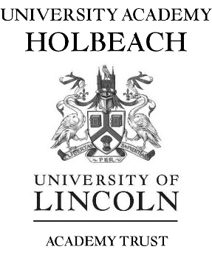

**Teacher of Science**

**MPS**

**January 2024/Immediate Start**

University Academy Holbeach is seeking to appoint an enthusiastic, highly motivated and inspirational teacher to join our Science department. This post is suitable for an experienced or early careers teacher (ECT) wishing to join a team of specialists who ensure a high standard of teaching, learning and achievement. Support for ECT induction is available.

Interested candidates will have:

* QTS
* the ability to teach Science across key stages 3 and 4
* the ability to plan and deliver high quality lessons
* the ability to motivate and achieve excellent results
* excellent organisational skills
* the ability to form positive working relationships with staff and pupils
* the ability to work collaboratively

University Academy Holbeach is an oversubscribed school in a rural location and serves the local community and the surrounding villages. The school site is equipped with state of the art facilities including teaching walls and an excellent ICT infrastructure/

Teachers wishing to embark upon further post graduate study as part of their CPD will be supported through our sponsor the University of Lincoln.

The school was rated as ‘Good’ by Ofsted (February 2019).

For an application pack please visit the school website [www.universityacademyholbeach.org](http://www.universityacademyholbeach.org)

University Academy Holbeach is committed to the safeguarding and promoting the welfare of young people and expect all staff to share this commitment. All posts will be subject to an enhanced DBS disclosure, medical and reference checks. Applicants may be subject to an online presence check.

Closing date: Monday 2nd October 2023