Teacher of Science
Recruitment Pack
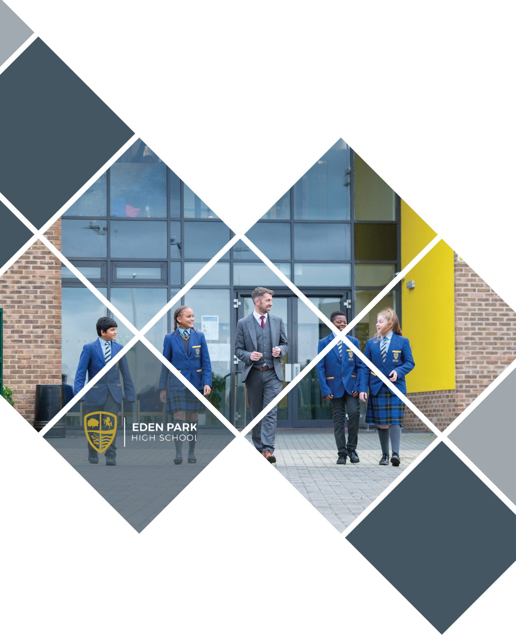

CONTENTS

Welcome from the CEO
Four Critical Questions
The E21C Backbone
Our schools
Improving Outcomes
Transforming Lives
Candidate charter
Welcome from the Head
About the school
About the role
Person Specification
How to apply
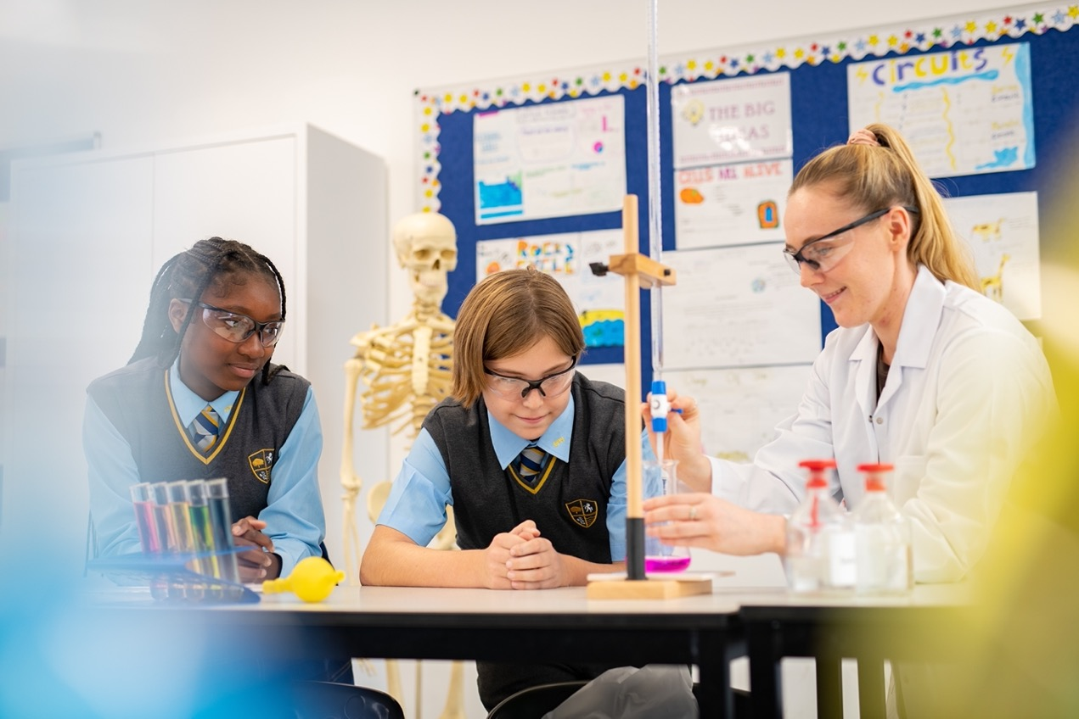
WELCOME FROM THE CEO
Thank you for showing an interest in our pupils, our schools and our Trust. This is an exciting time to join Education for the 21st Century. We are a very different organisation in 2023 than we were four years ago. We have understood the need to transform and have developed greater capacity in our leaders at every level. We have developed a shared understanding of what great teaching looks like, developed our curriculum model, developed clear behaviour principles, and landed upon an exciting model of instructional coaching to drive forward teacher efficacy.

Our strategy over the next two years reflects our growing capacity but it also reflects the need to improve quickly. In Year 1 we established the ‘backbone’ of the organisation and to align, where doing so impacts pupils progress, or allows us to influence progress through growing greater capacity in our schools and realising efficiencies. In Year 2, now, we hope to see all schools moving closer to national progress or beyond, as they realise the benefits of collaborative working based upon a common school workflow. In Year 3, as this rapid progress continues, we begin to add capacity for growth so we can support our mission of transforming lives and our aim of becoming one of the highest performing multi academy trusts in London and the South East.
Of course, our strategy is responsive to the needs of those closest to us. The wellbeing of the young people in our care has been significantly impacted by the recent pandemic. Our support will be strategic and comprehensive. Furthermore, the pandemic has had a dramatic impact upon the career prospects of our pupils. Our strategy over the coming years seeks to ensure that our pupils are well placed to move successfully into the next stage of their education or working life, with the right knowledge and skills to make a valuable contribution to society.
The development, wellbeing, and support of staff within the Trust will play a crucial part in our strategy. We adapted quickly to new ways of working and continue to refine and develop our HR processes. One key lever for change over the next three years, will be instructional coaching. The ongoing development of all staff, and in particular, our teachers, is critical if we are to deliver the high-quality teaching that we need to, in order to ‘improve outcomes and transform lives’.
Finally, I am extremely grateful for your interest in our Trust. We are moving forward at a rapid rate and it’s an exciting time to join us.
Simon Garrill

Chief Executive Officer

WHY DO WE EXIST?
Our Mission at E21C is ‘improving outcomes, transforming lives’. We believe in the collective power of schools working together as civic minded leaders to find shared ways of working that improve the lives of our pupils.
HOW DO WE BEHAVE?
Our core values of trust, kindness and endeavour define how we behave. These are the values that we hold most dear, and our schools align their own values to those of the Trust.

WHAT DO WE DO?
We create welcoming and open schools in the local community where every person thrives, makes excellent progress and succeeds.

HOW DO WE SUCCEED?
With aligned autonomy, a clear backbone, a strong culture, academic rigour and smart systems.

THE FOUR CRITICAL QUESTIONS

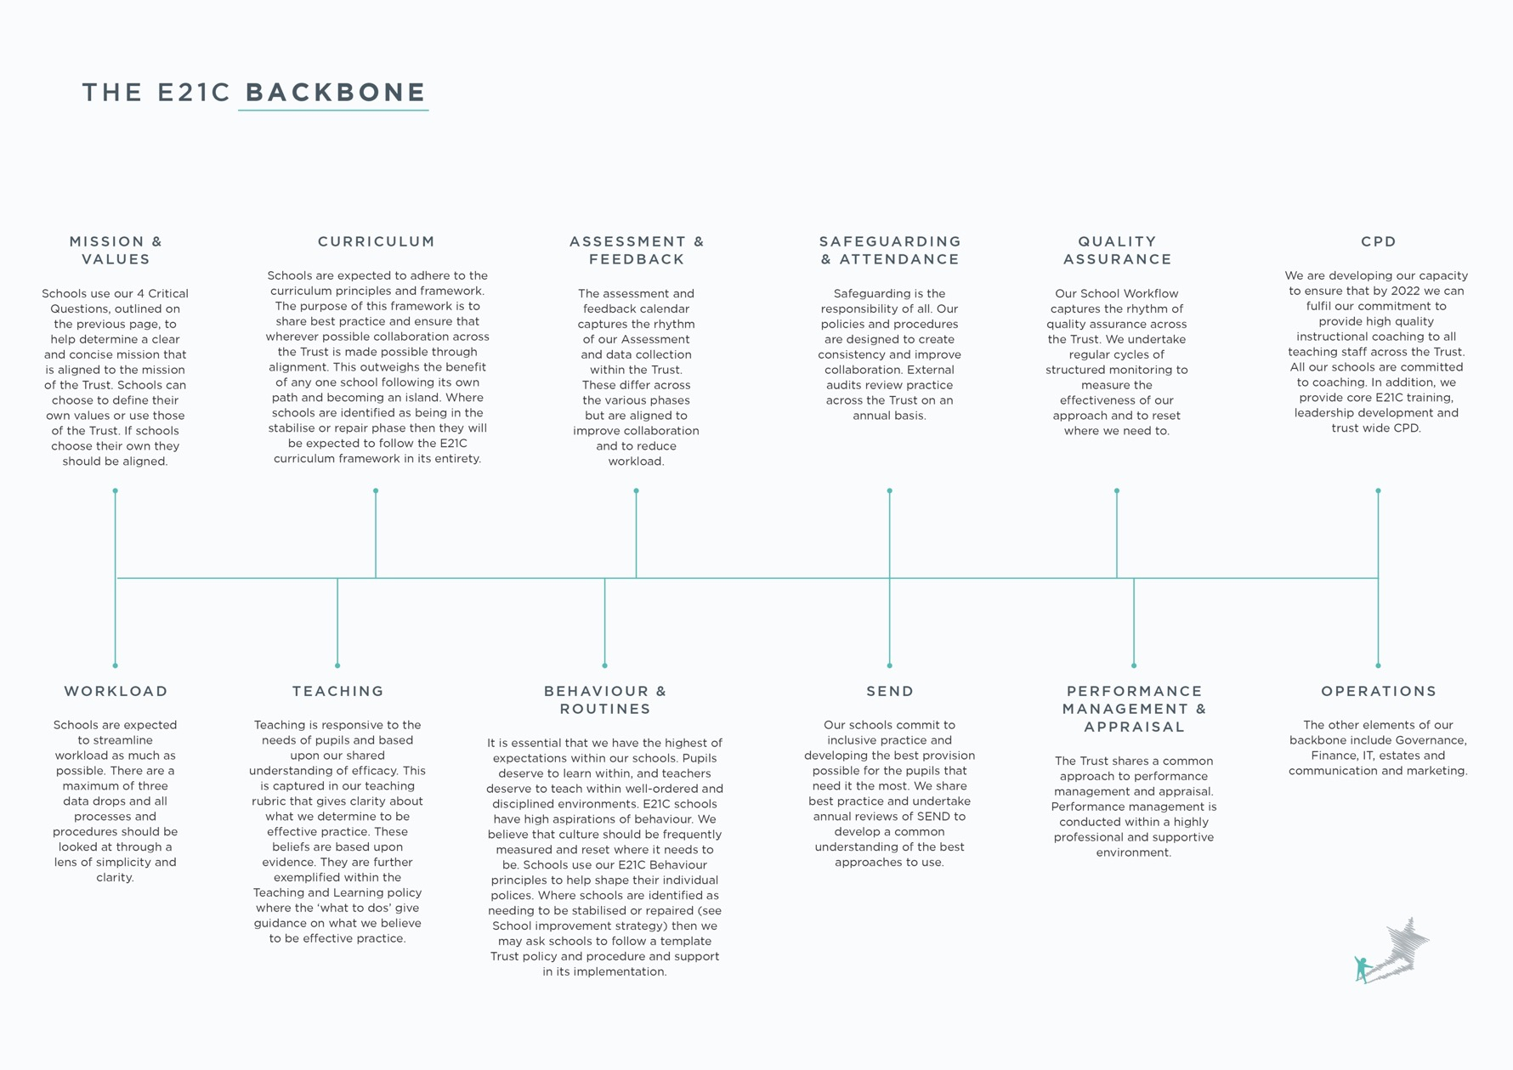
OUR SCHOOLS
There are currently four secondary schools and four primary schools within the Trust. Four of the primary schools and three of the secondary schools are located within Bromley, South East London. A further secondary is close to Canterbury in Kent. These schools include:
SECONDARY SCHOOLS
 | 
11-19 | 11-19
 | 
11-19 | 11-16

PRIMARY SCHOOLS
 | 
4-11 | 4-11
 | 
4-11  420 pupils | 4-7  510 pupils

CANDIATE CHARTER
E21C want every candidate to have an informed, engaging and positive experience, and to support this we’ve created our Candidate Charter which outlines our commitment to you.
OUR COMMITMENT TO YOU
- Transparency we will treat you with respect, honesty and fairness
- Protecting your privacy we’ll ensure your information is secure and handled sensitively
- Understanding you’ll be given everything you need to make informed decisions
- Showcasing talent we’ll provide a good opportunity for you to share your skills, experience and potential
- Feedback we will provide constructive feedback professionally and promptly
- Listening we welcome feedback and we’ll act on what you have to share
- Inclusivity our hiring decisions align with our commitment to create a high quality, diverse workforce
WE WILL
- Provide you with clear, accurate and timely information
- Give you the opportunity to ask questions ‒ and we’ll ensure you get the answers you need
- Respond to enquiries promptly and usually within 24 hours during the working week
- Adopt a fair and consistent assessment process
- Make sure you have all the documentation and details you need for an interview, well in advance
- Provide you with real insight about what it’s like to be part of our team
- Ensure all offers are fair and equitable
- Seek feedback on your experience at every opportunity, so we can continue to improve
IN RETURN WE ASK THAT YOU
- Be honest and upfront about your experience, aspirations and motivations
- Provide open and accurate information when submitting an application
- Always give yourself the best opportunity to succeed - research who we are and how we work
- Let us know if situations change in relation to your interest - and help us understand why
- Prepare yourself for interview and let us know how we can support you

WELCOME FROM THE HEAD
Eden Park High School is an oversubscribed school in Beckenham. We were rated Good by Ofsted in 2021. Students were welcomed into our new, purpose-built premises in 2019 and we welcomed our first ever sixth form cohort in September 2022. I started as the Headteacher in the summer of 2022 alongside a new leadership team.
New schools are exciting places to work. Not only do they provide excellent facilities, but they also offer an opportunity to play an important role in creating something great. At Eden Park we are committed to improving outcomes and transforming lives and know that we can and will do this to an increasing extent in the coming years.
I continue to be impressed by the warmth, positivity, and professionalism of our staff. Our shared desire is to see our efforts translate into meaningful educational experiences that build confidence and purpose in all our students. Staff, students, parents and carers all recognise the recent progress we’ve made in achieving that aim and I endeavour to ensure we continue to do so.
As a staff team at Eden Park, we seek to nurture strong relationships with students and prioritise student wellbeing and personal development through an extensive enrichment programme. The environment here is about fostering students' thirst for knowledge and helping them develop into inquisitive young adults. There is an impressive array of specialist facilities, which supports a commitment to a broad curriculum. Eden Park offers a very broad range of courses at both key stage 4 and 5, and encourages students to find their spark, nurture their interests and aspire to become experts in their field.
Similarly, I expect for staff to make excellent progress and succeed whilst working with here. I prioritise professional growth and invest in opportunities for staff to enhance their knowledge and skills, as well as helping others to do so.
Working in schools can sometimes be tough but it’s also hugely rewarding. With the support of kind, professional and respectful colleagues, Eden Park High School offers you the chance to join at an exciting phase in its young life. If you have the energy and drive to be part of something transformational, we’d love to hear from you.
Stephen Butler

Head Teacher
ABOUT THE SCHOOL
Eden Park High School
Eden Park High School is a new school in Beckenham. We opened in 2017, moved into our purpose-built new premises in 2019, celebrated our first ever GCSE results in 2022 and have opened our new Sixth Form this September. With a new and expanded leadership team, this young school is starting an exciting new chapter as we build the culture, systems and teams that will see us expand further over the next two years and deliver an outstanding quality of education for the community.
We are currently recruiting exceptional teachers who want to be part of our journey of transformation. We want people who will share in our ethos and values and set a new standard of excellence and inspire young minds.
Much as we see our staff nurture the interests and talents of our students, we support the professional growth of our staff. You can expect the following unique benefits to enhance your working life:
- Outer London Salary
- State-of-the art facilities, including access to our new gym
- Free onsite parking with electric charging points
- Funded CPD courses including MAs and NPQs
- Accredited training with recognised qualifications e.g. Outstanding Teachers Programme with Greenwich University
- Staff CPD library and numerous opportunities to work across the Trust in one of our many working forums
This is an exciting opportunity for a diligent and self-motivated individual who can join our team as a high performing teacher. This post offers the opportunity to take a key role in the strategic direction of this new and growing school as well as being able to work with colleagues and shape provision across our Trust. The post holder will be making a strong contribution to promoting the school’s high standards in all areas of school life.


ABOUT THE ROLE
Teacher of Science
Based at Eden Park High School
Education for the 21st Century is a values-led organisation, driven by a determination to create welcoming and open schools for the local community, where every person thrives, makes excellent progress, and succeeds. We are committed to improving outcomes and transforming lives, realising social mobility, and the transformative power of education. We value the difference in all our schools while seeking to bring them together around a framework that delivers an enriching experience and a great education for the young people within our care.
We want the very best for all our young people. Our plan to ensure that we deliver great schools is underpinned by our shared values of trust, kindness, and endeavour. Our schools and our staff are collaborative, and we seek to create consistency and quality throughout.
Our leaders create improvement in schools that is robust and sustainable. We are as enthusiastic about developing and nurturing our staff, as we are about developing our young people. Our professional development programs and our approach to school improvement provide quality and rigor while creating a depth of experience and learning for our staff.
In joining Eden Park High School and the family of schools within E21C you will gain access to an unparalleled level of support and development in a forward-thinking school and trust.
This is an exciting opportunity for an enthusiastic, inspirational and committed Teacher of Science, who has a passion and enthusiasm to make a positive impact on the pupils in our school.
The ideal candidate will maintain rigorous high expectations for staff and students alike. They will also be similarly passionate about their own learning and engagement with continuous professional development, recognising that meaningful learning is much more than what happens in the classroom alone and the importance of enriching the curriculum through meaningful contributions towards our broad extra-curricular provision.
You will have the opportunity to work with a talented team of like-minded leaders, teachers and a strong central team, all working together to build sustainable excellence in our schools
The successful candidate will:
- Join a forward-looking, high achieving school
- A school that offers a genuine opportunity for meaningful career development.
- A positive and supportive department of enthusiastic and motivated teachers, including TLR holders.
- Contribute to wider improvement of the school and trust
- Excellent career opportunities within the trust
- Be driven and committed to your students
- An excellent practitioner who is willing to challenge and be challenged



JOB DESCRIPTION

JOB TITLE: Teacher of Science
CLOSING DATE: 9am Monday 12 June 2023*
SALARY: MPS/UPS
CONTRACT TYPE: Permanent

LOCATION: Eden Park High School
REPORTING TO: Head of Science

JOB PURPOSE
All teachers at Eden Park High School are viewed as both leaders and managers of the academic and pastoral curriculum.
Definition of the role is: “To provide excellent teaching that facilitates high quality learning for all students. Encourage all students to be the best they can be through setting the highest of expectations”.
Key areas of RESPONSIBILITy
- To lead and undertake any job at the reasonable request of the Head Teacher
- Take part in duty teams as required.
- Work effectively with others to achieve tasks.
- Manage the Learning and Teaching process of students in your responsibility area.
- Challenge any low expectations from students or parents.
- Lead aspects of the department under the reasonable directive of your HoD.
- Attend departmental and school functions, including Options Evening and Open Evening.
- To meet all relevant deadlines as and when requested.
- To ensure adequate cover work is set in accordance with whole school practice.
- Teach throughout the age and ability range as required or with relevant training to teach in other curriculum areas at the direction of the Head Teacher
- Ensure all lessons are thoroughly planned and delivered to at least a ‘good’ standard
- Evaluate the impact of all activities on the quality of learning and teaching.
- Carry out the assessment, monitoring, recording, and reporting of students’ attainments and achievements in accordance with the Assessment Policy.
- Have thorough knowledge of and regularly use student data to track progress.
- Develop student literacy, numeracy, and ICT in lessons through high quality teaching.
- Pay due regard to the differing needs and abilities of students when planning curriculum delivery.
- Play a full and active role in departmental Curriculum development.
- Support all whole school policies.
- Fully participate in the school’s Pastoral Management and organisation, including the acceptance of a form tutor role as required.
- To actively support the school’s Rewards System.
- Ensure the effective use of associate staff as required.
- Take an active part in the school’s appraisal cycle.
- Develop your CPD needs in consultation with your Head of Department with due reference to Curriculum Area and whole school priorities.
- Seek advice from and consult with your line managers as and when necessary.
- Actively seek out expertise both within school and externally to enhance student learning.
- Maintain regular communication with parents via telephone, letters, contact books, written reports.
- Report any issues of repair and maintenance according to school practice.
- Deploy and use curriculum resources effectively and efficiently.
- Maintain the physical environment of your teaching area(s) to a high standard. Pay regard to the up-to-date display of students’ work (and other forms of display).
- Ensure all learning and teaching resources are up to date, engaging and challenging.
Employees will be expected to comply with any reasonable request from a manager to undertake work of a similar level that is not specified in this job description. Employees are expected to be courteous to colleagues and provide a welcoming environment to visitors and telephone callers.
The school will endeavour to make any necessary reasonable adjustments to the job and the working environment to enable access to employment opportunities for disabled job applicants or continued employment for any employee who develops a disabling condition (as defined in the Equality Act 2010).
Following consultation with you this job description may be changed by management to reflect or anticipate changes in the job which are commensurate with the salary and job title.

PERSONAL SPECIFICATION
 | Essential | Desirable | Method of assessment
Relevant Experience | Previous experience of teaching up to GCSE | Proven track record of achieving good results | Application form
Qualifications | Qualified Teacher Status (QTS) / PGCE  or working towards  Degree level in related subject | Evidence of continuing and recent professional  Development  Further degree | Production of the Applicant’s certificates  Discussion at interview  Independent verification of qualifications
Experience | Successful teaching experience at either  school(s) or on main teaching practice  Track record of good or outstanding  Lessons  Good understanding of effective and engaging teaching methods |  | Contents of the application form  Interview  Professional references
Skills | Ability to prioritise work  Ability to manage time effectively  Ability to maintain confidentiality in all school matters  Ability to inspire and motivate pupils and promote high standards of both work and behaviour  Ability to establish and maintain positive working relationships with both pupils and staff  Ability to teach all ability groups, meeting the needs of all students including those with SEN  Commitment to the pastoral care of pupils | Willingness to take personal responsibility for further training and development  Excellent planning and organisational skills | Contents of the application form  Interview  Professional references
Knowledge | Knowledge and understanding of subject related pedagogy  To have an updated knowledge of the delivery and assessment of the national curriculum.  Ability to manipulate data and to access and maintain electronic records and reports. |  | Contents of the application form  Interview  Professional references
Personal competencies and qualities | Genuine passion and belief in the potential of every student which is demonstrated by upholding a student-centred approach  Ability to communicate with a wide range of people  Ability to work effectively supported by a member of the school team and to work as part of a team  Holds high aspirations for children and young people and is passionate about providing learning opportunities for them which prepare them well for an adulthood which includes employment, independent living, good health, and community contributions  Demonstrate a continual commitment to safeguarding and promoting the welfare of children and young people  Be flexible to changing demands of the post  Reflective thinking, learn from mistakes and focus on key points during time of challenge  Confident and effective presentation skills  Take pride in a job well done.  A willingness to work flexible |  | Contents of the application form  Interview  Professional references
Equal Opportunities | An understanding of and commitment to equality of opportunity |  | Contents of the application form  Interview  Professional references
Additional Factors | Ability to form and maintain appropriate relationships and personal boundaries with children and young people  Commitment to quality and diversity  Commitment to Health & Safety  Commitment to sustaining regular attendance at work |  | Contents of the application form  Interview  Professional references

HOW TO APPLY
Education for the 21st Century is committed to developing exceptional teams to work with our communities. We invest heavily in talent and aim to provide rewarding careers and clear progression pathways.
To apply please complete the application and equal opportunities monitoring forms here and send to jobs@eph.e21c.co.uk.

PROCESS TIMELINE
Closing Date and Time: 9am Monday 12 June 2023*
Interviews: w/c 12 June 2023
Start date: September 2023
E21C_benefits_brochure_2022_October.indd
E21C Education for the 21st Century Trust - Working for Us
Completed applications and enquiries should be emailed to jobs@eph.e21c.co.uk
*We reserve the right to close this vacancy advert early should we receive an overwhelming response.
We look forward to hearing from you.
Education for the 21st Century is committed to safeguarding and promoting the welfare of young people and expects all staff and volunteers to share this commitment. All offers of employment are subject to an Enhanced DBS check and where applicable, a prohibition from teaching check will be completed for all applicants. Education for the 21st Century is fully committed to equality and to valuing diversity as an employer and a provider of education.
.

Education for the 21st Century
Mansion House, Coopers School
Hawkwood Lane, Chislehurst
Kent, BR7 5PS
020 8290 8505
enquiries@e21c.co.uk


