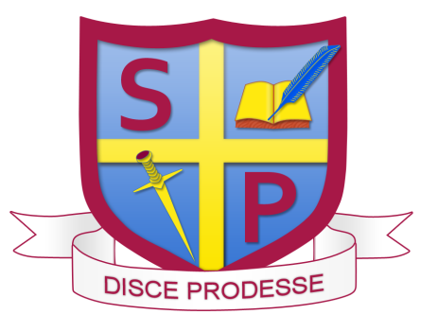
ST PAUL’S CATHOLIC COLLEGE
Manor Lane, Sunbury-on-Thames, TW16 6JE
Headteacher: Mr James Mc Nulty
(11-18 N.O.R. 1288 incl. Sixth Form)

Teacher of Science – ECT’s welcome
Required September 2023
London Fringe

St Paul’s is one of the most successful schools in the country and our GCSE results are consistently in the top 10% nationally. We have an excellent reputation for training and career progression and take pride in making sure that our teachers are the best they can be. We are seeking to appoint a highly motivated and enthusiastic teacher to join our Science Department within a deeply caring school environment.

We are looking for professionals with:
- Evidence of excellent classroom practice
- High expectations of pupil attainment and behaviour
- Evidence of ability to enthuse pupils
- Good organisation and communication skills
- Supportive of our Christian ethos

We offer:
- Teaching and Learning or pastoral responsibility will be offered to the right candidate
- Positive working environment
- Full ECT support and induction package
- Positive support for career development
- Subsidised day nursery
- The possibility of accommodation

Application packs are available at www.st-pauls.surrey.sch.uk.
Completed applications should be sent to: jobs@st-pauls.surrey.sch.uk.

If you require further information regarding the role, please contact Mrs De Rosa at mderosa@st-pauls.surrey.sch.uk.

Closing date for applications: 9am on Thursday 24 November 2022.

Applications are considered as they are received; we reserve the right to make an appointment prior to the closing date.

This school is committed to safeguarding and promoting the welfare of children and young people and expects all staff and volunteers to share this commitment. The successful applicant will be required to undertake an enhanced disclosure check by the Disclosure and Barring Service.
