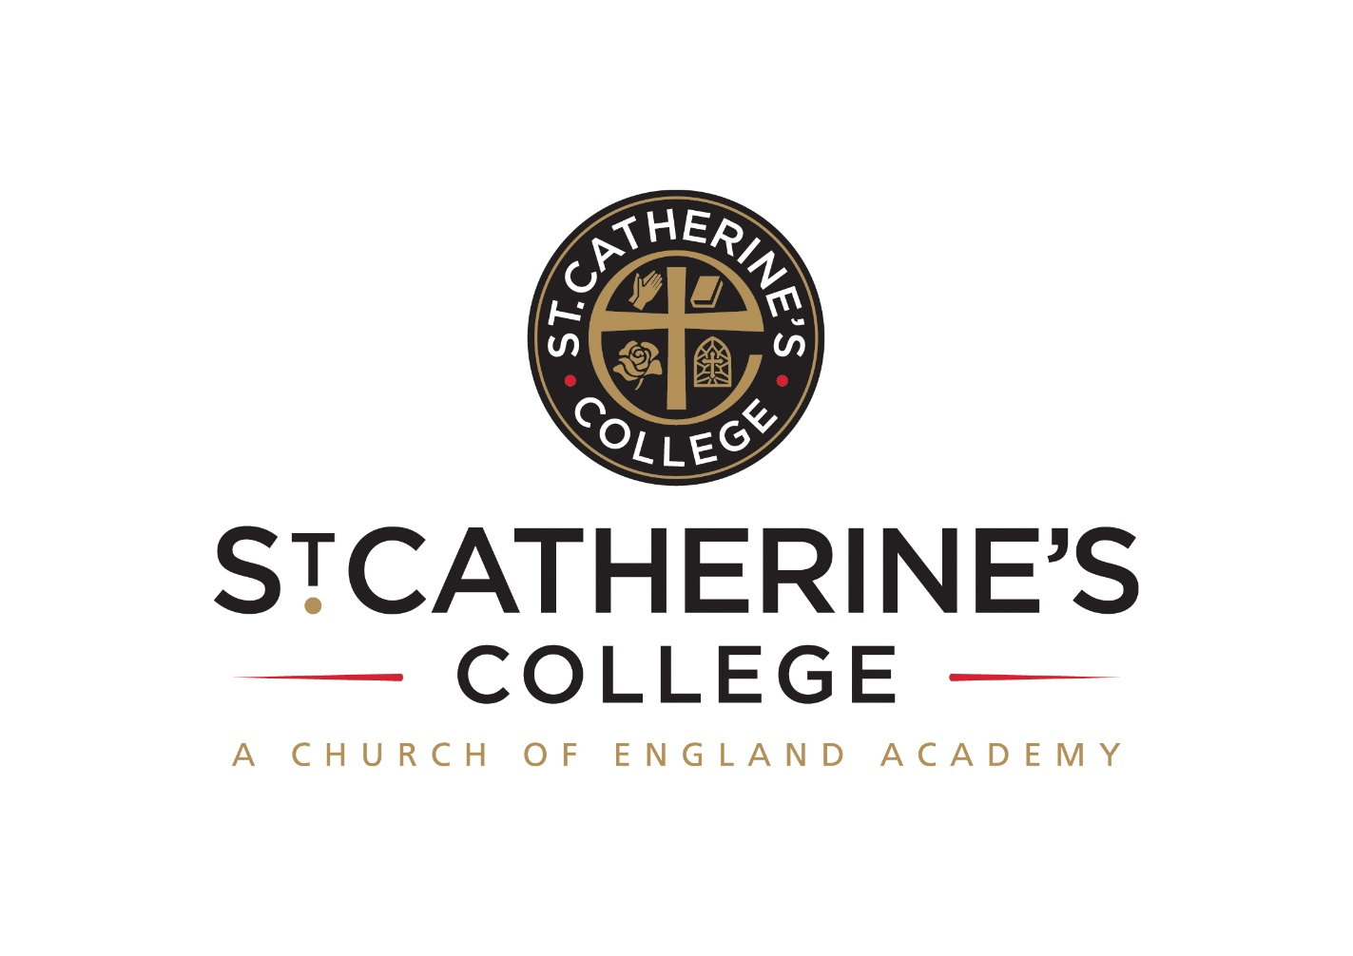 TEACHER OF SCIENCE

Salary: TMS / UPS

Required for Easter 2023

Post 1: Permanent full time

Post 2: Fixed term 0.4 fte Easter to August 2023
(to be worked on Tuesday and Wednesday)

INFORMATION FOR APPLICANTS

CONTENTS
- Letter from Headteacher
- Person Specification

January 2023

Dear Applicant

Teacher of Science

Thank you for your interest in these posts.

We are St Catherine’s College – preparing students to stand shoulder to shoulder with their peers, locally, nationally, and globally.

We are proud of our college, our talented and highly motivated staff and pupils. Our staff team work tirelessly to ensure that teaching is the best it can be and everyone has a role to play in this. We support each other and there is an open, friendly and collegiate atmosphere where new members of the team are welcomed and supported.

We are:

- An inclusive Church of England School with the benefits of links with The Diocese of Chichester and the opportunity to promote strong lasting values based on the Christian faith

Understandably this letter and our website only gives a flavour of the college. We therefore encourage visits for prospective candidates to see our college in action. We do understand however that visits are not always possible or practical and you would not be at a disadvantage if you are unable to visit the college.

The Posts

We are looking for an enthusiastic Science teacher to join a successful Science Department and supportive team of staff with the capacity and commitment to raise student achievement even further. Applications from experienced teachers or NQT’s very welcome.

We are also looking for a Science teacher for a fixed term contract from Easter until the end of the summer term. This is to work for two full days per week on a Tuesday and Wednesday (0.4fte).

The team of science teachers at St Catherine’s College teach across the full age and ability range. There will be an opportunity to teach Triple Science in a preferred specialism. We aim to foster a love of science in the students we teach, planning interesting and challenging lessons that engage all learners.

There is an open, friendly, and collegiate atmosphere within the department. We believe it is crucial that new members of the team are welcomed and supported. All teachers contribute to the development of shared resources, and we regularly run internal inset sessions. This approach has seen us develop many innovative new teaching strategies.

We set students by ability at the start of Year 7, and we structure the curriculum pathway to allow regular opportunities for students to move between groups.

We have eight well-equipped purpose-built Science laboratories and a dedicated team of Science Technicians to support us.

We offer you

We know it’s a competitive market and are proud of what we can offer:

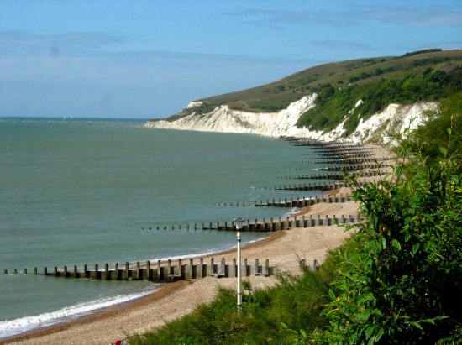
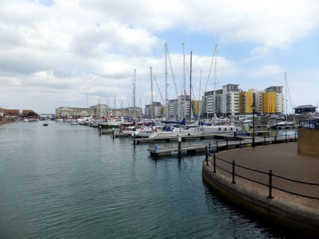
- Excellent career development opportunities
- A geographical location, being situated near Sovereign Harbour, Eastbourne’s award-winning Marina. It is part of several miles of beautiful coastline, including the South Downs National Park, the white cliffs of Beachy Head and 1066 country
- A friendly, supportive and caring staff team
- CPD, starts immediately upon employment
- A fabulous staff room with complimentary tea and coffee
- A café that serves at breakfast, break and lunch using freshly sourced ingredients
- Teachers’ Pension Scheme
- Free Flu Vaccine
- Highly visible supportive senior leaders
- Great students – you can make a massive difference to them

Your Application

Completed application forms and letters of application should be sent directly to the college addressed to Mrs S Windsor, Head of Personnel, swindsor@stcatherines.college, and arrive by no later than noon on Monday 6 February 2023.

Please use the standard application form, accompanied by a letter of application, which must be no more than two sides of A4. We are unable to consider CVs in place of application forms unless you are a person with a disability and a CV is the most convenient method of applying. In your letter of application you should clearly address the relevant sections (labelled ‘’) of the Person Specification for this post and may find it helpful to use headings. We are committed to safeguarding and promoting the welfare of children and young people, successful applicants will need to undertake a DBS enhanced clearance.

I am conscious of the time and effort it takes to submit an application and am grateful for your interest. We will contact short listed candidates to invite them to attend for interview shortly after the closing date.

St Catherine’s is a thriving college with a bright future and a vibrant and collegiate atmosphere within which to work. I am keen that we appoint quality candidates to join what is, I believe, one of the best staff teams. If I can be of any assistance or provide any further information, please do not hesitate to contact me.

Yours faithfully

Solomon Berhane
Headteacher



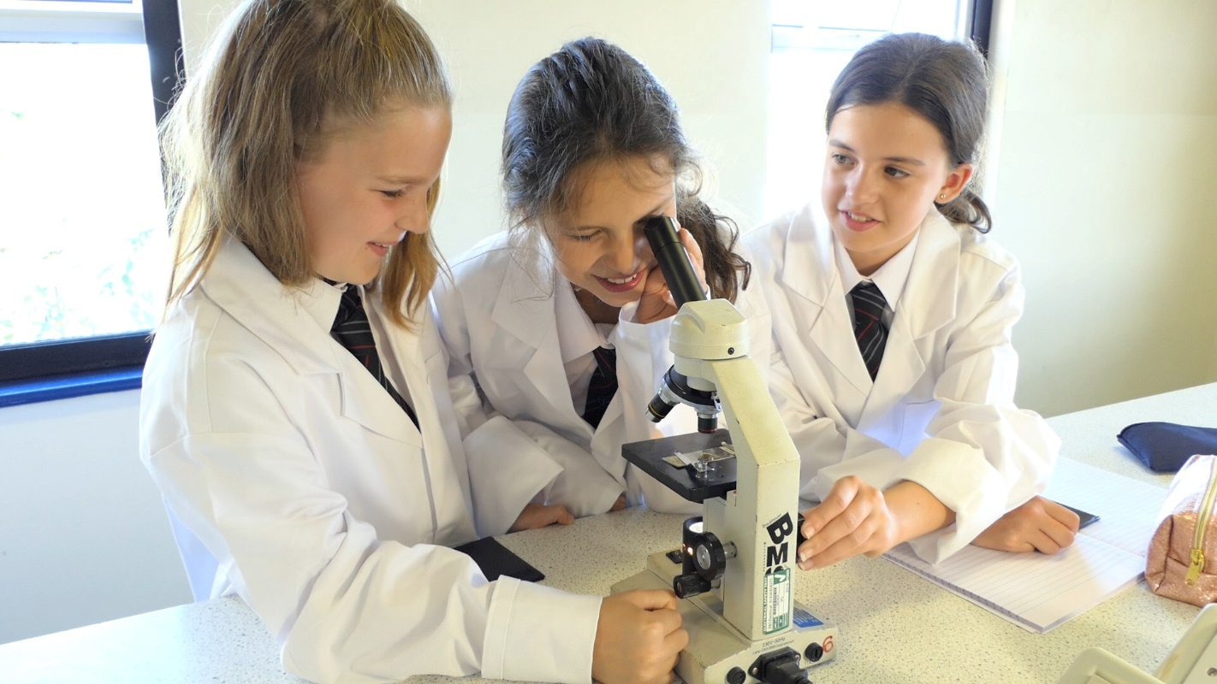

PERSON SPECIFICATION: TEACHER OF SCIENCE

Attributes | Essential | Desirable
Qualifications and training | - Qualified teacher status recognised by the DfES  - Graduate
Experience | - The post would suit an experienced or newly qualified teacher
Skills and Abilities | - Be a talented classroom practitioner, with potential to develop further  - Able to teach Science to GCSE  - Possess good ICT skills and be able to use them in their own teaching  - Able to communicate well, both in writing and orally  - Able to manage time effectively and work to deadlines
Knowledge and Understanding | - Understanding of the principles, processes and strategies underpinning outstanding teaching and learning  - Outstanding knowledge of current educational developments/issues in Science teaching
Values | - Be broadly in sympathy with the aims and ethos of the School  - A commitment to comprehensive education, equal opportunities and inclusion  - A passionate commitment to achieving the highest standards for all learners  - A commitment to teaching approaches which make learning interesting, challenging, relevant and effective  - An enthusiasm for, and involvement in, extra-curricular activities  A passion for Science | - A practising Christian
Personal Qualities | - Shows warmth, care and a sensitivity to the needs of others  - Is self-motivated and hard working  - Possesses a sense of humour and the humility to admit mistakes  - Shows imagination, vision and proactivity  - Possesses an infectious enthusiasm, stamina and considerable energy  - Can work effectively and professionally even when under pressure | Has a good health and attendance record

Criterion assessed by: = application form; = letter of application; = interview

