Welcome to our school
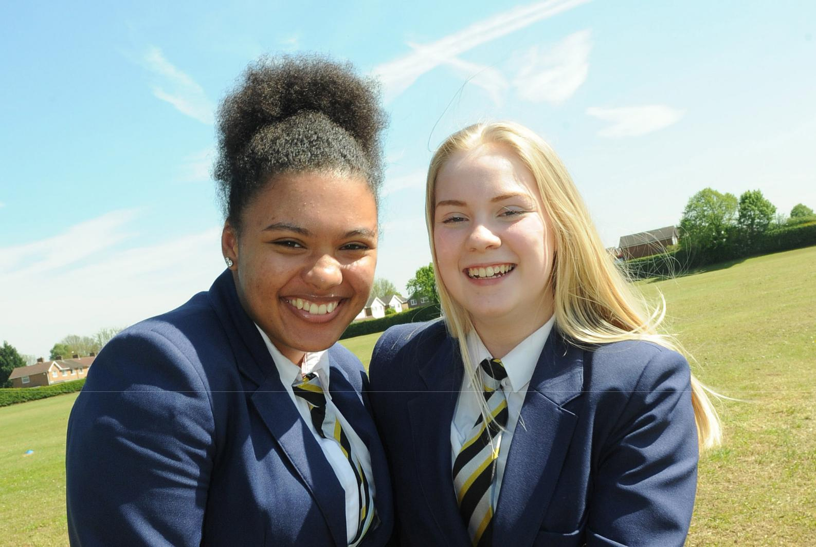

TEACHER
INFORMATION PACK

Welcome

Thank you for taking an interest in our vacancy.

Codsall High School is a vibrant, exciting and dynamic learning environment which embodies the value we place on working with our students to achieve the very best outcomes for each and every one.

We are very proud of our focus on staff and student wellbeing; driven in our aims and ambitions to build on our success in a supportive and friendly environment. The health and wellbeing of our staff is a priority; with an open-door senior leadership policy, a comprehensive new staff / NQT support programme, celebration of staff who go the extra mile and in-house pathways programmes for aspiring future leaders.
We are a high achieving school, providing education to students from years 9 to 13, with our results placing us amongst the highest performing state schools in the country. Through our committed staff, dedicated Governors and supportive parents, we continue to flourish.

We are looking for an inspirational teacher to join our school. If you feel that you have the attributes we are looking for then I’d be delighted to hear from you.

Alun Harding

Executive Headteacher
Codsall High Federation of Schools

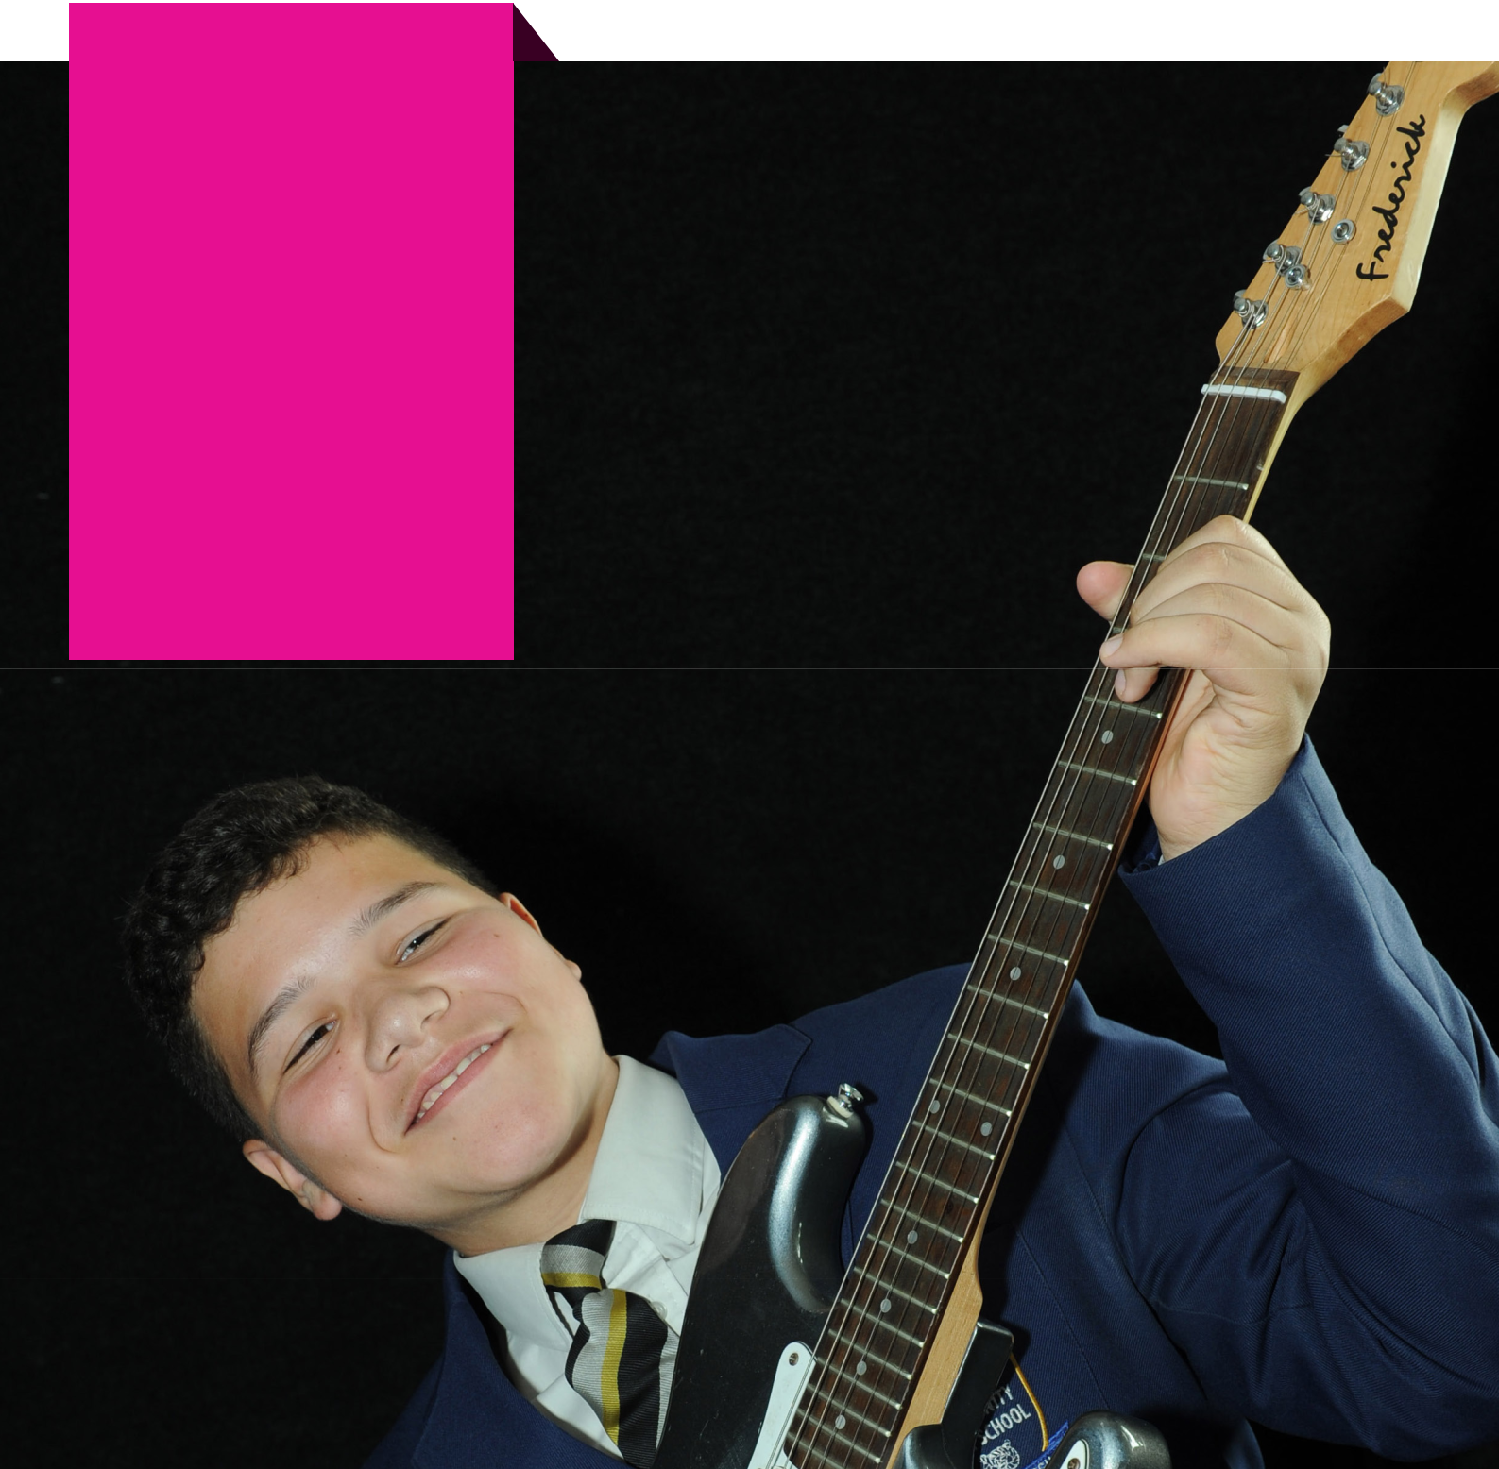
Pursuing our

challenge to

create a “world

class working

environment.”

Our beliefs - culture

- We wish to strip away the unnecessary and focus on the important – the craft of the classroom to ensure our students leave us with the best possible outcomes.

- We continue to develop an open and engaged culture where all staff have the opportunity to suggest ways things could be done better. Staff suggestion box is just one way for this to happen.

- We strive to ensure effective communication about whole school decisions before these decisions are made.

- No expectation or belief that getting to school early or staying in school late is the only way of showing you’re working hard. Work in a way that suits you making sure that you have time for yourself and the ones you love.

- No lesson observation gradings, no showcase lessons, no tick sheet approach – we focus on a culture of typicality and will strive to further develop a positive, inclusive culture of support and challenge.

- No expectation to answer emails outside of school working hours.

- Mental health and wellbeing a priority – resources and sign posting available in the staffroom.

- Visible SLT throughout the school day.

- Senior leadership team run lunch duties to ensure high standards of behaviour and support colleagues.

- Time off in lieu of PD days as twilights.

- Open door senior leadership – no issue is ever too small to discuss.

- Specific and meaningful support for any staff struggling with elements of their role.

- Staff going the extra mile celebrated and recognised through “Star of the Week” draw and handwritten letters of thanks from the Executive Headteacher.

- In house Pathways programmes for aspiring future leaders

– “Pathways to Middle Leadership” and “Pathways to Senior Leadership.”

- Strong and effective pastoral support team.

- A well developed and effective behaviour management system which improves behaviour.

- A comprehensive new staff / NQT support programme, with a welcome.

- Food provided for staff prior to evening events throughout the year.

- On weeks with evening events staff go home early on a
Thursday.

- Occasional staff meetings in the pub!

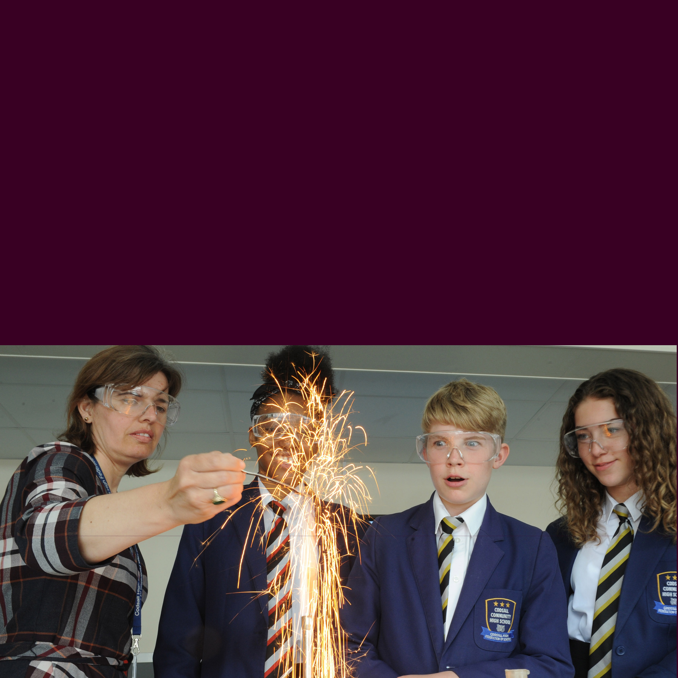
Our beliefs - workload

- No need or expectation to write lessons plans.

- An assessment and marking policy which significantly reduces workload by moving from “marking” culture to an effective assessment culture.

- Our goal is to ensure that there is no more than one cover lesson per half term, less if possible.

- We have trialled no written reports to parents and intend to expand this model.

- Data will never be asked for twice in different contexts.

- 3 data collection points per year group.

- If something new is introduced we will strive to take away something old, ensuring that we review everything we do annually.

- Collaborative planning time to ease workload, gained by shortening the school day once a week.

- Consultation on key policies which include workload assess-ments.

- 22 / 25 hours teaching time per week maximum.

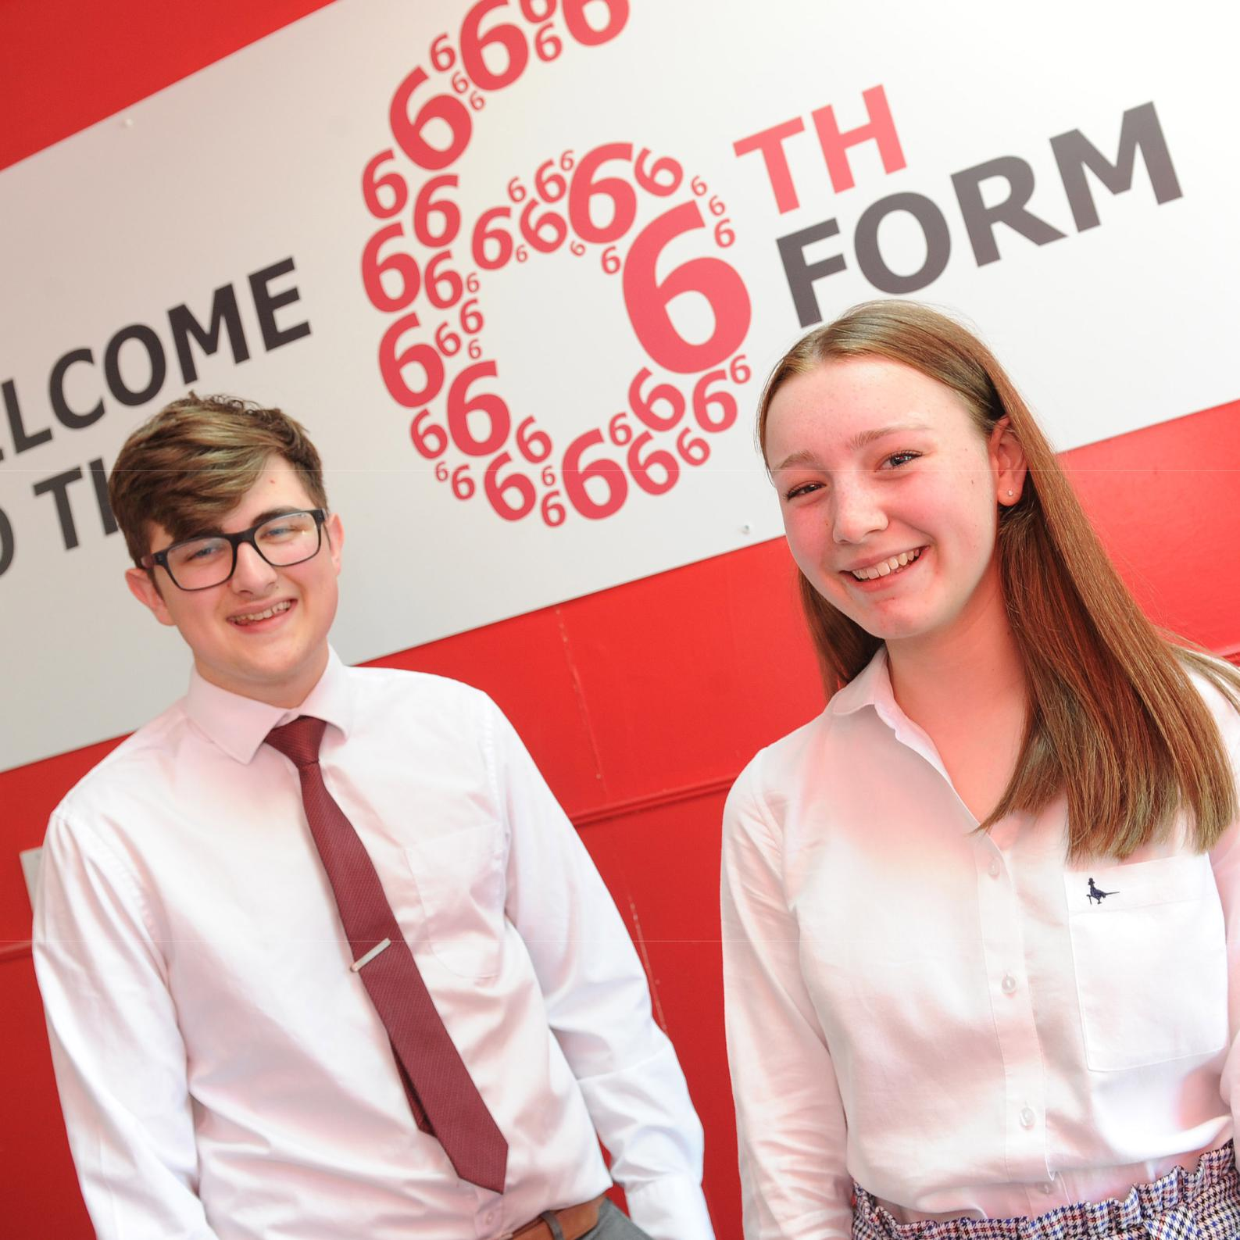

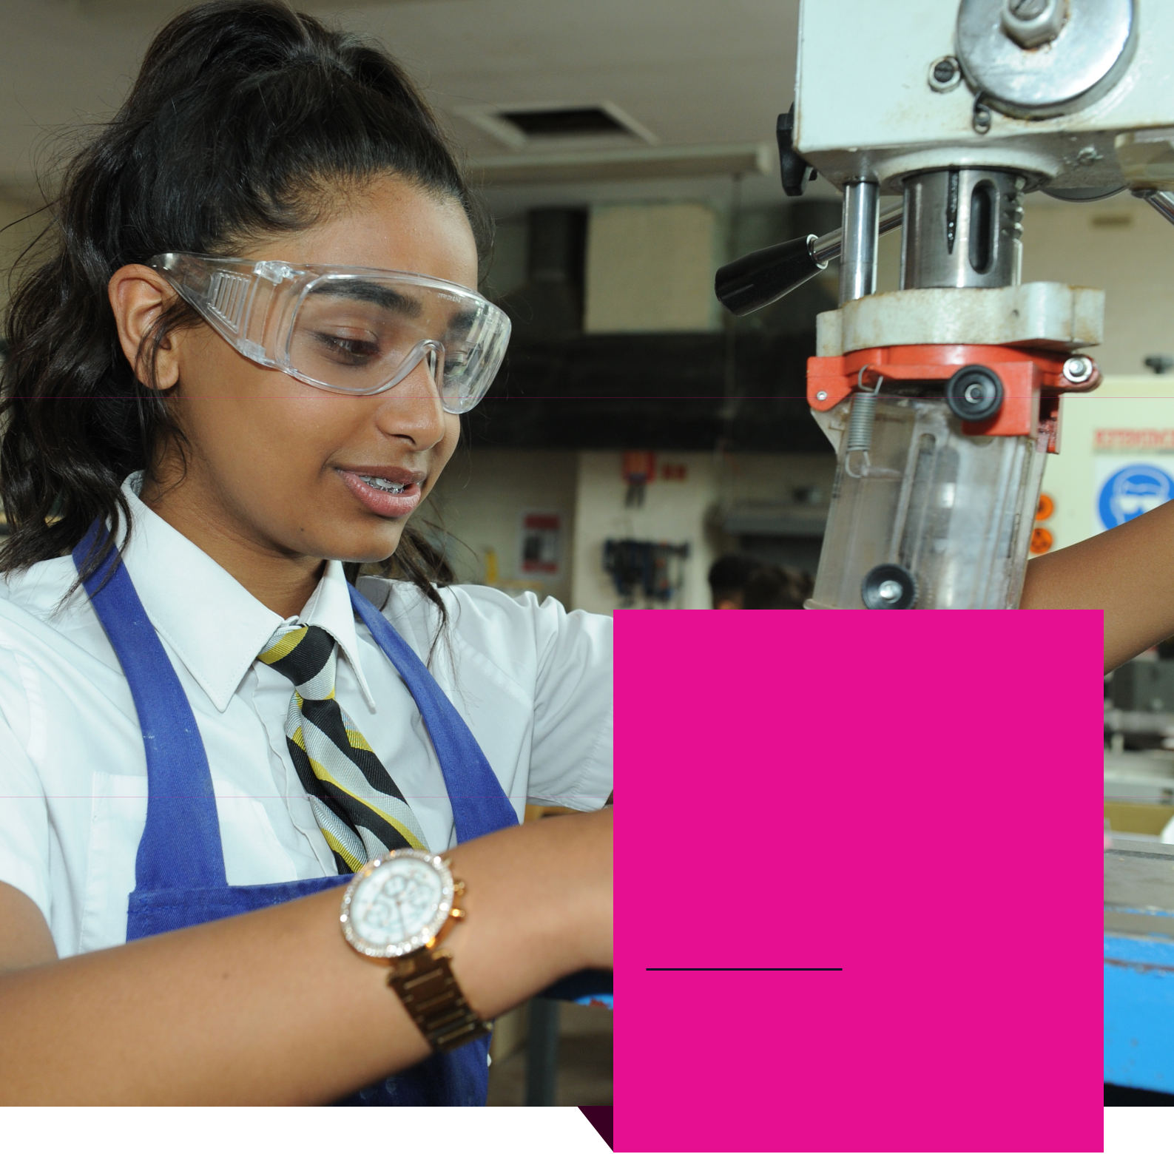

Ambition
Altruism

Achievement

www.cc-hs.com

@codsallhighschool @codsallhigh

