Broughton Hall Catholic High School
INFORMATION PACK
Teacher of Science

Start Date: 1st September 2023
Closing Date: 10.00am 30th January 2023
Shortlisting Date: 31st January 2023
Interview Date: To be confirmed

Salary Scale: MPS/ UPS
Contract Term: Permanent
http://www.broughtonhall.com/information/vacancies.php

Broughton Hall Catholic High School
Founded in 1928 under the trusteeship of the Sisters of Mercy, Broughton Hall Catholic High School, an all-girls Catholic secondary school in Liverpool, provides the very best in modern education based on the Gospel values of mutual respect and care.

The central aim of our school is to provide excellent educational opportunities enabling each pupil to develop their God given talents, to grow in confidence and self-esteem and to fulfil their potential.

As a Catholic school Broughton Hall centres its mission on the person of Jesus Christ, and promotes the Gospel values throughout the school community and in all aspects of school life: spiritual, academic, pastoral, and personal. By proclaiming and living out the faith of the Catholic Church, we support each other in shared experiences of teaching and learning, prayer, worship and charity. Our mercy values permeate throughout our community.

Broughton Hall is Ofsted rated as a “Good” provider (November 2022).

Our facilities are bright, spacious, high tech and designed to meet the needs of all our pupils. We have a separate 6th Form facility, which is shared with our neighbouring boys school Cardinal Heenan Catholic High School. A full range of extra-curricular activities are provided to further the creative, sporting and academic talents of each pupil and offer Outward Bound and Duke of Edinburgh Award schemes as well as the opportunity to attend educational visits and residential trips.

We pride ourselves on our high expectations of all pupils and have an ‘Ambition for All’ policy. Whatever your role within the school, you will share these values and be able to encourage and motivate pupils with your passion, presence and personality.

Our school motto ‘Cor Unum et Anima Una’ - One Heart and One Mind, reflects the strong sense of community amongst pupils, staff, parents and Governors.
We Offer

- Pensions Scheme – Teacher Pension Scheme for teaching staff or Merseyside Pension Fund for support staff
- Regular training and development programme
- Access to occupational health
- Cycle2Work Scheme
- Tax Free Childcare Vouchers
- Supportive work environment where all staff are valued
- Continuous professional development for all staff and follow a whole school approach to staff performance and development

And that’s not all, we place the outcomes of the children in our school at the heart of everything we do, so you’ll wake every day in the knowledge that your role will have a significant positive impact on the lives of others.

Equal Opportunities

Broughton Hall Catholic High school is an equal opportunities employer.

We welcome applicants from all backgrounds and value everyone as an individual. We are committed to organisational practices, which promote diversity and inclusion for all employees and volunteers regardless of age, gender reassignment, marriage or civil partnership status, pregnancy and maternity status, disability, race (including colour, nationality, ethnic or national origin), religion or belief, sex, or sexual orientation. Connecting these differences creates a productive environment in which everyone feels valued.

Monitoring information in relation to job applicants will be to assist us in equality monitoring. The recruitment panel will not have access to job applicant’s monitoring information.

To assist us in monitoring the operation of equal opportunities policy, and for no other reason, please ensure you complete and submit the Equal Opportunities Monitoring Form with your application form.
Safeguarding & Enhanced DBS Checks
Broughton Hall Catholic High School is committed to safeguarding and promoting the welfare of young people and expect all pupils, staff, volunteers and visitors to share this commitment

All posts are subject to an enhanced DBS check and full pre-employment checks to comply with the current Keeping Children Safe in Education statutory guidance for schools.

All staff will be expected to follow Broughton Hall Catholic High School’s child protection policies, code of conducts and managing allegations against staff procedures.

All roles in school, including this post, are exempt from the Rehabilitation of Offenders Act (ROA) 1974. The Ministry of Justice’s guidance on Rehabilitation of Offenders Act 1974 and the Exceptions Order 1975 provides information about which convictions must be declared during job applications and can be accessed here.

All applicants must therefore declare all previous convictions and cautions, including those which would normally be considered ‘spent’ except those received for an offence committed in the United Kingdom if it has been filtered in accordance with the DBS filtering rules. Information about filtering offences can be found in the DBC Filtering Guide, which can be accessed here.

By engaging in this recruitment process, shortlisted candidates consent to an online search in line with the Keeping Children Safe in Education Statutory Guidance 2022.

Welcome

Thank you for your interest in the position of Teacher of Science.

This pack has been designed to help you should you choose to submit an application form, which we sincerely hope you do. We hope it answers your initial questions, but if not, please do not hesitate to contact us and we will endeavour to help you through your application process.

Broughton Hall Catholic High School is the largest all-girls school in Liverpool and serves many different areas making us a vibrant a diverse school. Our aim is to be a good school in all areas and we are seeking staff to apply to work with to be of that journey. Ofsted rated the school as “Good” in November 2022.

We work hard to ensure Broughton Hall Catholic High School remains a friendly and welcoming environment for all those who work, study or visit here and hope that you are the person we are looking for to bring creativity and innovation to the role.

The school actively supports the training of middle leaders through well-respected Teaching Leaders’ programme. Opportunities for promotion exist for suitable candidates. Our staff are passionate about teaching and are committed to develop exciting and stimulating lessons that not only engage students.

We look forward to hearing from you.

Gerard Preston
Head Teacher

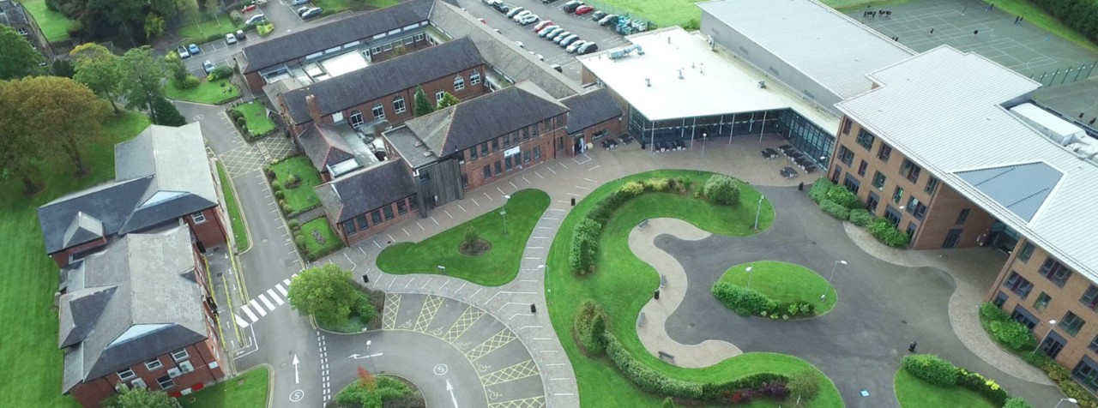

Advert

FULL TIME TEACHER OF SCIENCE
PERMANENT ROLE

Closing Date for Applications: Mon 22nd May at 9.00 am
Interview Date: To be held as soon after the closing date as possible
Start Date: 1st September 2023

The Governors wish to appoint a first rate, enthusiastic Teacher of General Science with the ability to teach Biology or Chemistry across the full age and ability range. If you are highly motivated, have a passion for Science and have the ability to inspire our pupils then we would love to hear from you.
The Science Department is a successful, supportive one and offers qualifications at both Key Stages 4 and 5. The Science Department is equipped with 8 new laboratories and is well-resourced.
The successful candidate will be:
- An outstanding classroom practitioner with a dedication and desire for teaching and learning
- Someone who is passionate about science and has the ability to inspire and foster a love of learning
- Committed to the school’s vision and demonstrating compassion through the mission statement
- Dedicated in ensuring students achieve the best outcomes

Applications from newly qualified teachers or more experienced colleagues most welcome.

The Trustees are the Sisters of Mercy

For further information and an application pack please visit the school’s website
www.broughtonhall.com

The post will be subject to an enhanced DBS clearance

Job Description
Teacher of Science

Purpose | To teach within the school at key stages 3, 4 and 5 as applicable and contribute towards the development of the department team; ensuring the highest possible standards of pupil achievement, personal development and well-being both within the curriculum and beyond.
Location | Broughton Hall Catholic High School, West Derby, Liverpool
Reporting to | Head of Department
Responsible for | The post holder will be responsible for departmental teaching including GCSE Science and the delivery of agreed extra-curricular provision.
Working Time & Conditions | These will be as specified in the latest School Teachers Pay and Conditions Document. Attendance at school functions beyond the working day including Parents/Awards Evenings will be required.
Safeguarding children | The post holder must safeguard and promote the welfare of the children and young people at Broughton Hall Catholic High School
Salary | MPS/ UPS

OVERVIEW

At the heart of the role of the main scale teacher is the provision of high quality teaching and learning, effective use of resources, improving standards of achievement for students, and the promotion of students’ personal development and well-being within this faith based community. Main scale teachers work as members of a department to secure the highest possible standards in all aspects of school and departmental life and are required to carry out such duties as are reasonably assigned by the Head Teacher to ensure the effective operation of the school.

DIMENSIONS

The post holder will be responsible for the following, with reference to the national framework of teachers:
- Classroom teaching and learning
- Pupil progress and standards of achievement

ACCOUNTABILITIES

The strategic direction and development of the subject

- To support the production of an annual subject development plan, which contributes to the achievement of the School Improvement Plan, and which involves all the subject staff in its design and evaluation.
- To contribute to the setting expectations and goals for colleagues and pupils in relation to standards of achievement and behaviour.
- To as appropriate, represent the department in the wider school community and liaise with the rest of the school, governors, partner schools, the Local Authority, further and higher education, industry, outside agencies, examination boards etc.
- To keep up to date with national developments in the subject area and teaching practice and methodology.
- To help develop current systems with regard to health and safety, risk assessments, collection and storage of valuables and other key procedural requirements.
- To contribute to the development of the school’s extra-curricular Science education programme.

Teaching and learning

- To contribute to the development and implementation of effective teaching and learning strategies, including ICT-based developments and new technologies.
- To contribute to the development and implementation of effective department assessment policies, within the framework of those for the whole school.
- To promote and support extra-curricular activities, which enrich and support the learning and experience of all pupils, and increases their participation in school life.
- To ensure homework where applicable, is set in line with school policy, and recorded departmentally.

Leading and managing staff

- To support the professional development of staff, for example through the sharing of good practice; participating in the school’s programmes of staff training and development.
- To participate in Performance Management process according to school and national regulations, including lesson observations.
- To fulfil the Teaching Standards according to school and national expectations.

Pupil progress and standards of achievement

- Within the framework of whole-school policies, to set and monitor appropriately challenging subject targets for pupils, which will make a measurable contribution to the fulfilment of those for the whole school; to manage interventions to maximise pupil progress.
- To maximise achievement by ensuring that any examination entries are maximised and non-entries are minimised; to assist with the management and conduct of examinations.
- To ensure effective communication with parents/carers, so they are kept up-to-date with curriculum developments and their children’s progress.
- Writing reports on students and attending meetings with parents.
- To track different groups of students’ progress and put in a clear intervention plan where gaps exist.

The efficient and effective deployment of staff and resources

- To manage assigned resources in order to create a safe, stimulating and positive learning environment, including maintaining the content of displays that promote interest, learning and achievement.

Other Specific Duties

- To undertake any other duty as specified by the School Teachers Pay and Conditions Document not mentioned in the above.
- Employees are expected to be courteous to colleagues, to be professional and punctual in the execution of their duties and responsibilities, model Gospel values and provide a welcoming, professional environment to visitors and external colleagues.
- Whilst every effort has been made to explain the main duties and responsibilities of the post, each individual task may not have been identified; therefore employees will be expected to comply with any reasonable request from a manager, including ad hoc projects, to undertake work of a similar level that is not specified in the job description.

The job description is current at the date shown, but, in consultation with you, may be changed by the Head Teacher to reflect or anticipate changes in the job commensurate with the grade and job title.

Person Specification
Teacher of Science

1. QUALIFICATIONS AND TRAINING
- University graduate
- Postgraduate teaching qualification/QTS
- Relevant Science qualifications
- Evidence of continuing professional development

2. TEACHING and PASTORAL EXPERIENCE
- The role is open to colleagues with one or more years teaching experience
- Teaching experience in at least KS3, 4 and, preferably, 5
- Evidence of consistently good and outstanding teaching and learning
- Evidence of cascading outstanding teaching and learning practices in school or a range of schools
- Evidence of excellent classroom management skills
- Outstanding knowledge of Assessment Practice in the context of the National Agenda and where appropriate best worldwide practice
- Excellent subject knowledge
- Excellent knowledge of current curriculum and extra-curricular developments in your subject area.
- An understanding of how to use assessment to inform planning for good teaching and learning.
- A good understanding of progress data.
- The ability to differentiate to provide appropriate challenges for all learners.
- Evidence of using data to inform planning and put in place successful intervention strategies to raise achievement.
- Evidence of pastoral experience, including taking responsibility for a form group.
- An interest in the wider curriculum.

3. LEADERSHIP AND MANAGEMENT
- The ability to inspire, enthuse, develop and support both students and colleagues.

4. PERSONAL QUALITIES
- A willingness to learn and develop new skills
- A willingness and flexibility to work outside normal school hours
- The ambition to continue to progress in your career
- A desire to make difference to the lives of young people
- An excellent attendance record
- Resilience and a sense of humour.

5. EQUAL OPPORTUNITIES AND EDUCATIONAL COMMITMENT
- A proven commitment to inclusion
- A proven commitment to curriculum access and opportunity
- A proven commitment to comprehensive education
- A proven commitment to professional development
- Support the school unreservedly in its commitment to safeguarding and promoting the welfare of children, young people and vulnerable adults.
Science Department

Departmental Descriptions
The Science Department is led by Mr Roberts and is presently comprised of 11 full time teachers and 3 technicians. Miss Skiming has responsibility for KS4 and Chemistry, Mrs Williams has responsibility for Biology and KS3 and KS5 Vocational matters are coordinated by Mr Finch. Broughton Hall Science is an improving and forward thinking department to work in, recently celebrating the best set of Science results in recent years. The department offers help and support to new staff whether they are trainees or experienced teachers.

August 2019 Results
- BIO: 75% of students achieved grades 7-9, Average grade 7+
- CHEM: 50% of students achieved top grade 9, Average grade 8-
- PHY: 58% of students achieved grades 7-9, Average grade 7-
The Science Department offers courses at KS3 which deliver a national programme of study in preparation for studies at KS4 where both GCSE Separate Sciences and Trilogy combined Science qualifications are studied. At KS5 A-level courses in Biology, Chemistry, Physics and BTEC Vocational Qualifications in Applied Science and Applied Human Biology have proved both popular and successful.

Our aims are to:
- Develop and maintain students’ interest in Science and related disciplines.
- Develop in our students a wide and relevant body of scientific knowledge and understanding.
- Help students to develop investigative skills across Biology, Chemistry and Physics.
- Continue to develop both literacy and numeracy within a scientific context.
- Develop transferable skills such as problem solving within our students.

The department has always believed that education is continually evolving and as teachers we need to keep developing our skills and practice. The department works closely with the Local Authority and Diocese networks to ensure that staff receive the most up to date training in new developments and approaches. The department is also benefitting from the Stimulating Physics Partnership with bespoke training being available for staff. As part of the Triple Science Support Programme Broughton Hall Science has access to resources and funding designed to increase uptake of the 3 separate science GCSE’s a national target.
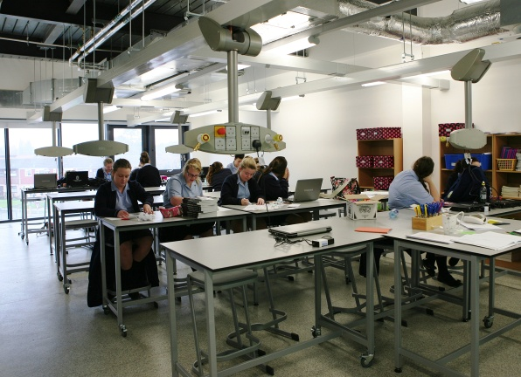
As with all departments science is also looking within itself for developments and improvements by sharing good practice via Triad teaching and learning groups and an openness to share ideas at department meetings which are regular within Broughton Hall.

Accommodation and Resources
The Science department is mainly based in 8 new purpose-built Labs with NAWIS gas and electric facilities. There are 3 science preparation rooms and a shared preparation area for use by teachers and technicians.

All laboratories benefit from Promethean interactive boards and 2 of these are apple enabled. The Science department also has access to 45 laptops for use solely within Science lessons, and two sets of interactive handsets. Practical equipment is well maintained by our experienced technicians and covers most standard practicals and topics. Excellent technical support from our technicians has allowed Broughton Hall to respond quickly to the emphasis on required practicals and a practical endorsement at both KS4 and KS5.

Key Stage 3
Year 7 & 8, follow an in house National Curriculum based scheme focusing on Core Scientific skills, which is fully resourced. Assessment is via tests at the end of each topic and an end of year exam. These assessments and the data they provide are used to give guidance on courses at KS4.

Key Stage 4
Year 10 students all study for a GCSE qualification in AQA Trilogy Combined Science or AQA Separate Sciences, this is offered as an elective over the two years.
The successful completion of these courses leads to students pursuing level 3 courses in Biology, Chemistry, Physics and Applied Science or Applied Human Biology.

Key Stage 5
In years 12 and 13 students enjoy quality teaching and learning towards AQA A-levels in Biology, Chemistry and Physics and BTEC Qualifications in Applied Science and Applied Human Biology. Students studying A levels in Biology, Chemistry and Physics typically have grades 6 or better in GCSE qualifications in Science and Maths. Students with GCSE grade 4 or better qualifications in Science and grade 4 in GCSE Maths will be offered a course leading to a BTEC in Science. Students who study A levels in science continue their studies at Further education level with the majority of students going on to science-based degrees in medicine, dentistry, radiography, chemical, civil and mechanical engineering, pharmacy and others at Universities that in 2020 included Oxford, Cambridge, Liverpool, Manchester, and Lancaster.
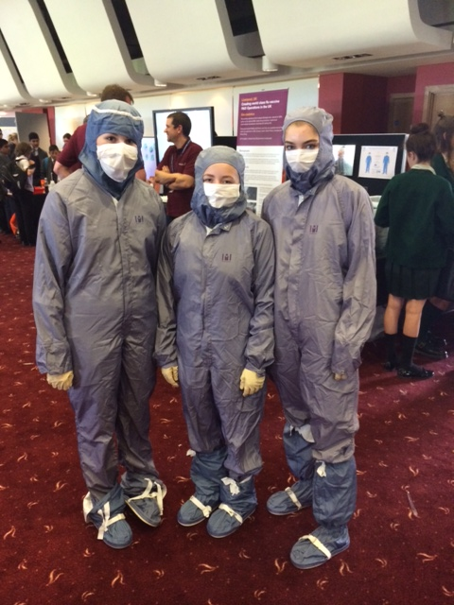

Extra-Curricular Activities
Intervention classes in Science are offered both before and after school to KS3/KS4 and KS5 students. There is also ‘Science Wednesday’s available to all year 10 and year 11 students on Wednesdays 3.05 – 4.05. KS3 students enjoy investigative work done within our STEM Club run after school. There are also intervention and general preparation classes at KS5 in all subjects. Numerous trips out add interest and enthusiasm to the science curriculum at Broughton Hall and recently there have been visits to Daresbury Laboratories for their ‘Chemistry at work day’, The Blood Transfusion Centre at Speke, the Blue Planet Aquarium, the Big Bang Event at Aintree, a Robotics Challenge Days at Liverpool University and Hugh Baird College, and an alien experience visit to Jodrell Bank. The 6th Form trip to Cern, Geneva proved exceedingly popular and proved to be an excellent opportunity to see cutting edge Science research up close.

